Exercise #3b – Modeling Concepts from Chapter 3, 4, and 5

1) You are being asked to create a data model for the American Long-Distance Running Association (ALDRA), using the following information:

A competitive long-distance runner may run many races during the year. Each race is identified by the combination of a name (ex: The Piedmont Trot), a length (ex: 5km, 10km, 21km, 42km), and a date. For each race that occurs, there is a need to capture the time and position of all of the runners.

A runner may only be part of one running club. Whereas each runner is permanently identified by a unique number provided by the ALDRA, a club is identified by a name (ex: The Atlanta Track Club), and has a particular address, phone number, and a date of foundation.

In attached .mwb file.

2) You are being asked to create a data model for the Shady Pines Elder’s Care Center, using the following information:
The Shady Pines Elder’s Care Center is made of many branches. Each branch is staffed by nurses. Each branch has a nurse who is in charge of the branch’s operations (i.e., the “head nurse”). A nurse can work at only one branch. Debate in which table would you place the head nurse, why you would or would not constrain the head nurse as an identifying or non-identifying in its respective table.

In my .mwb file, I had two tables, branch and nurse. There were two connections between the table. One non-identifying 1-M connection from Branch to Nurse and a second identifying 1-1 connection from Branch to Nurse, used to identify the head nurse of the Branch within the Branch table. This particular connection is identifying because each branch must have a head nurse, and each nurse can only work at one branch. Therefore, the branches must be constrained by their head nurse as identifying.
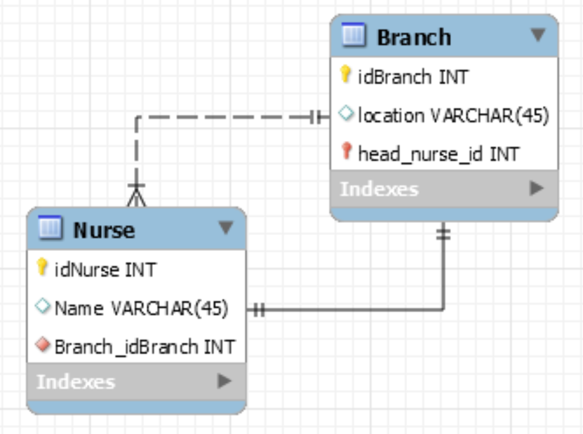
3) You are designing a data model for the facilities management and need to know at least what items (e.g., chairs, tables, desk, etc.) and the dimensions of the room for each room of each building on campus. Write the Create Statements to create the tables in the model.

SQL statements pulled from MySQL by doing database>forward engineer after construction of a model in the same attached .mwb file. Some of the generated code was manually removed (stuff pertaining to engine and some commenting) to make things cleaner.

CREATE TABLE IF NOT EXISTS `mydb`.`Building` (
`building_id` INT NOT NULL,
`building_name` VARCHAR(45) NULL,
PRIMARY KEY (`building_id`));

CREATE TABLE IF NOT EXISTS `mydb`.`Room` (
`room_no` INT NOT NULL,
`length` VARCHAR(45) NOT NULL,
`width` VARCHAR(45) NOT NULL,
`Building_building_id` INT NOT NULL,
PRIMARY KEY (`room_no`, `Building_building_id`),
INDEX `fk_Room_Building1_idx` (`Building_building_id` ASC),
CONSTRAINT `fk_Room_Building1`
FOREIGN KEY (`Building_building_id`)
REFERENCES `mydb`.`Building` (`building_id`)
ON DELETE NO ACTION
ON UPDATE NO ACTION);

CREATE TABLE IF NOT EXISTS `mydb`.`Item` (
`idItem` INT NOT NULL,
`item_description` VARCHAR(45) NULL,
`room_no` INT NOT NULL,
PRIMARY KEY (`idItem`),
INDEX `fk_Item_Room1_idx` (`room_no` ASC),
CONSTRAINT `fk_Item_Room1`
FOREIGN KEY (`room_no`)
REFERENCES `mydb`.`Room` (`room_no`)
ON DELETE NO ACTION
ON UPDATE NO ACTION);

