CERTIFICATION

This is to certify that this internship and project report entitled "
DESIGN AND IMPLIMENTATION OF A SMART WASTE MANAGE
MENT SYSTEM
" was originally written by Tarshi Williams Ngarfon in partial fulfillment of the requirements for the award of the Higher National Diploma (HND) in Software Engineering at Vishi Higher Institute. This report has been submitted in accordance with the academic and professional guidelines for the HND.

PROFFESIONAL SUPERVISOR

Mr. BESSON

SIGN: _____________________

DATE:_____________________

ACADEMIC SUPERVISOR

Mr. WALANDJI ELVIS

SIGN: _____________________

DATE:_____________________

DEDICATION

TO THE TARSHI’S FAMILY

ACKNOLAGEMENT

First and foremost, I express my sincere gratitude to God Almighty for granting me the strength, patience, and perseverance to complete this internship and project successfully.
I extend my deepest appreciation to my academic supervisor, Mr. besson………, for his valuable insights, guidance, and constructive criticism that have greatly improved the quality of this report.
Special thanks to ClingsTech. for providing me with an opportunity to carry out my internship. I am grateful to the CEO and staff members for their mentorship and for exposing me to real-world industry practices.
I also want to thank my friends and classmates for their continuous support and encouragement throughout my studies. Lastly, a heartfelt appreciation goes to my family for their constant love, motivation, and financial support.

ABSTRACT

The Smart Waste Management System (SWMS) is a web platform designed to digitize and optimize waste collection, agent management, and recycling tracking in urban areas. The system was developed using PHP, MySQL, HTML, CSS, JavaScript, and Tailwind CSS to enhance operational efficiency by automating route assignments, ensuring optimal collection, and facilitating citizen access to services.
This document presents the development process, from needs analysis to the deployment of a functional solution. The methodological approach follows the Software Development Life Cycle (SDLC), including database modeling, system architecture, and user interface design.
Furthermore, the internship experience provided practical skills in web application development, particularly in mobile payment integration (MTN and Orange Money) and geolocation services, which significantly influenced the design and implementation of this project. The results demonstrate that a well-structured waste management system can increase agent productivity, reduce operational costs, and improve urban cleanliness.

RESUME

Le Système Intelligent de Gestion des Déchets (SWMS) est une plateforme web conçue pour digitaliser et optimiser la collecte des déchets, la gestion des agents et le suivi du recyclage dans les zones urbaines. Le système a été développé en utilisant PHP, MySQL, HTML, CSS, JavaScript et Tailwind CSS afin d'améliorer l'efficacité opérationnelle en automatisant l'attribution des tournées, en garantissant une collecte optimale et en facilitant l'accès aux services pour les citoyens.
Ce document présente le processus de développement, depuis l'analyse des besoins jusqu'au déploiement d'une solution fonctionnelle. L'approche méthodologique suit le cycle de développement logiciel (SDLC), incluant la modélisation de la base de données, l'architecture système et la conception de l'interface utilisateur.
De plus, l'expérience de stage a permis l'acquisition de compétences pratiques dans le développement d'applications web, notamment dans l'intégration de paiements mobiles (MTN et Orange Money) et la géolocalisation, qui ont fortement influencé la conception et la réalisation de ce projet. Les résultats démontrent qu'un système bien structuré de gestion des déchets peut accroître la productivité des agents, réduire les coûts opérationnels et améliorer la propreté urbaine.

PREFACE

The journey toward professionalism in the field of software engineering involves both theoretical knowledge and practical application. This report is a reflection of the experiences gained from both my internship at Clings Tech. and the development of my final-year project, a Smart Waste Management System.
Throughout this process, I have been exposed to real-world industry standards, including database management, web development, system design, and software deployment. The knowledge acquired during my internship allowed me to build a more robust and scalable project, aligning it with best practices in the tech industry.
This document follows the structured guidelines for HND internship and project reports, detailing the conceptual framework, research methodology, system implementation, and the challenges encountered. It is my hope that this report will not only fulfill the academic requirements but also serve as a valuable resource for future students undertaking similar projects.

IDENTIFICATION FORM

COMPANY NAME: | Clings Tech
ACTIVITY: | SOFTWARE & SYTEM DEVELOPMENT
CAPITAL: | RAIL,DOUALA
CATEGORY: | Private Limited Company
CREATION: | Year 2014
EMAIL:
HEADQUATER: | RAIL ,DOUALA , CAMEROUN
No OF AGENCIES: | 1

Table 2: Identification form

LIST OF ABREVIATION

CSS: Cascading Style Sheet
ERD: Entity Relationship Diagram.
ERP: Enterprise Resource Planning. HTML: Hypertext Markup Language.
ICT: Information and Communication Technology.
IT: Information Technology.
JS: Java Script.
MySQL: A combination of “My”, the name of co-founder Michael Widenius’s daughter, and “SQL”, abbreviation for Structured Query Language.
PHP: Hypertext Pre-processor.
SDLC: Software Development Life Cycle.
XAMPP: Cross Platform Apache Mysql Php Perl.

LIST OF FIGURES

Figure 0.3 Use Case Diagram 30
Figure 0.4 Class Diagram 30
Figure 0.5 Database Schema 30
Figure 0.6 User Interface (UI) Wireframes 31
Figure 0.7 login 32
Figure 0.8 dashboard 32
Figure 0.9 patients 33
Figure 1.0 medicines 33
Figure 1.1 reports 34
Figure 1.2 users management page 34
Figure 1.3 Sequence Diagram 35

TABLE OF CONTENT

CERTIFICATION 2
DEDICATION 3
ACKNOLAGEMENT 4
ABSTRACT 5
RESUME 6
PREFACE 7
IDENTIFICATION FORM 8
LIST OF ABREVIATION 9
LIST OF FIGURES 10
TABLE OF CONTENT 11
GENERAL INTRODUCTION 13
PART ONE: THE INTERNSHIP FRAMEWORK 16
CHAPTER 1: PRESENTATIONA OF THE COMPANY & INTERNSHIP ACTIVITIES 17
CHAPTER 2: OVERVIEW OF THE TOPIC STUDIED 20
PART TWO: POJECT FRAMEWORK 23
CHAPTER 3: DIAGNOSTIC OF THE EXISTING SYSTEM 24
CHAPTER 4: DESIGN & IMPLEMENTATION OF THE PROPOSED SYSTEM 27
GENERAL CONCLUSION 36
BIBLIOGRAPHY 38

GENERAL INTRODUCTION

1.1 Contextualization of the Topic
The waste management sector plays a crucial role in ensuring environmental sustainability and public health in urban communities. With rapid urbanization and population growth, the need for efficient, systematic, and technology-driven waste management solutions has become increasingly critical. Traditionally, waste collection and disposal systems relied on manual coordination methods, which were prone to inefficiencies such as missed collections, poor route optimization, and lack of real-time monitoring.
In the modern era of smart city development, municipalities and waste management companies are increasingly adopting digital platforms to improve operational efficiency, enhance service delivery, and promote environmental sustainability. A Smart Waste Management System (SWMS) is a digital solution designed to automate various aspects of waste operations, including collection scheduling, agent assignment, route optimization, payment processing, and performance monitoring. By transitioning from manual to automated systems, waste management providers can optimize resource utilization, reduce operational costs, and improve urban cleanliness.

  - Problem Statement
Currently, many urban communities and waste management authorities rely on traditional manual systems for handling waste collection, agent coordination, and service management. These outdated approaches create significant societal and operational challenges, including:
➢ Public Health Risks: Irregular waste collection leads to garbage accumulation, creating breeding grounds for diseases and environmental pollution
➢ Urban Cleanliness Issues: Inefficient collection systems result in littered streets and public spaces, degrading urban quality of life
➢ Service Inequality: Manual coordination often leads to unequal service distribution, leaving some neighborhoods underserved
➢ Environmental Impact: Poor waste management contributes to soil contamination, water pollution, and greenhouse gas emissions
➢ Public Dissatisfaction: Citizens face inconsistent service delivery with no transparent tracking or accountability mechanisms
  - Research Questions
This research seeks to answer the following key questions:
- What are the main operational challenges faced by clinics using traditional manual systems?
- How do existing Clinic Management Systems compare in terms of functionality, usability, and effectiveness?
- What impact does the implementation of a digital clinic management system have on efficiency, patient satisfaction, and overall healthcare service delivery?

1.4 Objectives
The objectives of this study are as follows:
- To develop a user-friendly and efficient Clinic Management System that automates key operations such as patient registration, appointment scheduling, and billing.
- To enhance data security and privacy by implementing role-based access control and encryption mechanisms.
- To integrate a centralized database that allows easy retrieval and management of patient records.
- To provide real-time reporting and analytics for clinic administrators to monitor performance and make informed decisions.
- To improve the patient experience by minimizing waiting times and ensuring seamless access to healthcare services.

1.5 Plan of the Report
This report is structured into two major parts, following the standard HND report guidelines:

Part One: Internship Experience
- Chapter 1: General Presentation of the Company
This chapter provides an overview of Oprime Inc., the organization where the internship was carried out. It includes details about the company’s mission, vision, structure, and services.
- Chapter 2: Evolution of Internship Activities
This chapter details the tasks and responsibilities assigned during the internship, highlighting key projects and technologies encountered.

Part Two: Project Framework
- Chapter 3: Diagnosis of the Existing System
This section examines the shortcomings of traditional clinic management systems and evaluates existing solutions in the market.
- Chapter 4: Design & Implementation of the Proposed System
This chapter presents the Clinic Management System, outlining its design, architecture,

- database structure, functionalities, and implementation approach. It includes system diagrams such as ER diagrams, class diagrams, system architecture, use case diagrams, database schema, and UI wireframes.
- Finally, the report concludes with a General Conclusion summarizing the findings, challenges, and recommendations for future improvements.

PART ONE: THE INTERNSHIP FRAMEWORK

PART ONE: THE INTERNSHIP FRAMEWORK

INTRODUCTION:
Part one is made up of two chapters:

Chapter one which talks about the PRESENTATION OF THE COMPANY & INTERNSHIP ACTIVITIES
Chapter two which talks about the OVERVIEW OF THE TOPIC STUDIED

CHAPTER 1: PRESENTATIONA OF THE COMPANY & INTERNSHIP ACTIVITIES

SECTION 1: PRESENTATION OF OPRIME INC.

  - Introduction to Oprime Inc.
Oprime Inc. is a technology solutions company based in Douala, Cameroon, specializing in software development, ERP implementation, cloud-based solutions, and CMS management. Founded in 2015, the company has established itself as a key player in the Cameroonian and Central African IT sector, providing custom software solutions for businesses and institutions.

1.2 History and Evolution
Originally known as IT Solutions Cameroon, the company rebranded to Oprime Inc. in 2021 to reflect its expansion into enterprise resource planning (ERP) solutions, system security, and cloud-based applications. Over the years, Oprime has worked with schools, businesses, and government agencies to develop and deploy high-quality software applications.

1.3 Core Services and Specializations
Oprime Inc. offers a wide range of IT solutions, including:
- Cloud Infrastructure Development – Providing scalable cloud computing solutions for businesses.
- Systems Development – Custom software applications tailored to business needs.
- ERP Implementation – Deploying and managing enterprise resource planning systems.
- System Security – Ensuring high-level security for web and enterprise applications.
- WordPress & CMS Management – Creating and managing content management systems (CMS) for clients.

1.4 Organizational Structure
The company is structured into several departments:
- Department of Business Management
  - Accounting & Administration
  - Sales and Marketing
- Department of Technology and Development
  - Software Engineering
  - Technical Implementation

1.5 Market Reach and Clientele
Oprime Inc. operates primarily in Cameroon but has expanded its services to Gabon, Central African Republic, Ivory Coast, and Nigeria. The company’s reputation for delivering high-quality custom IT solutions has earned it a strong client base in the region.

SECTION 2: DETAILED ACTIVITIES CARRIED OUT DURING THE INTERNSHIP
Week | Focus Area | Key Activities

Week | Focus Area | Key Activities
Week 1-2 | Orientation & Understanding the Work Environment | - Introduction to company structure, policies, and expectations. - Familiarization with existing projects: Campus360, BetaPlace, and WordPress CMS Management.
Week 3-4 | Hands-on CMS & Web Hosting | - Learning to create, modify, and manage WordPress-based CMS websites. - Hosting websites using Plesk and deploying projects to live servers.
Week 5-6 | ERP Software & Cloud Computing | - Understanding Enterprise Resource Planning (ERP) software and its business applications. - Introduction to cloud-based systems and their integration with web applications.
Week 7-8 | Project Work & Final Internship Assessment | - Practical work on Campus360 and BetaPlace, including database updates and feature improvements. - Final presentation of internship experience and feedback from supervisors.

SECTION 3: CHOICE & JUSTIFICATION OF THE RESEARCH TOPIC
- The choice of the Clinic Management System was influenced by:
- Gaps observed in hospital patient record management, which caused inefficiencies.
- The need for a digital solution that automates processes such as patient tracking, prescriptions, and medical reports.
- My growing expertise in database management and software deployment, which made me confident in developing such a syst

CHAPTER 2: OVERVIEW OF THE TOPIC STUDIED

2.1 Introduction
Healthcare systems worldwide are continuously evolving, and with this evolution comes the increasing demand for efficient Clinic Management Systems (CMS). A CMS is designed to handle various administrative, medical, and operational aspects of a clinic, allowing for smooth and efficient patient care. As healthcare providers face significant challenges related to patient record management, scheduling, billing, and data security, digital solutions become essential to meet modern medical standards.
Traditional paper-based clinic operations are prone to inefficiencies such as misplaced records, slow appointment scheduling, and difficulty in accessing patient history. A Clinic Management System seeks to eliminate these challenges by offering an integrated, user-friendly, and automated system for clinics of all sizes. This chapter explores the key concepts of CMS, its components, limitations in existing solutions, and the need for an improved system that bridges current gaps in healthcare technology.

2.2 Definition and Key Concepts
A Clinic Management System is a web-based or desktop software that helps clinics digitize and automate their daily functions. It encompasses multiple interconnected modules, each designed to optimize a specific aspect of clinic operations. Some of the essential components include:

2.3 Existing Solutions and Their Limitations
Over the past decade, multiple Clinic Management Systems have been developed to improve healthcare efficiency. However, most of these systems are either too complex for small clinics or too expensive for healthcare providers in developing nations. Some of the commonly used CMS platforms include:
- Patient Registration and Management: A centralized database where patient records, personal information, and medical history are stored and retrieved efficiently.
- Appointment Scheduling: An automated calendar system allowing patients and staff to book, reschedule, or cancel appointments.
- Electronic Health Records (EHR): A digital format for storing patients' diagnoses, prescriptions, treatment plans, and medical test results.
- Billing and Invoicing: A module that manages financial transactions, including medical bills, insurance claims, and payment processing.
- Prescription and Medication Tracking: A system for storing and managing prescriptions, ensuring the right medication is administered to the right patient at the right time.
- User Access Management: A role-based security system that ensures only authorized personnel have access to sensitive medical data.

2.3.1 OpenEMR
- Strengths:
  - Open-source and free to use.
  - Robust features, including EHR, appointment scheduling, and billing.
- Limitations:
  - Requires technical expertise to install and configure.
  - Limited customer support and documentation.

2.3.2 Mediware
- Strengths:
  - Cloud-based platform with seamless integration.
  - Highly secure and scalable for large hospitals.
- Limitations:
  - High licensing fees.
  - Complex interface, requiring extensive staff training.

2.3.3 ClinicSoft
- Strengths:
  - Easy to use and designed for small clinics.
  - Affordable and accessible.
- Limitations:
  - Lacks advanced analytics and reporting.
  - Limited integration with third-party applications.
While these solutions offer various benefits, they often fail to address the unique needs of small- to medium-sized clinics, particularly in regions with limited financial and technical resources. Many existing systems are not fully customizable, making it difficult for clinics to tailor the software to their specific workflows.

2.4 Why This System Is Needed
Given the limitations of current CMS platforms, this project aims to bridge the gap by developing a cost-effective, user-friendly, and highly adaptable Clinic Management System. The main objectives of this system include:
- Providing an Intuitive and Easy-to-Use Interface: Many existing systems have complex interfaces, requiring extensive training for medical staff. This project prioritizes simplicity and ease of use.
- Enhancing Data Security and Privacy: By implementing role-based access controls and encryption, patient data will be protected against unauthorized access.
- Ensuring Customizability and Scalability: Unlike rigid commercial solutions, this system will allow clinics to modify features and expand functionalities based on their unique requirements.
- Automating Repetitive Tasks: Reducing administrative workload by automating appointment scheduling, billing, and prescription management.
- Generating Comprehensive Reports: Clinics can generate real-time patient reports, financial summaries, and operational insights to support better decision-making.
By addressing these challenges, this Clinic Management System will play a crucial role in improving patient care, operational efficiency, and overall healthcare delivery.

PART TWO: POJECT FRAMEWORK

In this part, we will talk about 2 chapters; that is, chaptethree and chapter four. Chapter three is on DIAGNOSTIC OF THE EXISTING SYSTEM and Chapter four is on DESIGN & IMPLEMENTATION OF THE PROPOSED SYSTEM

CHAPTER 3: DIAGNOSTIC OF THE EXISTING SYSTEM

3.1 Introduction
In modern healthcare facilities, managing patient records, appointments, and medical prescriptions is an essential yet challenging task. Many clinics still rely on traditional manual record-keeping systems, which often lead to inefficiencies such as misplaced records, duplication of data, delays in retrieving information, and errors in prescriptions. These inefficiencies negatively impact patient care, increase administrative workload, and slow down overall clinic operations.
The aim of this chapter is to provide a detailed diagnosis of the existing system, highlighting its challenges, inefficiencies, and areas that require improvement. By analyzing the current workflow and its limitations, this study will lay the foundation for the development of a more efficient and automated Clinic Management System.

3.2 The Traditional System of Clinic Management

3.2.1 Overview of the Existing Manual System
- Most clinics, especially in developing regions, continue to use a manual paper-based system to manage patient records. The traditional approach involves:
- Paper-based patient files, which contain handwritten medical histories and prescriptions.
- Manual appointment booking, where patients must visit the clinic physically or call to schedule an appointment.
- Handwritten prescriptions, leading to errors in medication and dosage administration.
- Physical storage of records, making retrieval difficult and time-consuming.
- Billing and payment tracking through receipts, increasing the risk of fraud and revenue mismanagement.

3.2.2 Limitations of the Manual System
Despite being widely used, manual clinic management systems present several limitations, including:

- Data Loss and Misplacement: Paper records can be easily lost, damaged, or misplaced, leading to serious issues in patient treatment.
- Slow Retrieval Process: Finding a patient’s history requires searching through numerous physical files, causing unnecessary delays in treatment.

- Human Errors: Misinterpretation of handwritten prescriptions or data entry errors can lead to medical errors, affecting patient safety.
- Lack of Data Security: Paper records can be accessed by unauthorized individuals, posing a risk of privacy violations.
- Difficulty in Generating Reports: Clinics struggle to analyze patient trends, medication inventory, and financial records due to the lack of automated reporting systems.
- Time and Resource-Consuming: A significant amount of time and resources are required to maintain and manage paper records effectively.

3.3 Study of the Existing Digital Solutions

3.3.1 Current Digital Systems Used in Clinics
Several digital solutions are available for clinic management, including:
- OpenEMR: An open-source Electronic Medical Record (EMR) system offering features such as appointment scheduling, billing, and medical history tracking.
- Medisoft: A commercial healthcare software for billing and patient management.
- SmartClinic: A cloud-based platform offering appointment booking, medical history management, and prescription tracking.
3.3.2 Challenges of Existing Digital Solutions
Despite their advantages, existing clinic management software solutions are not without their limitations, including:
- High Costs: Most premium healthcare management systems are expensive and not affordable for small or medium-sized clinics.
- Complexity in Usage: Some systems have a steep learning curve, requiring extensive training for clinic staff.
- Customization Issues: Many existing solutions do not allow custom modifications, making it difficult for clinics to tailor the system to their specific needs.

- Internet Dependency: Cloud-based solutions require a stable internet connection, which is not always available in developing areas.
5. Security Concerns: Clinics handling sensitive patient data require high-security standards, and not all digital solutions comply with necessary data protection regulations.

3.4 Justification for a New Clinic Management System
Based on the analysis of both manual and existing digital systems, it is evident that a customized, efficient, and affordable Clinic Management System is required to address the shortcomings observed. The new system should:
- Be cost-effective, making it accessible for clinics with limited financial resources.
- Be user-friendly, ensuring that clinic staff can easily navigate and use the system without extensive training.
- Improve data security, implementing encryption and access control measures to protect patient records.

- Automate key processes, including appointment scheduling, billing, and report generation, reducing human errors and administrative workload.
- Ensure scalability and flexibility, allowing clinics to expand functionalities as their needs grow.

CHAPTER 4: DESIGN & IMPLEMENTATION OF THE PROPOSED SYSTEM

4.1 Introduction
The successful implementation of a Clinic Management System (CMS) requires careful planning, architectural design, and execution. This chapter presents the detailed system design and implementation process, covering the functional and non-functional requirements, system architecture, database structure, and user interface. To ensure clarity, this section will include various diagrams that illustrate how different components interact within the system.

4.2 Functional and Non-Functional Requirements

4.2.1 Functional Requirements
The system is designed to provide the following functionalities:
- User Authentication: Secure login system for different user roles (Admin, Doctor, Receptionist, etc.).
- Patient Management: Storing and managing patient records, history, and visits.
- Appointment Scheduling: Allowing doctors and receptionists to manage patient appointments.
- Prescription Handling: Doctors can generate and store prescriptions for patients.
- Billing and Payments: Automated invoice generation and payment tracking.
- Reports and Analytics: Generating reports on patient visits, revenue, and overall clinic performance.

4.2.2 Non-Functional Requirements
The system is also expected to meet the following non-functional requirements:
- Security: User authentication, role-based access, and encrypted data storage.
- Scalability: Ability to accommodate future feature expansions.
- User-Friendliness: Simple and intuitive user interface.
- Performance: Optimized for fast response times and smooth operations.

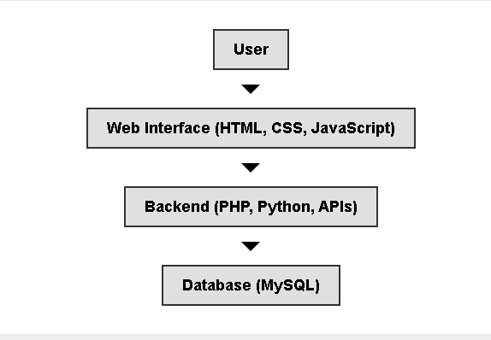
4.3 System Architecture

Figure 0.1 System Architecture

The system architecture follows a three-tier model, consisting of:
- Presentation Layer (Frontend): User interface built with HTML, CSS, JavaScript, and Bootstrap.
- Business Logic Layer (Backend): Developed using PHP and MySQL for database interactions.
- Data Layer (Database): MySQL database to store patient records, appointments, and transactions.

4.4 Entity-Relationship (ER) Diagram

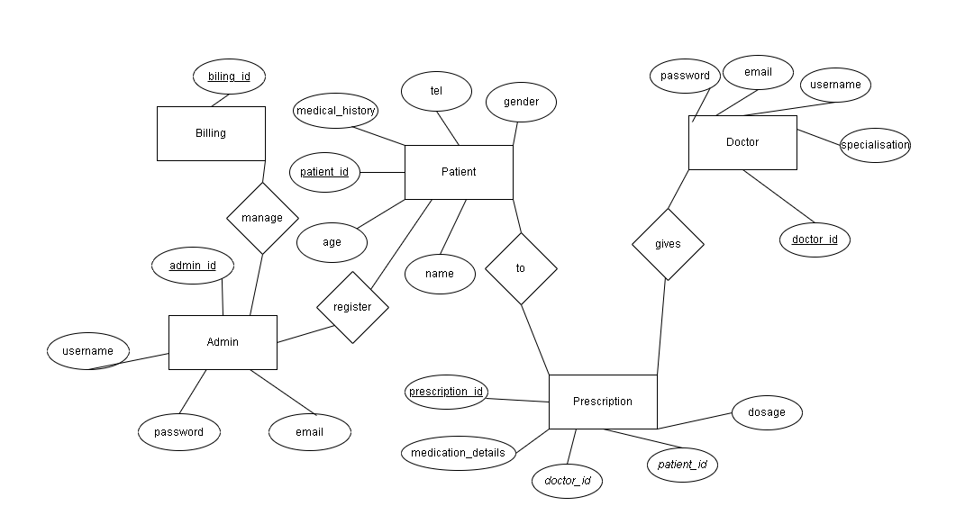

Figure 0.2 Entity-Relationship (ER) Diagram

4.5 Use Case Diagram
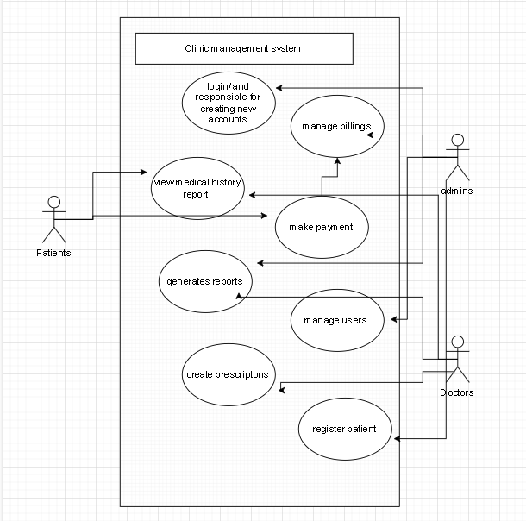

Figure 0.3 Use Case Diagram

4.6 Class Diagram

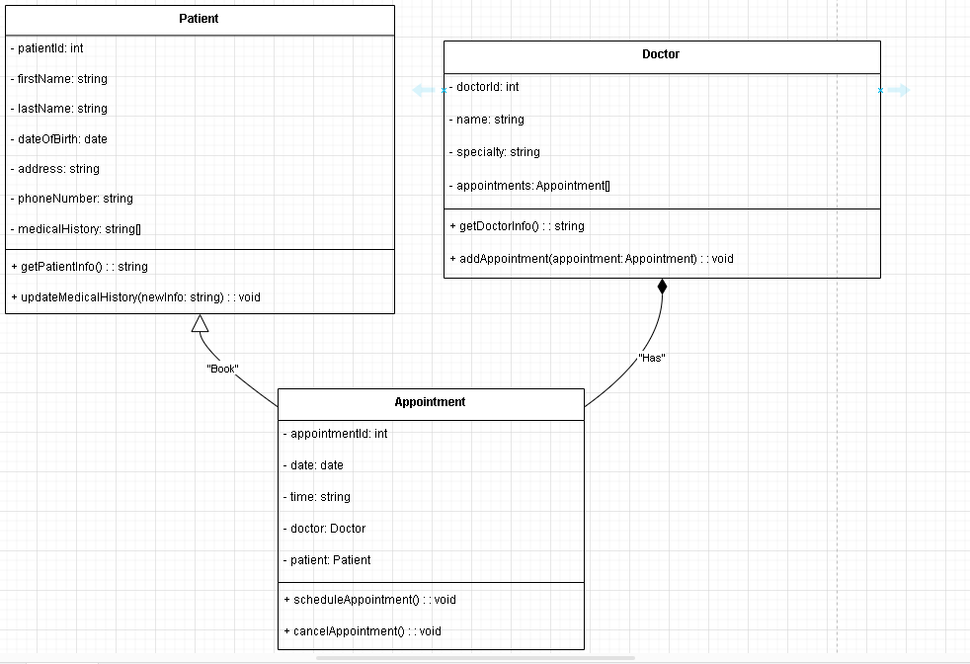

Figure 0.4 Class Diagram

4.7 Database Schema

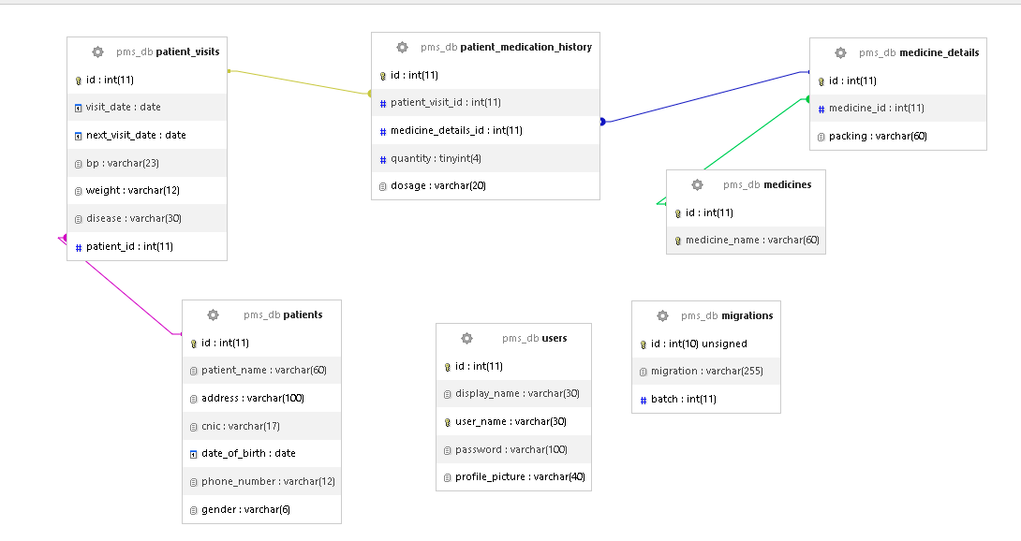

Figure 0.5 Database Schema

PART 2: SYSTEM IMPLEMENTATION & FEATURES

4.8 User Interface (UI) Wireframes

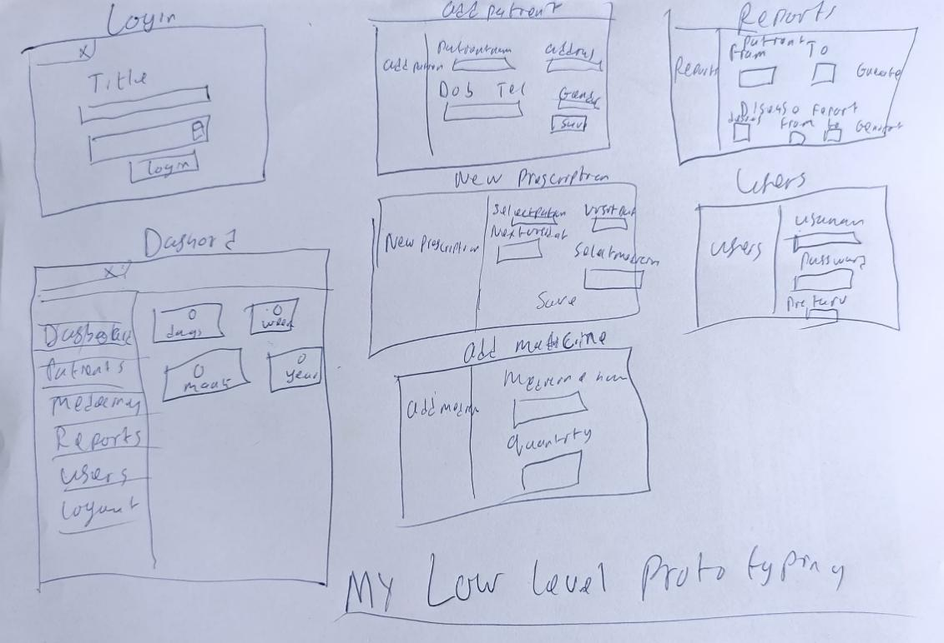

Figure 0.6 User Interface (UI) Wireframes

4.9 System Screenshots

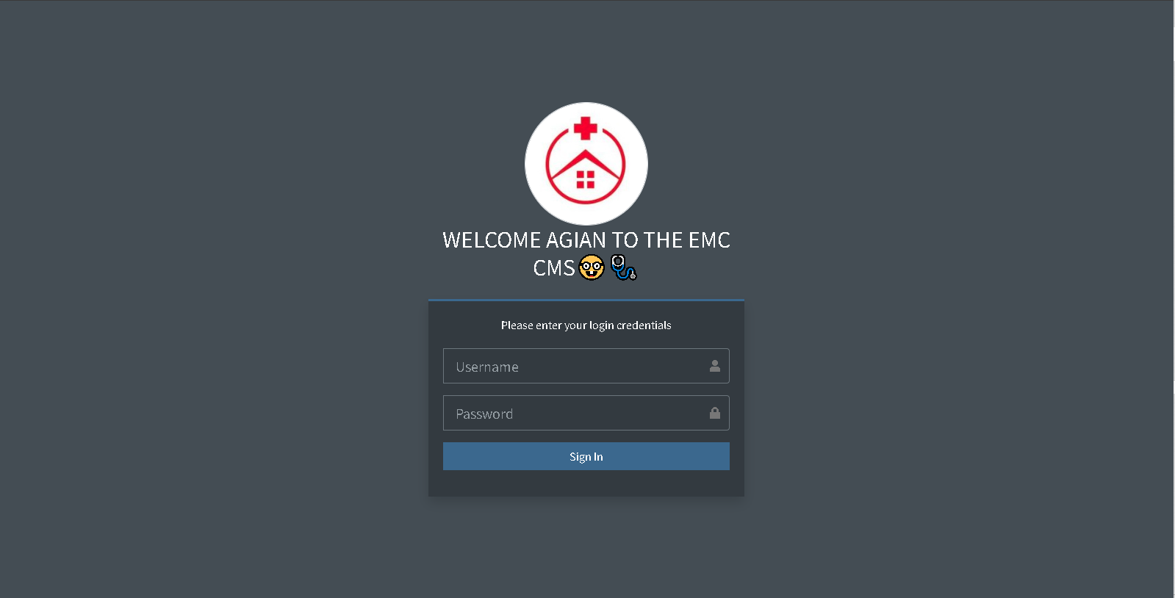

Figure 0.7 login

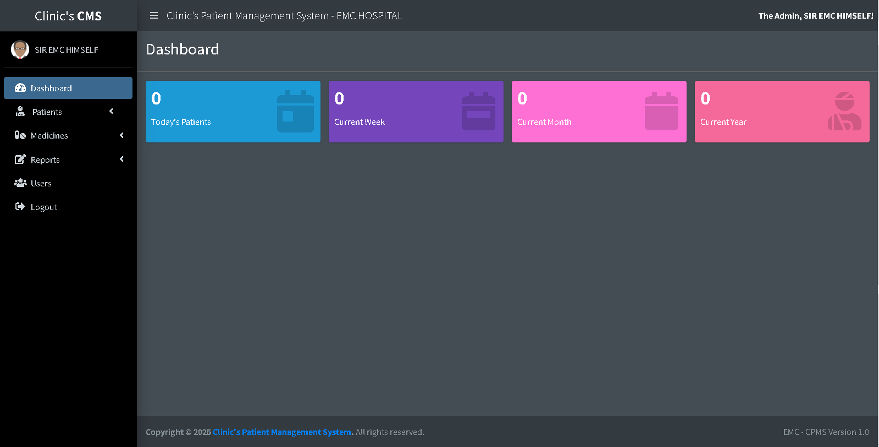

Figure 0.8 dashboard

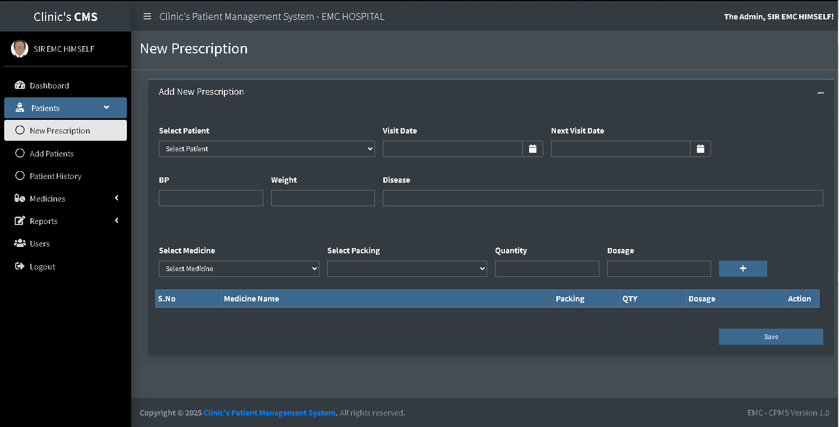

Figure 0.9 patients

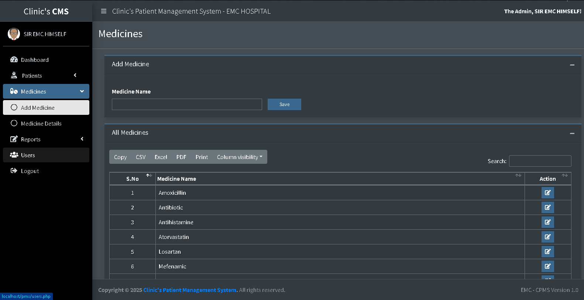

Figure 1.0 medicines

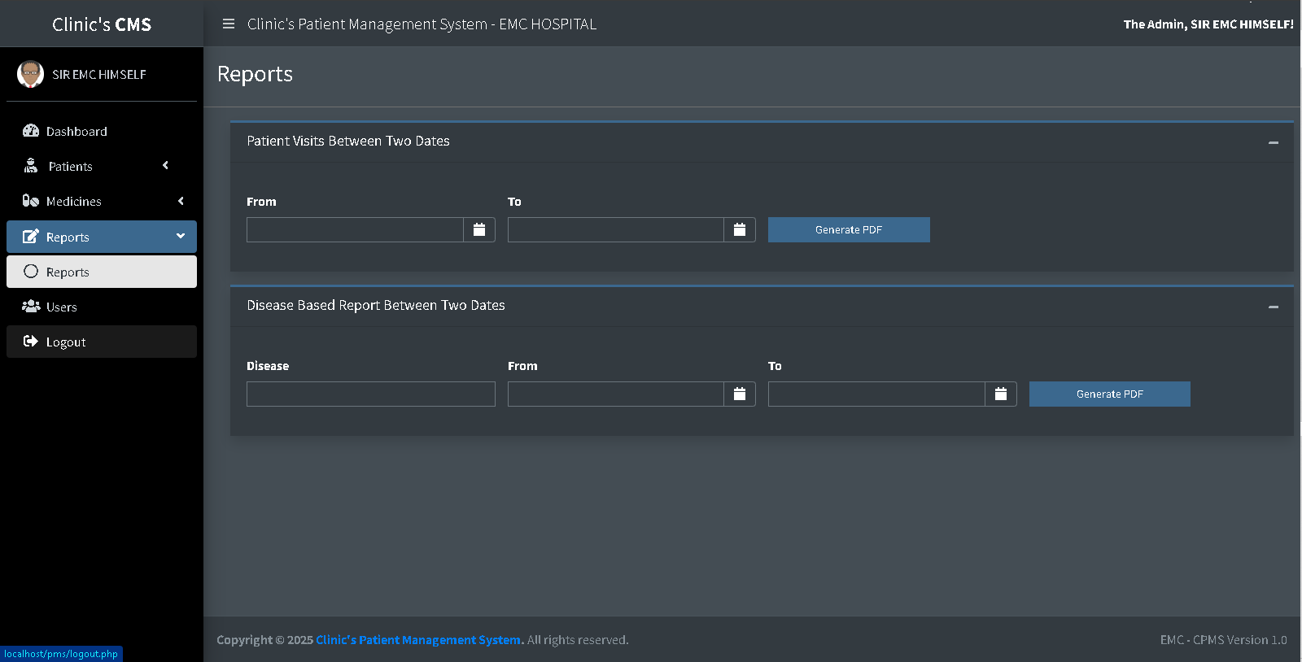

Figure 1.1 reports

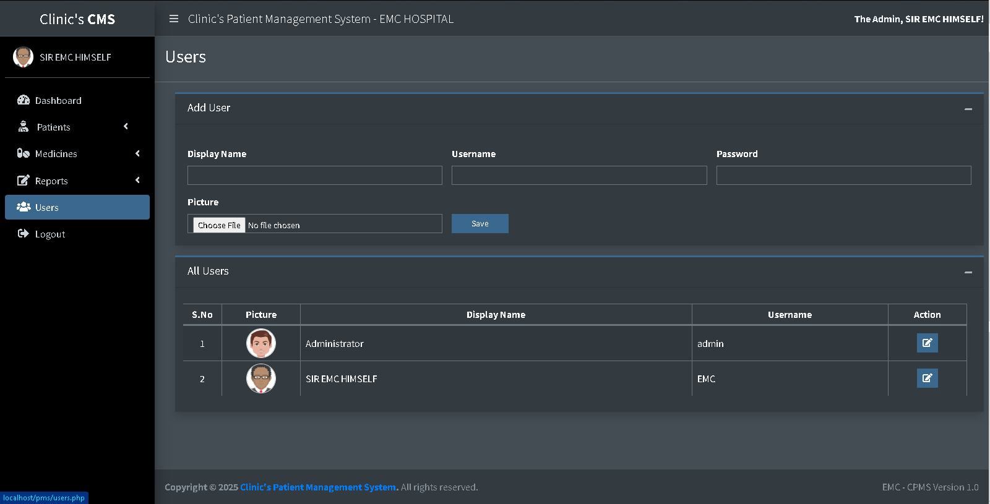

Figure 1.2 users management page

4.10 Sequence Diagram

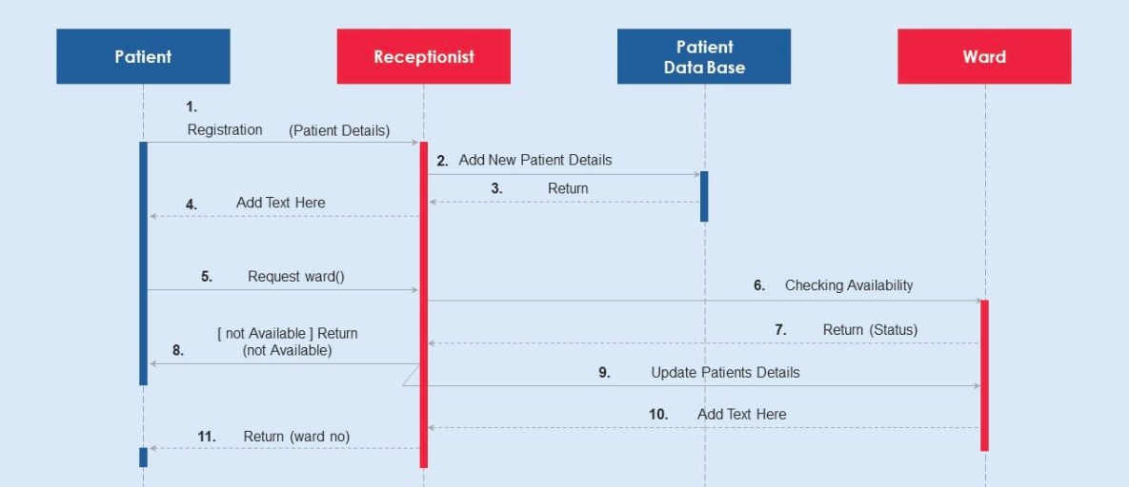

Figure 1.3 Sequence Diagram

4.11 System Functionalities & Features
This section describes the key functionalities of the Clinic Management System in detail, including:
- Dashboard Overview
- Managing Patient Records
- Doctor & Receptionist Features
- Prescription & Medical Reports

- Billing & Payment Handling
- System User Management

4.12 Security Measures
To ensure data security, the following security measures have been implemented:
- User Role Management: Admins, Doctors, and Receptionists have different levels of access.
- Data Encryption: Sensitive data such as passwords are encrypted.
- Session Management: Prevents unauthorized access by enforcing session expiration.

4.13 Testing & Validation
Before deployment, the system underwent extensive testing:
- Unit Testing: Individual modules were tested for expected outcomes.
- Integration Testing: Ensured all system components interact correctly.
- User Acceptance Testing: Real users tested the system to confirm usability.

4.14 Deployment & Hosting Considerations
The system was deployed using XAMPP for local testing and is ready for cloud deployment using a Plesk-managed hosting environment.

GENERAL CONCLUSION

BIBLIOGRAPHYGENERAL CONCLUSION

BIBLIOGRAPHY

BIBLIOGRAPHYGENERAL CONCLUSION

BIBLIOGRAPHYGENERAL CONCLUSION

5.1 General Conclusion
The development of the Clinic Management System has been a comprehensive journey that integrated knowledge gained from academic coursework, internship experience, and personal research. The goal of this project was to design and implement a modern, efficient, and scalable software solution to address the challenges faced in traditional clinic management. Through careful planning, system design, and rigorous testing, this project has successfully achieved its intended objectives.
The problem statement highlighted inefficiencies in traditional manual clinic operations, such as data mismanagement, slow appointment scheduling, difficulty in retrieving patient records, and security concerns. To address these issues, a web-based Clinic Management System was proposed and developed, incorporating automated patient record management, appointment scheduling, medical prescriptions, and billing functionalities.
Throughout the development process, various technologies such as PHP, MySQL, JavaScript, and Bootstrap were utilized to ensure a responsive, user-friendly, and secure platform. Additionally, the internship at Oprime Inc. played a crucial role in shaping this project by providing exposure to real-world software development practices, content management systems, ERP solutions, and cloud-based hosting.
One of the most significant takeaways from this project is the importance of database security, system usability, and scalability. The system has been designed with role-based authentication, ensuring that only authorized users can access sensitive patient data. Furthermore, user experience (UX) principles were applied to create an intuitive interface, making it easier for clinic staff to navigate and operate the system efficiently.
Despite the success of this project, challenges were encountered, including internet connectivity limitations, debugging complex queries, and optimizing system performance. However, these obstacles provided valuable learning opportunities, reinforcing problem-solving skills and adaptability.
Moving forward, future improvements can be made to enhance the system further. Potential

upgrades include:
- Mobile App Integration: Developing a mobile version of the system for doctors and patients.
- AI-powered Analytics: Implementing machine learning models to analyze patient data and predict trends.
- Telemedicine Feature: Allowing doctors to consult patients remotely via video calls.
In conclusion, this project has provided an in-depth understanding of software engineering principles, database management, and user experience design. It serves as a stepping stone toward future advancements in healthcare technology and demonstrates the importance of leveraging technology to improve efficiency, security, and accessibility in the medical field.

BIBLIOGRAPHY

BIBLIOGRAPHY

BIBLIOGRAPHY

BIBLIOGRAPHY

- Sommerville, I. (2015). Software Engineering (10th Edition). Pearson Education.
- Pressman, R. S. (2020). Software Engineering: A Practitioner's Approach. McGraw-Hill Education.
- Laudon, K. C., & Laudon, J. P. (2021). Management Information Systems: Managing the Digital Firm. Pearson.
- Date, C. J. (2019). An Introduction to Database Systems. Pearson Education.
- Martin, J. (2020). Systems Analysis and Design. Cengage Learning.
- Welling, L., & Thomson, L. (2017). PHP and MySQL Web Development. Addison-Wesley.
- Flanagan, D. (2020). JavaScript: The Definitive Guide. O'Reilly Media.
- Bass, L., Clements, P., & Kazman, R. (2012). Software Architecture in Practice. Addison-Wesley.
- Fowler, M. (2018). UML Distilled: A Brief Guide to the Standard Object Modeling Language. Addison-Wesley.
- Neapolitan, R. E. (2018). Foundations of Algorithms. Jones & Bartlett Learning.
- W3Schools. (2023). PHP MySQL Tutorial. Retrieved from https://www.w3schools.com/php/
- MDN Web Docs. (2023). JavaScript Guide. Retrieved from https://developer.mozilla.org/en-US/docs/Web/JavaScript
- MySQL Documentation. (2023). MySQL Reference Manual. Retrieved from https://dev.mysql.com/doc/
- Bootstrap Documentation. (2023). Bootstrap Framework Guide. Retrieved from https://getbootstrap.com/docs/

.

