**Tutorial**

**Data:**

1. glove_grasp_6_13_20_100points.mat: data from dataglove for human hand grasps, it includes 6 subjects, each subject performs 13 grasps, each grasp has 20 repeats, each repeat is sampled at 100 time points.
2. glove_inhand_6_10_20_100points.mat: data from dataglove for human hand in-hand manipulations, it includes 6 subjects, each subject performs 10 in-hand manipulations, each grasp has 20 repeats, each repeat is sampled at 100 time points.

**Method:**

Gaussian Mixture Models:

1. Training: Training of GMM by EM algorithm, initialized by k-means clustering.
2. Recognition: Recognising by Euclidean distance at centres of GMM components.

**Preparation:**

Put all files and datasets under the same folder, add this folder to your matlab path, choose “Add with Subfolders”, as you need all the functions in this folder and subfolders.

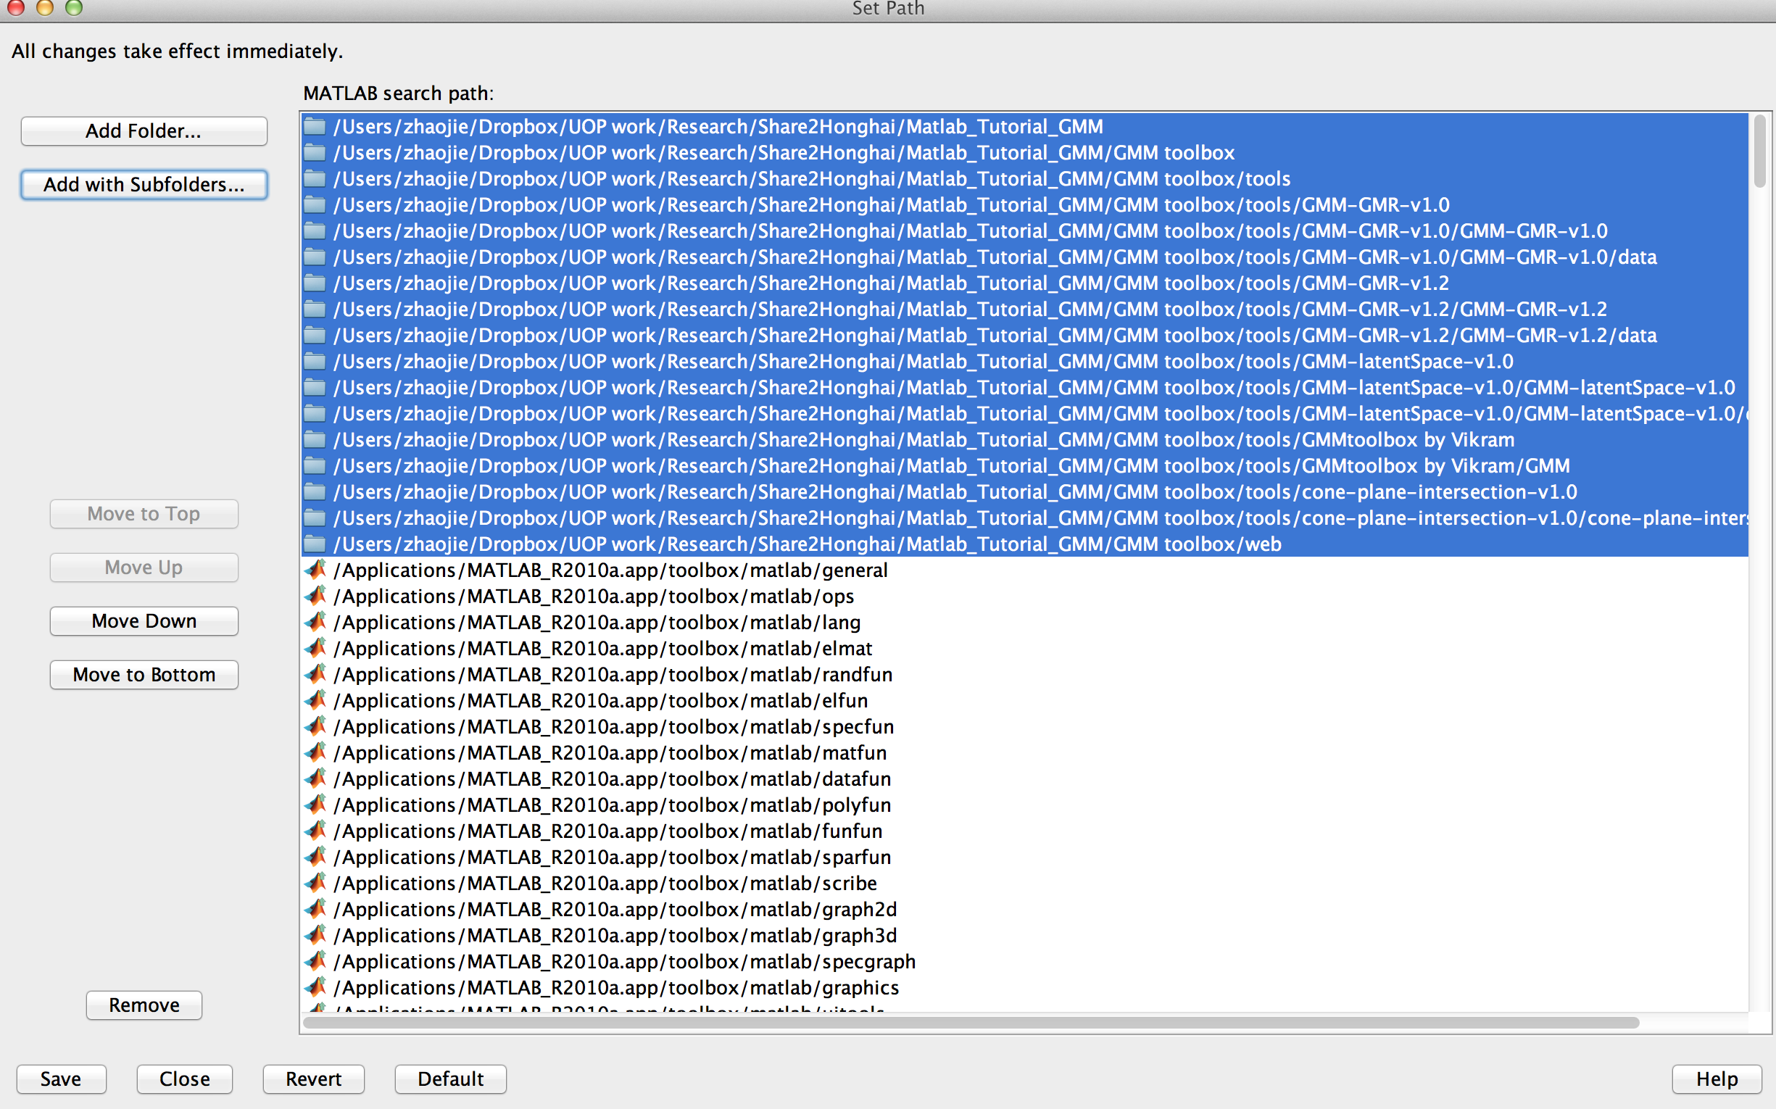

**Run:**

1. On grasps data, training data and testing data are both from the same/single subject:
   1. open Matlab, choose File —>Open, find “glove_grasp_analysis_GMM_result1.m”.
   2. In the Editor, run the file (by clicking or go to Debug—> run glove_grasp_analysis_GMM_result1.m)
2. On grasps data, training data and testing data are both from the multiple subject. Similarly run “glove_grasp_analysis_GMM_result2.m”
3. On in-hand manipulation data, training data and testing data are both from the same/single subject. Similarly run “glove_inhand_analysis_GMM_result1.m”
4. On in-hand manipulation data, training data and testing data are both from the multiple subject. Similarly run “glove_inhand_analysis_GMM_result2.m”

**Check Result:**

1. “allresult” shows the matrix of recognition rates in terms of the subjects and motions
2. “allrate” shows the overall recognition rate

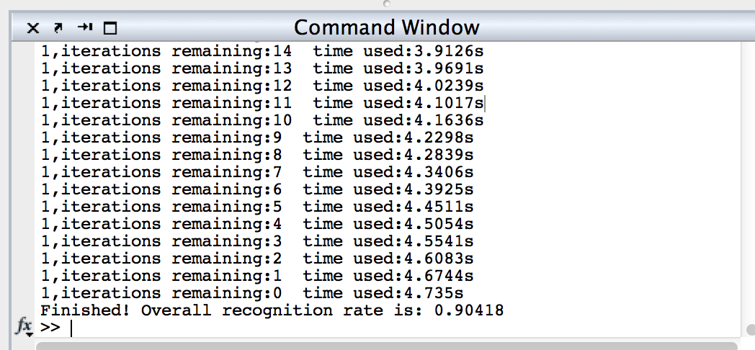

Note:

The following error might occur during the training process:

?? Error using ==> kmeans at 333

Empty cluster created at iteration 2.

Error in ==> EM_init_kmeans at 27

[Data_id, Centers] = kmeans(Data', nbStates);

Error in ==> glove_inhand_analysis_GMM_result1 at 37

[Priors, Mu, Sigma] = EM_init_kmeans(data4model,

nbStates);

This is due to the uncertainty of the Kmeans initialization. Re-run the program maybe avoid the problem.