N-CMAPSS DS03 Two-Stage Self-Supervised RUL Chain — Final Report
Complete experimental record and paper-figure candidates. Final architecture: stage 1 detects the degradation onset with the coverage-conditional confidence gate; stage 2 retrains the normal model on the detected healthy range and predicts RUL ungated.
0. Protocol
Data: N-CMAPSS DS03-012. Development: 9 run-to-failure units — the only data used for every model choice, sweep and calibration. Test: 6 sealed units, prediction input only. Disclosure — the DS03 test split has been opened sixteen times in total: one earlier cycle<5 chain, two by the earlier cycle<3 chain, three by the v4 chain (first rendering, HI recipe re-fix, filter edge refinement — all re-fixed on development data alone), one benchmark batch, one pre-registered verification of the coverage-conditional gate revision, one final-chain re-summary unifying the gate on the RUL path, one pre-registered batch re-verification after the chain re-freeze on the conditional-table lambda grid, one pre-registered batch completing the ablation tables on test, one scoring-robustness batch, one pre-registered verification of the stage-2 healthy-range chain, one residual-quality diagnostic re-summary on cached statistics, one pre-registered batch completing the stage-2 loss-term ablation on test together with the cross-model quality extension, and one pre-registered mixed-stack diagnostic feeding the stage-2 residuals through the frozen stage-1 health index.
Final architecture, fixed 2026-08-15 on top of the full ablation record: a serial two-stage self-supervised chain. Stage 1 (detection): sparse-window MOGP (cycle<=3) with the coverage-conditional confidence gate — the gate is a detection component only. Stage 2 (RUL): the same MOGP class retrained on the healthy range that stage 1 detects, ungated downstream, frozen recipe. The gate was removed from the RUL path because its RUL effect is null (ungated 7.47 vs gated 7.52, p = 0.40) while its onset effect holds on both splits; the earlier gated-RUL chain (dev 7.22 +/- 0.08, test 7.52 +/- 0.09) remains disclosed as history wherever a selection was made on it.
Metrics: (i) held-out zRMSE for model comparison; (ii) onset RMSE = RMS of detected minus true hs-transition, dev 27 cases; (iii) LOO truncation RUL at 20/40/60/80 % of life; (iv) NASA asymmetric score. Methodology rules: sweeps run on absolute axes past their minima until collapse; tie bands instead of nominal minima; selection eligibility requires all three seeds; no blank table cells; results reported regardless of direction.
1. Overall framework
Serial two-stage flow: operating conditions and sensors -> sparse-window MOGP -> residuals and confidence -> coverage-conditional gate -> onset detection -> detected healthy range -> MOGP retraining on the matched 27k budget -> ungated residuals -> health index network -> exponential first passage -> RUL. There is no branch after the gate: the gate lives inside the detection stage, and the RUL stage consumes only the healthy range that detection defines.
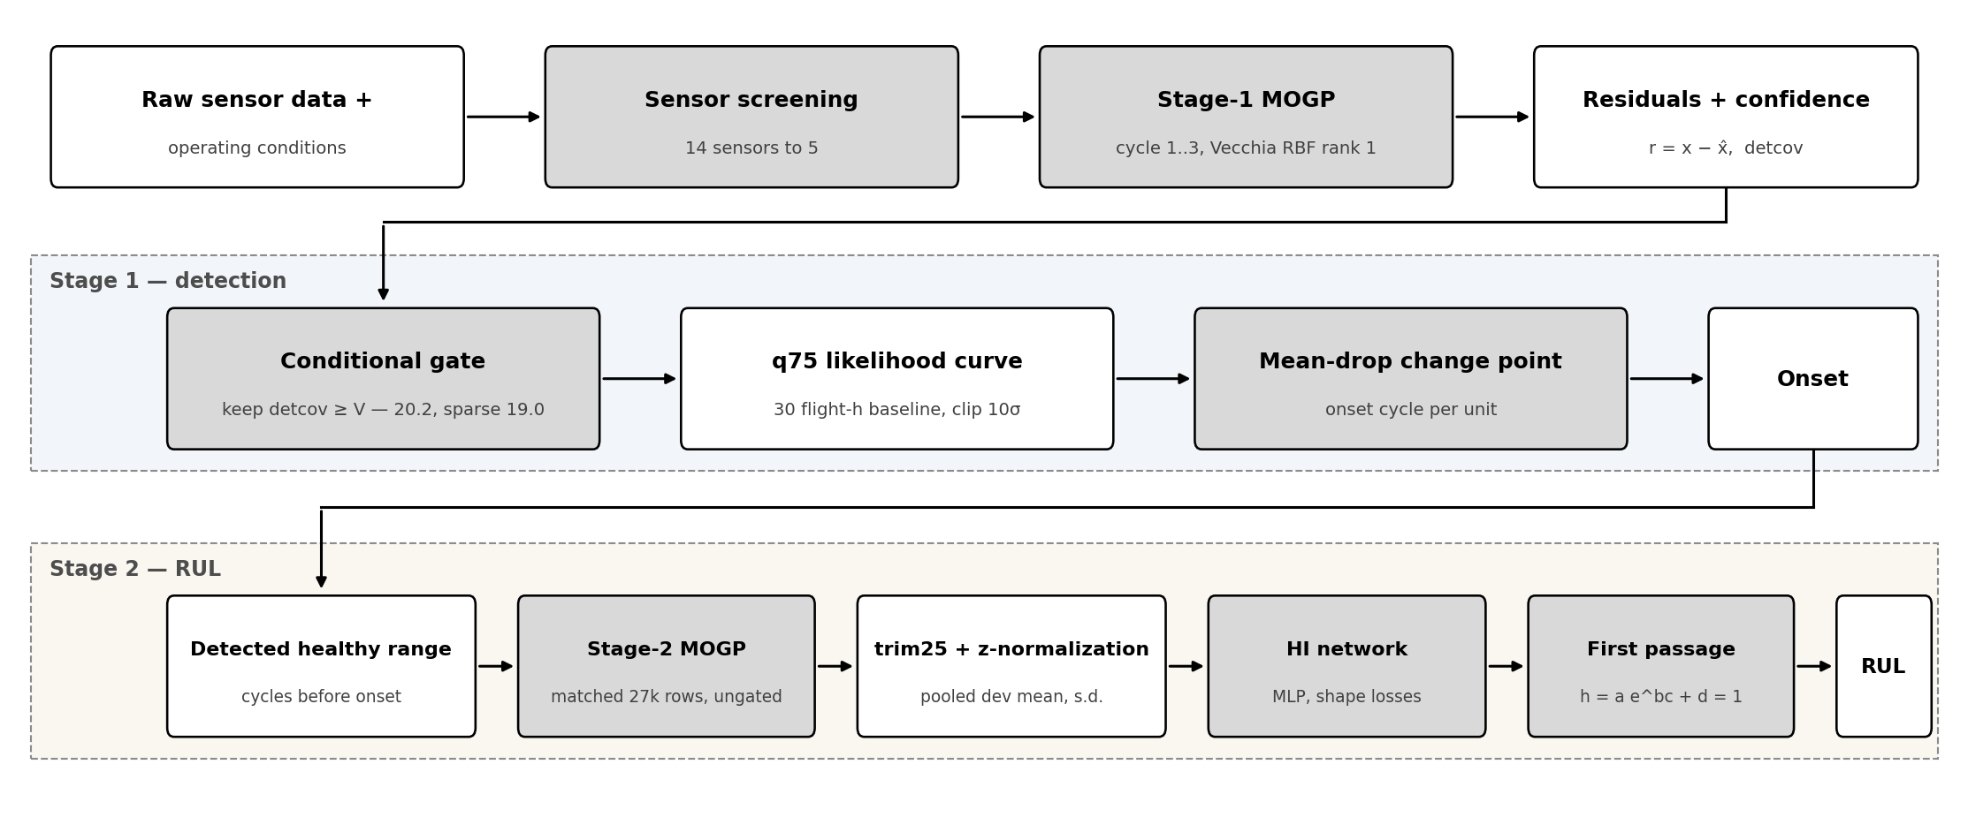
Figure 1. Overall framework of the two-stage self-supervised chain. The shared front end produces residuals and confidence; stage 1 detects the degradation onset through the coverage-conditional gate; stage 2 retrains the MOGP on the detected healthy range and predicts RUL ungated. Shaded blocks are learned or calibrated components.
2. Sensor sensitivity screening (model-free)
Table 1. Degradation-sensitivity screening of all 14 sensors under the cycle<=3 window (kNN k=10 healthy reference over standardized operating conditions; zRMS of degraded residuals in healthy-noise units — an insensitive sensor scores ~1). Candidate sets are the top-3/5/7.
Rank | 1 | 2 | 3 | 4 | 5 | 6 | 7 | 8 | 9–14
Sensor | T50 | T48 | Wf | Nc | T30 | P40 | Ps30 | Nf | others
zRMS | 2.99 | 2.17 | 1.19 | 1.16 | 1.06 | 1.06 | 1.05 | 1.03 | ≤1.02
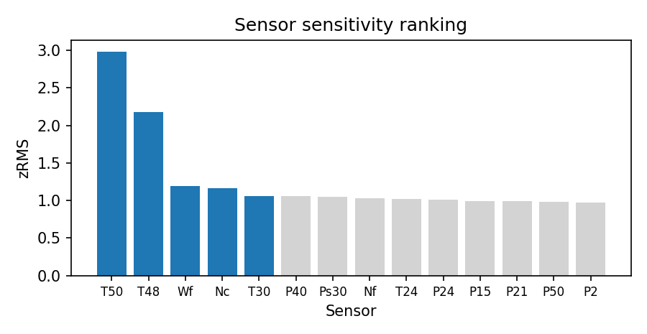
Figure 2. Sensor sensitivity ranking. Blue bars are the finally selected set.
3. Normal model: kernel x rank x sensor-set grid
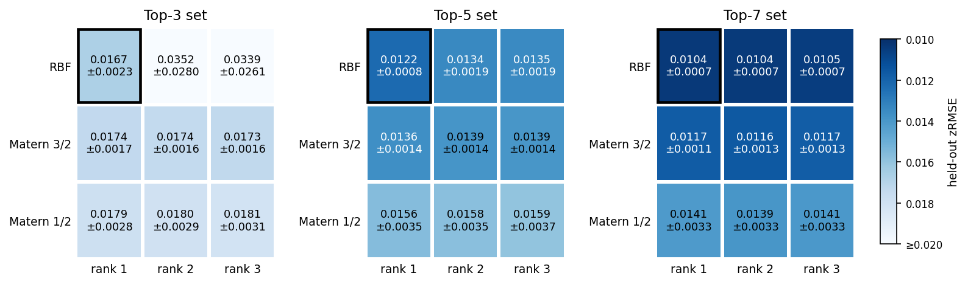
Figure 3. Full grid, held-out zRMSE: {RBF, Matern 3/2, Matern 1/2} x rank {1,2,3} x candidate set {3,5,7}, 3 seeds, one shared Blues scale capped at 0.020. The black frame marks the selection. Matern 5/2 is excluded for chronic float32 Cholesky failures in sets 3 and 5; in set 7 it converged but is omitted for cross-panel comparability.
Note. Two separate decisions, disclosed separately: the grid tie band (minimum mean, one-seed-s.d. band, simplest inside) fixes the kernel and rank — RBF rank 1 in every set — while the sensor-set choice rests on the downstream detector sweep, where top-5 [T30, T48, T50, Nc, Wf] is best both ungated (6.78 vs 7.15 / 6.95) and gated (5.65 vs 6.41 / 5.76); on raw grid zRMSE top-7 is in fact lower (0.0104 vs 0.0122). Pairwise detector differences are not significant, so the set decision rests on the consistent detector minimum, simplicity, and the numerical instability of top-3. Stage-1 model: Vecchia MOGP, RBF rank 1, m = 18 neighbours, trained on flight cycles 1..3 only, 27,000 stratified rows per seed.
4. Residual and confidence generation
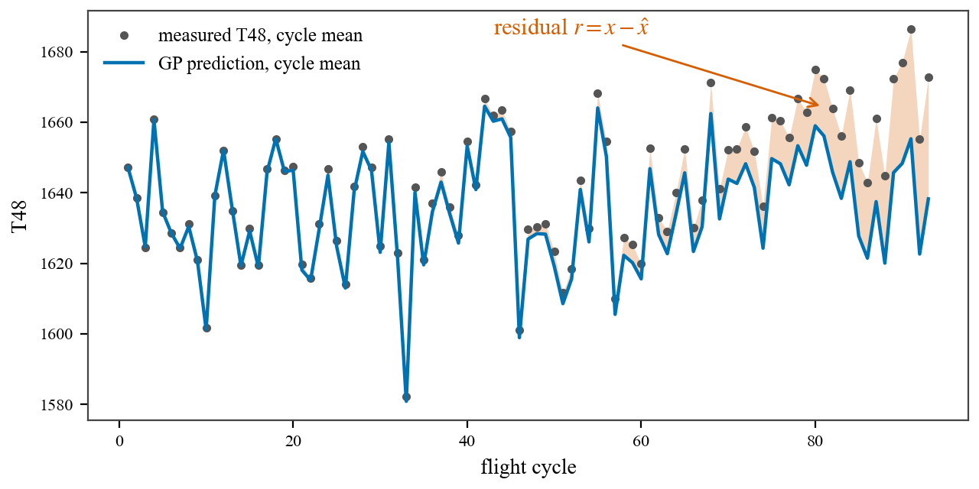
Figure 4. Residual construction on unit u5: measured T48 cycle means against the GP prediction; the shaded gap is the residual r = x − x̂. The GP tracks operating conditions but not degradation, so the gap grows with damage.
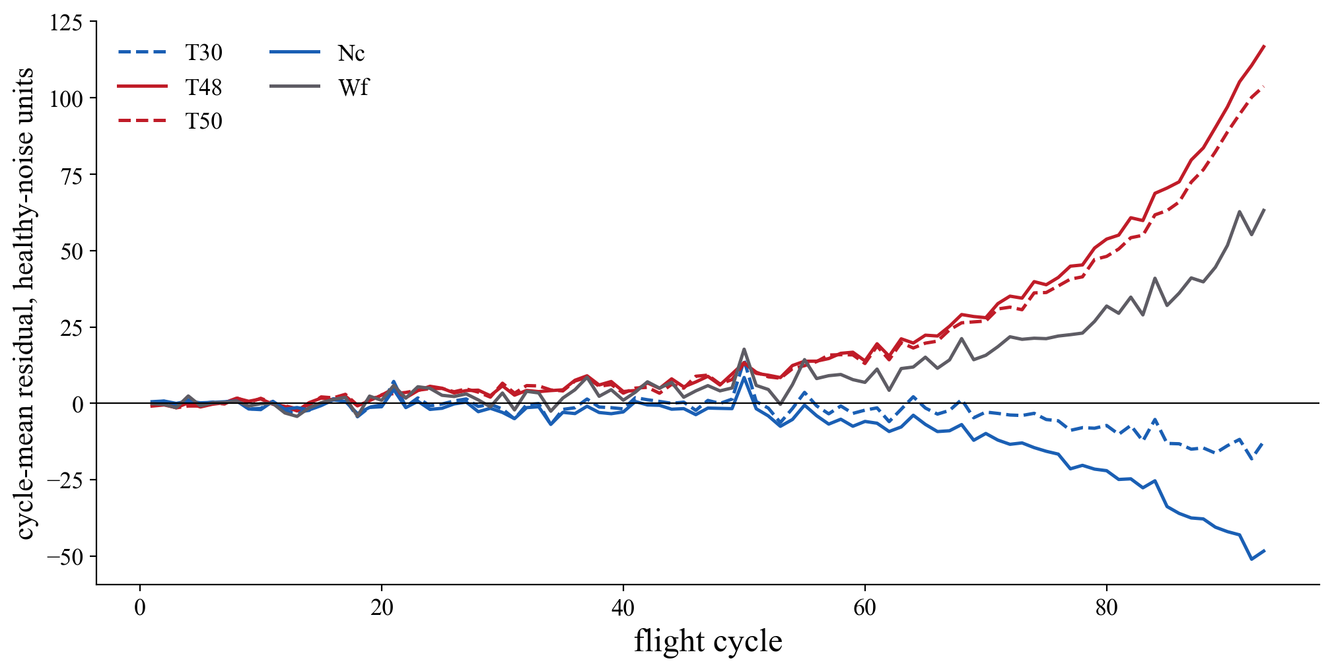
Figure 5. Per-cycle mean residuals of unit u5 over the five selected channels, standardized by the mean and s.d. of the first ten cycles. The healthy stretch stays near zero on every channel; after damage begins, the hot-section channels T48 and T50 drift upward, Nc downward, Wf upward — all five channels stay alive over the extrapolated life.
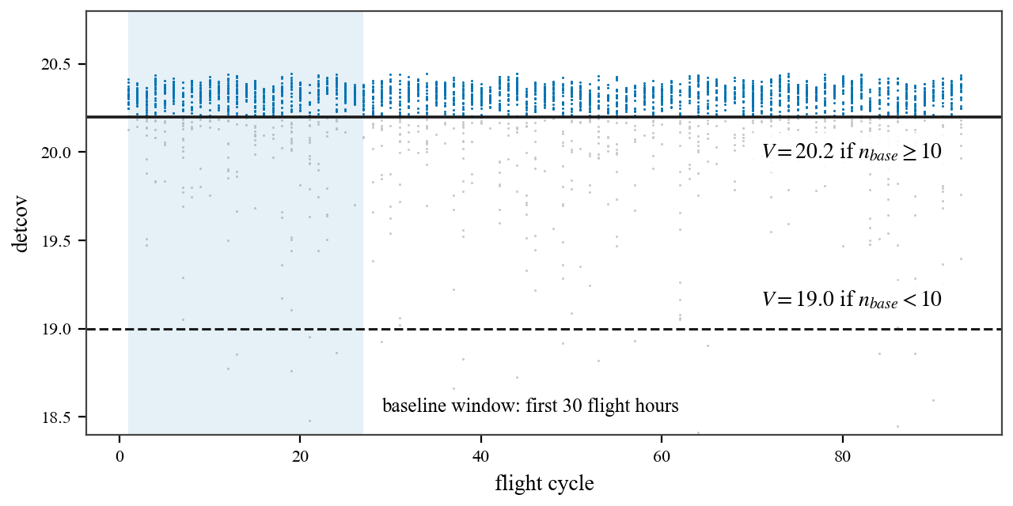
Figure 6. Confidence index detcov per sampled point, unit u5. detcov = −(1/2) log det Sigma(w) is computed from operating conditions only. On the detection path, points below the applicable threshold V are dropped before the cycle summary; the shaded band is the 30 flight-hour baseline window.
5. Coverage-conditional gate and onset detection (stage 1, final)
Gate rule, final: count the flight cycles inside the 30 flight-hour baseline window; if fewer than 10, apply V = 19.0, otherwise V* = 20.2. Both constants are absolute development-calibrated values, transferred without re-derivation. Selection history, disclosed in order: (1) the absolute-axis sweep selected V* = 20.2 (sweep minimum, sole tie-band member, all seeds); (2) the test verification exposed a long-haul reversal, diagnosed to sigma0 inflation on sparse baselines (the gate keeps confident, not accurate, points within an isolated cycle); (3) the class-stratified re-scoring showed the long-haul optimum is a plateau at 18.8–19.2, and the conditional rule was frozen on development data (seed and leave-one-unit-out stability) and verified once on test.
Onset detector, frozen: per-cycle q75 of the gated log-likelihood curve; baseline = first 30 flight-hours; clip at mu0 − 10 sigma0; full-range mean-drop change point. Final dev onset RMSE 5.21 cycles. Role, finalized: the gate is a detection component; its former RUL-path application — historically unified for consistency — was removed after the ablation showed a null RUL effect (ungated 7.47 vs gated 7.52, p = 0.40). The baseline-window sweep is reported as ablation (d) in Section 9 (Table 10, Figures 15–16).
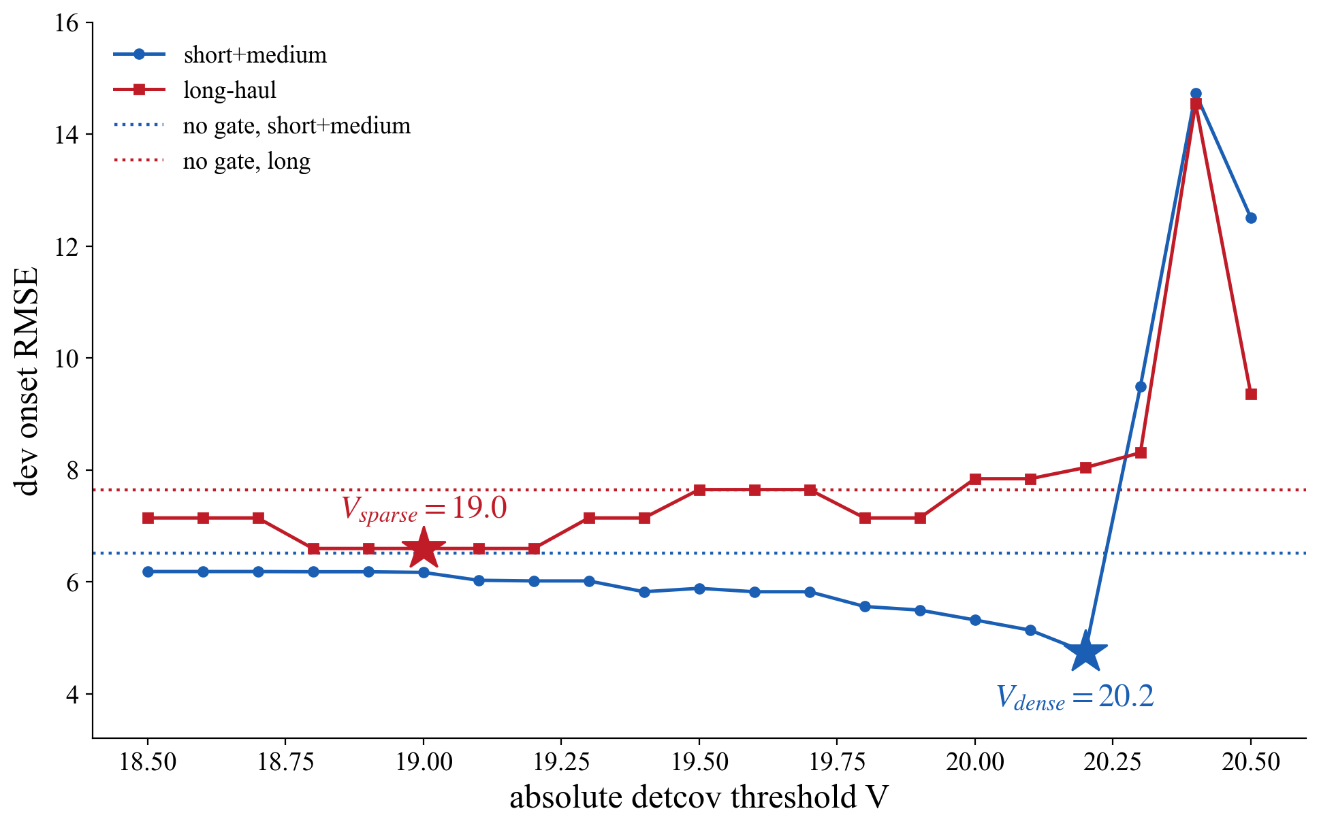
Figure 7. Class-stratified gate sweep. One absolute V trades the classes off: the short+medium optimum is 20.2 while the long-haul optimum is a plateau at 18.8–19.2 whose centre 19.0 becomes V sparse. Dotted lines are the ungated references.
Table 2. One-time test verification of the conditional gate (eighth opening, pre-registered): onset RMSE by flight class. The sparse rule fires on test units u10/u11/u13 (7–9 baseline cycles).
Detector | Dev overall | Dev short+med | Dev long | Test overall | Test short+med | Test long
Conditional gate (final) | 5.21 | 4.75 | 6.60 | 8.54 | 5.54 | 10.73
Ungated | 6.78 | 6.51 | 7.65 | 9.01 | 5.73 | 11.38
Note. The conditional gate beats the ungated reference on every subset of both splits. Mechanism verified: the sigma0 inflation that a single absolute threshold suffers on the sparse-baseline units u10/u11 (2.54x/2.77x) collapses to 0.91x/0.79x under the conditional rule. Dev advantage over ungated is significant (p = 0.003, 27 cases); test subsets hold 9 cases each and are descriptive. The rule is label-free and deployable: the trigger is the observable baseline cycle count.
6. Stage-1 health index (HI #1, ungated cycle<=3 residuals)
Inputs: per-flight trim25 of the stage-1 residuals, z-normalized with the pooled development mean and s.d.; MLP with shape losses; width-3 median post-filter with a non-decreasing endpoint. With the gate confined to detection, the RUL-path tables are ungated. HI #1 retrains the frozen recipe (lambda1 = 12, lambda2 = 0.25) on these tables; the recipe itself — frozen loss terms, the tuning grid on the final stage-2 base, and its full provenance — is documented in Section 7. HI #1 chain numbers (ungated): dev LOO 7.15 +/- 0.10, test 7.47 +/- 0.06, NASA 19.5 +/- 0.8. Gated-table history: dev LOO 7.22 +/- 0.08, test 7.52 +/- 0.09; lambda8 conditional chain dev 7.10 +/- 0.07, paired difference not significant (p = 0.39).
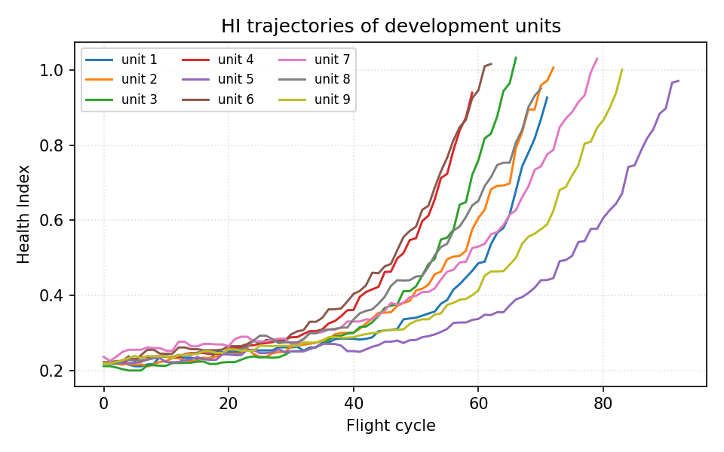
Figure 8. HI #1 trajectories of the 9 development units, seed 0, ungated cycle<=3 tables.
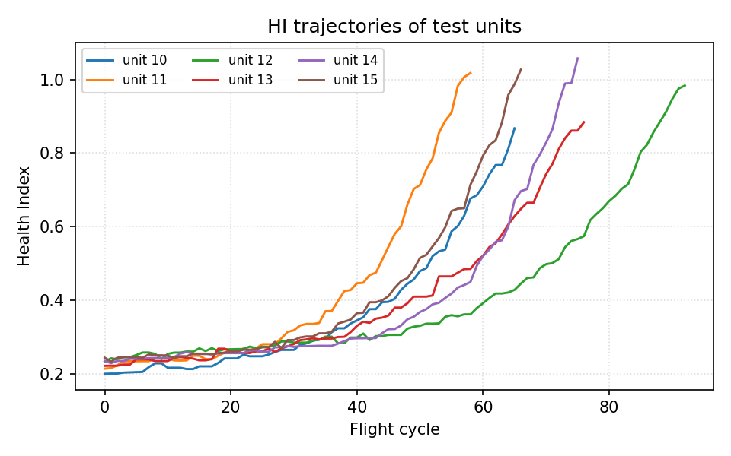
Figure 9. HI #1 trajectories of the 6 test units — dev-trained network with the same normalization; test data enters only as input.
7. Proposed stage 2: healthy-range retraining and RUL
Stage 2, pre-registered and verified once on test (thirteenth opening). Window, per seed and unit: all cycles strictly before the stage-1 conditional-gate onset — self-supervised (detected, not labelled). Sample: 3,000 rows per unit stratified equally over its healthy cycles, 27,000 rows in total — the same budget as cycle<=3, so coverage is the only variable. GP internals frozen (RBF rank 1, m = 18); models saved per seed. Downstream ungated with the frozen recipe; data-derived constants re-derived on the stage-2 residuals: pooled z-normalization, network weights (HI #2 — the same frozen recipe as HI #1, retrained; only the input residuals differ), and beta by the frozen dev-LOO NASA rule (30/30/30). Shape criteria pass 3/3.
HI #2 recipe: the frozen loss terms are listed in Table 3, and the two tuned shape weights stay frozen at lambda1 = 12, lambda2 = 0.25. Provenance, disclosed in order: (8, 0.25) was selected on the fixed-gate tables and initially inherited; the conditional-gate re-sweep promoted (12, 0.25) — the lambda1 = 12 column first passed the shape gate 3/3 on those tables and topped the composite — and the recipe was frozen there; the final re-sweep on the stage-2 tables (Table 4) leaves the recipe frozen by the tie-band rule (selection rule and full rationale under Table 4).
Table 3. Frozen loss terms and the two tuned shape weights.
Loss term | Parameter | Value | Status
Initial level | lambda0, thr | 1, 0.20 | frozen
End level | end_target | 1.03 | frozen
Tail flatness | w, m | 800, 0.004 | frozen
Monotonicity | lambda1 | {2, 4, 6, 8, 12, 16} | tuned
Convexity | lambda2 | {0.25, 0.5, 1, 2, 4} | tuned
Table 4. lambda1 x lambda2 property grid, re-swept on the final stage-2 healthy-range tables (9 dev units x 3 seeds; protocol identical to the earlier sweeps, med3-free). Mono = 100 x sum of negative increments; Curv = 100 x sum of second differences; Rng = mean(end − start); Pass = seeds passing the shape gate. The bold cell is the frozen recipe (12, 0.25).
Tuning | λ2 = 0.25 |  |  |  | λ2 = 0.5 |  |  |  | λ2 = 1.0 |  |  |  | λ2 = 2.0 |  |  |  | λ2 = 4.0
Properties | Mono | Curv | Rng | Pass | Mono | Curv | Rng | Pass | Mono | Curv | Rng | Pass | Mono | Curv | Rng | Pass | Mono | Curv | Rng | Pass
λ1 = 2 | -20.6 | 3.82 | 0.763 | 3/3 | -19.9 | 3.83 | 0.759 | 3/3 | -19.0 | 3.85 | 0.752 | 3/3 | -18.0 | 3.85 | 0.740 | 3/3 | -16.9 | 3.83 | 0.719 | 3/3
λ1 = 4 | -18.8 | 3.86 | 0.754 | 3/3 | -18.5 | 3.86 | 0.751 | 3/3 | -18.0 | 3.87 | 0.745 | 3/3 | -17.4 | 3.87 | 0.735 | 3/3 | -16.5 | 3.83 | 0.713 | 3/3
λ1 = 6 | -17.9 | 3.87 | 0.748 | 3/3 | -17.7 | 3.88 | 0.745 | 3/3 | -17.4 | 3.89 | 0.740 | 3/3 | -16.9 | 3.88 | 0.729 | 3/3 | -16.2 | 3.83 | 0.708 | 3/3
λ1 = 8 | -17.3 | 3.91 | 0.742 | 3/3 | -17.2 | 3.91 | 0.740 | 3/3 | -16.9 | 3.91 | 0.734 | 3/3 | -16.5 | 3.88 | 0.724 | 3/3 | -15.9 | 3.83 | 0.703 | 2/3
λ1 = 12 | -16.5 | 3.94 | 0.732 | 3/3 | -16.5 | 3.94 | 0.730 | 3/3 | -16.3 | 3.93 | 0.725 | 3/3 | -16.0 | 3.90 | 0.714 | 3/3 | -15.4 | 3.84 | 0.692 | 1/3
λ1 = 16 | -16.0 | 3.95 | 0.722 | 3/3 | -15.9 | 3.94 | 0.720 | 3/3 | -15.7 | 3.93 | 0.714 | 3/3 | -15.5 | 3.90 | 0.704 | 2/3 | -14.9 | 3.82 | 0.682 | 0/3
Note. Why (12, 0.25). Selection rule, development data only: eligibility requires the shape gate on all three seeds (Pass 3/3); eligible combos are ranked by the composite property score — the equal-weight mean of min–max-normalized Mono, Curv and Rng, end-shift excluded; truncation RUL is disclosed but never a selection criterion. (12, 0.25) entered the recipe on the conditional-gate re-sweep as the outright composite winner (0.718 vs 0.691 for the runner-up) and as the strongest monotonicity weight short of shape collapse — the lambda1 = 16 column already failed the gate there (best 2/3). On the stage-2 tables above the gate stops discriminating (26 of 30 combos pass), the composite top (16, 0.25) leads the frozen recipe by only 0.010 (0.737 vs 0.727) — inside the tie band — and its dev-LOO RUL is seed-unstable (7.80 +/- 0.20 vs 7.53 +/- 0.05); by the tie-band rule the frozen recipe is retained.
Table 5. Stage-2 truncation RUL. Dev = LOO over 9 units; test = 6 sealed units, everything frozen beforehand. 3 seeds.
 | 20 % | 40 % | 60 % | 80 % | Overall RMSE | NASA
dev LOO | 11.18 | 7.63 | 5.49 | 3.87 | 7.56 ± 0.05 | 30.3 ± 0.3
test | 10.92 | 7.63 | 4.78 | 2.48 | 7.18 ± 0.05 | 17.7 ± 0.2
Note. Both directions disclosed: development prefers the sparse window (HI #1 7.15 vs 7.56) while test prefers the healthy range (7.18 vs 7.47, the best test figures in the record); the paired difference is not significant (p = 0.49 over 72 test predictions, unit n = 6). The reversal replicates the healthy-range pattern already present in the ablation record under fresh onsets, fresh sampling and fresh fits. Stage 2 is adopted on architectural grounds, not on a test-side selection: retraining on the coverage that the chain itself measures halves the healthy residual floor at preserved end-of-life signal, so the degradation SNR improves on every unit of both splits (per-unit gains 1.27–4.16x; 27/27 and 18/18 unit-seed cases won, p < 1e-5) and more than doubles in aggregate — 16.8 to 37.2 on dev, 15.1 to 34.1 on test (fourteenth opening, ground-truth onsets used for diagnostics only; stage-2 dev onsets are circular and excluded from claims). Secondary, pre-registered: onset re-detection with the stage-2 GP (ungated) scores 9.21 on test against the stage-1 conditional 8.54 (p = 0.155) — full-coverage training does not repair detection, so detection remains a stage-1 responsibility.
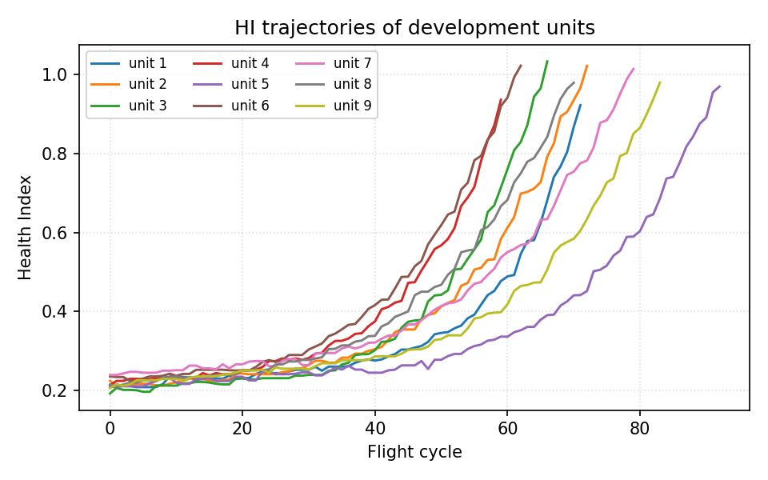
Figure 10. HI #2 trajectories of the 9 development units, seed 0, stage-2 healthy-range tables, ungated.
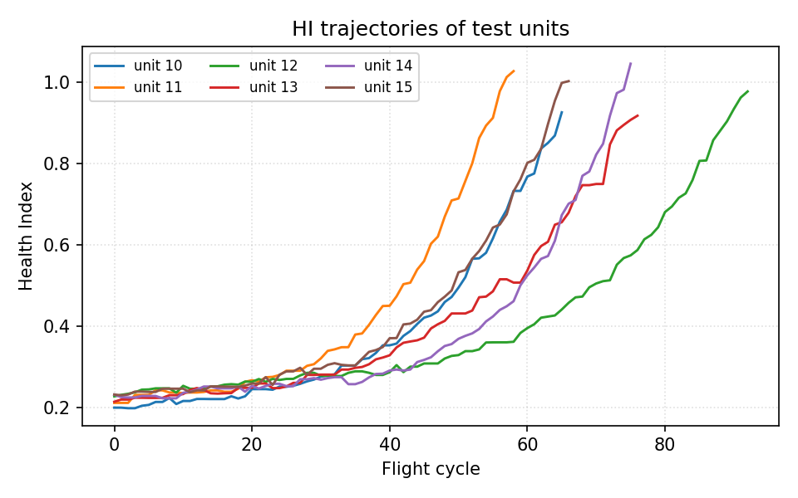
Figure 11. HI #2 trajectories of the 6 test units — dev-trained network, test as input only. The stage-2 curves stay flat over the healthy stretch and rise monotonically to the first passage.
8. Case study: normal-model benchmark on the stage-1 window
Component-swap convention: every competitor is trained on the identical 27k cycle<=3 rows with its own CV-chosen hyperparameters — LLKE (h = 0.1), B-spline (30 knots), LR, CaBN (lambda_1 = 0 selected; the covariate-adjusted mean of CaBN coincides with LR, so their residuals and RUL are identical by construction — CaBN differs only through the BN-implied covariance, which the RUL path does not consume). The downstream is byte-identical (HI #1 recipe, retrained per model, ungated everywhere). The Proposed row differs only by its training window and is included for reference.
Table 6. Test truncation RUL with the frozen downstream, and running time under the unified current-configuration protocol (seed 0, NTHREADS 12: fast models median of 5 fits, GP fits single run, inference median of 3 runs on the 87,600-point test grid). The stage-2 fit costs about 1.7x the stage-1 fit at the same 27k row budget.
Model | 20 % | 40 % | 60 % | 80 % | Overall RMSE | NASA | Train s | Infer s
Proposed (healthy-range MOGP) | 10.92 | 7.63 | 4.78 | 2.48 | 7.18 ± 0.05 | 17.7 ± 0.2 | 1690.0 | 148.5
MOGP | 11.09 | 8.47 | 4.74 | 2.44 | 7.47 ± 0.06 | 19.5 ± 0.8 | 1017.5 | 153.9
LLKE | 11.14 | 8.65 | 5.21 | 3.07 | 7.67 ± 0.07 | 19.4 ± 0.3 | 3.7 | 317.1
B-spline | 11.12 | 7.95 | 4.62 | 2.44 | 7.32 ± 0.11 | 18.6 ± 0.2 | 0.1 | 2.3
LR = CaBN | 10.85 | 8.24 | 4.66 | 2.57 | 7.31 ± 0.10 | 18.3 ± 0.5 | < 0.1 | < 0.1
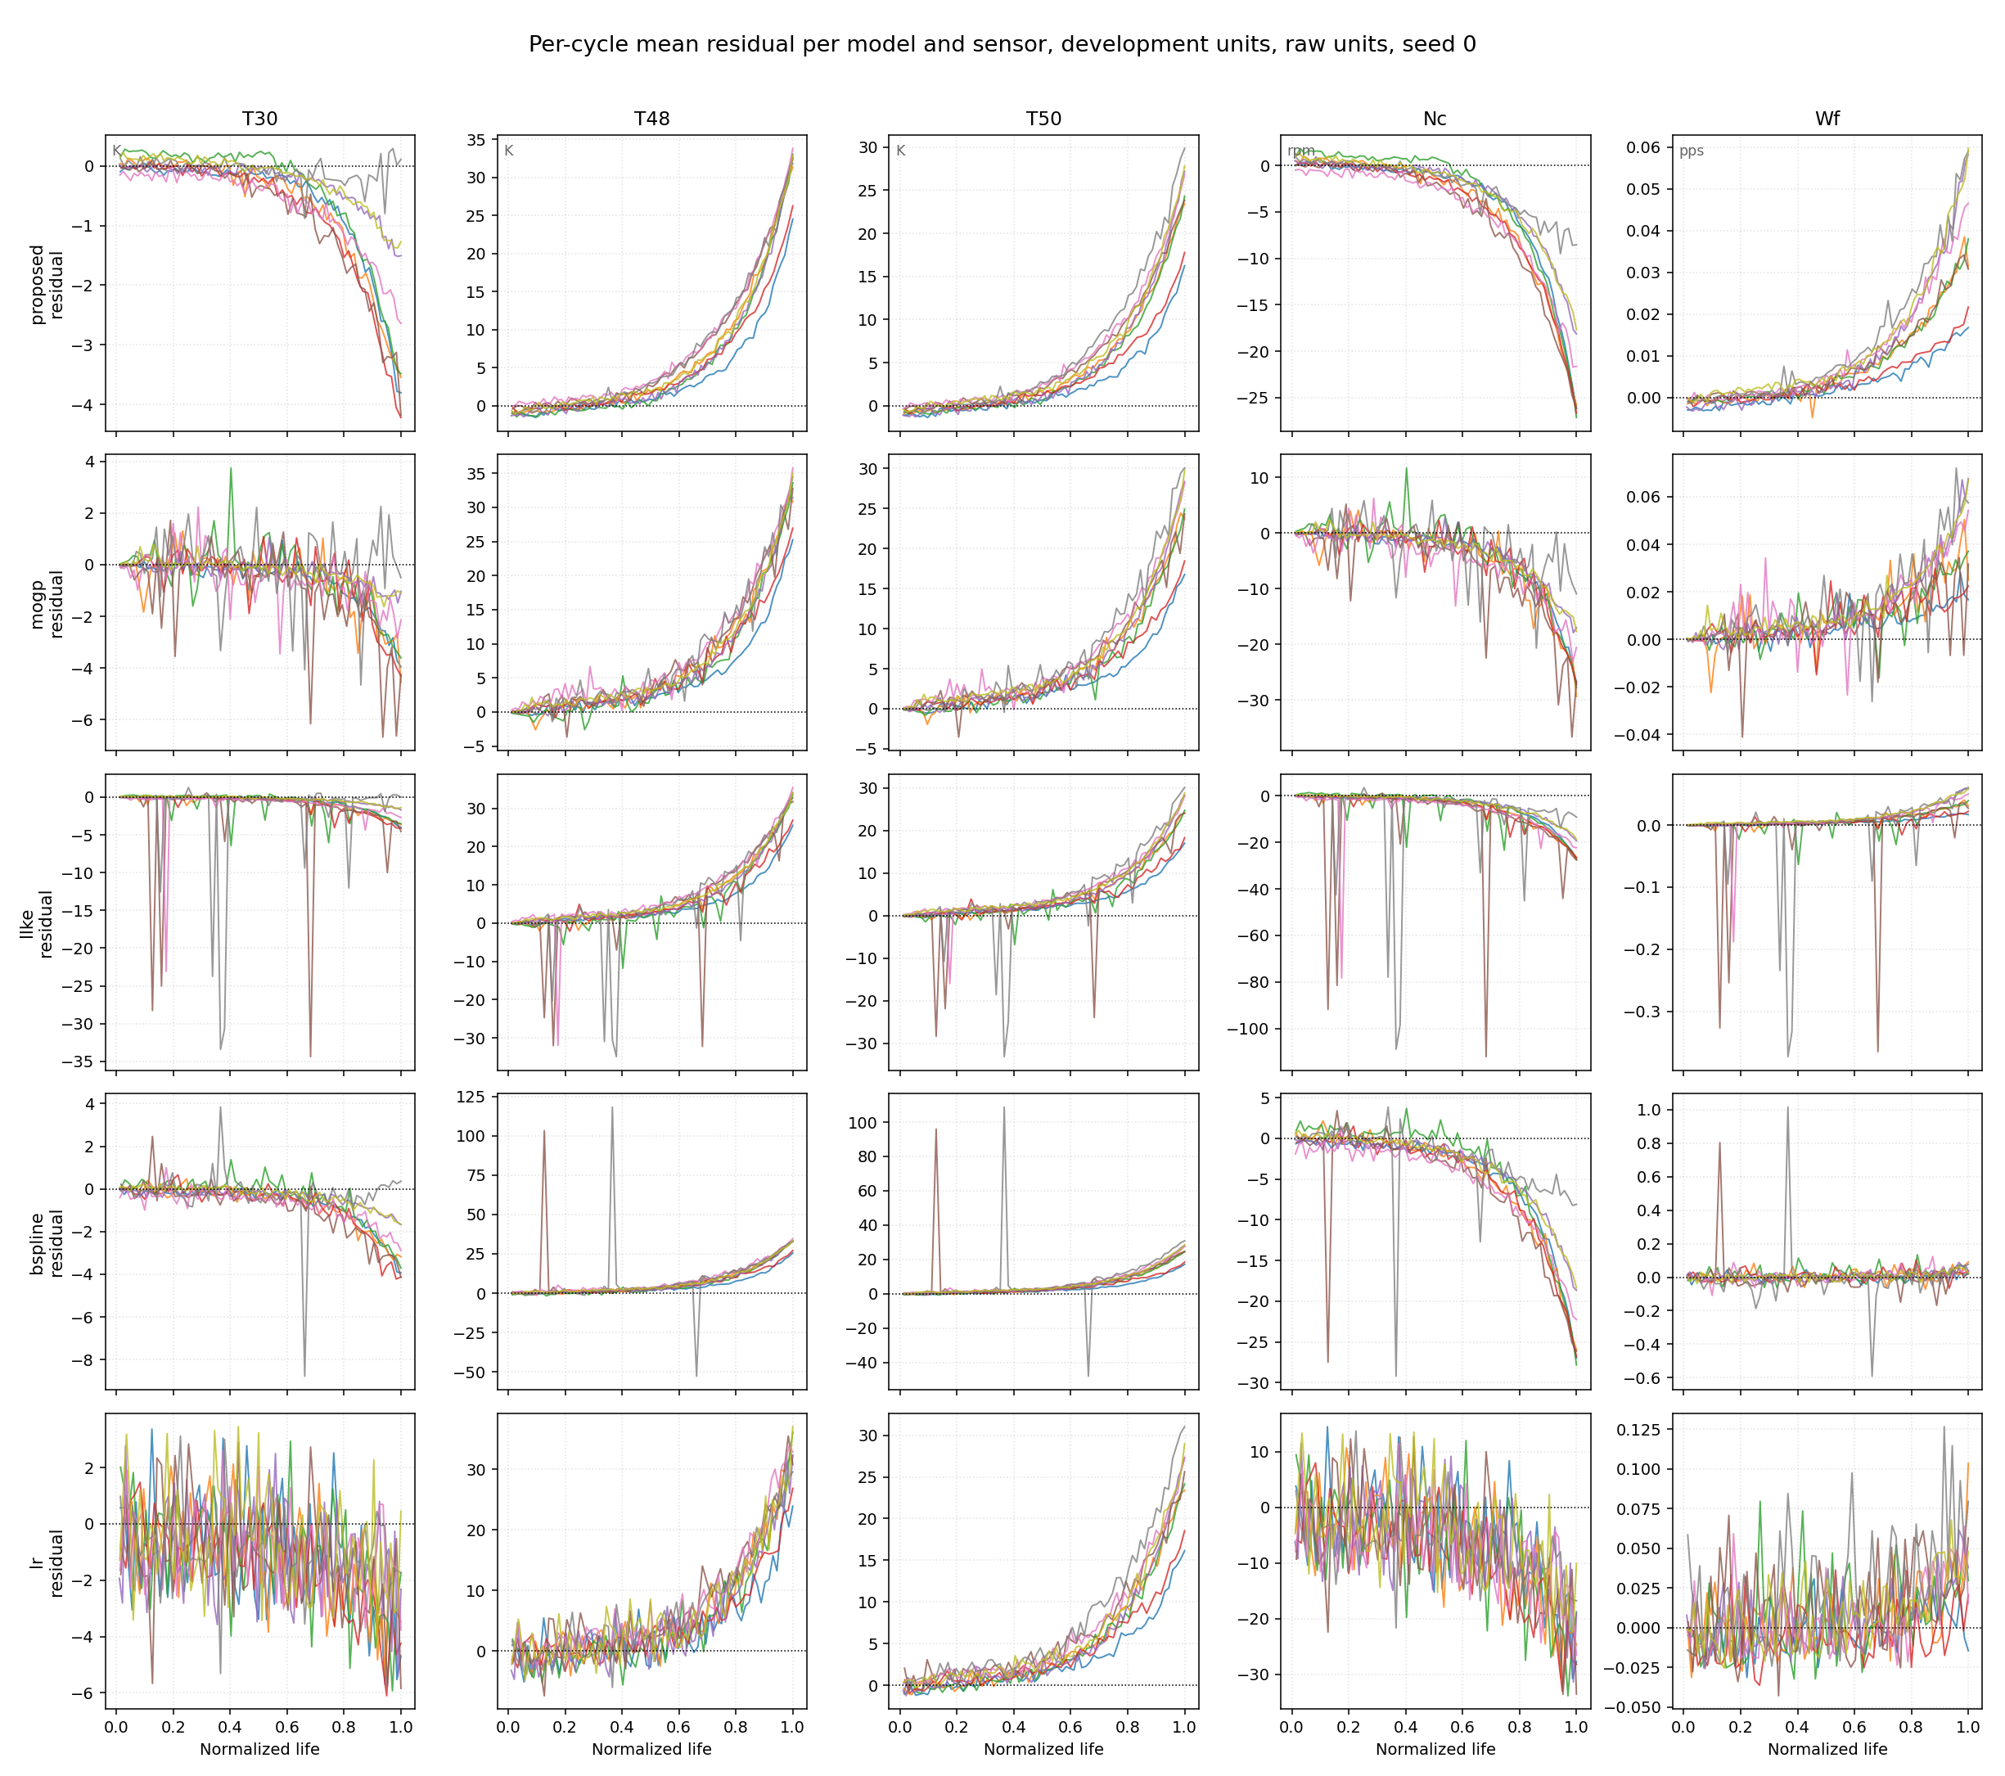
Figure 12. Per-cycle mean residual per model and sensor, raw units, 9 development units, seed 0. Top row: the stage-2 healthy-range MOGP.
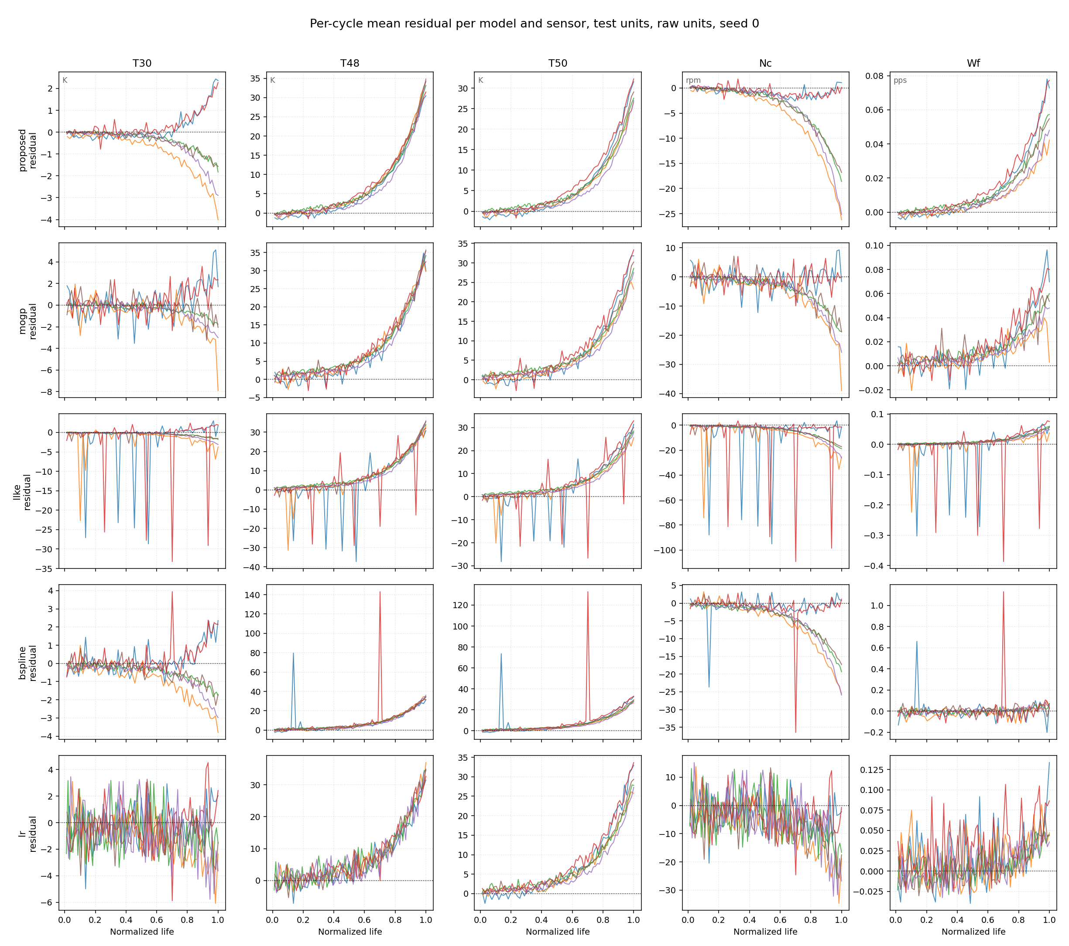
Figure 13. Per-cycle mean residual per model and sensor on the test units, raw units, seed 0. The stage-2 row shows the flattest healthy stretch at a preserved end-of-life swing; LLKE shows coverage spikes, B-spline isolated large spikes, LR broadband noise.
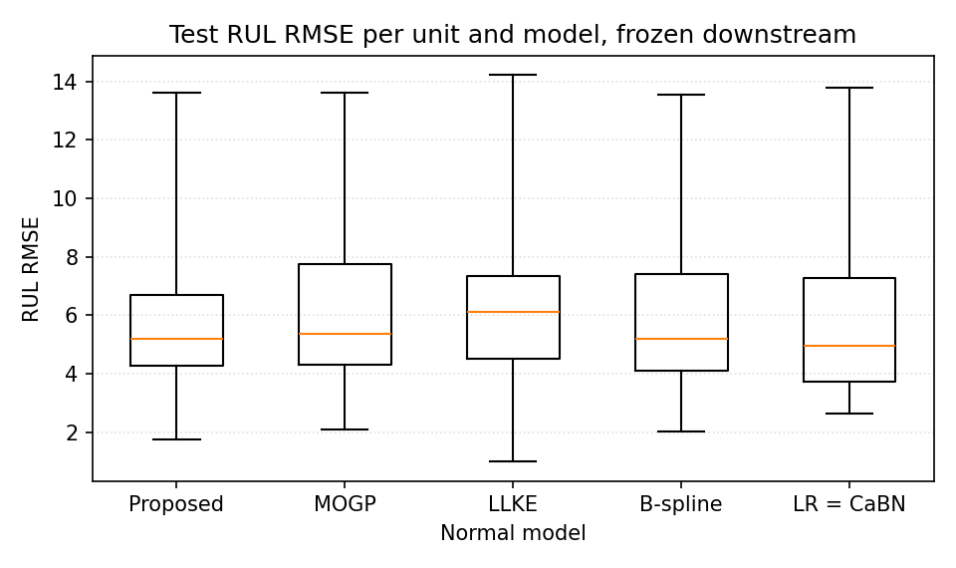
Figure 14. Test RUL RMSE per unit and model, frozen downstream, full-range whiskers. The Proposed box is the tightest; no pairwise difference is significant.
Note. Honest reading of quality against RUL across models (dev, 27 unit-seed cases, 3 seeds, common yardstick): the SNR ordering — Proposed 37.2 +/- 11.0 > LLKE 21.1 +/- 9.9 > MOGP 16.8 +/- 3.2 > B-spline 4.9 +/- 1.5 > LR 3.1 +/- 0.3 — does not track the RUL ordering: LR has the noisiest floor (5.94) yet the second-best test RUL, LLKE the second-best SNR yet the worst. The fifteenth-opening test extension reproduces the ordering out-of-sample: Proposed 34.1 > LLKE 18.2 +/- 8.4 > MOGP 15.1 > B-spline 3.9 +/- 1.3 > LR 3.0 +/- 0.2. The pooled z-normalization absorbs white-noise scale, so what damages RUL is structured artefacts, not floor height. The causal quality-to-RUL evidence therefore lives in the controlled window swap of Sections 7 and 9(a), not in cross-model correlation. End-metric insensitivity, retained from the disclosed record: no pairwise RUL difference is significant, and the downstream armor-removal grid keeps all 24 test cells in the narrow 7.27–7.87 band with no collapse.
9. Ablation studies — each component on the axis where it operates
Each component is ablated on the axis where it operates: (a)–(c) on the RUL axis against the stage-2 chain, (d) on the onset axis of the detection stage. The gate itself is not an ablation row by design: its null RUL effect (7.47 vs 7.52, p = 0.40) and its both-split onset gains are what fixed it as a detection-only component (Section 5).
Table 7. Ablation (a) — training window: cycle<=3 replaces the stage-2 healthy range at the same 27k budget, identical ungated downstream. Development prefers the sparse window while test prefers the healthy range; the paired test difference is not significant (72 predictions, unit n = 6).
Window | dev LOO | test RMSE | test NASA
Healthy range — chain | 7.56 ± 0.05 | 7.18 ± 0.05 | 17.7 ± 0.2
cycle<=3 | 7.15 ± 0.10 | 7.47 ± 0.06 | 19.5 ± 0.8
Table 8. Ablation (b) — HI #2 loss terms, one deleted at a time; every variant is dev-trained on the stage-2 tables with beta by the frozen rule, and test-scored at the fifteenth opening. The deletions transfer from dev to test with matching magnitudes and no reversal.
Variant | dev RUL | test RUL | test NASA | shape
full recipe — chain | 7.56 ± 0.05 | 7.18 ± 0.05 | 17.7 | 3/3
without the initial-level term | 9.78 ± 0.51 | 9.86 ± 0.55 | 26.6 | 0/3
without the end-level term | 39.32 ± 1.78 | 39.10 ± 1.82 | 1495 | 0/3
without the tail-flatness term | 8.42 ± 0.57 | 8.31 ± 0.68 | 21.1 | 3/3
Note. Gated-base history for comparison (eleventh opening, test, base 7.52): without initial 18.89 +/- 0.98, without end 40.71 +/- 0.50, without tail-flatness 7.81 +/- 0.16. The initial-anchor deletion is markedly less catastrophic on the stage-2 tables (9.78 vs 18.9) — consistent with their halved healthy floor — while the tail-flatness term reaches test significance on the stage-2 base (p = 0.02). The two level anchors remain existence conditions: shape 0/3, outright collapse without the end anchor.
Table 9. Ablation (c) — conditional normalization: raw per-cycle sensor means replace the stage-2 residuals in the same five-channel table-to-HI interface; no GP anywhere. The variant is GP-independent, recorded at the eleventh opening and re-based against the stage-2 chain.
Input | dev LOO | test RMSE | test NASA | shape
Stage-2 residuals — chain | 7.56 ± 0.05 | 7.18 ± 0.05 | 17.7 ± 0.2 | 3/3
Raw sensor means | 9.18 ± 0.10 | 8.31 ± 0.35 | 22.6 | 0/3
Note. Removing conditional normalization costs +21 % on dev and +16 % on test, and the raw HI curves fail the shape criteria on every seed. Scope: the ablation removes the normalization stage while keeping the table-to-HI interface fixed; learning the normalization inside the HI network is outside the frozen recipe.
Table 10. Ablation (d) — detection baseline window: sensitivity at the frozen clip 10 sigma, re-scored on the conditional-gate curves (gate rule frozen as deployed). 30 h — originally frozen on the fixed-gate grid — remains the grid minimum and reproduces the final chain value.
Window | 3cy | 4cy | 5cy | 6cy | 8cy | 12cy | 20cy | 10h | 15h | 20h | 25h | 30h | 50h
RMSE | 20.01 | 17.91 | 14.66 | 10.31 | 10.47 | 8.66 | 10.21 | 12.40 | 9.42 | 8.24 | 6.02 | 5.21 | 11.95
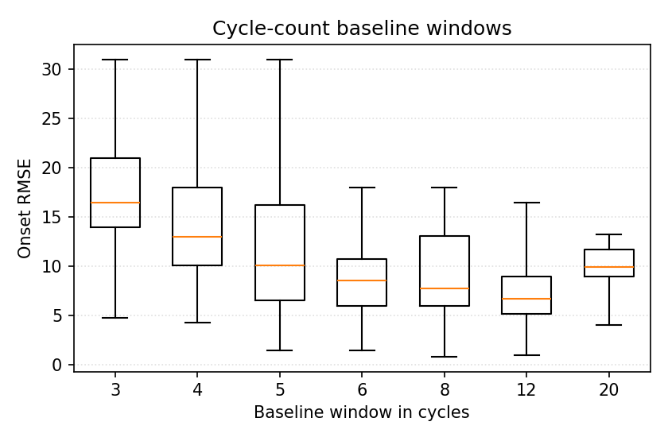
Figure 15. Onset RMSE per cycle-count baseline window at clip 10 sigma. Each box holds the per-unit RMSE over 3 seeds, 9 units per box; whiskers span the full range.
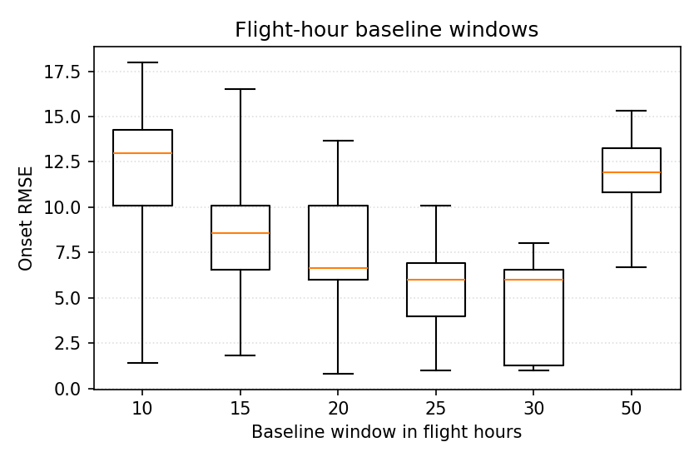
Figure 16. Onset RMSE per flight-hour baseline window. The 20–30 h windows beat every cycle-count window (15 h still trails 12cy, 9.42 vs 8.66, and 50 h deteriorates again to 11.95); 30 h is the grid minimum with the tightest per-unit spread.
10. Conclusions
(1) A two-stage self-supervised chain under varying operating conditions transfers to sealed test data with every constant frozen: onset dev 5.21 / test 8.54 cycles; truncation RUL dev 7.56 / test 7.18 (NASA 17.7) — the best test figures in the record, with all pairwise differences within noise and disclosed as such. (2) The coverage-conditional confidence gate is a detection component: it improves onset on both splits and every flight class, its failure mode was diagnosed (sigma0 inflation — confidence is not accuracy) and repaired by a label-free deployable rule, and its null RUL effect was measured and acted on: the RUL path runs ungated. (3) Retraining the normal model on the healthy range that the chain itself detects halves the healthy residual floor at preserved end-of-life signal (aggregate SNR x2.2 development, x2.3 test; improved on every unit of both splits) — the measured mechanism behind the stage-2 RUL figures; development still prefers the sparse window and the test-side reversal is reported, the adoption being architectural. (4) Honest negative finding: the truncation-RUL end metric does not discriminate normal models, before or after downstream armor removal — RUL evaluations alone cannot justify a normal-model choice; the discriminating evidence lives in residual quality and in the confidence machinery that only the GP provides.
11. Work queue (pending items)
(i) Slide deck synchronization with this architecture — separate deliverable, on instruction. Nothing else is pending in this report.

