NAME: LEWINS MUREITHI
REG NUMBER: G127/1415/2023
COURSE: INFORMATION TECHNOLOGY
YEAR: 3 SEMESTER 1
ACADEMIC YEAR: 2025/2026

1.User Interface

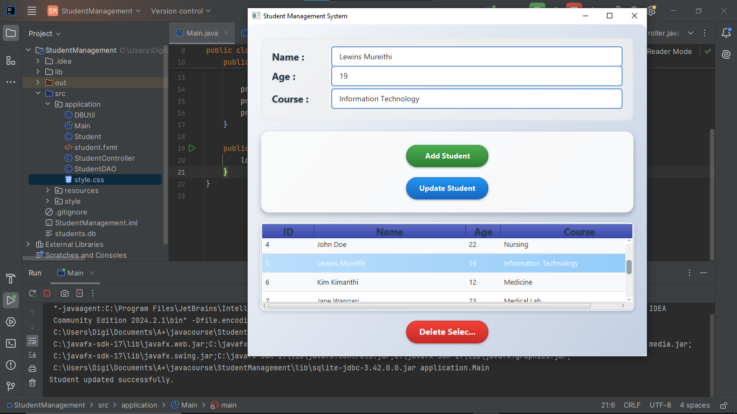

2. Adding students

I added students in the record - added 4 students in the table
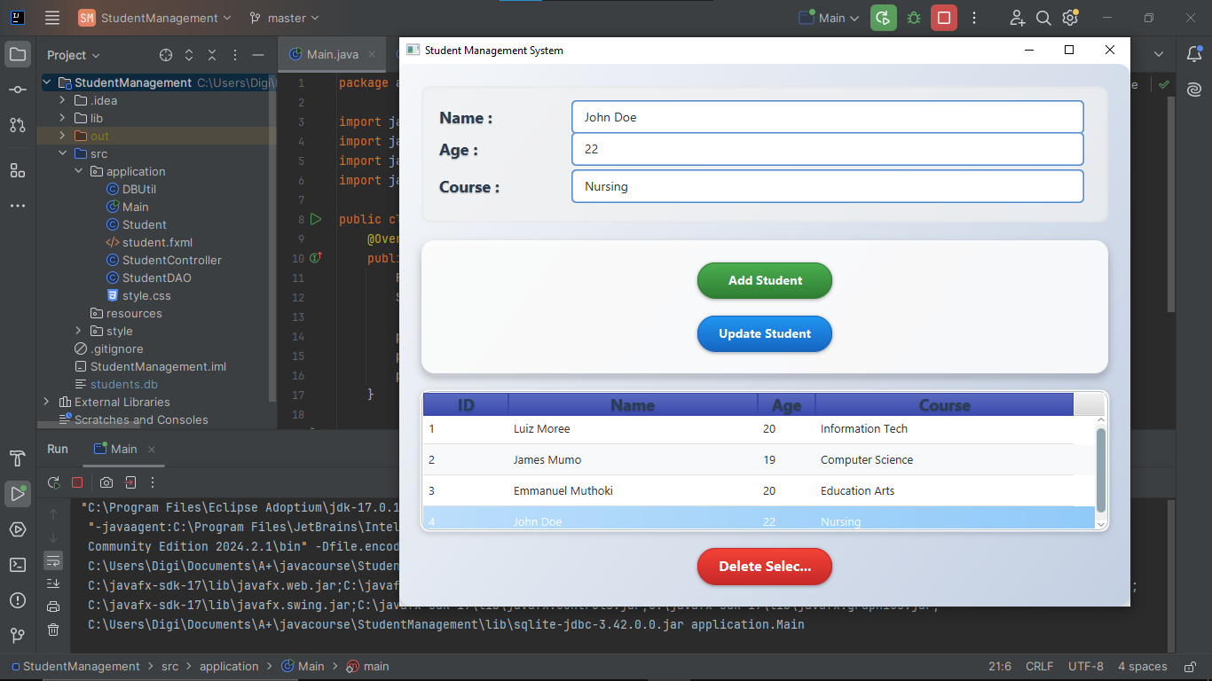

3. Deleting students in the list.
I deleted 2 student from the table – number 3 and 4

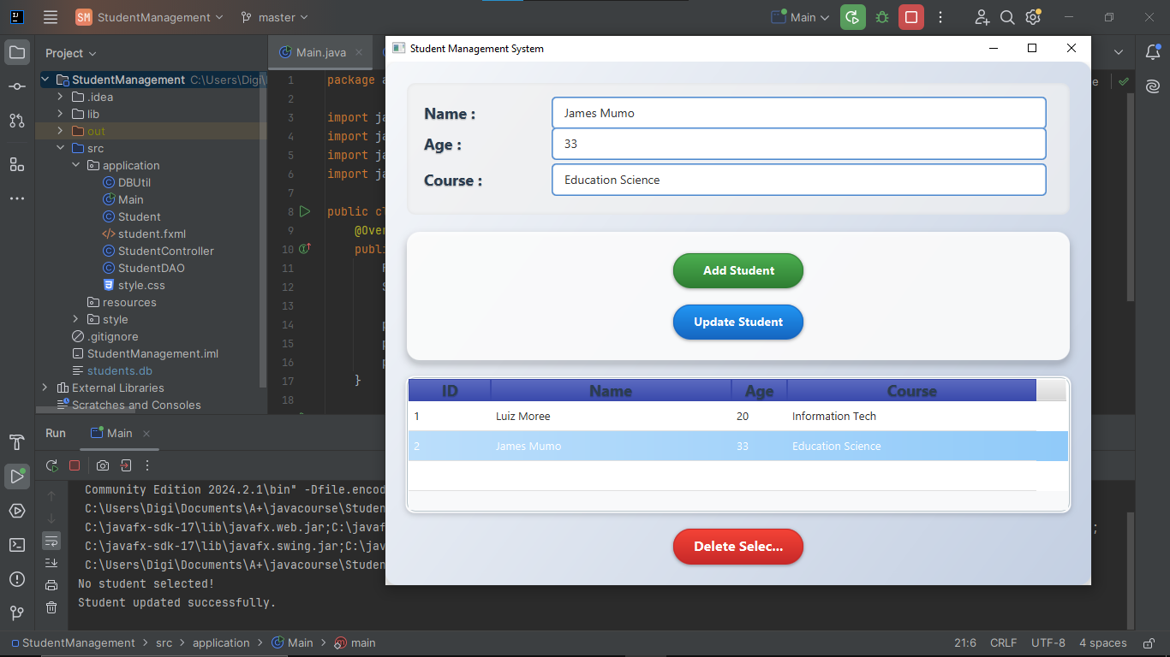

4. Updated student details in the table

I update James Mumo details including Age and Course
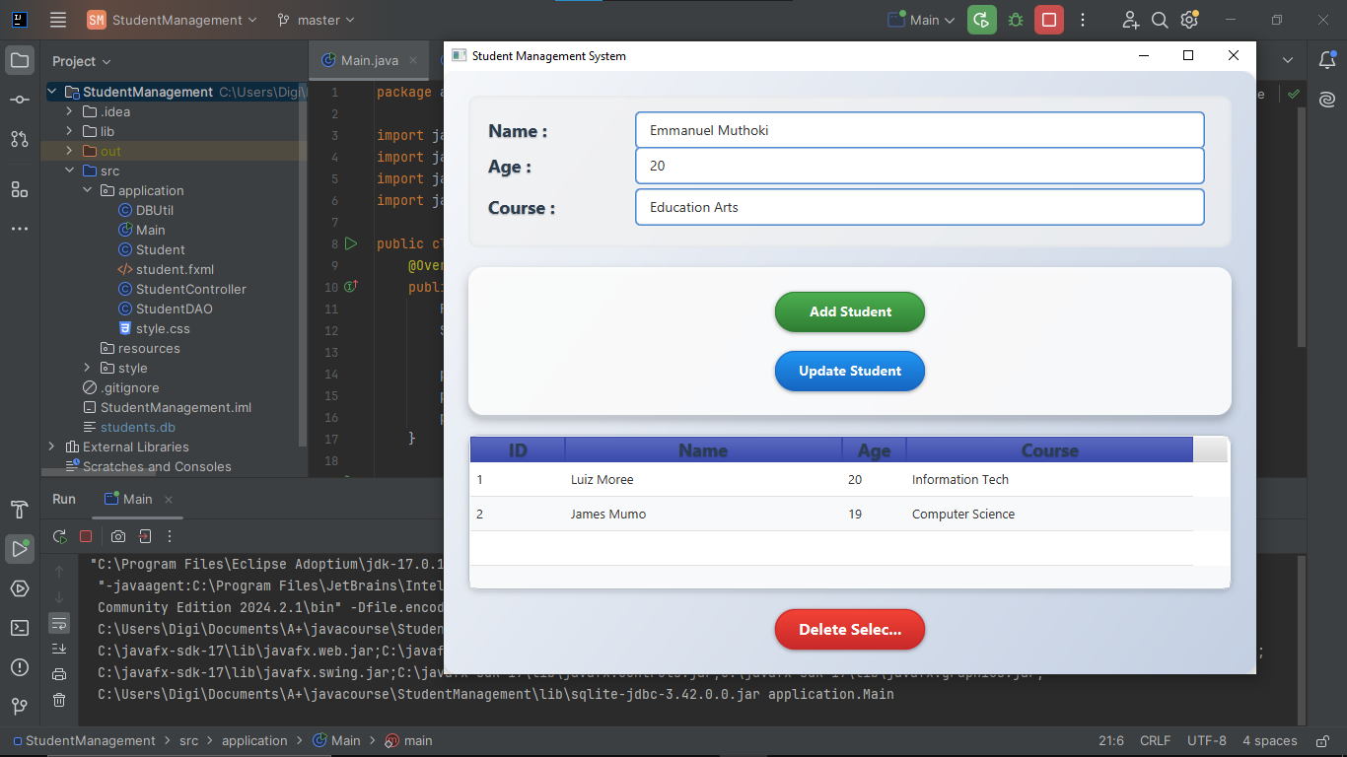

5. Code for update/Edit functionality

- StudentController.java

package application;
import javafx.collections.ObservableList;
import javafx.fxml.FXML;
import javafx.scene.control.*;
public class StudentController {
@FXML private TextField txtName;
@FXML private TextField txtAge;
@FXML private TextField txtCourse;
@FXML private TableView<Student> tableView;
@FXML private TableColumn<Student, Integer> colId;
@FXML private TableColumn<Student, String> colName;
@FXML private TableColumn<Student, Integer> colAge;
@FXML private TableColumn<Student, String> colCourse;
@FXML
public void initialize() {
colId.setCellValueFactory(cell -> new javafx.beans.property.SimpleIntegerProperty(cell.getValue().getId()).asObject());
colName.setCellValueFactory(cell -> new javafx.beans.property.SimpleStringProperty(cell.getValue().getName()));
colAge.setCellValueFactory(cell -> new javafx.beans.property.SimpleIntegerProperty(cell.getValue().getAge()).asObject());
colCourse.setCellValueFactory(cell -> new javafx.beans.property.SimpleStringProperty(cell.getValue().getCourse()));
// Add row selection listener for auto-filling fields
tableView.setOnMouseClicked(event -> onRowSelect());
loadStudents();
}
private void loadStudents() {
try {
ObservableList<Student> list = StudentDAO.getStudents();
tableView.setItems(list);
} catch (Exception e) {
e.printStackTrace();
}
}
@FXML
private void addStudent() {
try {
String name = txtName.getText();
int age = Integer.parseInt(txtAge.getText());
String course = txtCourse.getText();
StudentDAO.addStudent(name, age, course);
loadStudents();
clearFields();
} catch (Exception e) {
e.printStackTrace();
}
}
@FXML
private void deleteStudent() {
Student selected = tableView.getSelectionModel().getSelectedItem();
if (selected != null) {
try {
StudentDAO.deleteStudent(selected.getId());
loadStudents();
} catch (Exception e) {
e.printStackTrace();
}
}
}
@FXML
private void onRowSelect() {
Student = tableView.getSelectionModel().getSelectedItem();
if (student != null) {
txtName.setText(student.getName());
txtAge.setText(String.valueOf(student.getAge()));
txtCourse.setText(student.getCourse());
}
}
@FXML
private void updateStudent() {
Student selected = tableView.getSelectionModel().getSelectedItem();
if (selected == null) {
System.out.println("No student selected!");
return;
}
try {
String name = txtName.getText();
int age = Integer.parseInt(txtAge.getText());
String course = txtCourse.getText();
Student updatedStudent = new Student(selected.getId(), name, age, course);
StudentDAO.updateStudent(updatedStudent);
loadStudents();
clearFields();
} catch (NumberFormatException e) {
System.out.println("Please enter a valid age!");
e.printStackTrace();
} catch (Exception e) {
e.printStackTrace();
}
}
private void clearFields() {
txtName.clear();
txtAge.clear();
txtCourse.clear();
}
}

b) StudentDAO.java

package application;
import javafx.collections.FXCollections;
import javafx.collections.ObservableList;
import java.sql.*;
public class StudentDAO {
public static void addStudent(String name, int age, String course) throws SQLException {
String sql = "INSERT INTO students(name, age, course) VALUES(?, ?, ?)";
try (Connection conn = DBUtil.getConnection();
PreparedStatement stmt = conn.prepareStatement(sql)) {
stmt.setString(1, name);
stmt.setInt(2, age);
stmt.setString(3, course);
stmt.executeUpdate();
}
}
public static ObservableList<Student> getStudents() throws SQLException {
ObservableList<Student> list = FXCollections.observableArrayList();
String sql = "SELECT * FROM students";
try (Connection conn = DBUtil.getConnection();
Statement stmt = conn.createStatement();
ResultSet rs = stmt.executeQuery(sql)) {
while (rs.next()) {
list.add(new Student(
rs.getInt("id"),
rs.getString("name"),
rs.getInt("age"),
rs.getString("course")
));
}
}
return list;
}
public static void deleteStudent(int id) throws SQLException {
String sql = "DELETE FROM students WHERE id=?";
try (Connection conn = DBUtil.getConnection();
PreparedStatement stmt = conn.prepareStatement(sql)) {
stmt.setInt(1, id);
stmt.executeUpdate();
}
}
public static void updateStudent(Student student) {
String sql = "UPDATE students SET name = ?, age = ?, course = ? WHERE id = ?";
try (Connection conn = DBUtil.getConnection();
PreparedStatement stmt = conn.prepareStatement(sql)) {
stmt.setString(1, student.getName());
stmt.setInt(2, student.getAge());
stmt.setString(3, student.getCourse());
stmt.setInt(4, student.getId());
stmt.executeUpdate();
System.out.println("Student updated successfully.");
} catch (SQLException e) {
e.printStackTrace();
}
}
}

