Instructions

Username: microscope Password: microscope

Database password: microscope

Microscope brightness: preset

Shutter speed 1/30

ISO 200

White balance: custom

Picture quality: S2 (1920x1080)

1. Open EOS Utility software and run the Python program from Spyder (or *scan.bat* if you just want one scan).
2. Move the lens to the lower right corner of the area to be scanned and focus (see below for the controller setting).
3. Move the lens to the upper right corner of the area and focus. (This relative movement is recorded).
4. Move the lens to the upper left corner of the area and focus. (This relative movement is recorded). The program will take this corner as the origin and calculate how many photos need to be taken. The scanning starts.

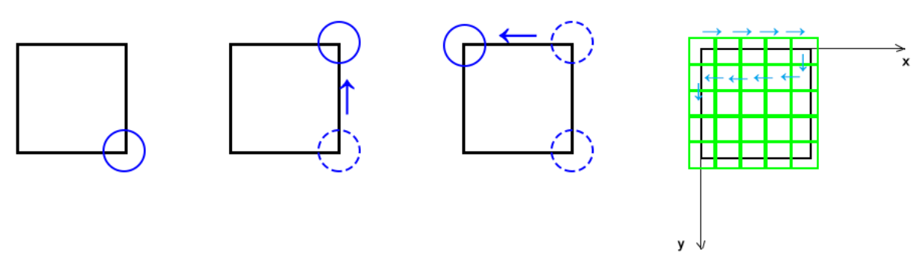

Remark

1. Program structure (main.py)

Cell 1: import modules, set parameters and initialize devices

Cell 2: define functions

Cell 3: scan

Cell 4: image processing

To enable joystick control, call *joyControl()*

1. Semi-auto mode (in development)

Use *scanArea(size in mm)*, which does the translational motion for us. We wait until it reaches the target position specified in the argument and then we focus it. We may also adjust the position when we focus.

1. It is recommended to calibrate the linear stage after the load changes. This can be done by using the function *calibrate()*, which will give the number of steps for forward and backward motion. Then go to *calibrationResult.xlsx* and fill this in to calculate pixel per step. Write this parameter into the variable *pxPerStep* in *main.py*

B – small movement

A – medium movement

X - large movement

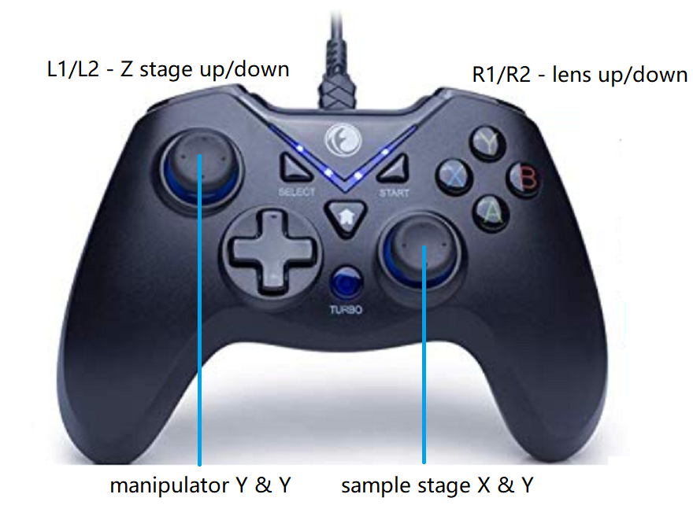

START – proceed