Site Plan

Miles Hemmert

WDD 130

Overview

Purpose
Recommend to people movies based on preferences they lay out

Audience
People who have a hard time picking a movie

Branding

Website Logo


Style Guide

Color Palette
Primary | Secondary | Accent 1 | Accent 2
#222034 | #d9d7ad | #801818 | #e6c13c

Typography

Heading Font: Verdana

Paragraph Font: Posterama

Navigation
Home Quiz History

Content

Home is an intro to the site and a button that leads to the quiz page

Quiz is a series of questions about what kind of movie your looking for, upon completion your given 5 or so options to pick from.

History will show movies you watched in the past and show your personal rating of the movie if you left one, as well as an option to clear it

Wireframes

Home
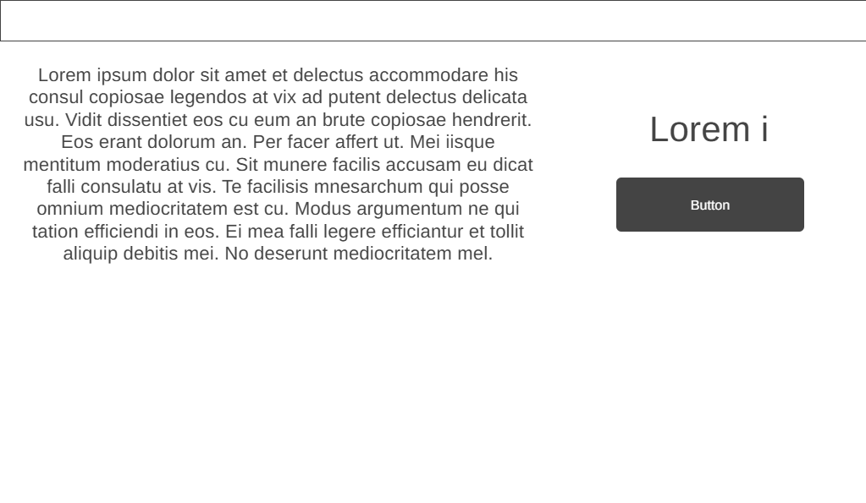

Quiz
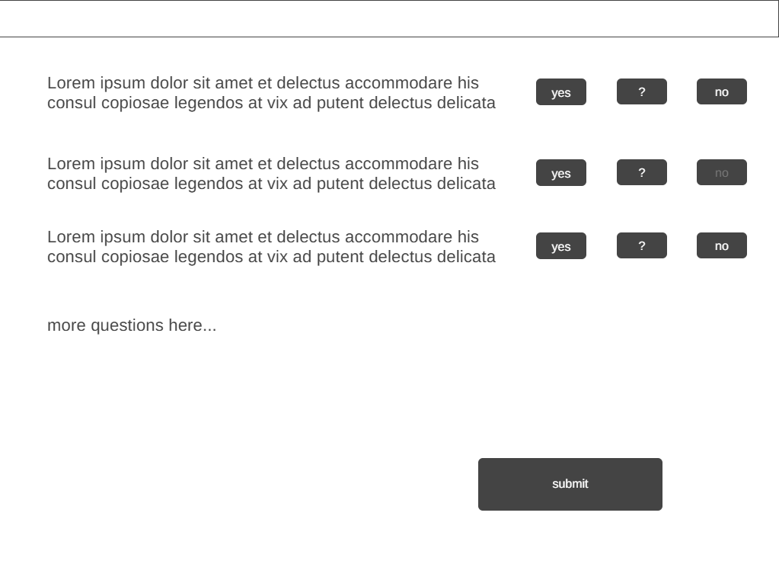

History
