The Learning Story-1
Name of Child: Grace
Date of Observation: March 18, 2025
Date of Birth: March 2023

Observer: Dron Lakhanpal
Location: Indoor play area

Developmental Area: Physical and Cognitive

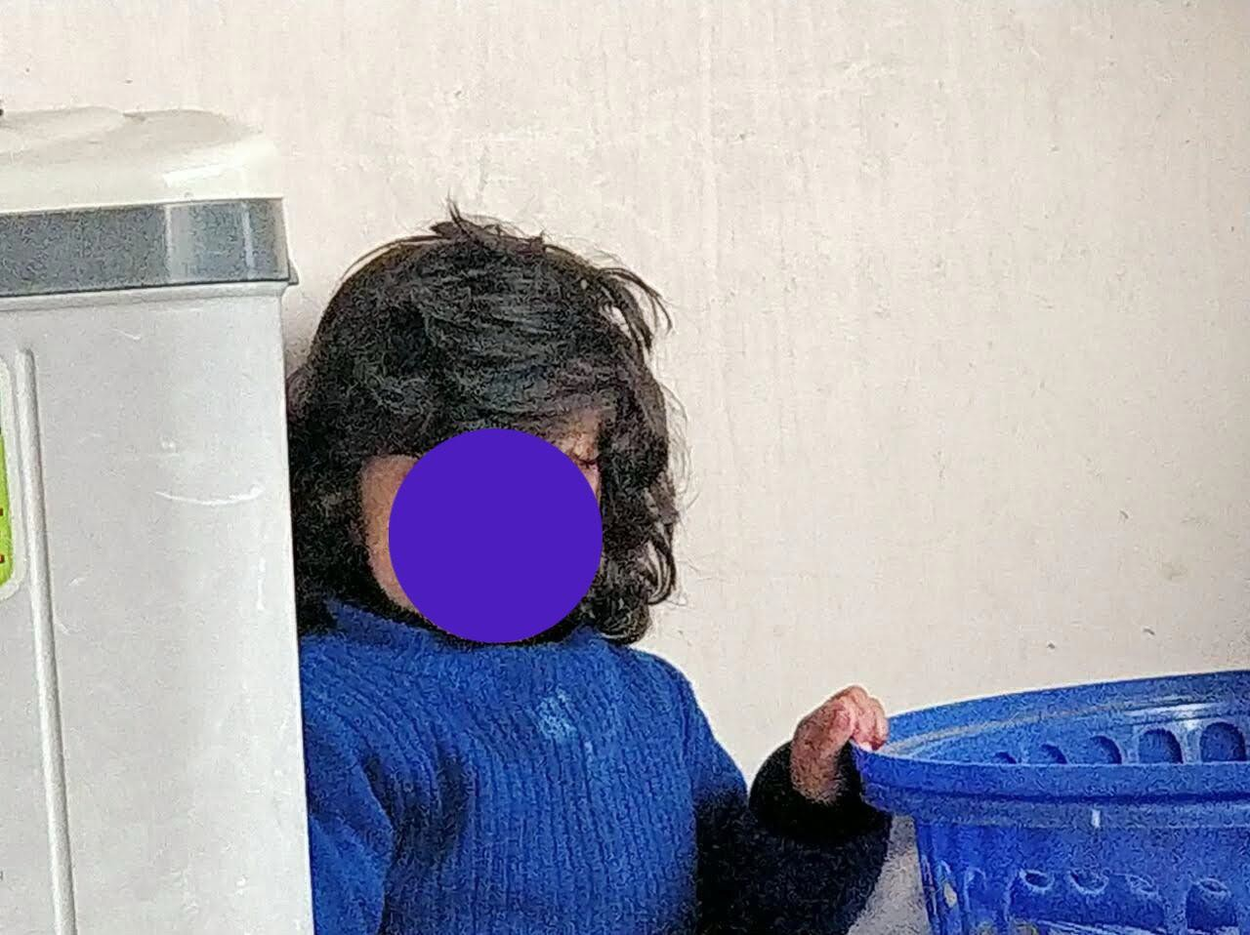
Little Organizer moment

I watched as Grace gathered her toys, each one individually, and placed them in the blue basket. She grasped each toy firmly with her small hands and took a moment to examine

each one before placing it inside. She paused, looked at the basket, and then retrieved another toy, repeating it with growing confidence.
She seemed fully engrossed, her gaze focused and introspective. She stopped once, held two toys in her palms, and stared between them as if deciding which to use first. She
picked after a time, putting the toy inside tenderly before picking up the other.
Grace, you were so concentrated and problem-solving today! You were sorting and storing your toys so carefully, using your fine motor skills to pick them up and place them in the
basket. You also showed patience and persistence, making positive choices along the way. It was wonderful to observe you so engaged in your activity!

Reflecting and Interpreting the Learning That Took Place
Grace is clearly learning important physical and thinking skills by doing this activity. She is developing her fine motor skills and hand-eye coordination because she is reaching for
objects and putting them away. She also demonstrates emergent problem-solving skills by selecting which toy she will pick up first and sort through.
Grace's engagement in this activity also demonstrates her growing independence and
concentration. She demonstrated interest as she looked into the basket, assessed where she was putting her toys, and sustained in the activity. The activity is also conducive to early math thinking because sorting and categorizing objects are pre-skills to conceiving patterns and classification.

Future Opportunities and Extension of Learning
What if you add some different baskets and containers so that you can learn about sorting by shape, size, and color. And we could offer soft cloth toys and hard plastic ones to you, in order to investigate and sort by feel too.
Maybe we can turn it into a game where you pick up the toys based on a prompt, such as "Can you get something red?" or "Can you sort all the round toys into the basket?" This would help to reinforce your compliance with instructions and categorizing.
We can also read a sorting or tidying book, like The Very Hungry Caterpillar, to introduce
you to sequencing and the idea of order. Softer music played during sorting may also make it even more pleasant!

