|  |  |  |  |  |  |  |  |  |  |  |  |  |  |  |  |  |  |  |  |  |  |  |  |  |  |  |  |  |  |  |  |  |  |  |  |  |  |  |  |  |  |  |  |  |  |  |  |  |  |  |  |  |  |  |  |  |  |  |  |  |  |  |  |  |  |  |  |  |  |
| --- | --- | --- | --- | --- | --- | --- | --- | --- | --- | --- | --- | --- | --- | --- | --- | --- | --- | --- | --- | --- | --- | --- | --- | --- | --- | --- | --- | --- | --- | --- | --- | --- | --- | --- | --- | --- | --- | --- | --- | --- | --- | --- | --- | --- | --- | --- | --- | --- | --- | --- | --- | --- | --- | --- | --- | --- | --- | --- | --- | --- | --- | --- | --- | --- | --- | --- | --- | --- | --- |
| **FACULTY OF INFORMATION TECHNOLOGY**   |  | | --- | | **INTRODUCTION TO INFORMATION TECHNOLOGY 500** |   **2nd SEMESTER ASSIGNMENT**    **Name & Surname: _ ITS No:**  **Semester:**        **Qualification: Module Name:**    **Date Submitted:**     |  |  |  |  | | --- | --- | --- | --- | | **ASSESSMENT CRITERIA** | **MARK**  **ALLOCATION** | **EXAMINER MARKS** | **MODERATOR MARKS** | | **MARKS FOR CONTENT** | | | | | **QUESTION ONE** | **30** |  |  | | **QUESTION TWO** | **30** |  |  | | **QUESTION THREE** | **30** |  |  | | **TOTAL** | **90** |  |  | | **MARKS FOR TECHNICAL ASPECTS** | | | | | **TABLE OF CONTENTS**  Accurate numbering according to the numbering in text and page numbers. | **2** |  |  | | **LAYOUT AND SPELLING**  Font – Calibri 12  Line Spacing – 1.0  Margin should be justified. | **3** |  |  | | **REFERENCES**  According to the Harvard Method | **5** |  |  | | **TOTAL** | **10** |  |  | | **TOTAL MARKS FOR ASSIGNMENT** | **100** |  |  | | **Examiner’s Comments:** | | | | |  | | | | | **Moderator’s Comments:** | | | | |  | | | | | **Signature of Examiner: Mr. Thabang Nkuna Signature of Moderator: Ms. Anika Ramsingh** | | | | |

Table of Contents

ASSIGNMENT INSTRUCTIONS 4

QUESTION 1 CASE STUDY 4

Questions 5

QUESTION 2 MICROSOFT POWERPOINT PRESENTATION 6

Using Microsoft PowerPoint Presentation, Apply the following instructions: 6

QUESTION 3 PRACTICAL MICROSOFT ACCESS 8

Answer all the questions below using Microsoft Access application: 8

# ASSIGNMENT INSTRUCTIONS

1. All assignment must be typed, not handwritten.
2. Every assignment should include the cover page, table of contents and a reference list or bibliography at the end of the document
3. A minimum of five current sources (references) should be used in all assignments and these should reflect in both in-text citations as well as the reference list or bibliography
4. Make use of Google Scholar to get sources for this assignment (i.e., your lecturer will take you through Google Scholar)
5. In-text citations and a reference list or bibliography must be provided. Use the Harvard Style for both in-text citations and the reference list or bibliography
6. Assignments submitted without citations and accompanying reference lists will be penalised.
7. Students are not allowed to share assignments with fellow students. Any shared assignments will attract stiff penalties.
8. The use of, and copying of content from websites such as chegg.com, studocu.com, transtutors.com, sparknotes.com or any other assignment-assistance websites is strictly prohibited. This also applies to Wiki sites, blogs and YouTube.
9. Any pictures and diagrams used in the Assignment should be properly labelled and referenced.
10. Correct formatting as indicated on the Cover Page should be followed (font-size 12, font-style Calibri, line spacing of 1.0 and margins justified).
11. As long as you do not have the capacity to invent any theories, you are required to cite each and every information used in this assignment.
12. All Assignments must be saved in PDF using the correct naming-convention before uploading on Moodle. Eg StudentNumber_CourseCode_Assignment (402999999_IIT500D_Assignment).

|  |  |
| --- | --- |
| QUESTION 1 CASE STUDY | **(30 MARKS)** |

**Title: Safeguarding Data at HealthTech Solutions Background:**

HealthTech Solutions is a rapidly growing healthcare technology company that develops and manages electronic health record (EHR) systems for hospitals and clinics across the country. The company has 500 employees and handles sensitive medical data for millions of patients. Recently, there have been increasing concerns about cybersecurity threats in the healthcare sector.

**Current Situation:**

HealthTech Solutions stores and processes large volumes of patient data, including personal information and medical histories.

The company has a bring-your-own-device (BYOD) policy for employees.

Many employees work remotely, accessing company systems from various locations.

The company uses cloud services for data storage and some of its applications.

There's an increasing trend of ransomware attacks targeting healthcare organizations.

Recent regulatory changes have introduced stricter data protection requirements.

**Challenges:**

Ensuring compliance with healthcare data protection regulations (e.g., HIPAA in the US).

Protecting against various cyber threats, including malware, phishing, and insider threats.

Maintaining data integrity and availability while ensuring strict access controls.

Securing remote access for employees working from home or on the go.

Balancing security measures with system usability and efficiency.

Educating employees about cybersecurity best practices.

**Recent Incident:**

Last month, HealthTech Solutions experienced a security breach. An employee fell victim to a phishing email, inadvertently providing their login credentials to an attacker. The attacker gained access to the company's network for 48 hours before being detected and blocked. While no patient data was confirmed to be stolen, the incident highlighted significant vulnerabilities in the company's security posture.

## Questions

1.1 Analyze the current digital safety and security measures at HealthTech Solutions. (5)

1.2 Identify the key vulnerabilities in the company's existing security infrastructure. (5) 1.3 Propose a comprehensive digital safety and security strategy that addresses the company's challenges and prevents similar incidents in the future. (5)

1.4 Discuss the potential impacts of implementing stricter security measures on employee productivity and

user experience. (5)

1.5 Develop a detailed incident response plan for potential future security breaches. (10)

**(Hint: use at least 5 sources for this question) [30 Marks]**

QUESTION 2 MICROSOFT POWERPOINT PRESENTATION **(30 MARKS)**

## Using Microsoft PowerPoint Presentation, Apply the following instructions:

* 1. Create a presentation from the slides below (10)

|  |  |  |  |  |  |
| --- | --- | --- | --- | --- | --- |
| |  |  |  | | --- | --- | --- | | **Copyright and the Law** |  | **Definition**   * A copyright provides to   written or artistic work    * Protected work may   include: poetry, novels, songs  | | |  | | --- | | **Exclusive Rights**   * A copyright gives the author exclusive rights to the use and duplication of work for a designated time * The Author may sell and or give up a portion of that right | |

**Slide 1**  **Slide 2**  **Slide 3**

|  |  |  |  |  |  |  |  |  |
| --- | --- | --- | --- | --- | --- | --- | --- | --- |
| |  |  |  | | --- | --- | --- | | **Conveying Limited Rights**  • Software developers convey limited rights to the software through –  End User Licence  Agreement |  | **Copyright Infringement**  • Occurs when a copyright  is violated without permission of the owner | | |  | | --- | | **Software Piracy**   * Poses a unique problem because of the ease with which is done * Its not good to borrow your   friend’ Office CD for installation | | | | |
| **Slide 4**  **Slide 5** |  | **Slide 6** |  |  |
| 2.2 Apply a slide design called “Circuit” |  |  |  | (4) |
| 2.3 Change the 1st slide font type headings to “Britannic Bold” |  |  |  | (4) |
| 2.4 Change the bulleted text on slide 2 to numbering |  |  |  | (4) |
| 2.5 Insert footer on the slides with your student number |  |  |  | (2) |
| 2.6 Insert a date & time and slide number in all your slides |  |  |  | (4) |

2.7 Change the colour scheme to any colour of your choice (2)

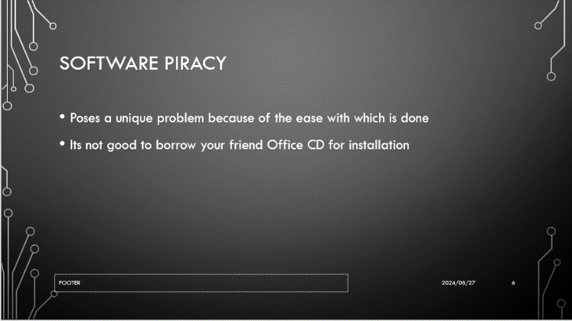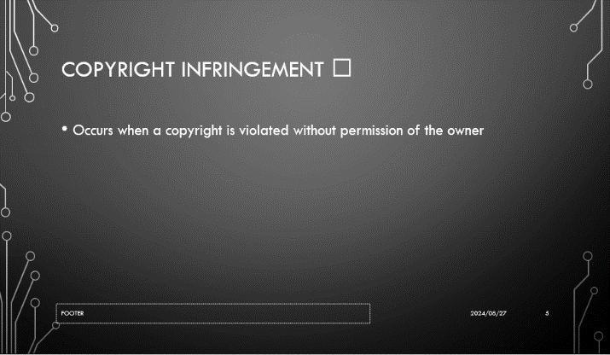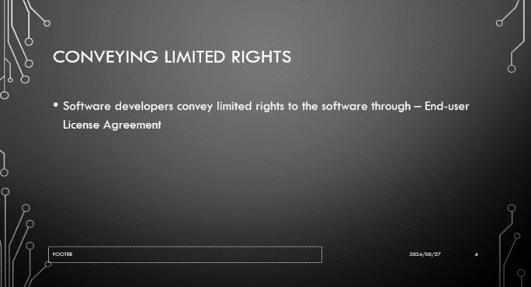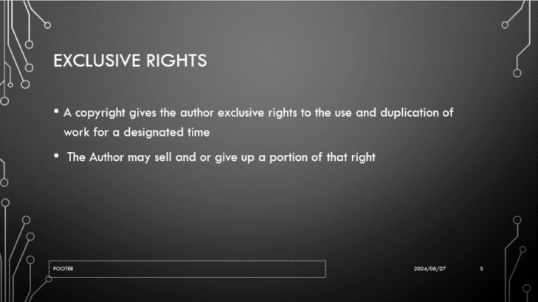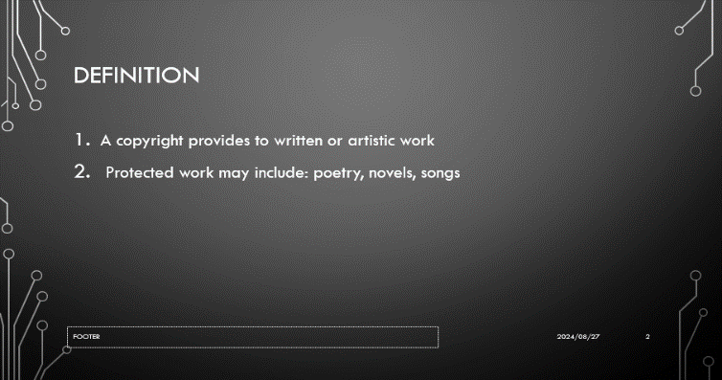

**[30 Marks]**

|  |  |
| --- | --- |
| QUESTION 3 PRACTICAL MICROSOFT ACCESS | **(30 MARKS)** |

## Answer all the questions below using Microsoft Access application:

|  |  |  |  |  |  |  |  |
| --- | --- | --- | --- | --- | --- | --- | --- |
| **Name** | **Gender** | **Dept** | **Hourly Rate** | **Hours Worked** | **Gross** | **Deductions** | **Net** |
| Phoebe | Female | Sales | 1900 | 5 |  |  |  |
| Selby | Female | Sales | 2200 | 5 |  |  |  |
| Carol | Female | Marketing | 3000 | 4 |  |  |  |
| Lindani | Female | Accounts | 1450 | 8 |  |  |  |
| Israel | Male | Marketing | 2350 | 5 |  |  |  |
| Lucky | Male | Admin | 1760 | 6 |  |  |  |
| Vanessa | Female | Sales | 1450 | 6 |  |  |  |
| Sbu | Male | Workshop | 1000 | 9 |  |  |  |
| Nishaan | Male | IT | 1200 | 8 |  |  |  |
| Vincent | Male | Workshop | 1690 | 6 |  |  |  |
| Chriss | Male | IT | 1900 | 6 |  |  |  |
| Shane | Male | Workshop | 2000 | 4 |  |  |  |

* 1. Create the database using your name followed by student number followed by the Question e.g.

Ronald 401111111 Q3. (5)

* 1. Create a table and add the details. 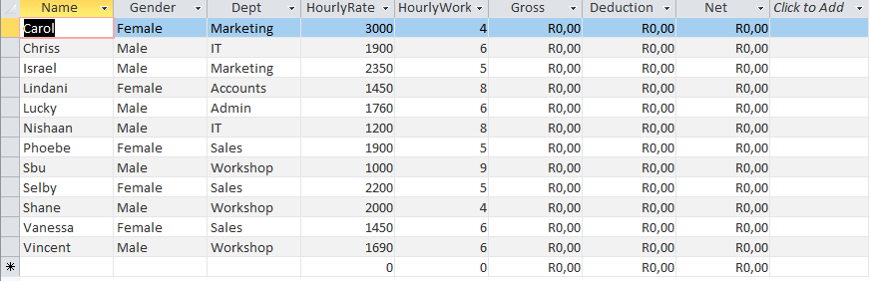 (5)
  2. Sort your database in an ascending order. (2)



* 1. Create a query to calculate the gross, deduction (20% of Gross) and Net. (10)

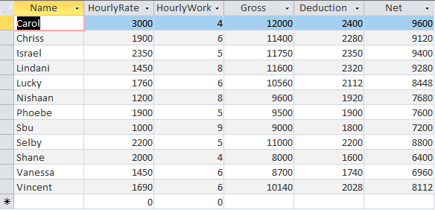

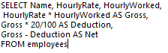

* 1. Create a query to display all the names under the Workshop department. (2)

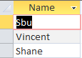



* 1. Create a query to display all the names with a Gross Less than 10000. (2)

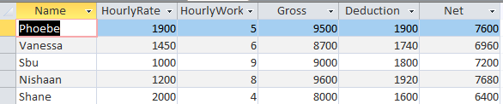

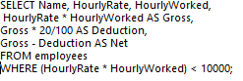

* 1. Create a query to display all males (2)

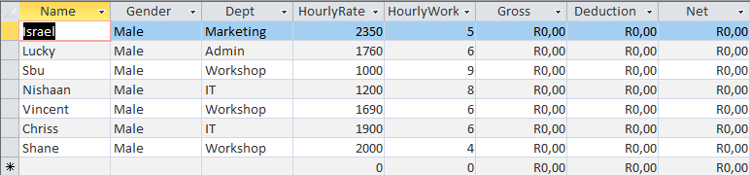



* 1. Create a form using all the fields. (2)

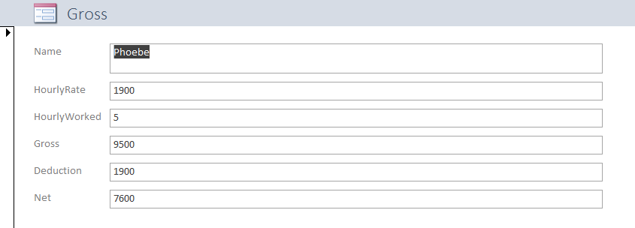

**[30 Marks]**

# References