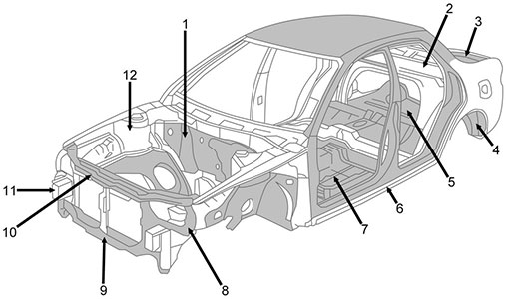

Internal Structural Parts

1- Cowl panel / Dash panel  
2- Rear shelf panel  
3- Back panel  
4- Rear inner panel  
5- Trunk floor  
6- Side sill / Side step  
7- Floor panel  
8- Baffle (around the light)  
9- Primary member / Front cross member  
10- Upper radiator support  
11- Front frame  
12- Front inner panel

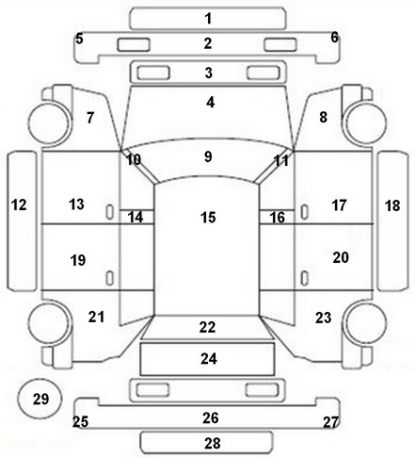

Body And Exterior

1 - under front bumper  
2 - front bumper  
3 - grill  
4 - bonnet / hood  
5 - left front bumper corner  
6 - right front bumper corner  
7 - left front panel  
8 - right front panel  
9 - front windscreen  
10 - left front pillar  
11 - right front pillar  
12 - left side step / sill  
13 - right side step / sill  
14 - left center pillar  
15 - roof  
16 - right center pillar  
17 - right front door  
18 - right side step  
19 - left rear door  
20 - right rear door  
21 - left rear panel  
22 - rear window  
23 - right rear panel  
24 - trunk lid / boot lid  
25 - left rear bumper corner  
26 - rear bumper  
27 - right rear bumper corner  
28 - under rear bumper

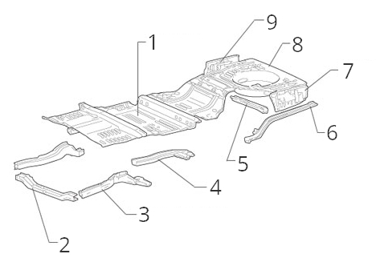

More Structural Parts

1- Floor panel  
2- Front cross member  
3- Front side member  
4- Floor side member  
5- Rear cross member  
6- Rear side member  
7- Side pocket  
8- Trunk floor / Boot floor  
9- Rear side panel