Microsoft Corporation

06 June 20204

Ms. Patsy Richardson

123 Main St.

Winnipeg, Manitoba

R2B 5F2

Dear Ms Richardson

This letter is a confirmation of your request for a ticket to the Annual Fireman’s Ball. Our corporation is happy to provide the ticket to you at **no cost.**

As you will note from the tickets, the Ball is being held **November 25th** at the **Norseman Inn** and will begin promptly at 9 p.m. The famous band, **Cappy’s Capers,** will provide an entertaining evening of dancing and comedy.

Thank you for allowing our company to be of service to you.

Warmest Regards,

Alpha Tapfuma.

# LEARN TO RIDE

High-quality **Western and English** riding lessons, focusing on safety and including instruction on horse care, saddling a horse, and other aspects of horsemanship.

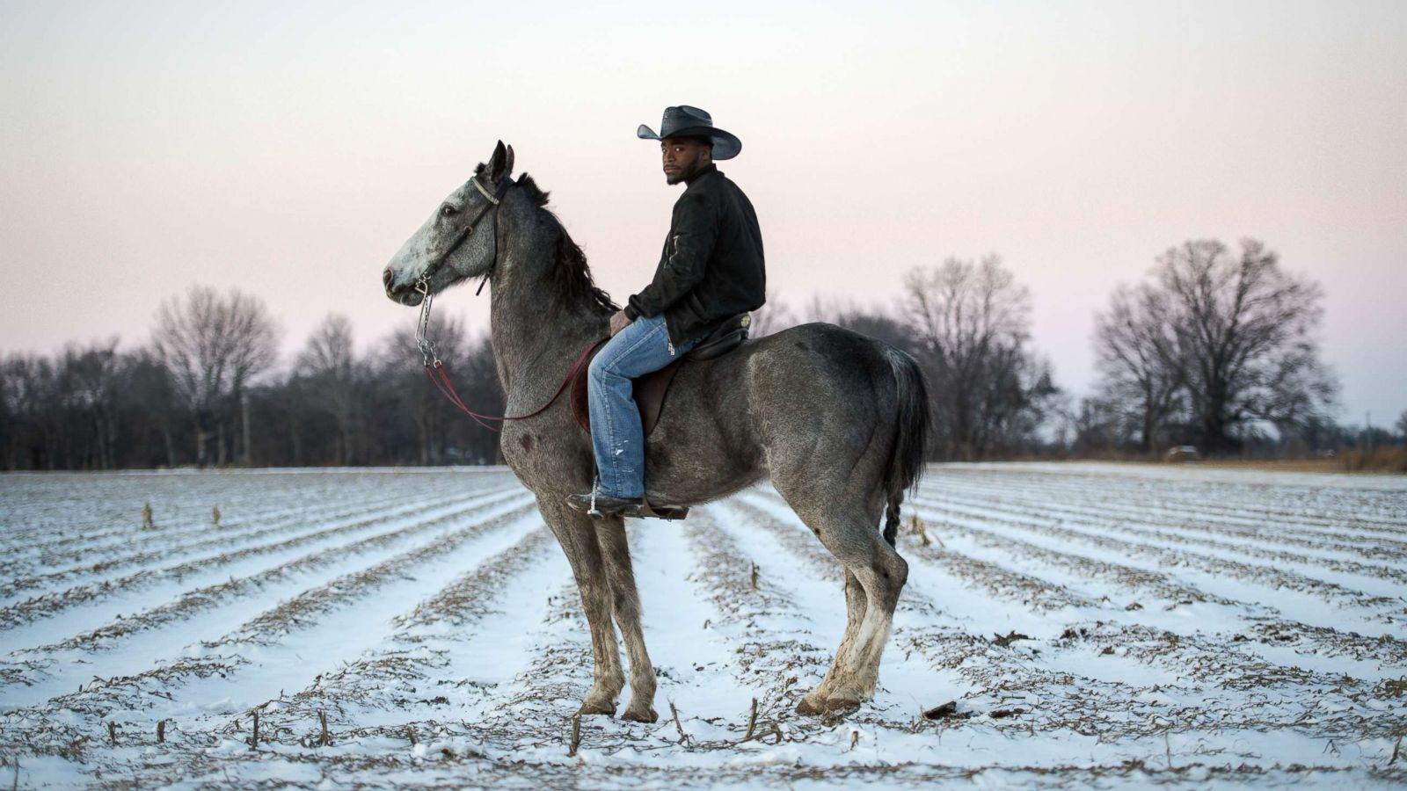

* Novice to advanced instruction for children and adults.
* Indoor and outdoor arenas.
* $40 per hour for private lessons: $25 for group lessons.

CALL TRI-VALLEY STABLES AT 555-2030 TODAY!

|  |  |  |  |  |  |
| --- | --- | --- | --- | --- | --- |
| Icebox jewellery boutique  “Quality Gemstones, Gold and Silver Jewellery for the Discriminating Buyer” | | | | | |
| Bill to:  Name  Address    City/Prov/State  Postal/Zip Code | | | Ship to:  Name  Address  City/Prov/State  Postal/Zip Code | | |
|  | | | | | |
| Quantity | ITEM | STYLE | TYPE | UNIT COST | COST |
|  |  |  |  |  |  |
|  |  |  |  |  |  |
|  |  |  |  |  |  |
|  |  |  |  |  |  |
|  |  |  |  |  |  |
|  |  |  |  |  |  |
|  |  |  |  |  |  |
|  |  |  |  |  |  |
|  |  |  |  |  |  |

|  |  |
| --- | --- |
| Shipping |  |
| Tax |  |
| Total Order |  |

XSSSSSSS

Thank you for your order