Development Guide

1. Environment setup
   1. JDK 1.6
   2. Eclipse with GIT plugin
   3. Tomcat 6.0
   4. MYSQL 5.2
2. Open Eclipse

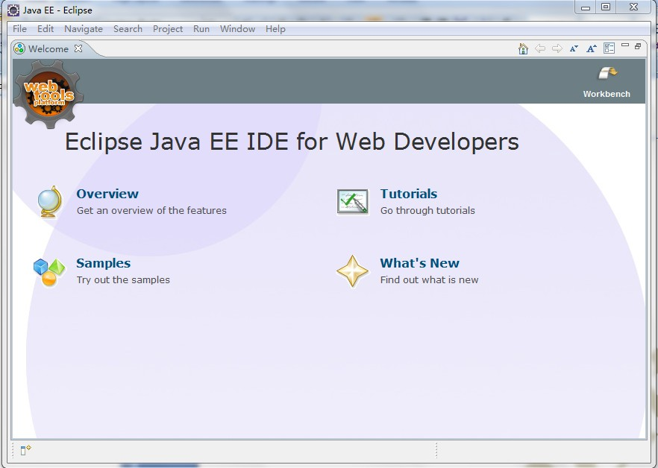

1. Select import project from GIT

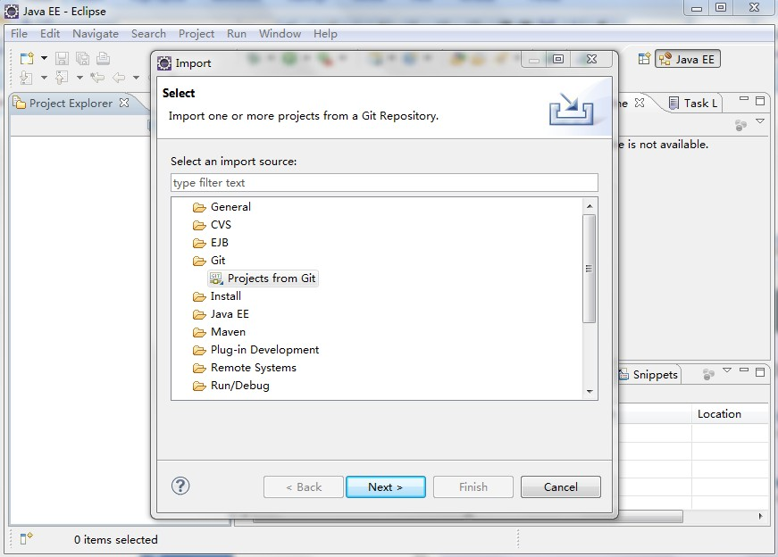

1. Select URI -> Enter: <https://github.com/KingAndrew/The-Social-Choring-Engine.git>

Username/Password

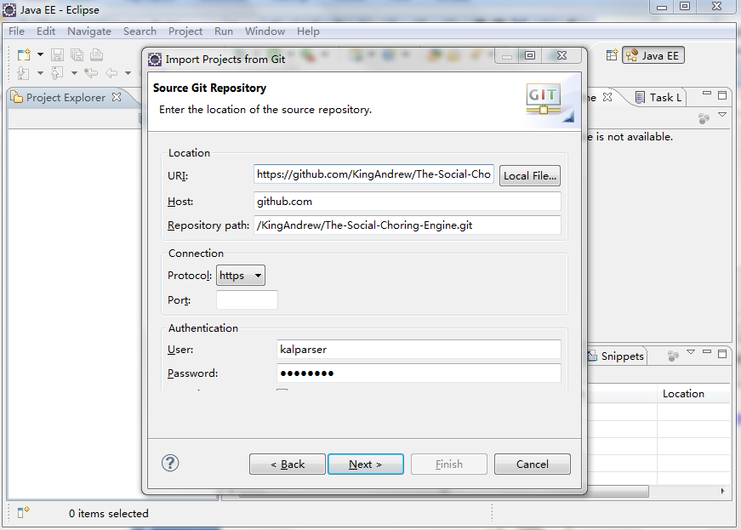

1. Next -> Next, select a Local directory for the project

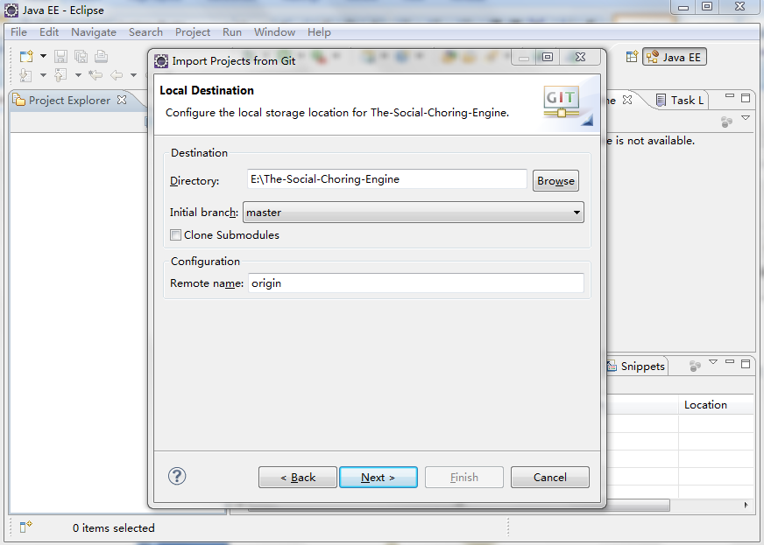

1. Next -> Select “Import Existing project”, -> Next, click Finish

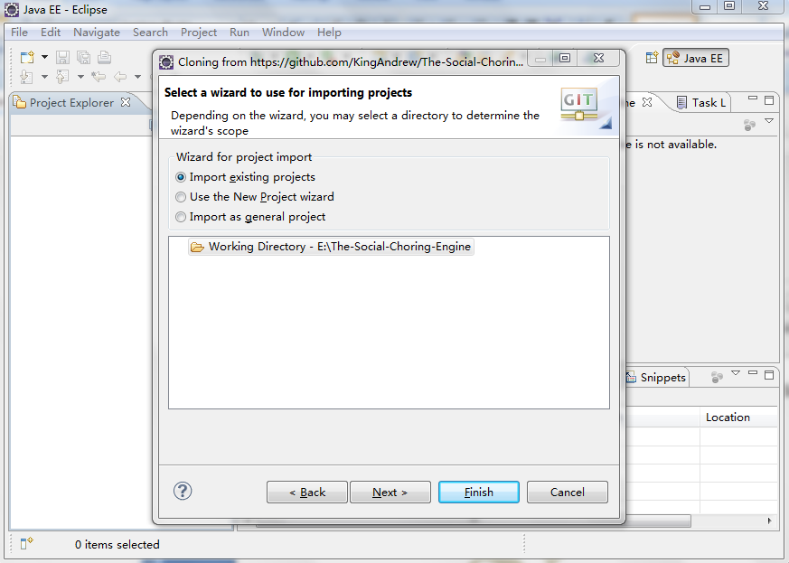

1. Then your Eclipse will be like this, don’t worry about the compile error for now.

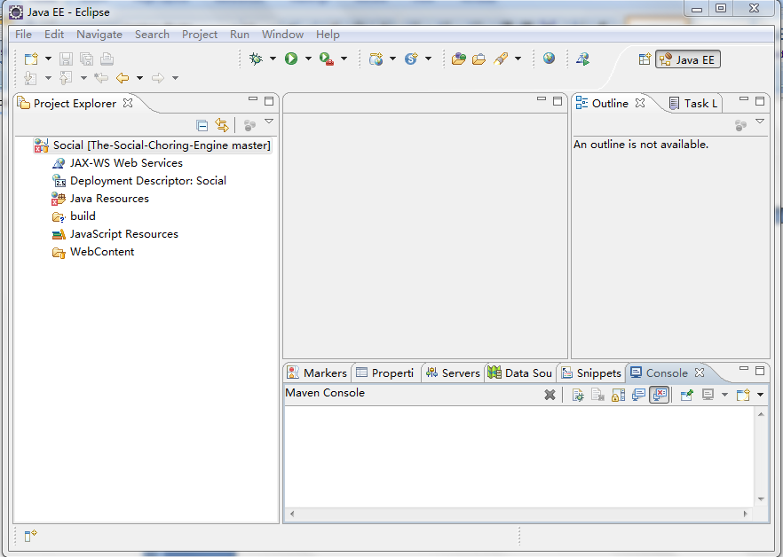

1. Create a Tomcat Server instance in eclipse, select the installed tomcat and click Finish

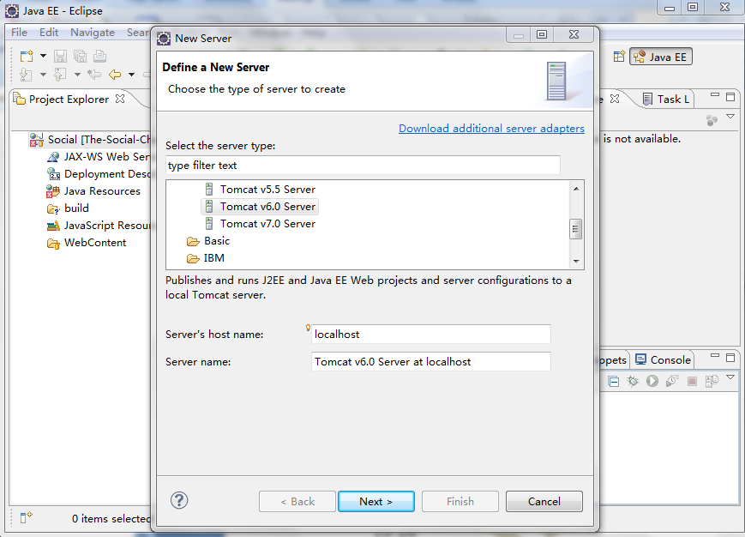

1. Then the compile error is gone automatically

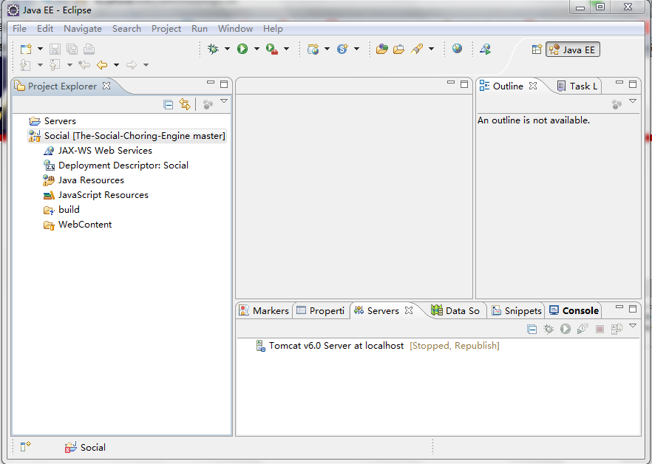

1. Add the Social Chore project to the server, click Finish,

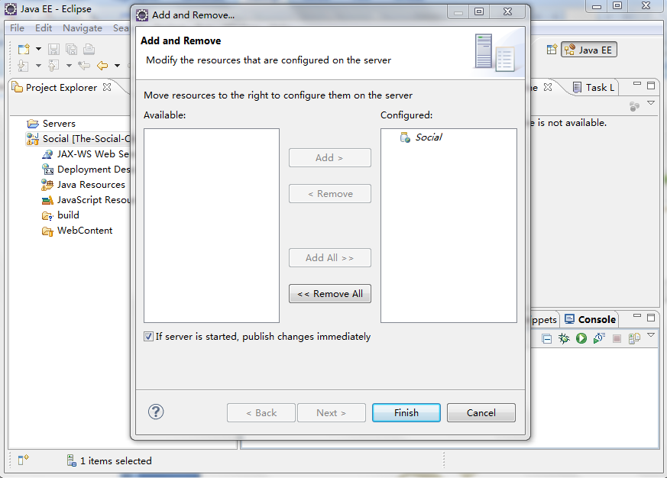

1. Prepare Database. Open your MySQL client

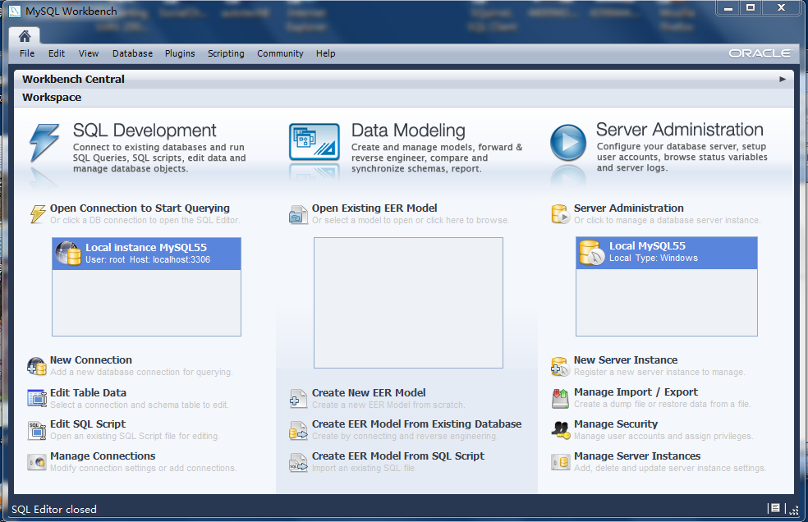

1. Click on “Manage Import/Export” -> Select Data Import/Restore -> Select “Import from Self-Contained File” -> Choose the “dump-2012-XX-XX.sql” file which located in your SocialChoring project /src/sql folder -> Start Import

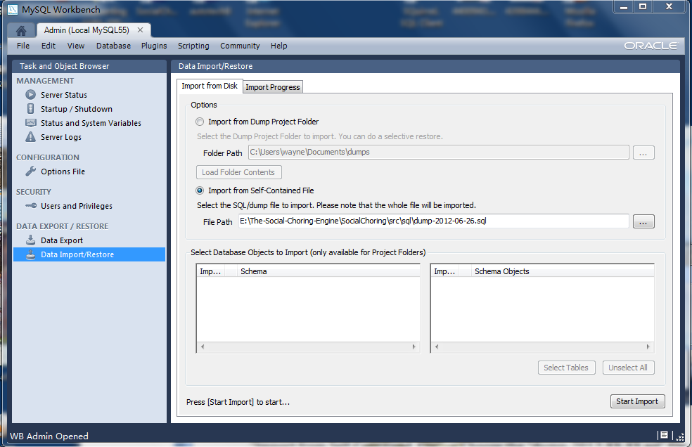

1. After import finished, go back to MySQL Workbench home, and double clicking on Local instance, you will see the new database created:

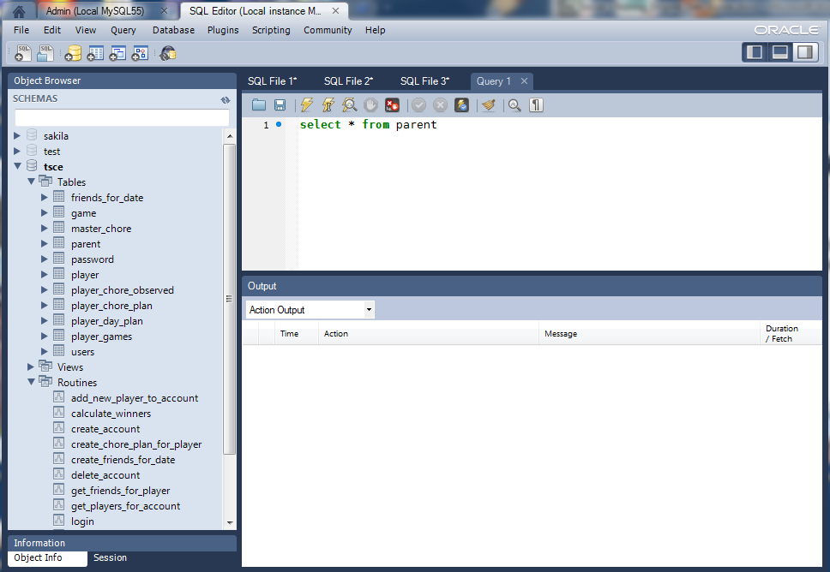

1. Go back to Eclipse, let’s try the unit tests. All the unit tests for Scenario A to Scenario E are in com.socialchoring.test.SocialChoringServiceTest.java file

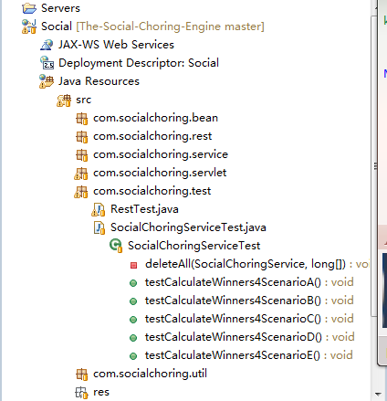

1. Before you run the unit tests, check the db connection properties in your com.socialchoring.service.SocialChoringServiceImpl.java class (Will be changed to use configuration file)

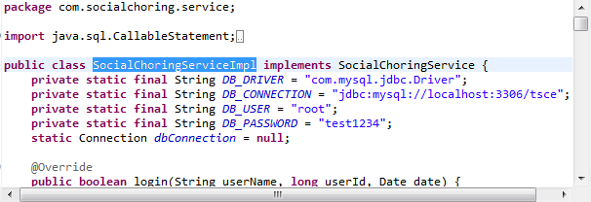

1. Run unit tests one by one or all together.

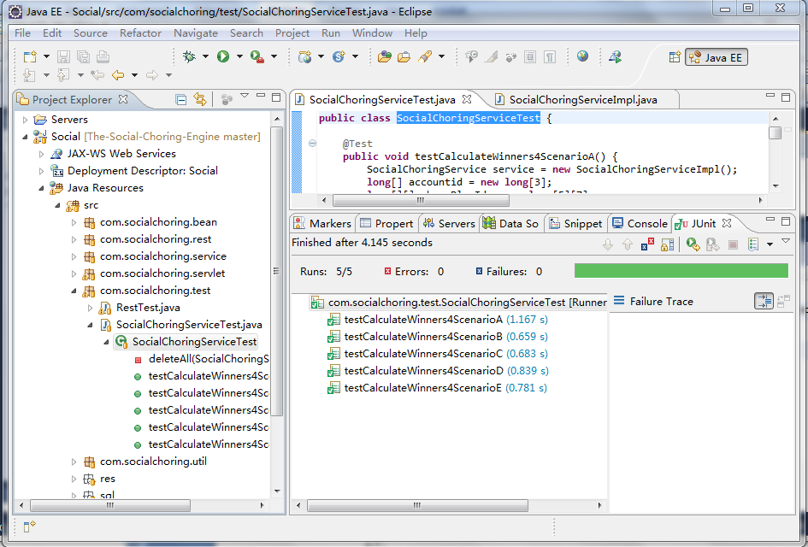

1. Try the authentication from twitter. Start your tomcat server from eclipse.
2. Open browser and try to visit <http://localhost:8080/SocialChore/> , this is the home page we have for now, you will see:

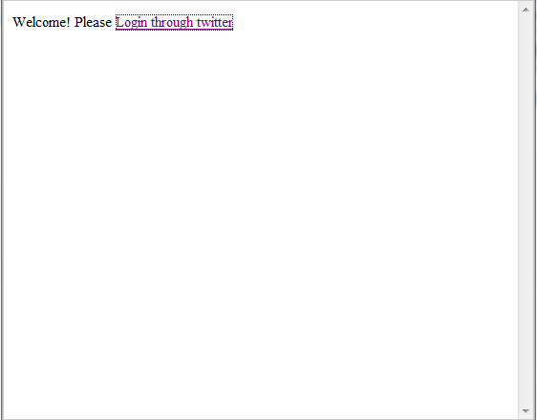

1. Click on the “Login through twitter” link, it will direct you to Twitter and authorize the app, enter your username and password, click on login,

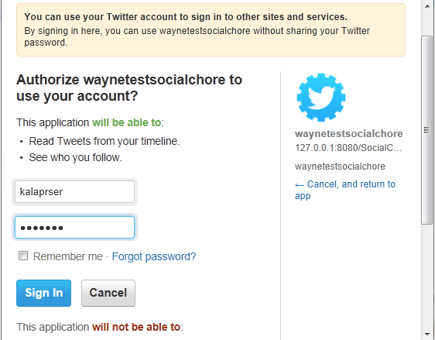

1. Then you will see you have logged in and your username is displayed with @Twitter tail,

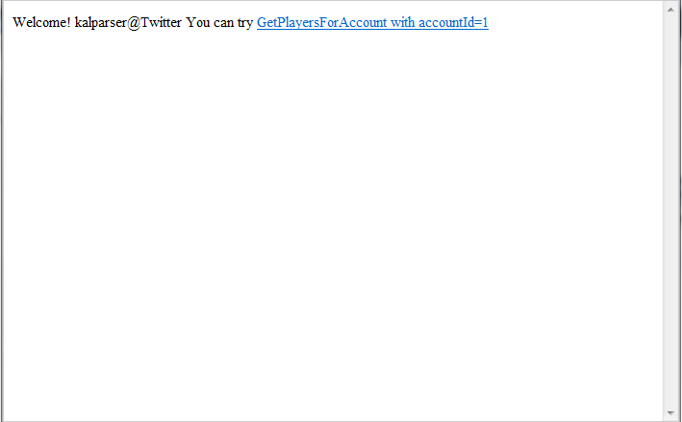

1. Click on the “GetPlayersForAccount with accountId=1” link which will call our GetPlayersForAccount rest api, then the Jason output is displayed:

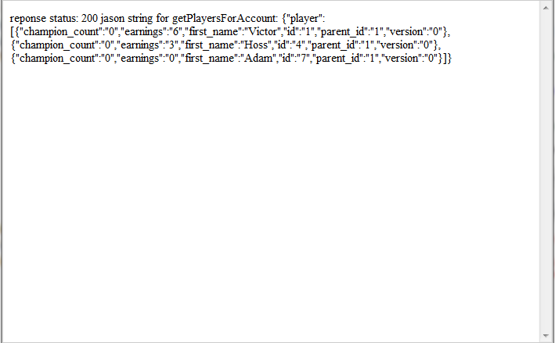

1. In case you haven’t logged in or your “cookie” timed out, it will redirect you to the first welcome page.
2. Load test TODO