User Manual



Table of Contents

**Introduction1**

Connect to server2

Switching rooms3

**Settings4**

Change your name5

Push-To-Talk6

Mute7

# **Introduction**

VoIP is simple Push-To-Talk Java based application for gamers.

* Voice communication with multiple people.
* Cross channel communications.
* Muted channels.
* Portable cross platform server.

1. **Click on the Vobitax.jar file**

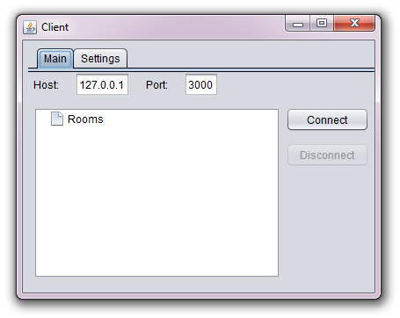

## **Connecting to server**

**1. Insert your host and port and click the “Connect” button.**



You will automatically connect to Room number 1, then you can switch between rooms.

## **Switching rooms**

**1. Double-Click on the desired room to switch room.**

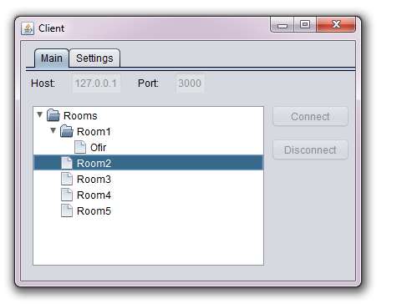

Then your name will appear on Room number 2.

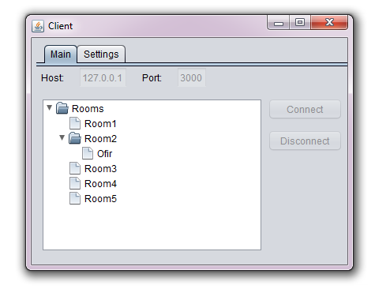

# **Settings**

**1. Click on “Settings” tab .**



Then you will see

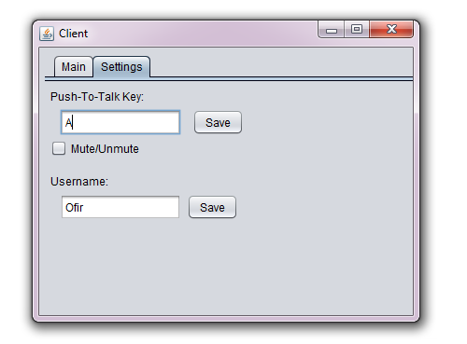

## **Change your name**

**1. To change your name, insert your desired name and click “Save” button next to the input.**



## **Push-To-Talk**

**1. To change your Push-To-Talk button click on the Push-To-Talk input with your desired “Key” and click on the “Save” button next to the input.**



## **Mute**

**1. To mute incoming data , click on the “Mute” checkbox.**

