Server Manual



Table of Contents

**Introduction2**

Starting the server3

# **Introduction**

VoIP is simple Push-To-Talk Java based application for gamers.

* Voice communication with multiple people.
* Cross channel communications.
* Muted channels.
* Portable cross platform server.

1. **Click on the VobitaxServer.jar file**

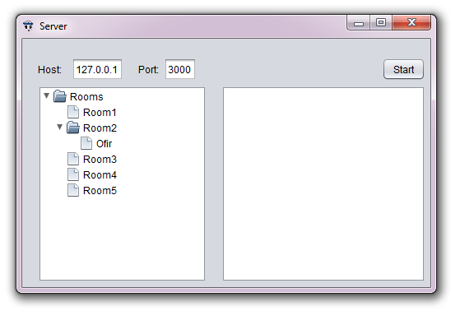

## **Starting the server**

**1. Insert your host (your IP address ) and port ( listening port ) and click the “Start” button.**



Note:

The server is standalone, you can view the clients on the server, this Client Tree broadcasted to everyone.

**BE SURE THE PORT YOU SET IS FORWARDED IN YOUR ROUTER.**