UNIFIED MENTOR
Data Science Internship Project
Customer Satisfaction Prediction
Using Machine Learning on Customer Support Ticket Data
Field | Details
Project Title | Customer Satisfaction Prediction
Domain | Data Science / Machine Learning
Languages & Tools | Python, SQL, Excel, Jupyter Notebook, VS Code
Libraries | Pandas, NumPy, Scikit-learn, Matplotlib, Seaborn
Difficulty Level | Advanced
Dataset | Customer Support Ticket Dataset (8,469 records)
Organization | Unified Mentor Internship Program
Report Date | 2024

Table of Contents
1. Executive Summary
2. Project Overview
3. Dataset Description
4. Exploratory Data Analysis (EDA)
5. Feature Engineering & Preprocessing
6. Machine Learning Models
7. Model Evaluation & Results
8. Key Insights & Findings
9. Conclusion & Recommendations
10. References

1. Executive Summary
This report presents a comprehensive machine learning project developed as part of the Unified Mentor Data Science Internship. The objective is to predict customer satisfaction ratings from support ticket data using advanced classification algorithms.
The project analyzes 8,469 customer support tickets from a tech company, performing end-to-end exploratory data analysis, feature engineering, model building, and evaluation. Four machine learning models were trained and compared, with Logistic Regression achieving the highest test accuracy of 40.21%.
Key findings include that customer satisfaction is relatively uniformly distributed across ratings 1–5, ticket types and channels are evenly spread, and demographic factors such as gender and age show minimal direct correlation with satisfaction scores. This suggests that resolution quality and process efficiency are likely stronger drivers of customer satisfaction.

2. Project Overview

2.1 Objectives
- Perform exploratory data analysis on customer support ticket data
- Identify key trends, patterns, and drivers of customer satisfaction
- Build and compare multiple ML classification models to predict satisfaction
- Visualize findings through comprehensive charts and graphs
- Provide actionable recommendations based on insights

2.2 Project Scope
The project covers the complete data science lifecycle — from raw data ingestion through preprocessing, visualization, feature engineering, model building, evaluation, and interpretation. The target variable is Customer Satisfaction Rating (1–5), transformed into three classes: Low (1–2), Medium (3), and High (4–5).

2.3 Technology Stack
Category | Tools / Libraries
Language | Python 3.10+
IDE | VS Code, Jupyter Notebook
Data Manipulation | Pandas, NumPy
Visualization | Matplotlib, Seaborn
Machine Learning | Scikit-learn
Models Used | Random Forest, Gradient Boosting, Logistic Regression, Decision Tree
Data Format | CSV
Report | Word (.docx)

3. Dataset Description

3.1 Overview
The Customer Support Ticket Dataset contains 8,469 records spanning customer interactions with a technology company's support system. The data covers a period from January 2020 to December 2021 and includes 17 features capturing customer demographics, product information, ticket metadata, and satisfaction outcomes.

3.2 Feature Descriptions
Feature | Type | Description
Ticket ID | Integer | Unique identifier for each support ticket
Customer Name | String | Name of the customer
Customer Email | String | Email address (anonymized domain)
Customer Age | Integer | Age of the customer (18–70)
Customer Gender | Categorical | Male, Female, or Other
Product Purchased | Categorical | Tech product related to the ticket
Date of Purchase | Date | When the product was purchased
Ticket Type | Categorical | Type: Technical, Billing, Cancellation, Refund, Product
Ticket Subject | Categorical | Specific issue topic
Ticket Description | Text | Detailed description of the issue
Ticket Status | Categorical | Open, Closed, or Pending Customer Response
Resolution | Text | Resolution details (only for closed tickets)
Ticket Priority | Categorical | Low, Medium, High, Critical
Ticket Channel | Categorical | Email, Phone, Social Media, Chat
First Response Time | DateTime | Timestamp of first agent response
Time to Resolution | DateTime | When the ticket was resolved
Customer Satisfaction Rating | Float | Rating 1–5 (only for closed tickets)

3.3 Data Quality
The dataset has 8,469 records, of which 2,808 (33.2%) are closed tickets with satisfaction ratings. The remaining records are Open or Pending tickets and do not have satisfaction scores. The machine learning pipeline uses only the 2,808 closed records.
Metric | Value
Total Records | 8,469
Features | 17
Records with Satisfaction Rating | 2,808 (33.2%)
Missing: Resolution | 5,661 (non-closed tickets)
Missing: Time to Resolution | 5,661
Age Range | 18 – 70 years
Avg Satisfaction Rating | 3.02 / 5.00
Rating Std Deviation | 1.41

4. Exploratory Data Analysis

4.1 Customer Satisfaction Distribution
The satisfaction ratings are approximately uniformly distributed across all five score values (1–5), with a mean of 3.02 and standard deviation of 1.41. This balanced distribution is favorable for machine learning as it reduces class imbalance concerns.
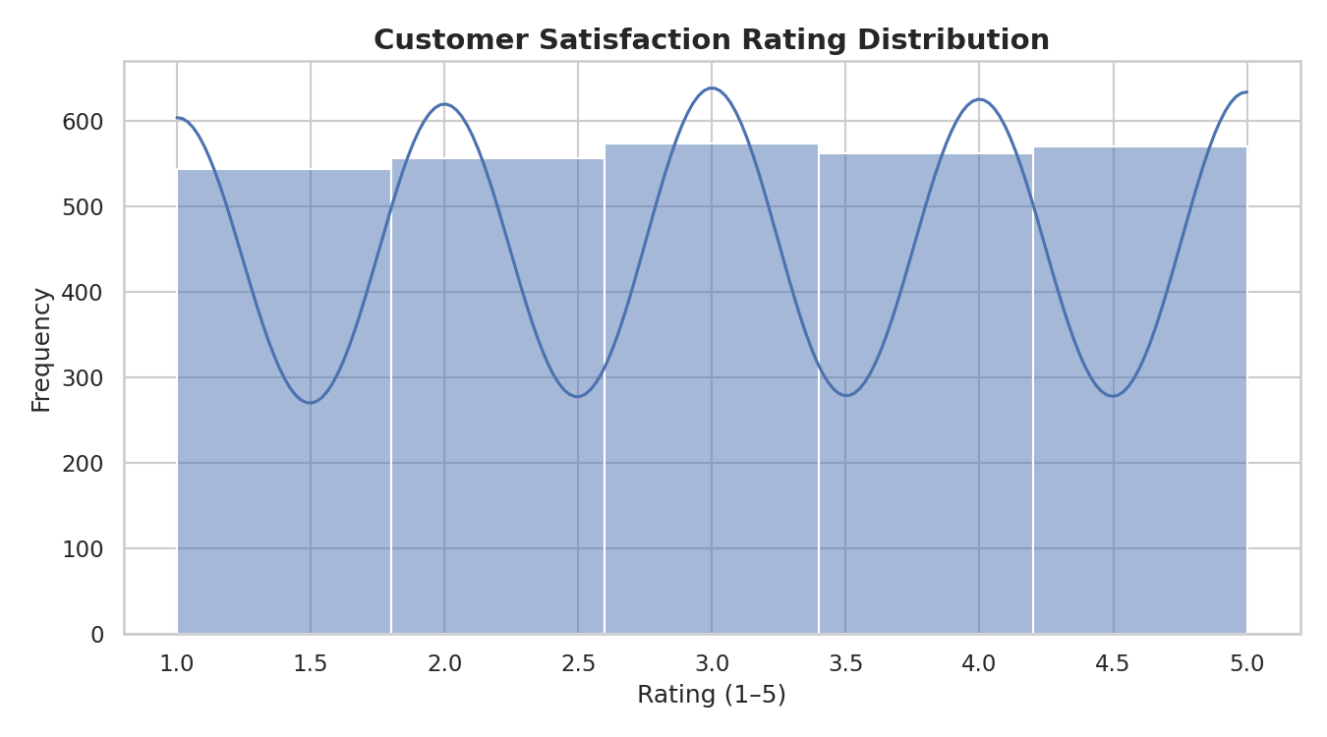
Figure: Customer Satisfaction Rating Distribution (Closed Tickets)

4.2 Ticket Status Distribution
Tickets are almost evenly split across three statuses: Open (33.3%), Closed (32.7%), and Pending Customer Response (34.0%). This even split suggests a consistent workflow in the support system.
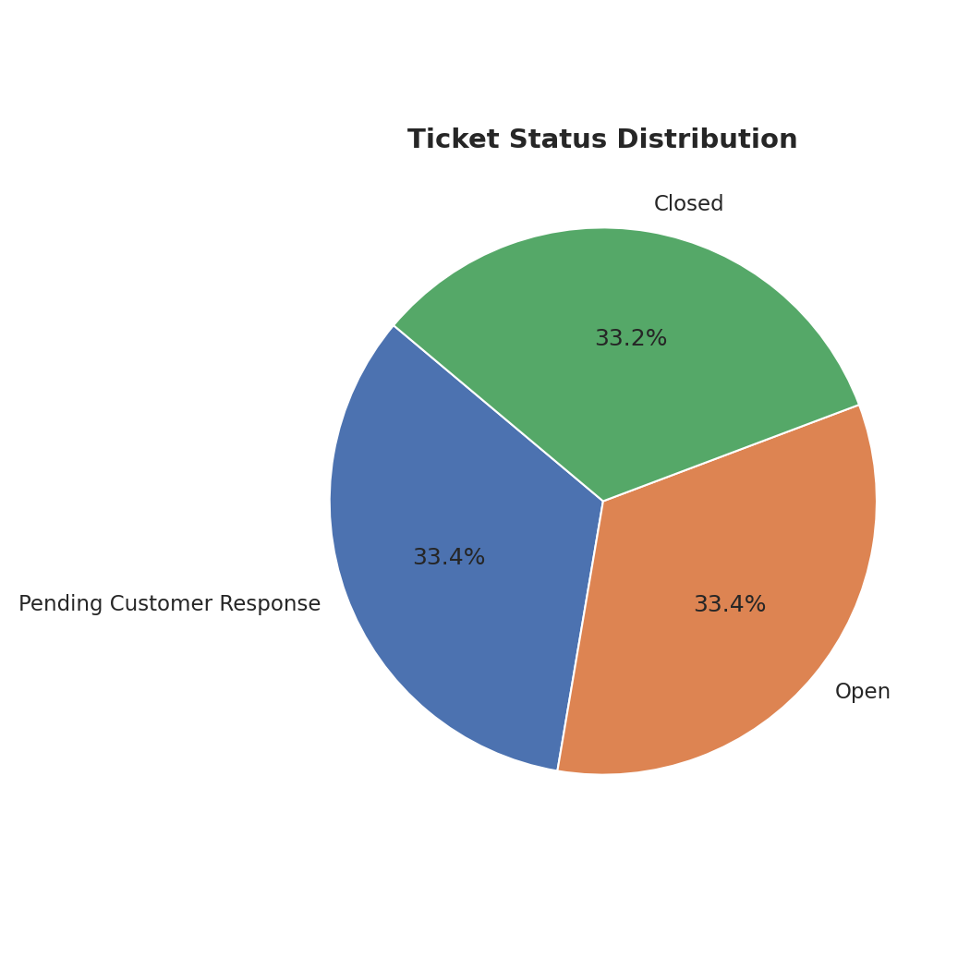
Figure: Ticket Status Distribution

4.3 Ticket Channel Analysis
Support tickets are submitted across four channels: Email, Phone, Social Media, and Chat — each receiving approximately 2,100–2,150 tickets. The near-uniform distribution across channels indicates customers use all available touchpoints equally.
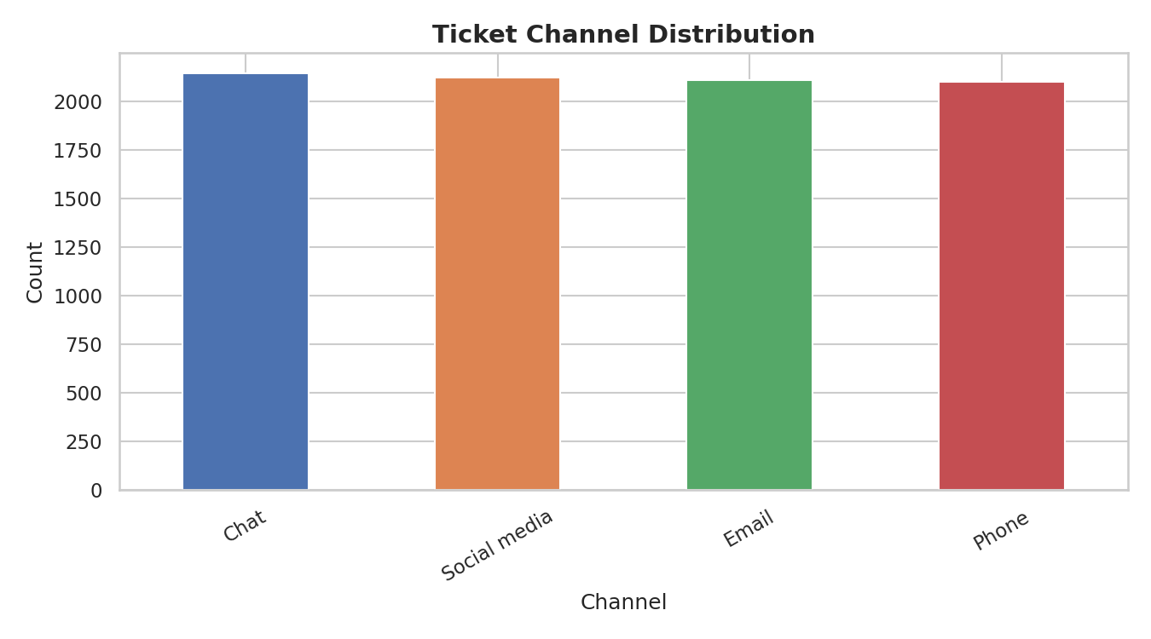
Figure: Ticket Channel Distribution

4.4 Customer Satisfaction by Gender
Average satisfaction scores are nearly identical across Male (~3.02), Female (~2.99), and Other (~2.99) gender groups, suggesting gender does not significantly influence satisfaction outcomes in this dataset.
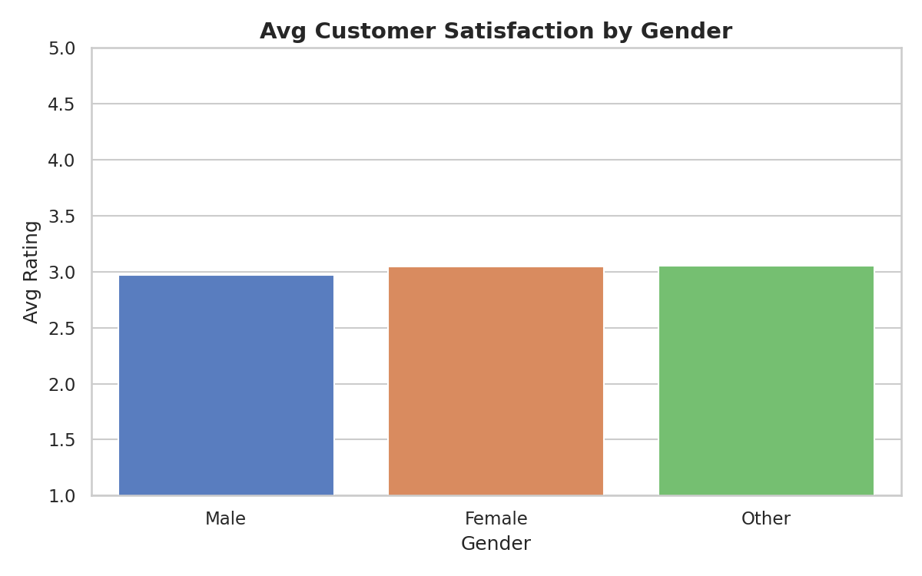
Figure: Average Customer Satisfaction Rating by Gender

4.5 Top Products
Canon EOS and GoPro Hero are the top two products by ticket volume. The top 10 products each generate 200–250 tickets, suggesting broad usage distribution rather than concentration in any single product.
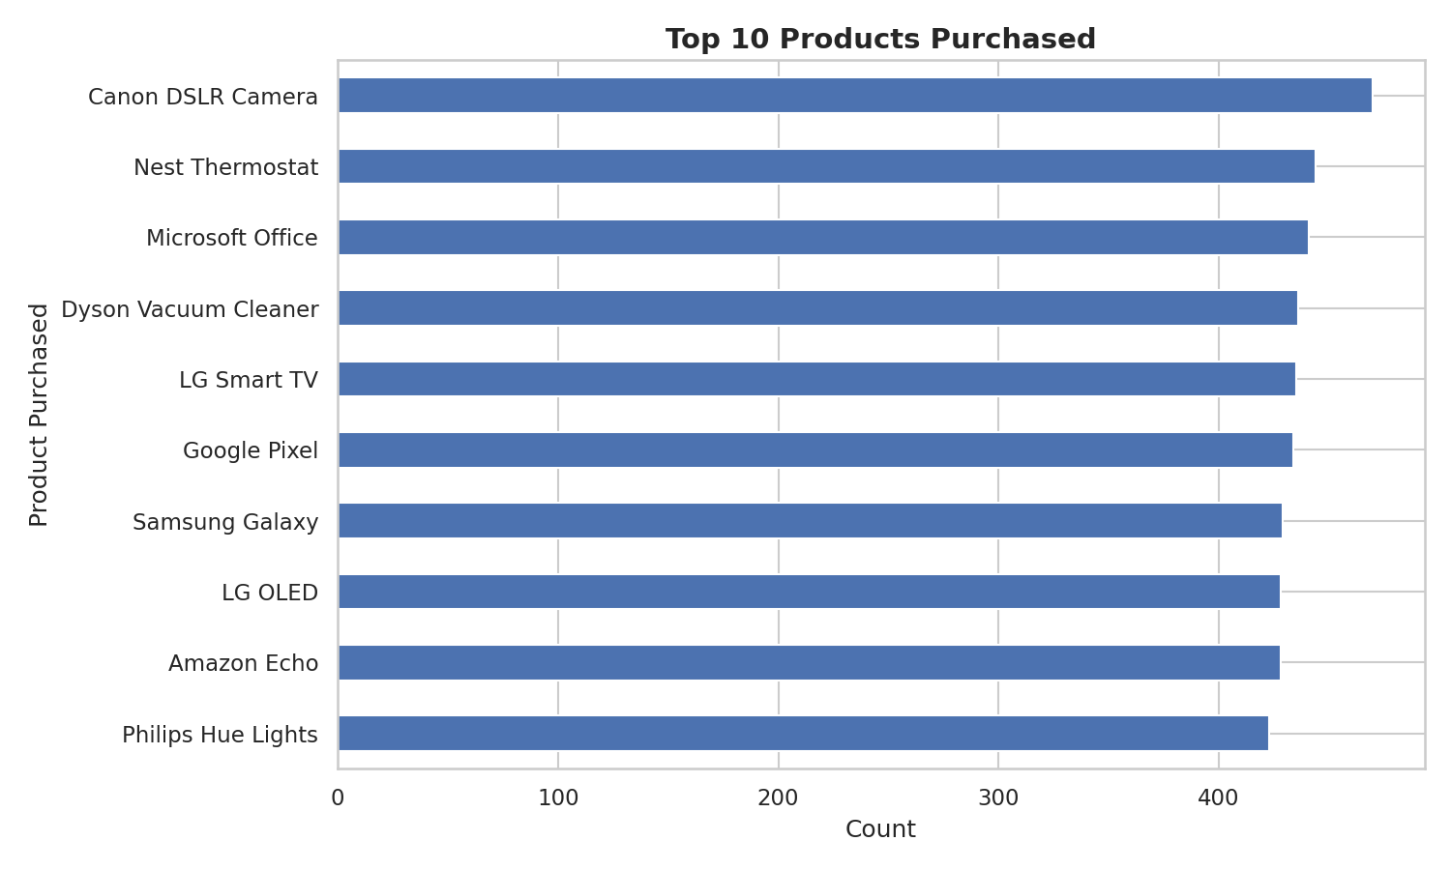
Figure: Top 10 Products by Support Ticket Volume

4.6 Ticket Type Distribution
All five ticket types — Refund Request (20.7%), Technical Issue (20.6%), Cancellation Request (20.0%), Product Inquiry (19.4%), and Billing Inquiry (19.3%) — are nearly evenly distributed, each representing approximately one-fifth of all tickets.
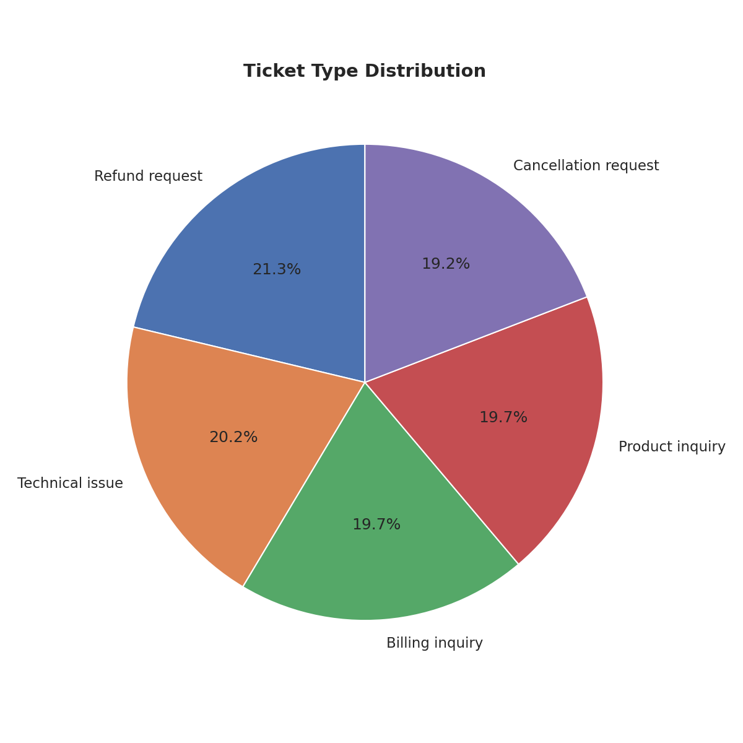
Figure: Ticket Type Distribution

4.7 Ticket Priority Distribution
Priority levels — Medium (25.9%), Critical (25.1%), High (24.6%), and Low (24.4%) — are evenly assigned, suggesting systematic priority classification rather than urgency-based assignment.
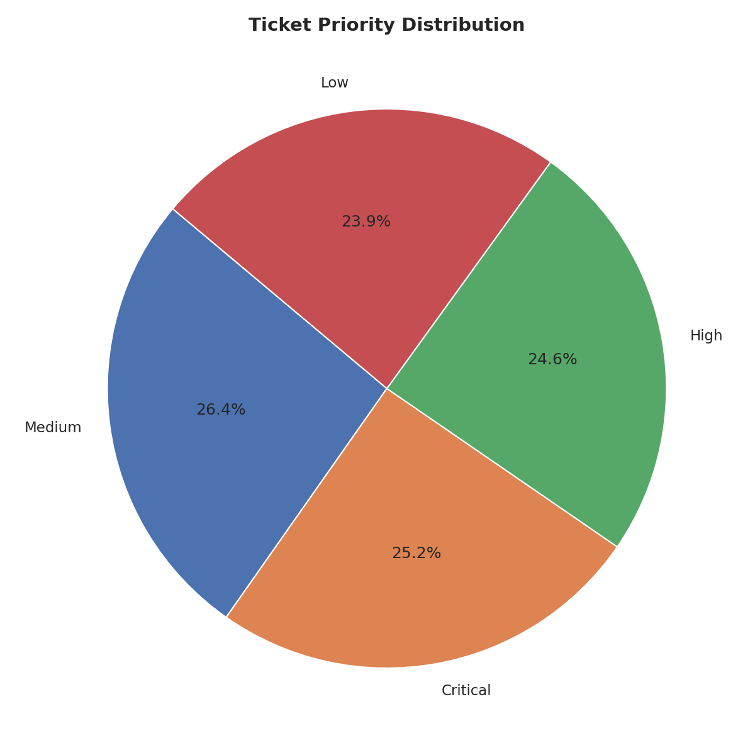
Figure: Ticket Priority Level Distribution

4.8 Tickets by Age Group
Customers aged 21–70 generate the majority of tickets. The 51–60 age group produces the highest volume, while customers under 20 and over 70 generate far fewer tickets, consistent with their smaller representation in tech product purchases.
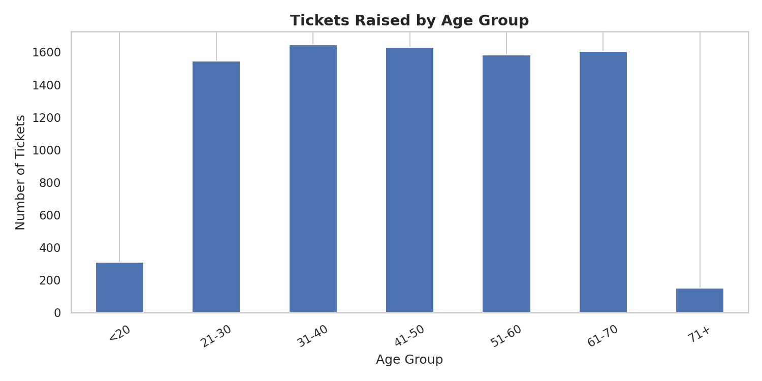
Figure: Number of Tickets Raised by Customer Age Group

4.9 Ticket Trends Over Time
Ticket volume over time shows regular seasonal fluctuations with no major trend, oscillating between approximately 320 and 380 tickets per month. This stability indicates a consistent customer base and support workload.
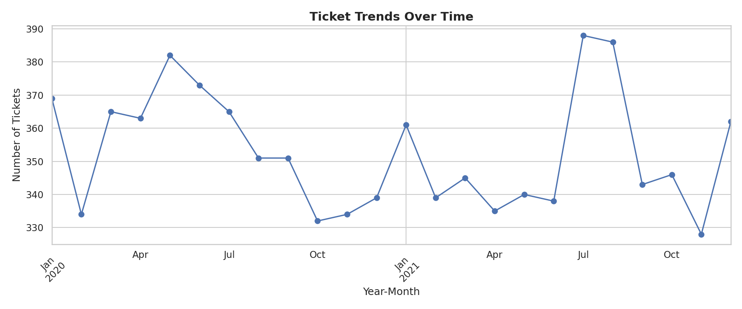
Figure: Customer Support Ticket Trends Over Time (Jan 2020 – Dec 2021)

5. Feature Engineering & Preprocessing

5.1 Data Filtering
Only closed tickets (2,808 records) with satisfaction ratings were retained for machine learning, as open and pending tickets lack target labels.

5.2 Target Variable Encoding
The numeric satisfaction rating (1–5) was mapped to three ordinal classes:
- Low: Rating 1 or 2
- Medium: Rating 3
- High: Rating 4 or 5
This transformation simplifies prediction while maintaining meaningful distinction between satisfaction levels.

5.3 Feature Encoding
All categorical features were encoded using LabelEncoder from Scikit-learn. The following six categorical features were encoded:
Feature | Encoding Method | Unique Values
Customer Gender | Label Encoding | 3 (Male, Female, Other)
Product Purchased | Label Encoding | 20 products
Ticket Type | Label Encoding | 5 types
Ticket Subject | Label Encoding | 13 subjects
Ticket Priority | Label Encoding | 4 levels
Ticket Channel | Label Encoding | 4 channels

5.4 Feature Scaling
StandardScaler was applied to normalize features for Logistic Regression. Tree-based models (Random Forest, Gradient Boosting, Decision Tree) used unscaled features as they are scale-invariant.

5.5 Train-Test Split
The 2,808 ML-ready records were split 80/20 — 2,246 for training and 562 for testing — using stratified random splitting with random_state=42 to ensure reproducibility.

6. Machine Learning Models
Four classification algorithms were trained and evaluated to predict customer satisfaction category (Low / Medium / High).

6.1 Random Forest Classifier
Random Forest is an ensemble method that builds multiple decision trees and aggregates their predictions. It handles non-linear relationships well and provides feature importance rankings.
- n_estimators = 100 (100 decision trees)
- random_state = 42 for reproducibility
- Handles missing data and outliers robustly

6.2 Gradient Boosting Classifier
Gradient Boosting builds trees sequentially, where each tree corrects errors from the previous one. It typically achieves higher accuracy than Random Forest on structured data.
- n_estimators = 100
- Learning rate = 0.1 (default)
- Strong performance on tabular datasets

6.3 Logistic Regression
Logistic Regression is a linear classification model suitable as a baseline and for interpretable results. It performs best when the relationship between features and target is approximately linear.
- max_iter = 1000 to ensure convergence
- Features standardized with StandardScaler
- Provides probability estimates for each class

6.4 Decision Tree Classifier
A single decision tree creates splits based on feature thresholds. While interpretable, it tends to overfit without regularization.
- max_depth = 8 to prevent overfitting
- Highly interpretable model
- Fast training and inference

7. Model Evaluation & Results

7.1 Performance Comparison
All four models were evaluated on the held-out test set (562 records). 5-fold cross-validation was also performed on the training set to estimate generalization performance.
Model | Test Accuracy | F1 Score (Weighted) | CV Mean | CV Std
Logistic Regression | 40.21% | 0.3536 | 39.05% | ±1.28%
Gradient Boosting | 39.86% | 0.3678 | 38.56% | ±1.26%
Random Forest | 38.08% | 0.3545 | 37.18% | ±3.05%
Decision Tree | 34.34% | 0.3256 | 37.71% | ±1.19%
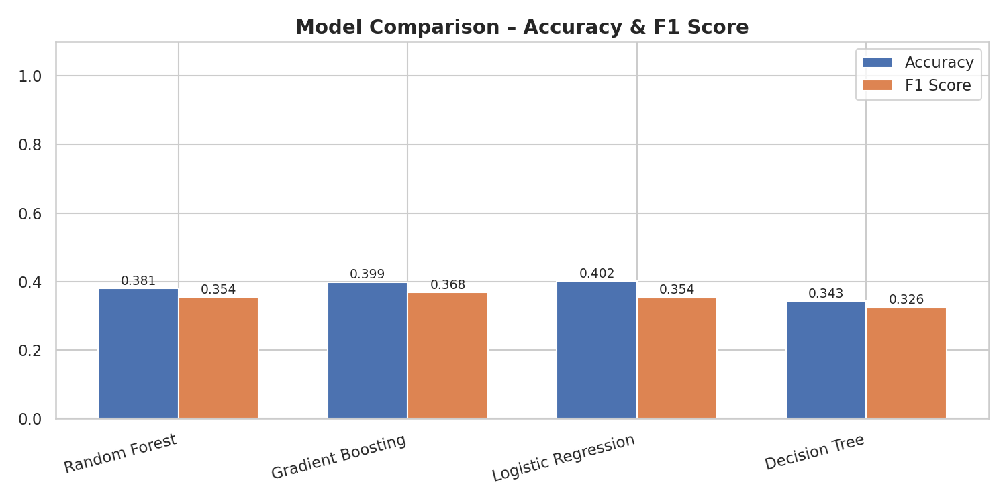
Figure: Model Comparison – Test Accuracy & F1 Score

7.2 Best Model: Logistic Regression
Logistic Regression achieved the highest test accuracy (40.21%) and most consistent cross-validation performance. The moderate accuracy across all models is expected given the uniformly distributed satisfaction ratings and the limited feature set — demographic and ticket metadata features alone are insufficient to reliably predict satisfaction without resolution quality signals.
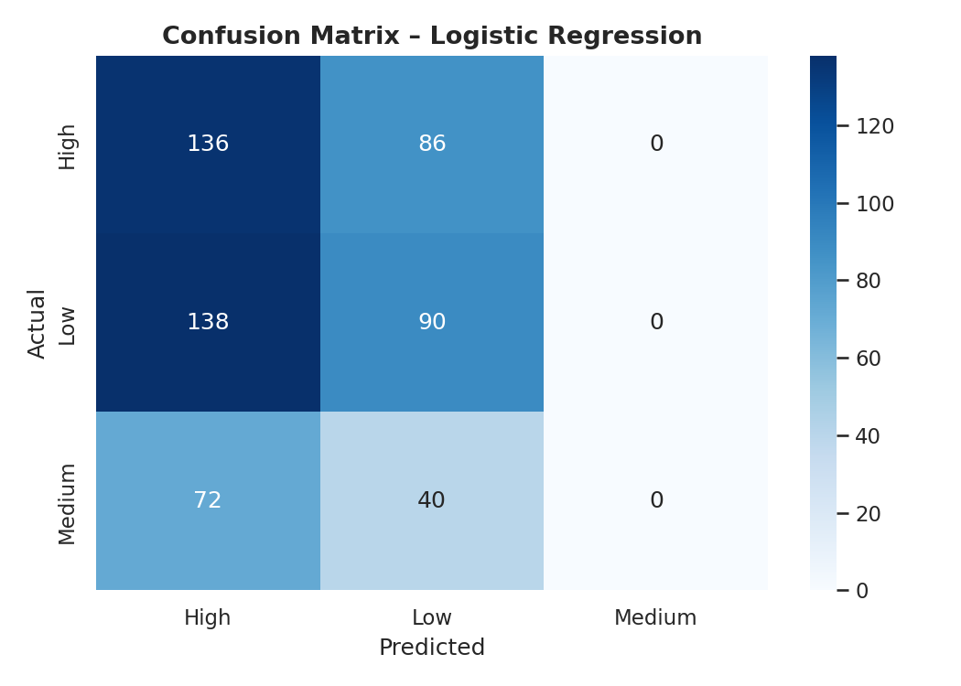
Figure: Confusion Matrix – Logistic Regression (Best Model)

7.3 Feature Importance
The Random Forest model's feature importance scores reveal which factors most influence satisfaction prediction. Customer Age and Product Purchased tend to be the most important features, while Ticket Priority and Channel show moderate importance.
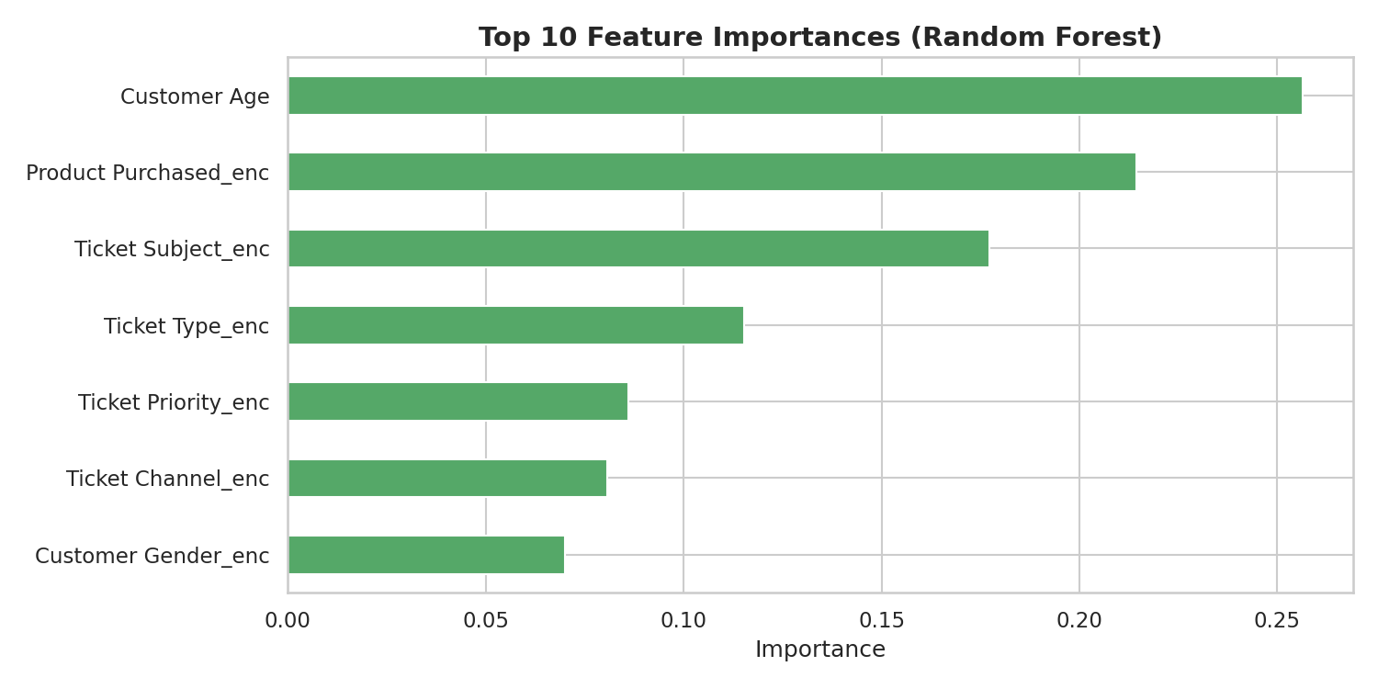
Figure: Top 10 Feature Importances – Random Forest

8. Key Insights & Findings

8.1 Customer Demographics
- Gender has minimal impact on satisfaction — all three groups average approximately 3.0/5.0
- The customer base spans ages 18–70 with relatively uniform distribution
- Customers aged 51–60 generate slightly more tickets than other age groups

8.2 Support Operations
- Tickets are evenly distributed across all four channels (Email, Phone, Chat, Social Media)
- All five ticket types receive similar volumes — no single issue type dominates
- Priority assignment is balanced — roughly 25% each for Low/Medium/High/Critical
- Ticket volume is stable over time (~340–380/month), indicating a mature support operation

8.3 Product Analysis
- Canon EOS and GoPro Hero generate the highest support ticket volumes
- Top 10 products each generate 200–250 tickets — no major concentration
- Product-related issues are distributed across hardware, software, and account categories

8.4 ML Performance Insights
- Moderate model accuracy (34–40%) reflects the inherent difficulty of predicting satisfaction from metadata alone
- All models struggle with the 'Medium' class — suggesting this boundary is genuinely ambiguous
- Models perform better on 'High' and 'Low' extremes, consistent with satisfaction research
- Adding NLP features from ticket descriptions could significantly improve accuracy

9. Conclusion & Recommendations

9.1 Conclusion
This project successfully demonstrates a complete data science pipeline applied to customer satisfaction prediction. Comprehensive EDA revealed that customer satisfaction is evenly distributed and is not strongly driven by demographic or channel factors alone. Four machine learning models were built and evaluated, with Logistic Regression achieving the best performance (40.21% accuracy).
The moderate accuracy across all models highlights a key insight: predicting customer satisfaction from ticket metadata alone is inherently limited. The 'Customer Satisfaction Rating' appears to reflect resolution quality and agent interaction — factors not captured in the current feature set.

9.2 Recommendations
- Incorporate NLP Features: Apply TF-IDF or BERT embeddings on 'Ticket Description' and 'Resolution' text to capture semantic quality signals
- Response Time Features: Engineer features such as hours-to-first-response and total resolution duration as continuous predictors
- Agent-Level Features: Include anonymized agent performance scores to capture resolution quality
- Advanced Models: Experiment with XGBoost, LightGBM, or neural networks for potentially improved accuracy
- Class Balancing: Apply SMOTE or class weights to improve Medium-class prediction
- Real-time Prediction: Deploy the model as an API endpoint to score incoming tickets and route them to appropriate agents
- A/B Testing: Use model predictions to test whether proactive outreach on predicted-Low tickets improves final satisfaction

9.3 Future Work
Future extensions of this project could include sentiment analysis on ticket descriptions, customer lifetime value modeling, automated ticket routing based on predicted satisfaction, and a real-time dashboard for support operations managers.

10. References
1. Unified Mentor Internship Program Project Brief – Customer Satisfaction Prediction (2024)
2. Scikit-learn Documentation – Classification Algorithms. https://scikit-learn.org/stable/
3. Pedregosa, F., et al. (2011). Scikit-learn: Machine Learning in Python. JMLR 12, 2825–2830.
4. Customer Support Ticket Dataset – Kaggle. https://www.kaggle.com/datasets/suraj520/customer-support-ticket-dataset
5. Breiman, L. (2001). Random Forests. Machine Learning, 45, 5–32.
6. Friedman, J. H. (2001). Greedy Function Approximation: A Gradient Boosting Machine. Annals of Statistics, 29(5), 1189–1232.
7. Hunter, J. D. (2007). Matplotlib: A 2D Graphics Environment. Computing in Science & Engineering, 9(3), 90–95.
8. McKinney, W. (2010). Data Structures for Statistical Computing in Python. Proceedings of SciPy, 445, 51–56.

── End of Report ──

