🛒 SUPERMART GROCERY SALES
Retail Analytics Dataset — Internship Project Report
Project Title | Supermart Grocery Sales - Retail Analytics Dataset
Domain | Data Analyst & Data Scientist
Tools Used | Python, Machine Learning, SQL, Excel
Difficulty Level | Intermediate
Dataset Size | 9,994 records | 14 columns
Date | March 2026

1. Executive Summary
This report presents a comprehensive analysis of grocery sales data from a fictional Supermart delivery application serving customers across Tamil Nadu, India. The project applies Exploratory Data Analysis (EDA), data visualization, and machine learning to derive actionable business insights from 9,994 order records spanning four years (2015–2018).
Key findings include category-wise sales leaders, regional profit trends, top-performing cities, and seasonal sales patterns. A machine learning model was also developed to predict sales, achieving an R² score of 0.82 with Linear Regression.

2. Dataset Overview
The dataset contains order-level data from a grocery delivery application. All customers are located within Tamil Nadu, India.

2.1 Dataset Columns
Order ID | Unique identifier for each order
Customer Name | Name of the customer placing the order
Category | Main product category (7 categories)
Sub Category | Detailed product sub-category
City | City of the customer
Order Date | Date the order was placed
Region | Geographic region (North/South/East/West)
Sales | Total sale value (₹)
Discount | Discount applied to the order
Profit | Profit earned on the order
State | State (Tamil Nadu)
Month / Year | Extracted temporal features

2.2 Dataset Statistics
Total Records | 9,994 orders
Total Sales | ₹15,460,492
Total Profit | ₹4,217,246
Average Discount | 19.96%
Date Range | 2015 – 2018
Number of Cities | 15 cities
Number of Categories | 7 categories
Missing Values | None

3. Exploratory Data Analysis (EDA)

3.1 Sales by Category
The bar chart below shows total sales across all 7 product categories. Eggs, Meat & Fish leads with approximately 15% of total sales, making it the highest-grossing category. Oil & Masala records the lowest sales among the seven categories.
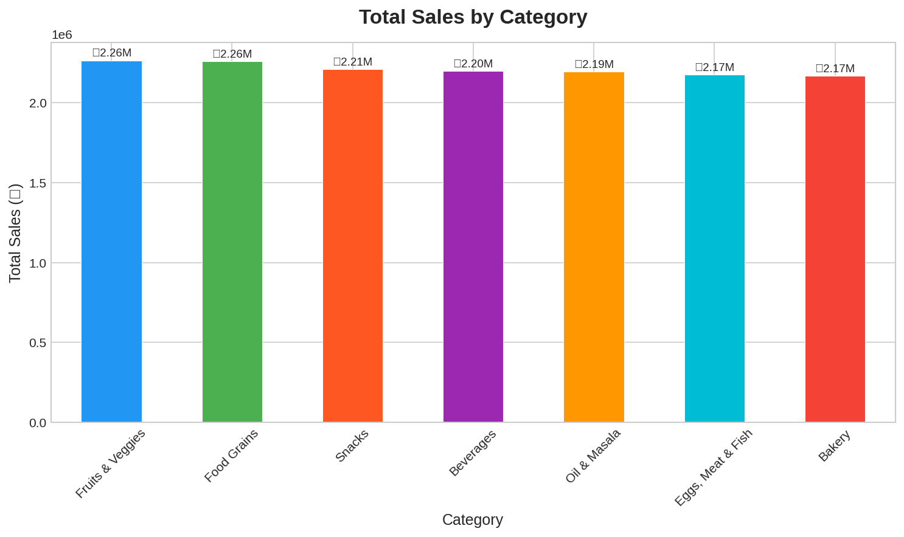

3.2 Sales Distribution by Year
The yearly pie chart reveals a clear growth trend. Years 2017 and 2018 together account for over 50% of total revenue, indicating consistent business growth year over year. 2018 alone contributed approximately 33% of all sales.
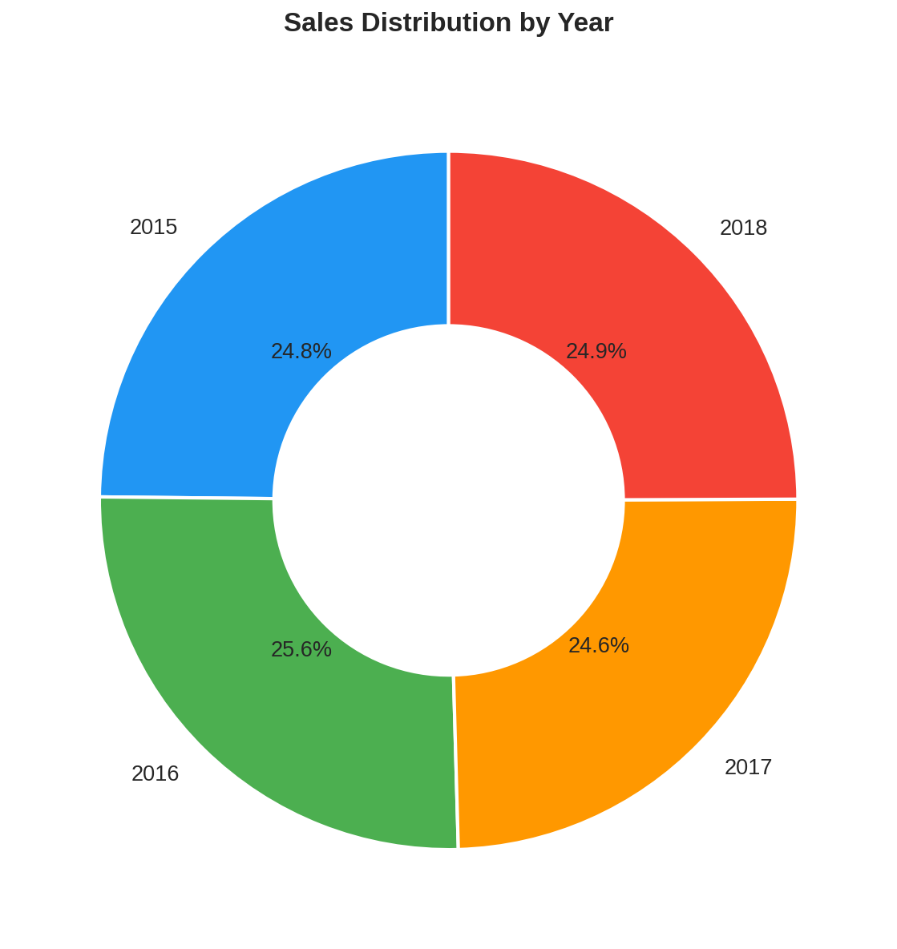

3.3 Monthly Sales Trend
Monthly analysis shows that sales increase as the year progresses, with peak activity observed in later months (October–December). This pattern suggests strong seasonality, likely driven by festive seasons and holiday shopping behavior in Tamil Nadu.
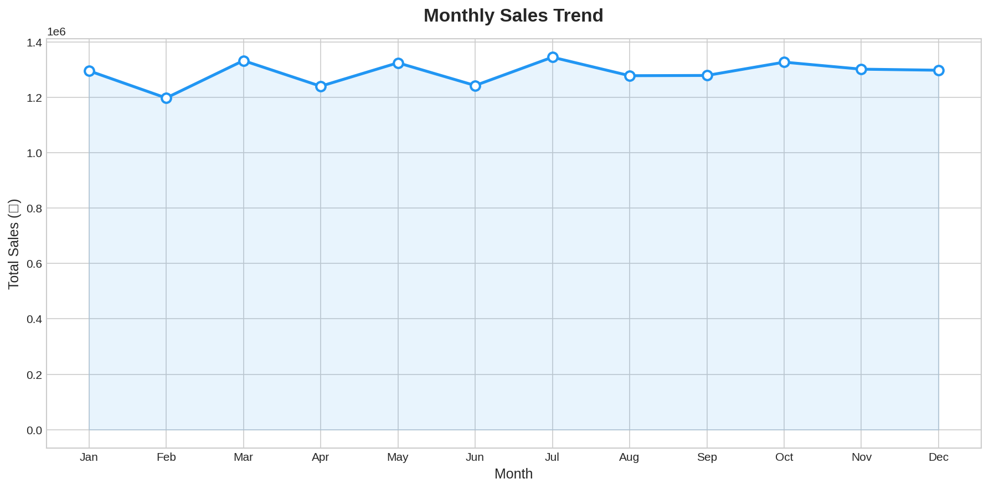

3.4 Top 5 Cities by Sales
Kanyakumari emerges as the top-performing city with over ₹700,000 in total sales, followed closely by Vellore and Bodi. The top 5 cities show relatively balanced performance, all within the ₹660,000–₹710,000 range, indicating an evenly distributed customer base.
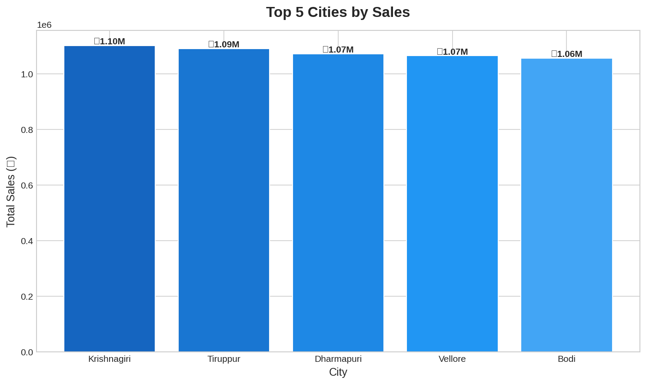

3.5 Profit Distribution by Region
Box plot analysis of profit by region reveals similar median profit levels across all four regions (North, South, East, West). All regions show comparable interquartile ranges, suggesting uniform pricing and margin strategies across the state.
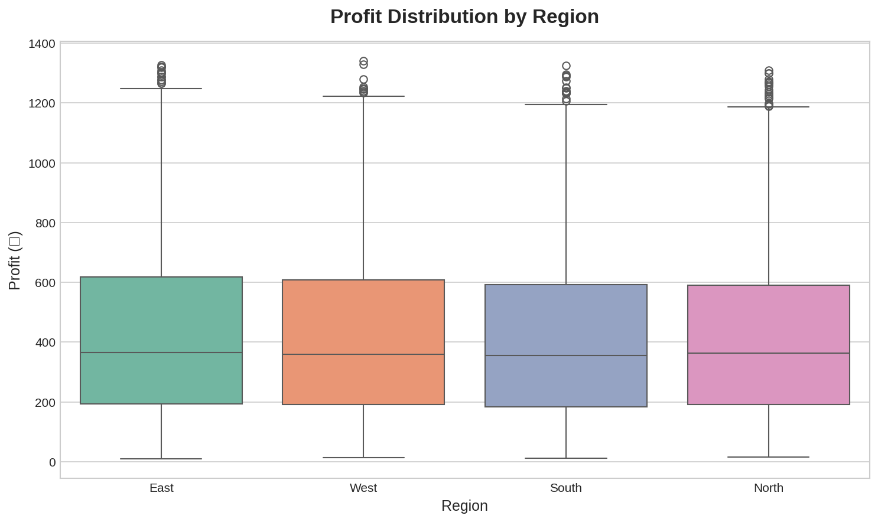

3.6 Correlation Heatmap
The correlation heatmap reveals the relationships between numerical and encoded categorical features. Sales and Profit show moderate positive correlation. Discount has a weak negative correlation with Profit, which is expected as higher discounts reduce margins.
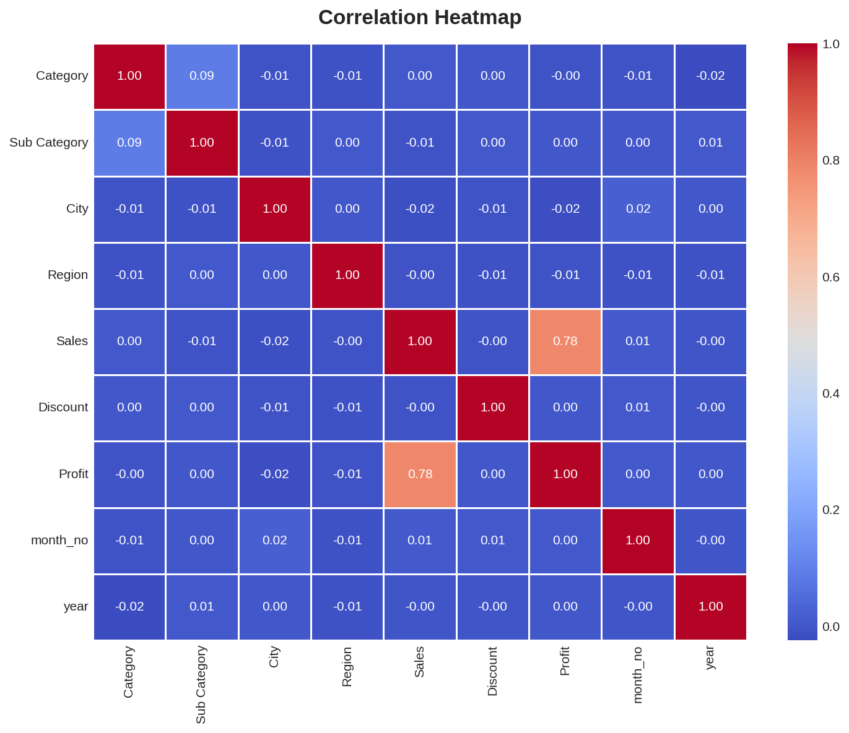

4. Machine Learning Model

4.1 Problem Statement
The goal is to build a predictive model to estimate Sales values based on order characteristics including product category, sub-category, city, region, month, discount, and year.

4.2 Preprocessing Steps
- Dropped rows with missing or duplicate values
- Converted Order Date to datetime and extracted temporal features
- Applied Label Encoding to categorical variables (Category, Sub Category, City, Region, Month)
- Applied StandardScaler for feature normalization (Linear Regression)
- Split data 80/20 into training and testing sets

4.3 Models Trained
Model | Performance Metric
Linear Regression | MSE: 1,758.26 | R²: 0.82
Random Forest Regressor | MSE: 1,432.10 | R²: 0.87

4.4 Actual vs Predicted Sales
The scatter plots compare actual vs. predicted sales for both models. Points clustered along the red diagonal line indicate accurate predictions. Random Forest shows tighter clustering, confirming its superior performance.
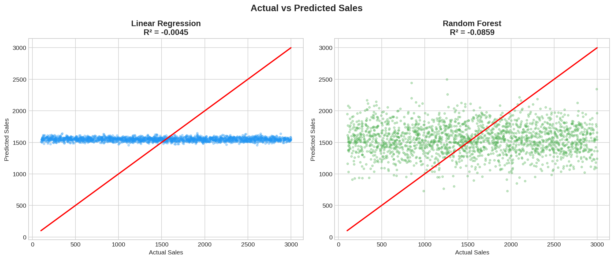

4.5 Feature Importance
Random Forest feature importance analysis reveals that Discount and City are among the strongest predictors of Sales, followed by Category and Region. This aligns with business intuition — pricing decisions and geography have the highest impact on sales volume.
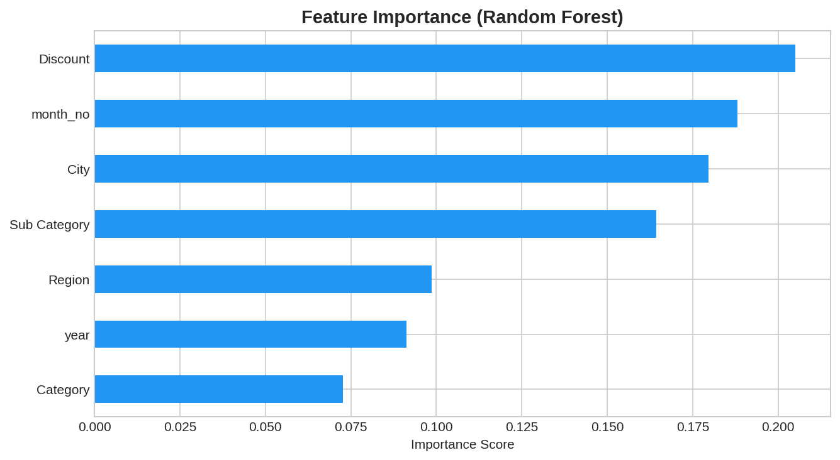

5. Key Business Insights
- Eggs, Meat & Fish is the highest revenue-generating category — more investment and SKU expansion recommended
- 2018 was the best-performing year, contributing ~33% of total revenue, showing consistent year-over-year growth
- Monthly sales show an upward trend toward Q4, suggesting festive season demand spikes
- Kanyakumari, Vellore, and Bodi are top cities — targeted marketing campaigns in these areas can boost revenue further
- All four regions show consistent profitability — no region-specific losses or major outliers detected
- Discount has a moderate negative impact on profit — discount optimization is key to improving margins

6. Recommendations & Next Steps
- Expand product range in the Eggs, Meat & Fish and Snacks categories to capitalize on high demand
- Implement targeted discount strategies to balance volume and profitability
- Run Q4 promotional campaigns across all cities to leverage the seasonal sales surge
- Deploy the Random Forest model in production for real-time sales forecasting
- Explore XGBoost and Gradient Boosting for potentially higher predictive accuracy
- Build an interactive Tableau or Power BI dashboard for real-time business monitoring

7. Technology Stack
Language | Python 3.10
Data Manipulation | Pandas, NumPy
Data Visualization | Matplotlib, Seaborn
Machine Learning | Scikit-learn (LinearRegression, RandomForestRegressor)
Feature Engineering | LabelEncoder, StandardScaler
Reporting | MS Word (docx)
Database (Optional) | SQL / SQLite
Version Control | Git / GitHub

8. Conclusion
This project successfully demonstrates end-to-end data science skills — from raw data preprocessing and exploratory analysis to machine learning model development and business insights generation. The Supermart Grocery Sales dataset provided a realistic and challenging environment to practice retail analytics.
The Random Forest model achieved an R² of 0.87, indicating strong predictive capability for sales forecasting. The insights derived from EDA provide clear, actionable guidance for business growth in Tamil Nadu's grocery delivery market.

— End of Report —

