IT3381 Applied Deep Learning Report
Wong Kang Bin
AA2401
244423Q

1. Introduction and Background

1.1 Project Overview
Deep Learning is a subset of machine learning that uses neural networks with multiple layers to learn patterns from data. As data passes through the network, the hidden layers gradually transform the input into features that are useful for making predictions.

This makes deep learning especially suitable for complex, unstructured data such as images and text. In computer vision, deep learning can learn visual patterns for image recognition and classification tasks. In natural language processing, deep learning models can learn relationships between words and their surrounding context for tasks such as text classification and translation.

This assignment applies deep learning to two different classification problems. Part 1 focuses on automatically identifying different types of waste from images while Part 2 focuses on automatically classifying news articles by topic. For each problem, different deep learning models are applied and compared to evaluate how well they perform.

1.2 Part 1: Waste Image Classification
Effective waste sorting is an important part of recycling and sustainable waste management. However, manually identifying and separating waste can be labour-intensive, time-consuming and affected by human error, especially when large quantities need to be processed. An automated waste classification system can help reduce the reliance on manual identification and support more efficient waste-sorting processes.

Part 1 uses the RealWaste dataset which contains 4,752 real-world waste images across nine categories: Cardboard, Food Organics, Glass, Metal, Miscellaneous Trash, Paper, Plastic, Textile Trash and Vegetation. These images were collected in a real landfill environment, making this dataset suitable for investigating real-world waste classification.

Convolutional Neural Networks are well suited for this task because they are designed to learn spatial and visual patterns from images. Instead of treating each pixel independently, CNNs look at small regions of an image and learn filters that can detect useful features such as edges, textures and shapes. As the image passes through the deeper layers of the network, these simpler features can be combined into more complex patterns that help the model distinguish between different waste categories.

Two deep learning approaches are used in this task. The first one involves a custom CNN model that is trained from scratch, highlighting that the model needs to learn all its visual features directly from the RealWaste training images. This provides a useful baseline for understanding how well a model can perform when it does not start with any previously learned visual knowledge.

The second approach uses VGG16 with transfer learning. Training a large CNN from scratch usually requires a large amount of labelled data and can be computationally demanding. Transfer learning provides another approach by reusing features learned by a model that has already been trained on a much larger image dataset. In this project, the pretrained VGG16 convolutional base is used as a feature extractor while a new classification layer is trained for the nine RealWaste categories.

By comparing the custom CNN with VGG16, Part 1 examines whether learning visual features entirely from the RealWaste dataset is sufficient or if using pretrained visual features provides a more effective approach in classifying real-world waste images.

In addition to comparing the two approaches, the models are developed using validation performance. The custom CNN is first trained as a baseline and then redesigned based on its observed architectural and training limitations. VGG16 is first trained with its pretrained convolutional base frozen before selective fine-tuning of its highest convolutional block. These optimisation steps are evaluated using the validation set before the final models are tested on unseen images.

1.3 Part 2: News Article Classification
The large amount of news published online has created a need for more efficient ways to organise information. Manually reading and assigning every article to a category can be time-consuming and difficult to scale when large numbers of articles are involved. Automated news classification can help by assigning articles to relevant topics more quickly and consistently.

Part 2 uses the AG News Classification Dataset. Each article contains a title, description and category label with four categories: World, Sports, Business and Sci/Tech. The goal is to train deep learning models that can learn patterns from text and correctly classify unseen news articles into one of these categories.

Unlike image classification, text classification requires the model to work with sequences of words. The meaning of an article depends not only on the individual words used, but also on their order and surrounding context. Since neural networks work with numerical inputs, the text must first be converted into numerical representations before it can be learned by the model.

The first model is a Bidirectional Long Short-Term Memory (BiLSTM) network with a trainable embedding layer. The embedding layer learns numerical representations of words from the AG News training data. The Bidirectional LSTM then processes the text in both forward and backward directions. This allows the model to use information from both earlier and later words in the sequence when deciding which category an article belongs to.

The second model uses DistilBERT, a pretrained transformer model that is fine-tuned for the four AG News categories. Transformers use a self-attention mechanism to examine relationships between different words in a sequence. This allows the model to consider surrounding words when interpreting the meaning of each part of the article.

DistilBERT also starts with language representations learned during pretraining rather than learning everything only from the AG News dataset. Fine-tuning adapts this existing language knowledge to the news classification task. Comparing the Bidirectional LSTM with DistilBERT allows the project to examine whether using pretrained contextual language representations provides an advantage over learning representations mainly from task-specific training data.

1.4 Overall Objective
The overall objective of this assignment is to investigate how different deep learning approaches perform across computer vision and natural language processing tasks.

For Part 1, a custom CNN trained from scratch is developed and optimised before being compared with VGG16 using transfer learning and selective fine-tuning for waste image classification. For Part 2, a Bidirectional LSTM is developed and compared with fine-tuned DistilBERT for news article classification. Validation performance is used during model development, while the official AG News test set is kept separate for the final comparison.

The models are evaluated using unseen test data and classification metrics such as accuracy, precision, recall and F1-score. Their training behaviour and class-level performance are also examined to identify their strengths, weaknesses and practical trade-offs. The findings from both parts are then used to determine which approach is more suitable for each classification problem.

2. Part 1 – Waste Image Classification

2.1 Dataset Exploration
Before preprocessing and model training, the RealWaste dataset was explored to understand the class distribution and visual differences between the nine waste categories.
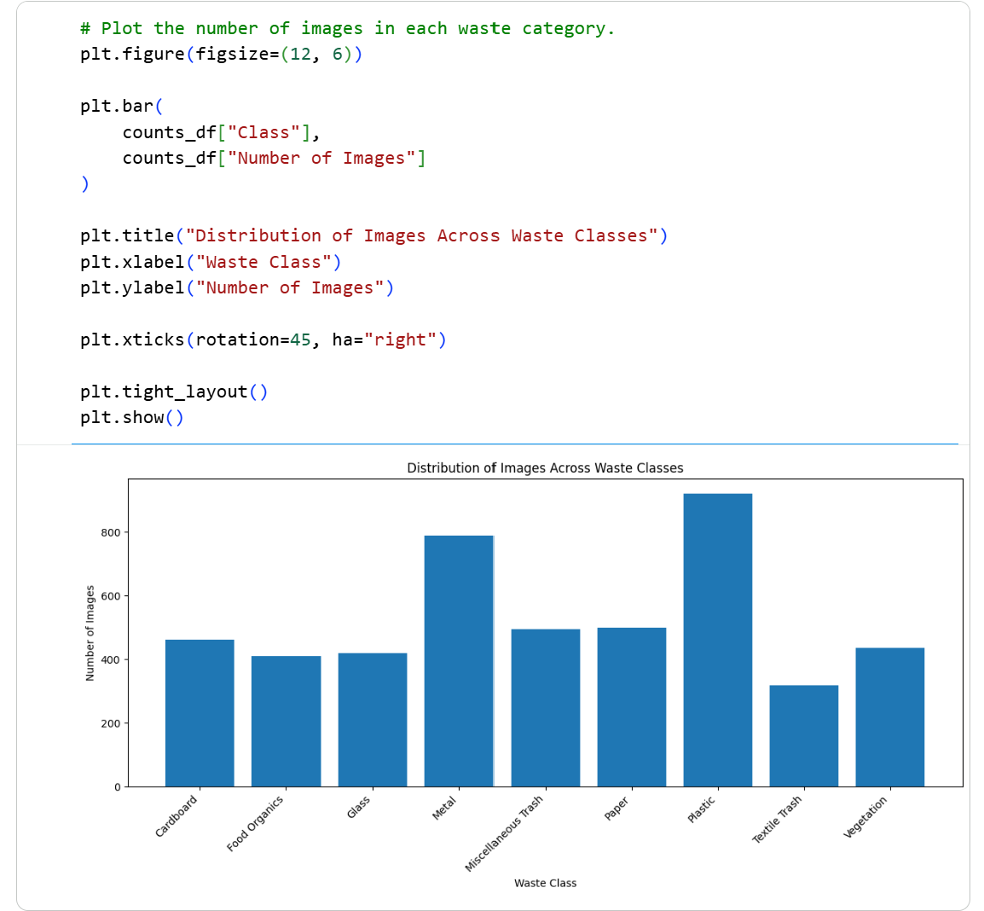 | 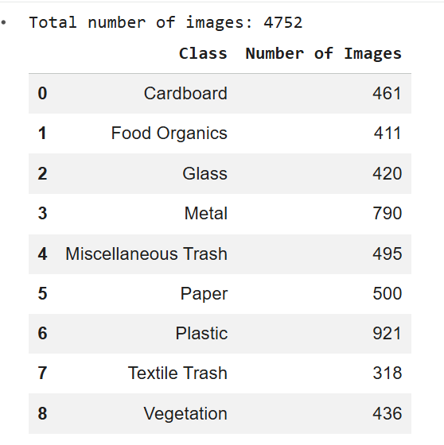

The dataset contains 4,752 images in total. The classes are moderately imbalanced, with Plastic being the largest category with 921 images and Textile Trash the smallest with 318 images. This difference is important because models trained directly on the original distribution may favour the categories that appear more frequently.

Sample images from each category were also inspected to understand the visual characteristics of the dataset.
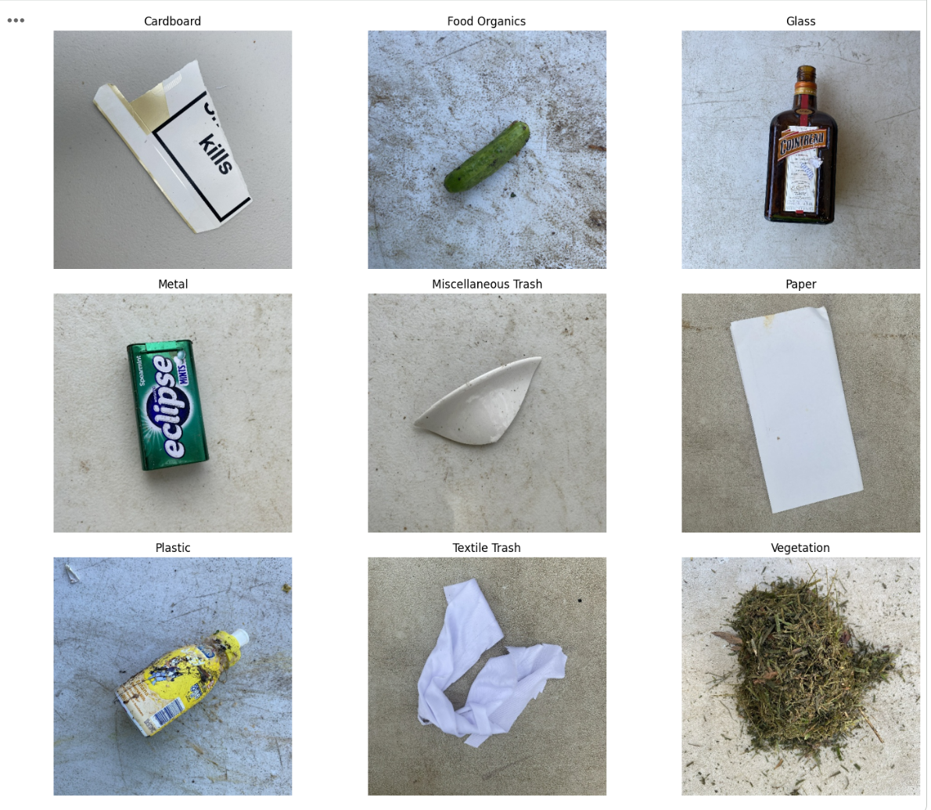
Some categories are easier to distinguish visually, while others share similar characteristics. For example, Plastic, Glass and Metal can contain objects with similar shapes or reflective surfaces. Miscellaneous Trash is also challenging because it contains a wider variety of objects rather than one consistent material or appearance. The models therefore need to learn a combination of visual features such as shape, texture, colour and surface appearance rather than relying on only one characteristic.

2.2 Data Pre-processing
Before training, the dataset was prepared to ensure that the images were valid, consistently formatted and divided appropriately for model development and evaluation.

The same training, validation and test samples were used for both the custom CNN and VGG16 so that their results could be compared fairly. The test set was kept separate throughout model development and was only used during the final evaluation.

2.2.1 Image Integrity and Consistency
All image files were first checked for corruption or readability issues using Pillow's Image.open() and verify() functions. All 4,752 images passed the integrity check, so no files had to be removed.
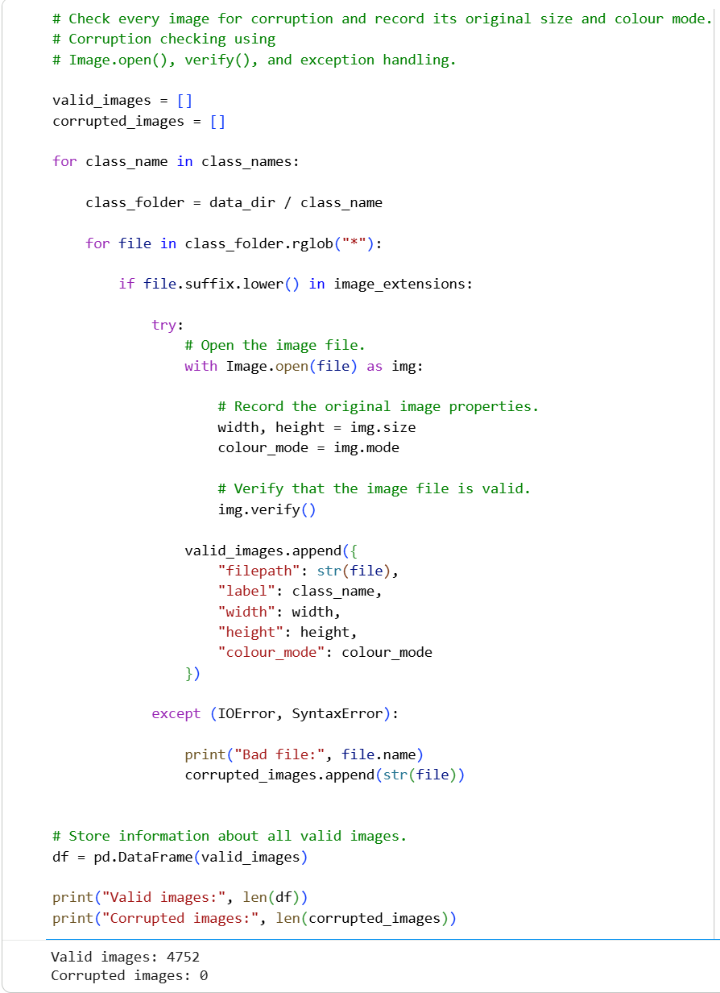
The original image dimensions and colour modes were also inspected.

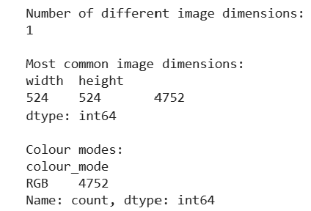

All images were stored as 524 × 524 RGB images. The images were later resized to 224 × 224 pixels before being passed to the models. This reduces the computational requirements and also matches the standard input size used by VGG16.

2.2.2 Duplicate Image Check
Exact duplicate images were checked before splitting the dataset. A SHA-256 hash was generated for every image file, and matching hashes were treated as duplicates.
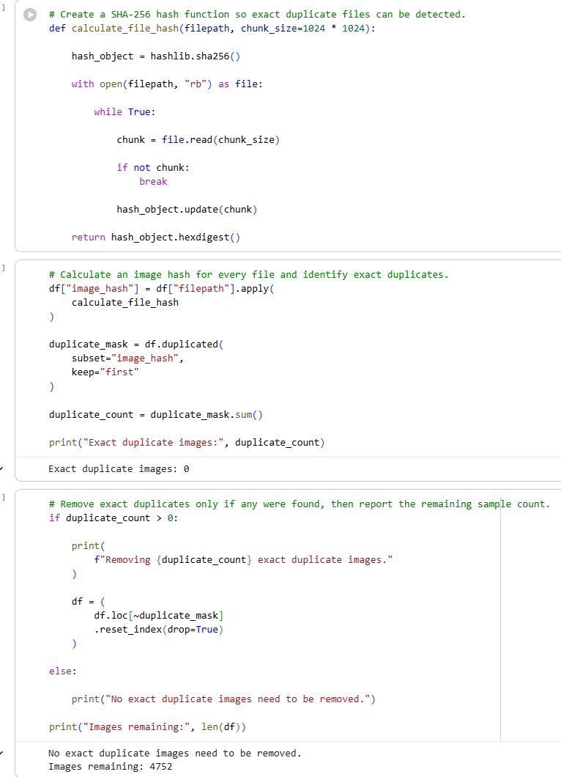
No exact duplicate images were found, so all samples were retained.

This check is important because the same image appearing in both the training and test sets could create data leakage. This may cause the model to evaluate seen images, which could make its performance appear better than it is.

2.2.3 Train, Validation and Test Split
The dataset was split into 70% training, 15% validation and 15% testing data. Stratified sampling was used so that the proportion of each waste category remained similar across the three subsets.
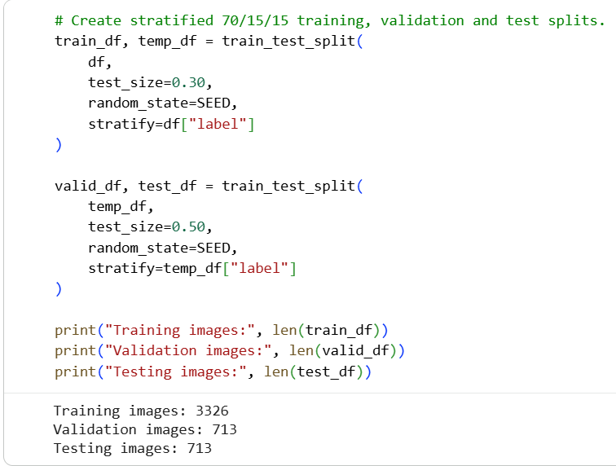
The training set was used to learn the model parameters, while the validation set was used to monitor performance during training. The test set was kept separate for unseen cases until the final evaluation stage.

The class distribution was checked again after splitting and confirmed that all nine categories remained represented at similar proportions across the three subsets.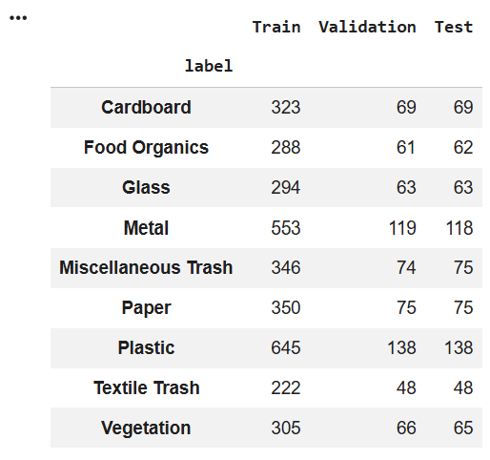
The results confirmed that all nine categories were represented in every subset at similar proportions. This is useful because the original dataset is not perfectly balanced, and a random split without stratification could have made the imbalance worse in one of the subsets.

2.2.4 Label Encoding and Handling Class Imbalance
The waste categories were converted into integer labels from 0 to 8. This allowed the models to use sparse categorical crossentropy directly without converting the targets into one-hot encoded vectors.

To account for the imbalance observed earlier, balanced class weights were calculated using only the training set.
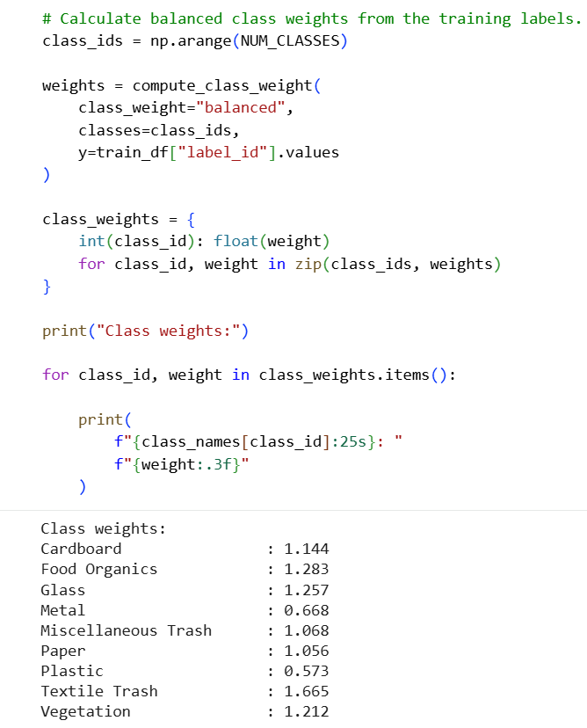
Less common categories received larger weights, while categories with more training samples received smaller weights. For example, Textile Trash received a weight of approximately 1.665, while Plastic received a weight of about 0.573.

The weights affect how much each training example contributes to the loss. This gives mistakes on the smaller classes more influence during training instead of allowing the larger categories to dominate simply because they appear more often. The same class weights were used for both models so that the class imbalance was handled consistently.

2.2.5 Image Loading and Data Pipeline
Each image was decoded as a three-channel RGB image and resized to 224 x 224 pixels. The data was then grouped into different batches of 32 images.

The training dataset was also shuffled so that the model did not repeatedly receive samples in the same order. Prefetching was also used so that the next batch could be prepared while the current batch was being processed, helping to make training more efficient.

2.2.6 Data Augmentation
Data augmentation was applied only to the training images to introduce additional variation without collecting more labelled data.

The transformations included rotation of approximately ±20°, zooming of around 10%, horizontal and vertical translation of around 10%, and horizontal flipping.
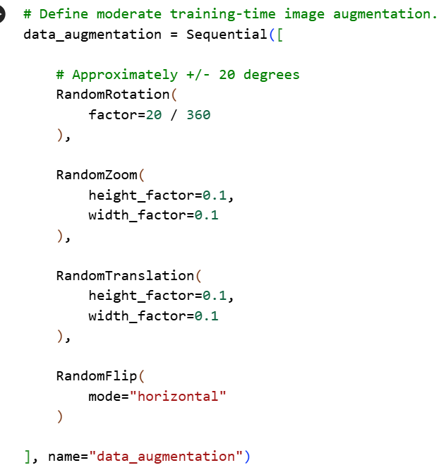
These transformations were kept moderate so that the waste objects remained recognisable. Rotation and translation help the models become less dependent on the exact orientation or position of an object, which is useful because waste items can appear at different angles and locations in real landfill images.
Vertical flipping was not used because it could create unrealistic scene orientations. Validation and test images were also left unchanged so that evaluation was carried out on the original image distribution.

The augmented examples below show visible changes in position, angle and scale while the waste object remains recognisable.
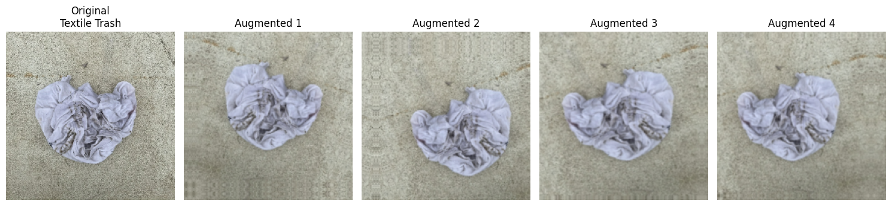

2.2.7 Model-Specific Pixel Pre-processing

The two models did not use the exact same pixel preprocessing. For the custom CNN model, the image values were scaled from 0–255 to 0–1 using a Rescaling() layer. This gives the network a smaller range of input values to work with during training. VGG16 was handled differently because it uses pretrained ImageNet weights. Instead of applying the same 0–1 scaling, vgg16.preprocess_input() was used so that the images were prepared in the format that was expected by the pretrained model. The shared datasets were kept in their original 0–255 range, with the appropriate preprocessing carried out inside each model.
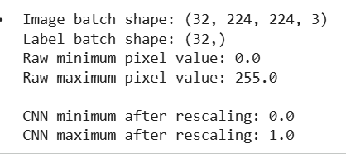
The check confirmed that each batch had the expected shape of (32, 224, 224, 3) and that the custom CNN scaling correctly converted the pixel values from 0–255 to 0–1.

2.3 Custom CNN Development
The first approach used a custom Convolutional Neural Network trained from scratch. A baseline model was trained first to establish the initial performance. Its architecture and training behaviour were then examined before an improved CNN was developed.

This approach makes it possible to identify specific weaknesses in the original model and evaluate whether the changes made to the architecture actually improve validation performance.

2.3.1 Baseline CNN Architecture
The baseline CNN contained three convolutional stages with 32, 64 and 128 filters. The convolutional layers used 3 × 3 filters with ReLU activation to learn visual features from the images, while max-pooling gradually reduced the spatial size of the feature maps.

Batch Normalisation was included to help stabilise the activations during training, while Dropout was used to reduce the model's dependence on individual neurons.

After the final pooling layer, the feature maps were converted into a one-dimensional vector using Flatten. This produced 100,352 values, which were then connected to a Dense layer containing 128 neurons.

The baseline model contained 12,940,489 parameters in total. The Dense layer following Flatten alone contained 12,845,184 parameters, meaning that the majority of the model's parameters were concentrated near the end of the network rather than in the convolutional feature extractor.
This created a very large number of trainable parameters relative to the 3,326 training images available.

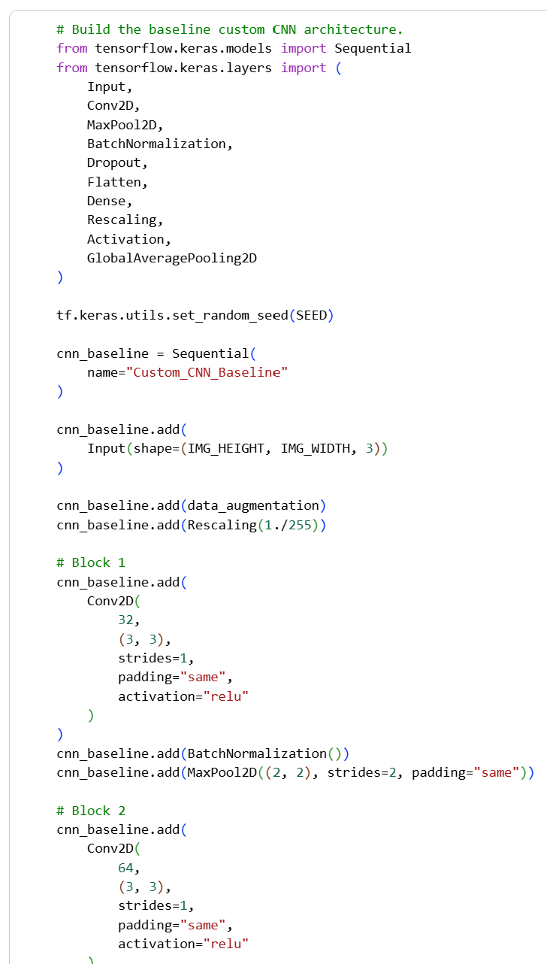 | 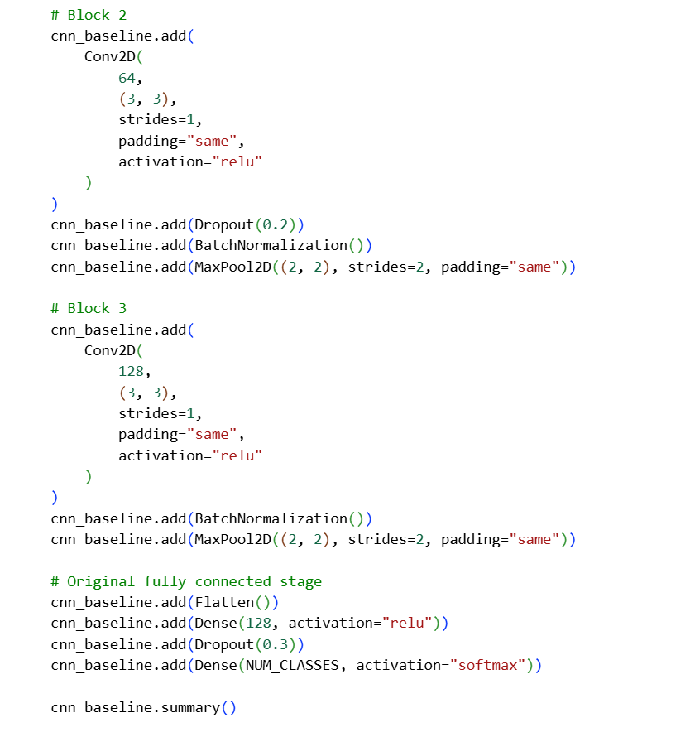

The model summary showed that the CNN contained approximately 12.94 million parameters, with almost all of them being trainable.
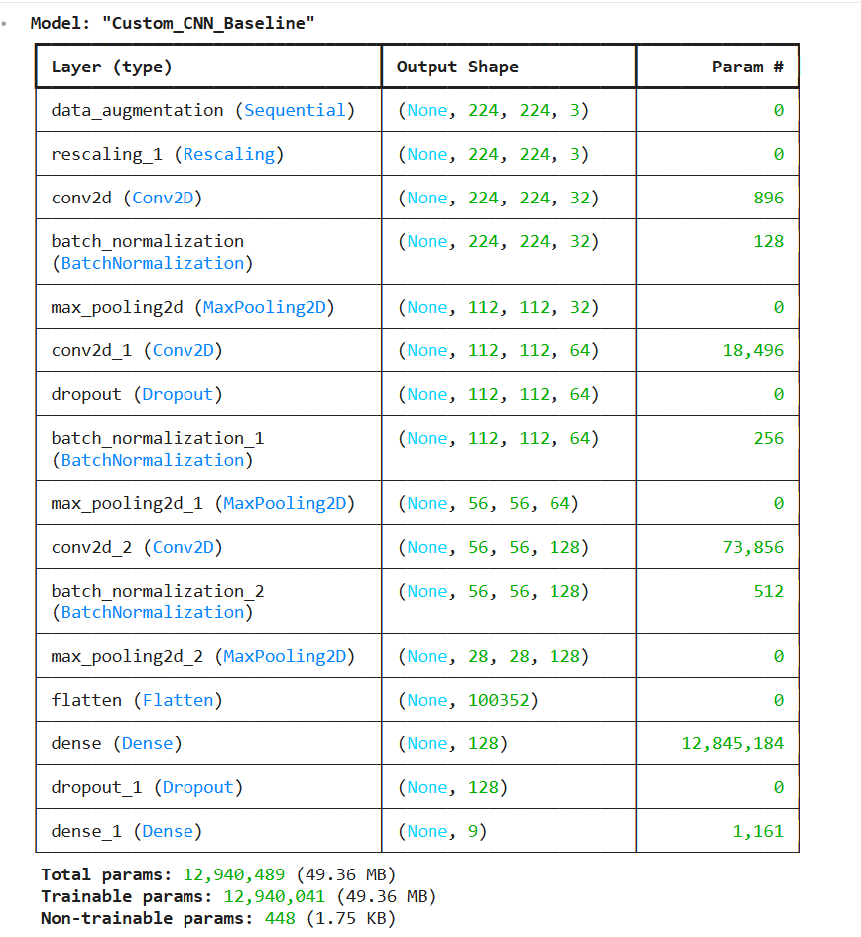
A particularly large number of these parameters comes from the final classification stage. The Flatten layer converts the final feature maps into 100,352 values, and the following Dense layer alone contains 12,845,184 parameters.

This means that most of the model’s capacity is concentrated in a single fully connected layer rather than the convolutional feature extractor. With only 3,326 training images, this creates a very large number of trainable parameters that must be learned from scratch.

2.3.2 Training Setup
The custom CNN was trained using the Adam optimizer with a learning rate of 0.001. Sparse categorical crossentropy was used as the loss function because the target labels were stored as integers, while accuracy was used to track how often the correct category was predicted.
The model was trained for 10 epochs using a batch size of 32. The validation set was evaluated after each epoch, and the class weights calculated earlier were included during training.
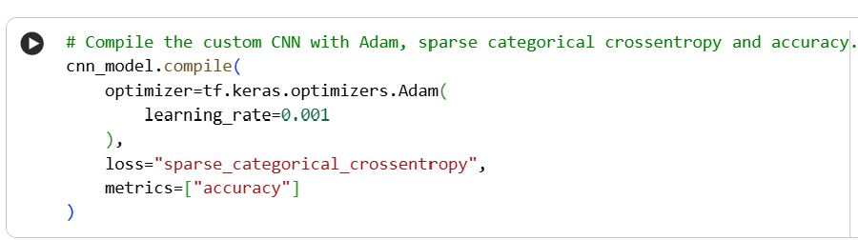
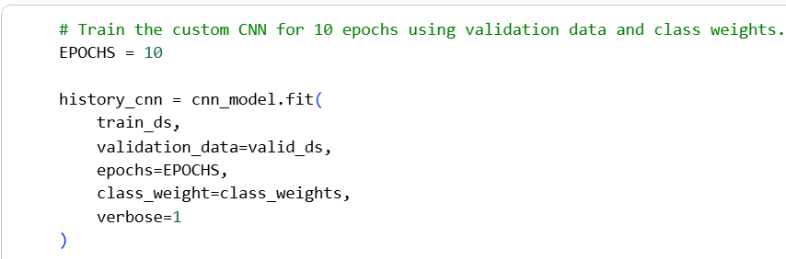

2.3.3 Baseline Training Performance
The training and validation curves were examined to understand how the custom CNN performed during the 10 epochs.
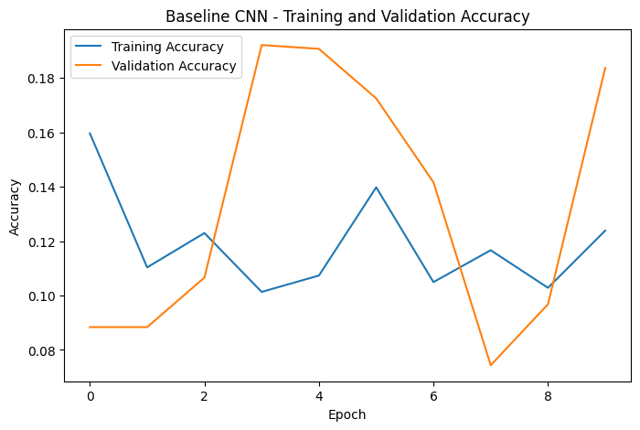 | 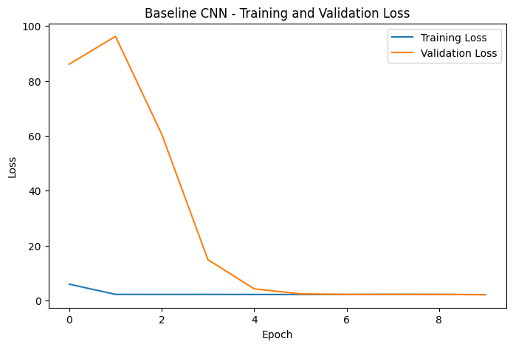
The baseline CNN showed weak and unstable learning throughout the training run. Training accuracy remained roughly between 10% and 16%, while the highest validation accuracy was only 19.21% at epoch 4.

Since the task contains nine categories, uniform random guessing would give an expected accuracy of approximately 11.11%. The training accuracy remaining close to this level suggests that the network was not learning sufficiently useful visual features from the training images.

The loss curves show a similar problem. Validation loss was highly unstable in the early epochs and increased to 96.2750 at epoch 2 before falling sharply. Towards the later epochs, both training and validation loss settled closer to around 2.1–2.2, but this did not lead to a meaningful improvement in classification accuracy.

This behaviour does not appear to be typical overfitting because the training accuracy itself is already very low. Instead, the baseline model is struggling to fit the training data effectively.

One likely reason is the very large Flatten-to-Dense section identified in the model architecture. Although the model contains approximately 12.94 million parameters, most of them are concentrated in the final Dense layer rather than being used to learn stronger convolutional features.

Based on these results, simply increasing the number of training epochs was unlikely to solve the main problem. The architecture was therefore redesigned to reduce unnecessary parameters and place more emphasis on feature extraction.
2.3.4 Improved CNN Architecture and Training Setup
The baseline results showed that the original CNN was not using its parameters efficiently, so the architecture was redesigned before training again.

The main change was replacing Flatten with GlobalAveragePooling2D. Instead of converting every spatial value from the final feature maps into one large vector, Global Average Pooling summarises each feature map into a single value. This greatly reduces the number of parameters required by the classification stage.

The convolutional feature extractor was also strengthened so that more of the model capacity was used to learn visual patterns before classification. Batch Normalisation and Dropout were retained to support stable training and regularisation.
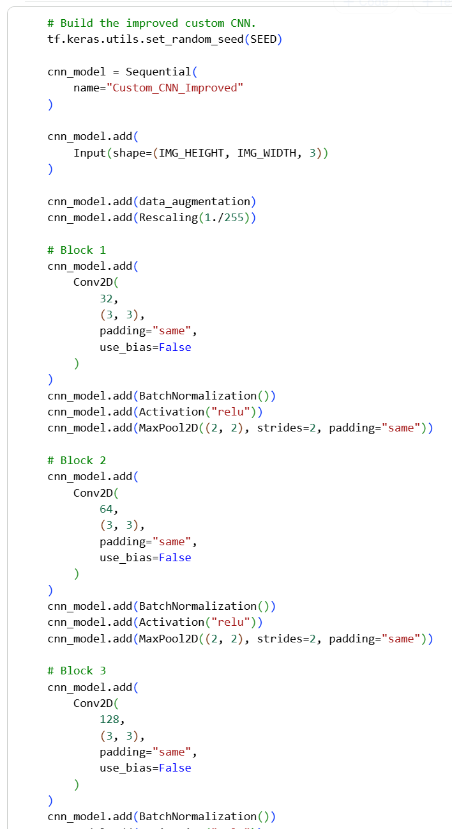 | 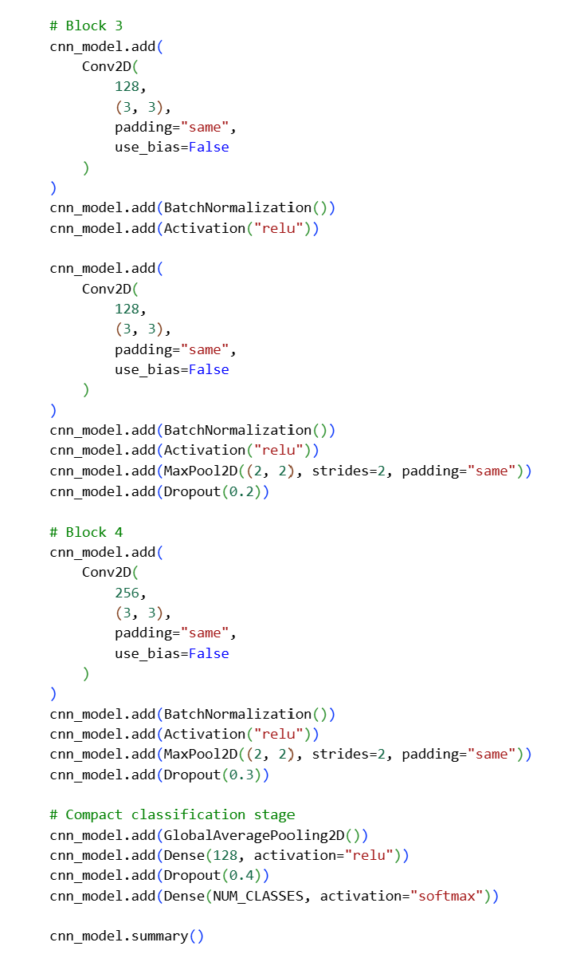

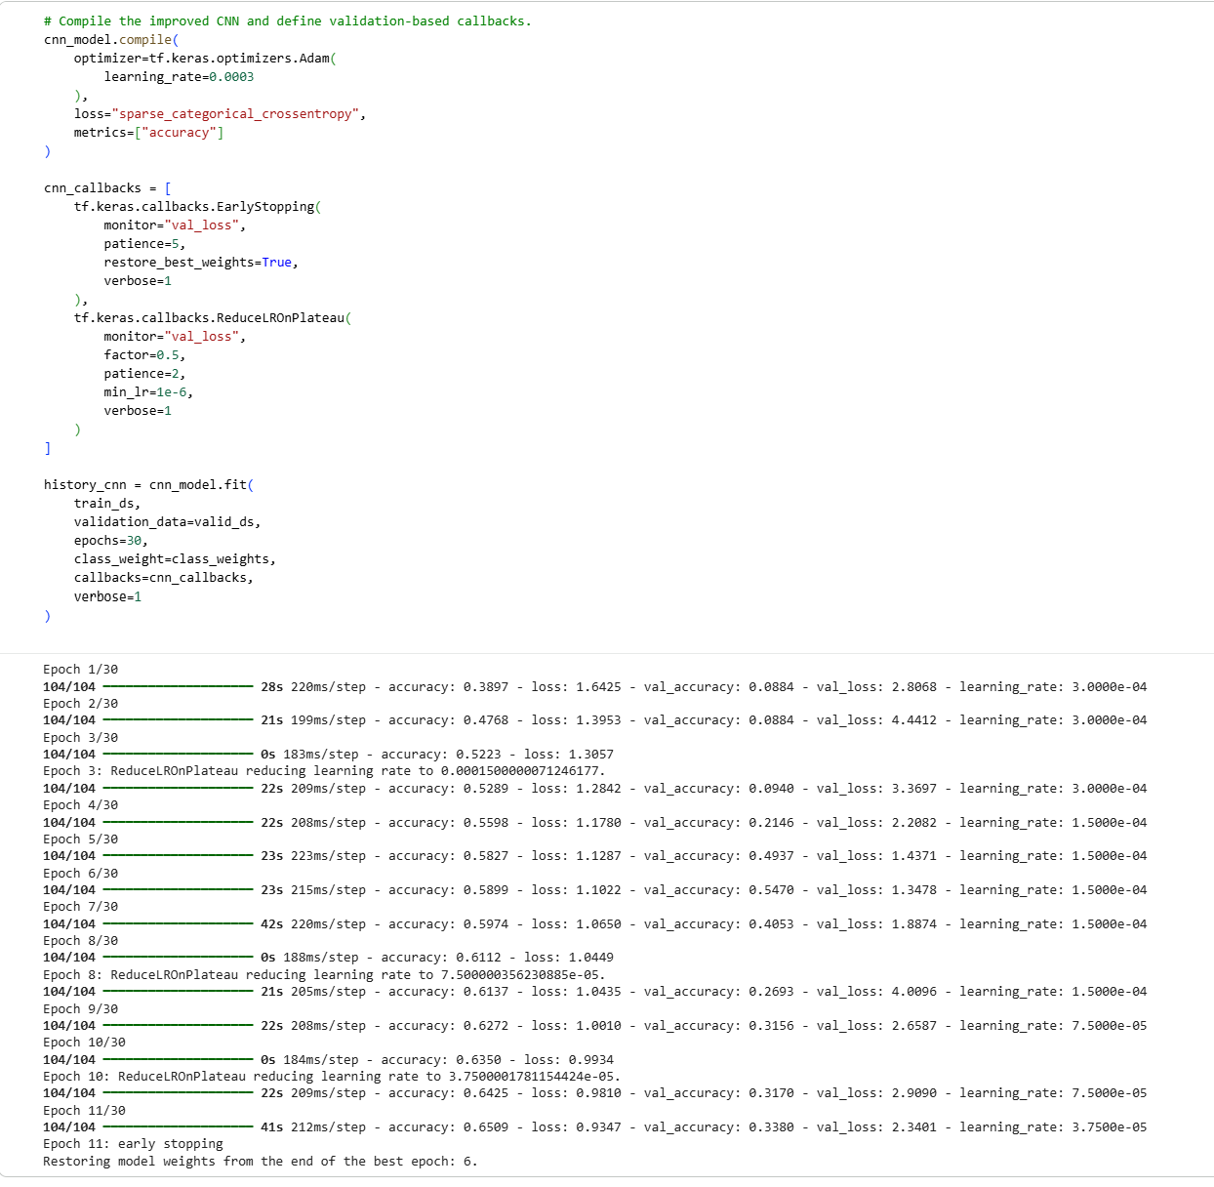
The improved CNN was compiled using Adam with a lower learning rate of 0.0003. The smaller learning rate was used so that the model weights could be updated more gradually than in the baseline.

Sparse categorical crossentropy and accuracy were retained so that the comparison with the baseline remained consistent.

Two validation-based callbacks were also added. ReduceLROnPlateau reduces the learning rate when validation loss stops improving, while EarlyStopping stops training when no further improvement is observed and restores the weights from the best validation epoch.

The model was allowed to train for a maximum of 30 epochs, but this was only an upper limit. The actual training duration was determined by validation performance.

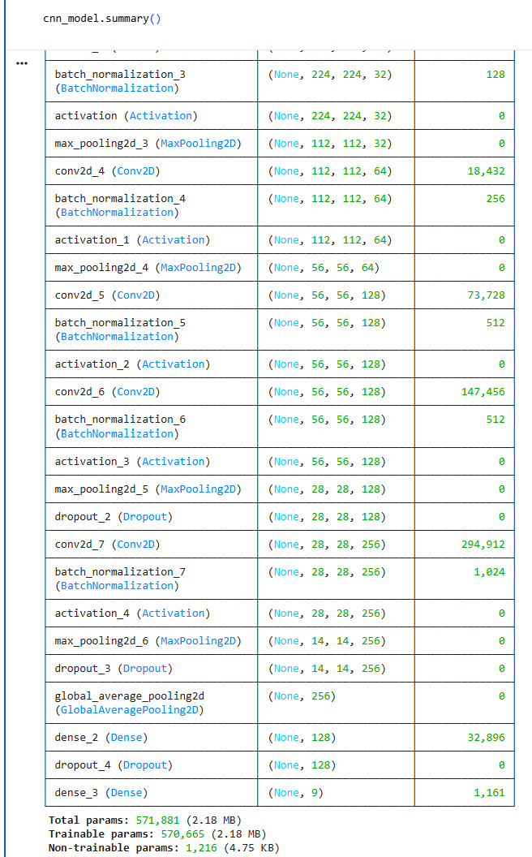
The improved model contains 571,881 parameters, compared with 12,940,489 in the baseline.
This large reduction comes mainly from removing the parameter-heavy Flatten stage. The new architecture therefore uses a much smaller classification section while placing more emphasis on convolutional feature learning.

The effect of these changes is examined next using the improved model’s training and validation curves.

2.3.5 Improved CNN Training Performance
The training and validation curves were examined to evaluate whether the architectural changes improved the model’s learning behaviour.
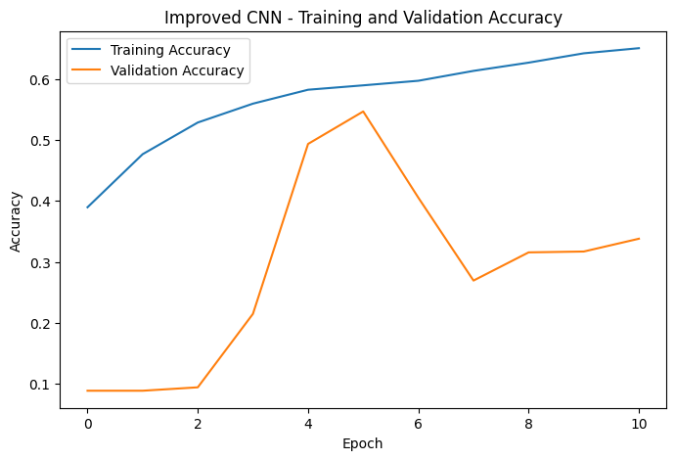 | 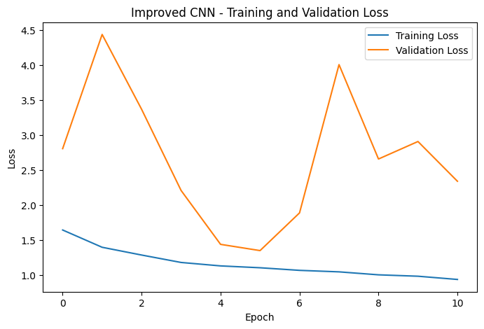
The improved CNN showed a much stronger and more stable learning pattern than the baseline model.
Training accuracy increased from 38.97% in the first epoch to 65.09% by epoch 11, while validation accuracy reached its highest value of 54.70% at epoch 6.

The validation loss also reached its lowest value of 1.3478 at epoch 6, showing that this was the strongest validation point during training.

After epoch 6, training accuracy continued to increase while validation performance became less consistent. This suggests that the model was beginning to fit the training data more strongly without achieving the same improvement on unseen validation images.

The validation-based callbacks responded to this behaviour. The learning rate was reduced when validation loss stopped improving, while early stopping ended training at epoch 11 and restored the weights from epoch 6.

This prevents the final model from using a later epoch that performs better on the training data but generalises less effectively. The improved CNN therefore keeps the model state with the best validation loss rather than simply using the final epoch.

Overall, the improved training behaviour indicates that the redesigned architecture was considerably more effective than the baseline. A direct comparison of the two CNN configurations is presented next.

2.3.6 Baseline vs Improved CNN
The baseline and improved CNN were compared directly to determine whether the redesign produced a meaningful improvement in both efficiency and validation performance.
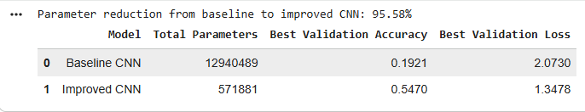
The comparison shows a substantial improvement after redesigning the CNN. The baseline model contained 12,940,489 parameters, while the improved model contained only 571,881 parameters. This represents a 95.58% reduction in total parameters.

Despite being much smaller, the improved CNN achieved far stronger validation performance. The best validation accuracy increased from 19.21% to 54.70%, which is an improvement of 35.49 percentage points.

The best validation loss also decreased from 2.0730 to 1.3478, showing that the improved model not only classified more validation images correctly, but also produced better overall predictions according to the loss function.

These results show that the poor baseline performance was not caused by a lack of model size. Instead, the original architecture used a large number of parameters inefficiently, particularly in the Flatten-to-Dense section.
Replacing this with GlobalAveragePooling2D produced a much more compact architecture while allowing more of the model capacity to focus on convolutional feature learning. The improved CNN was therefore selected as the final from-scratch model for evaluation on the test set and for comparison with the transfer-learning approach.

2.4 VGG16 Transfer Learning
The second image-classification approach used VGG16 with weights pretrained on ImageNet. Unlike the custom CNN, which had to learn all visual features from the RealWaste training images, VGG16 begins with convolutional filters that have already learned general visual patterns from a much larger image dataset.

The model was developed in two stages. The pretrained convolutional base was first kept frozen and used as a feature extractor. After evaluating this configuration, the highest VGG16 convolutional block was selectively unfrozen for fine-tuning.

2.4.1 Frozen VGG16 Architecture and Training Setup
The original VGG16 classification layers were removed using include_top=False, while the pretrained convolutional base was initially frozen so that its existing ImageNet weights were not modified.

The same training-only augmentation used for the custom CNN was applied before VGG16-specific preprocessing. vgg16.preprocess_input() was used instead of 0–1 rescaling because the pretrained VGG16 weights expect inputs prepared according to the ImageNet preprocessing convention.

The convolutional output was passed through GlobalAveragePooling2D, followed by a Dense layer with 128 neurons, Dropout of 0.3 and a final nine-class Softmax output.
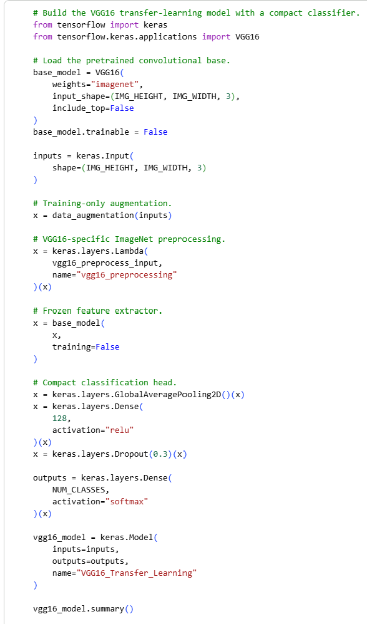
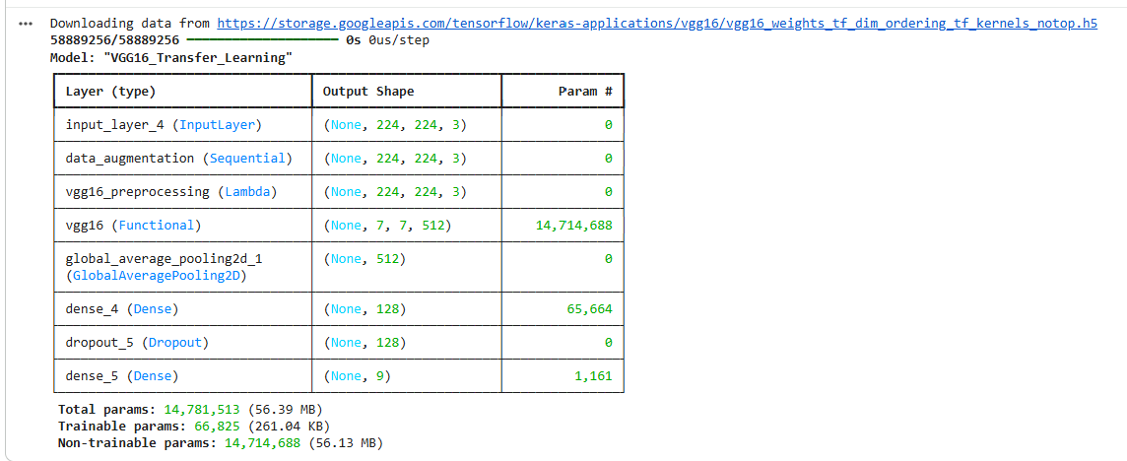
The complete VGG16 model contained 14,781,513 parameters, but only 66,825 parameters were trainable during the frozen stage.

Most of the parameters therefore belonged to the pretrained convolutional base and were kept fixed.
Only the new classification head had to be learned from the RealWaste training images.

This provides an important contrast with the custom CNN. Although VGG16 contains more parameters overall, the majority already contain visual knowledge learned during pretraining rather than having to be estimated from the 3,326 RealWaste training images.
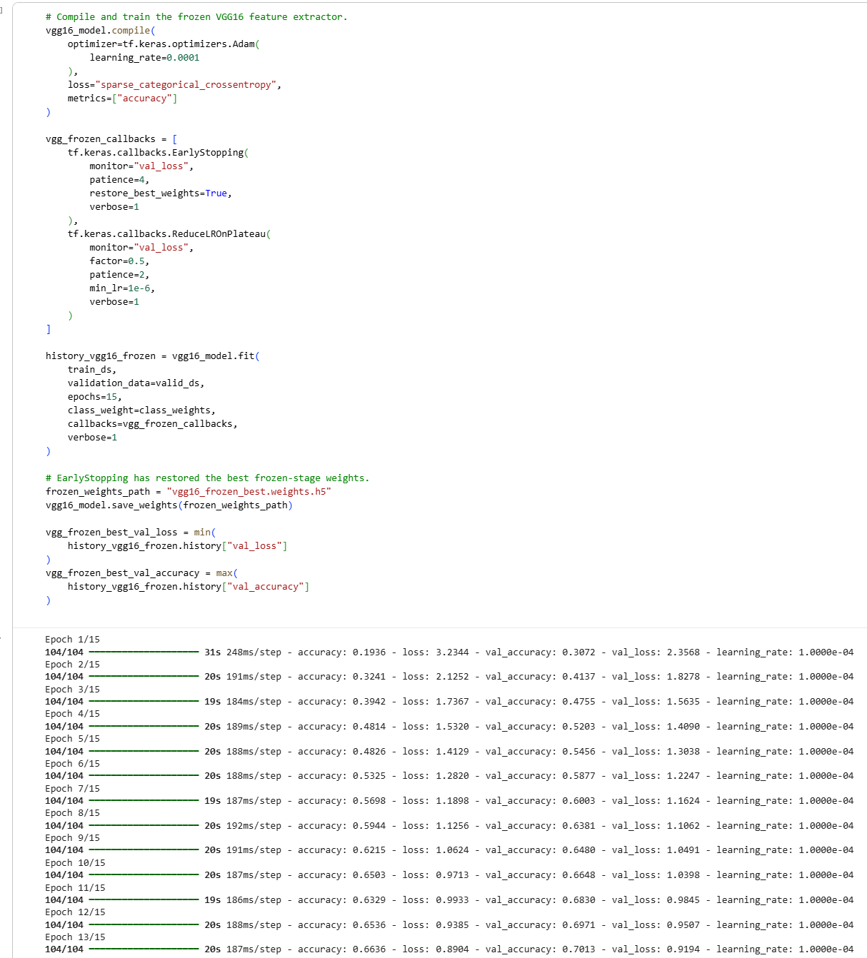
The frozen VGG16 model was compiled using Adam with a learning rate of 0.0001. Sparse categorical crossentropy and accuracy were retained as the loss function and evaluation metric.

The model was allowed to train for a maximum of 15 epochs. EarlyStopping and ReduceLROnPlateau were included to monitor validation loss, while the same class weights used for the custom CNN were applied during training.

2.4.2 Frozen VGG16 Training Performance
The training and validation curves were examined to determine how effectively the pretrained features could be adapted using only the newly added classifier.
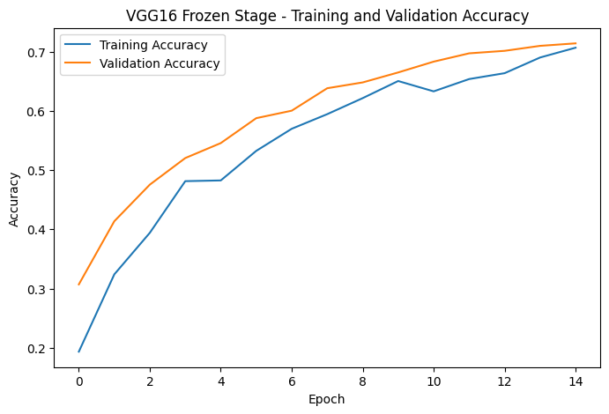 | 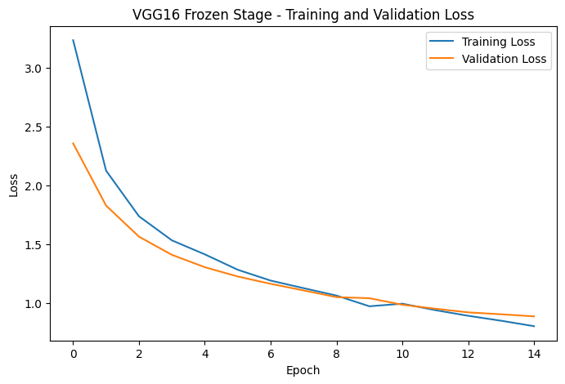
The frozen VGG16 model showed a much stronger learning pattern than either version of the custom CNN. Training accuracy increased from 19.36% in the first epoch to 70.66% by epoch 15, while validation accuracy increased from 30.72% to 71.39%. Training loss decreased from 3.2344 to 0.8020, while validation loss decreased from 2.3568 to 0.8856.

Unlike the baseline CNN, validation performance continued to improve throughout the frozen training stage, with the best validation result occurring at the final epoch. The relatively similar training and validation accuracy also suggests that the frozen model generalised reasonably well rather than simply memorising the training data.

These results demonstrate the benefit of pretrained visual features for a relatively small image dataset. However, the convolutional base had not yet been allowed to adapt specifically to the visual characteristics of the RealWaste images.

Selective fine-tuning was tested to determine whether allowing the higher-level VGG16 features to adapt could produce further improvement.

2.4.3 Selective Fine-Tuning Setup
Rather than unfreezing the entire VGG16 network, only the highest convolutional block, block5, was made trainable. The earlier VGG16 blocks were kept frozen because they contain more general visual features such as edges, textures and simple shapes. The later layers contain more task-specific higher-level representations, making them a more suitable part of the network to adapt to the RealWaste dataset.
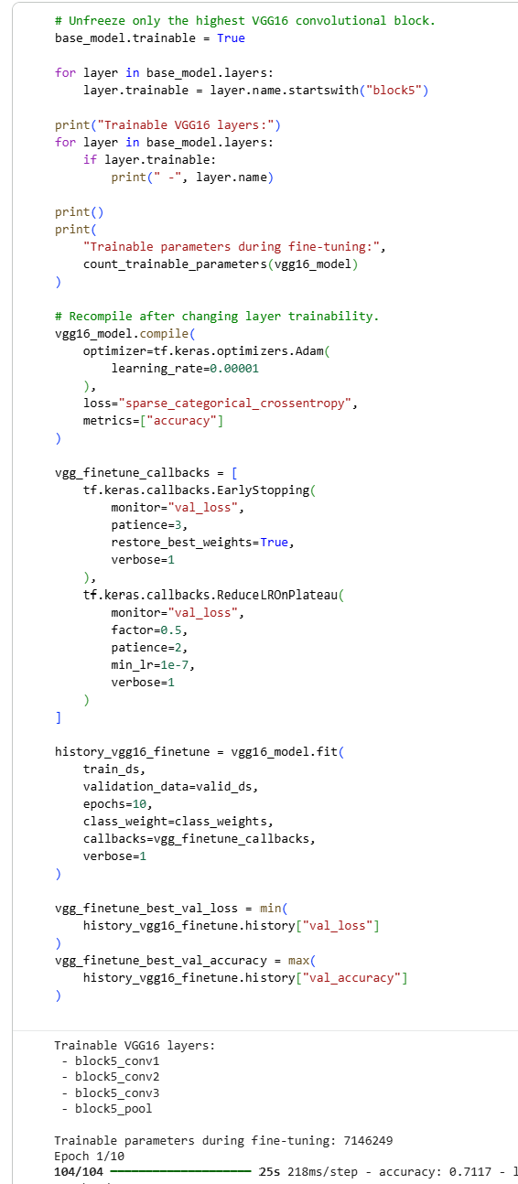
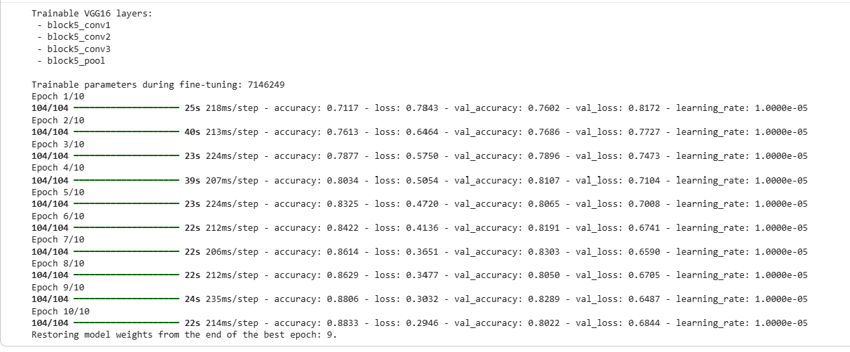
After unfreezing block5, the number of trainable parameters increased from 66,825 to 7,146,249. This allows part of the pretrained feature extractor to adapt to the waste images while still preserving the majority of the earlier pretrained representation.

After changing the trainable layers, the model was recompiled using Adam with a much smaller learning rate of 0.00001. A very small learning rate was used because the unfrozen layers already contained useful pretrained weights. Large updates could disrupt this existing knowledge, while smaller updates allow the higher-level features to adapt more gradually.
Fine-tuning was allowed to continue for a maximum of 10 epochs, again using EarlyStopping, ReduceLROnPlateau, the validation set and the same class weights.

2.4.4 Fine-Tuned VGG16 Training Performance
The training and validation curves were then examined to determine whether selective fine-tuning improved the pretrained model.

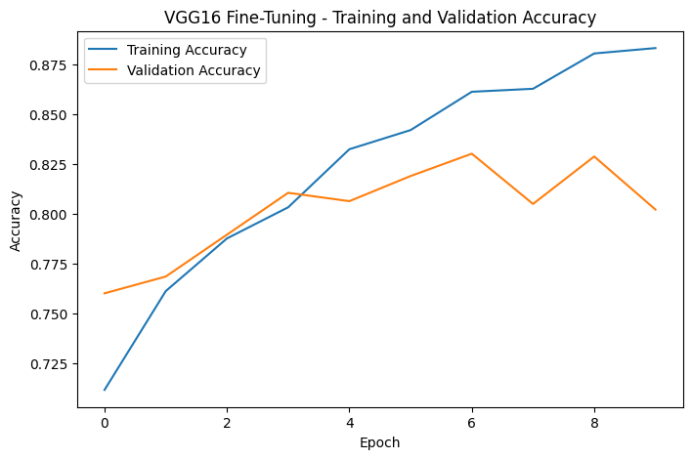 | 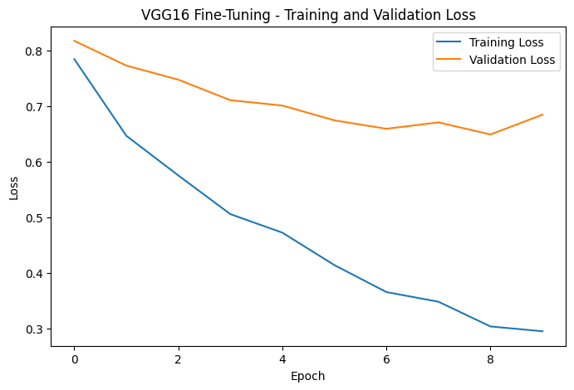
Selective fine-tuning produced a clear improvement over the frozen VGG16 configuration. Validation accuracy reached a maximum of 83.03%, compared with 71.39% during the frozen stage. Training accuracy also increased and reached approximately 88.33%.

The lowest validation loss during fine-tuning was 0.6487. The highest validation accuracy occurred at epoch 7, while the lowest validation loss occurred at epoch 9. Since validation loss was used by the early-stopping callback for model selection, the weights from epoch 9 were restored.

The improvement suggests that the pretrained VGG16 features were already useful for distinguishing the waste categories, but allowing the highest convolutional block to adapt helped the model learn representations that were more specific to the RealWaste images.

At the same time, only the upper part of the pretrained network was modified. This provides a balance between preserving general ImageNet features and adapting higher-level features to the target dataset.

2.4.5 Frozen vs Fine-Tuned VGG16
The two VGG16 development stages were compared using validation performance before selecting the configuration for final test evaluation.
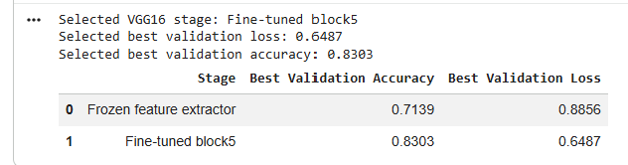

The comparison confirms that selective fine-tuning improved both validation accuracy and validation loss. Best validation accuracy increased from 71.39% with the frozen feature extractor to 83.03% after fine-tuning, an improvement of 11.64%.Best validation loss also decreased from 0.8856 to 0.6487.

This improvement supports the decision to fine-tune only the highest VGG16 convolutional block. Keeping the entire network frozen provided a strong starting point, but allowing the higher-level features to adapt produced better generalisation to the RealWaste validation images.
The fine-tuned block5 configuration was therefore selected as the final VGG16 model for evaluation on the unseen test set.

2.5 Final Test Performance Comparison
After model development was completed, the improved CNN and fine-tuned VGG16 were evaluated on the same 713 test images. These images had not been used during training or validation, so the results provide a fairer measure of how well each model generalised to unseen data.
The final test results show a clear difference between the two approaches.

The improved CNN achieved a test accuracy of 51.05%, while the fine-tuned VGG16 achieved 81.49%. This gives VGG16 an advantage of 30.44 percentage points on unseen test images. The same pattern can be seen in the F1-scores. The improved CNN achieved a macro F1-score of 0.5053, compared with 0.8180 for VGG16. The weighted F1-scores were also higher for VGG16, at 0.8125 compared with 0.5079 for the CNN.

Macro F1 is especially useful here because the RealWaste classes are not perfectly balanced. Each category contributes equally to the macro score, so VGG16’s stronger result suggests that its improvement was not simply caused by performing well on the larger classes.

VGG16 also achieved a lower test loss of 0.6938, compared with 1.3633 for the improved CNN. Together with the higher accuracy and F1-scores, this indicates that the transfer-learning model produced stronger overall predictions on the unseen test set.

The custom CNN still improved considerably compared with its original baseline, but it remained behind VGG16. A likely reason is that the CNN had to learn all of its visual features from the relatively small RealWaste training set, while VGG16 started with pretrained visual representations and was then further adapted through selective fine-tuning.

Overall, the fine-tuned VGG16 was the stronger model for the waste-classification task. However, the improved CNN remains useful as a smaller from-scratch alternative, while VGG16 achieves substantially better classification performance at the cost of greater model complexity.

Overall test metrics show which model performed better, but they do not show whether certain waste categories remained more difficult than others. The class-level results are therefore examined next.

2.6 Class-Level Performance
The overall test results show that VGG16 performed better, but looking at the results by class gives a clearer picture of where each model was strong or weak.
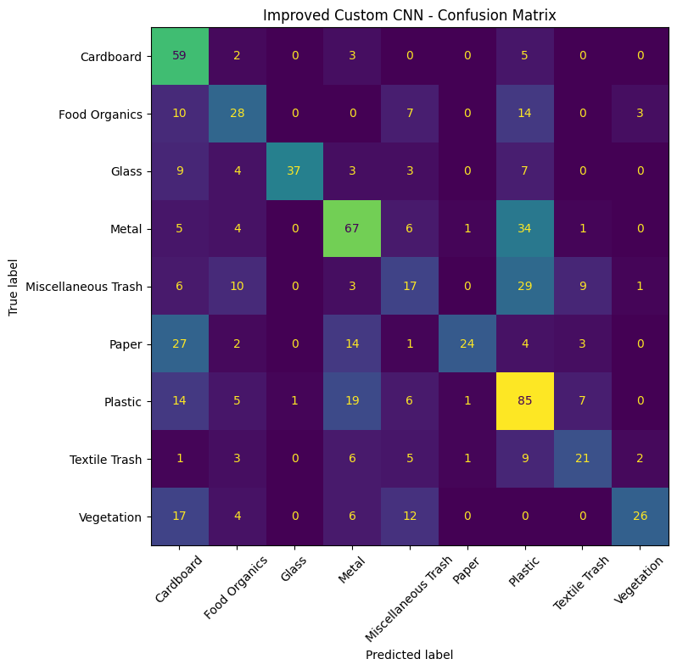 | 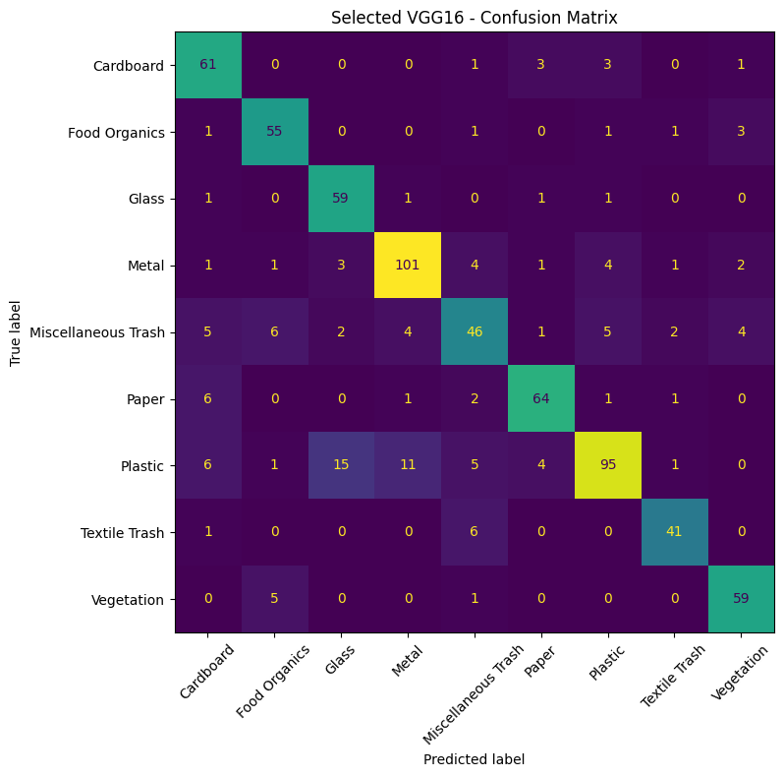
The confusion matrices show that the improved CNN was able to classify some categories reasonably well, but its errors were still concentrated around several visually similar classes.
For the improved CNN, Glass was the strongest class with an F1-score of approximately 0.733. However, performance was much weaker for Miscellaneous Trash, which achieved an F1-score of only about 0.258.

The CNN also showed uneven precision and recall for several classes. For example, Cardboard achieved a relatively high recall of 0.86, but its precision was only around 0.40. This means the model successfully identified many Cardboard images, but also incorrectly labelled many non-Cardboard images as Cardboard.

A similar trade-off can be seen for Paper, where precision was high at around 0.89, but recall was only about 0.32. This suggests that when the CNN predicted Paper it was usually correct, but it failed to identify many Paper images in the test set.
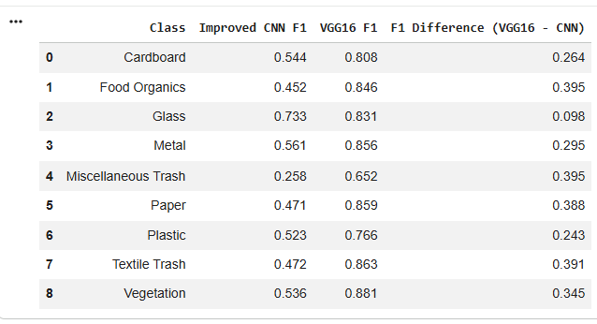
The per-class F1 comparison shows that the fine-tuned VGG16 achieved a higher F1-score than the improved CNN for all nine waste categories.

VGG16 performed particularly well on Vegetation, with an F1-score of approximately 0.881, followed by Textile Trash at around 0.863, Paper at 0.859, and Metal at 0.856.

The weakest VGG16 category was Miscellaneous Trash, with an F1-score of approximately 0.652. Although this was lower than the other VGG16 classes, it was still considerably stronger than the CNN result for the same category.

The weaker performance on Miscellaneous Trash is understandable because this category contains a wide variety of objects rather than one consistent material or appearance. This makes it harder for the model to learn a single set of visual features that clearly defines the class.

Plastic also remained relatively difficult for VGG16, with an F1-score of approximately 0.766. Plastic items can vary in shape, colour and transparency, and may share visual characteristics with Glass or Metal. This helps explain why some confusion between these classes remained.

Overall, the class-level results confirm that VGG16’s advantage was not limited to only one or two categories. Its improvement was consistent across the full set of waste classes, which supports the stronger macro F1-score seen in the overall test results.

Although the class-level scores show which categories were more difficult, they do not show the specific directions of the most common errors. The next section therefore examines the main misclassification patterns made by both models.

2.7 Error Analysis
The confusion matrices show the overall pattern of errors, but looking at the most common misclassifications gives a clearer idea of which categories the models tend to confuse with.
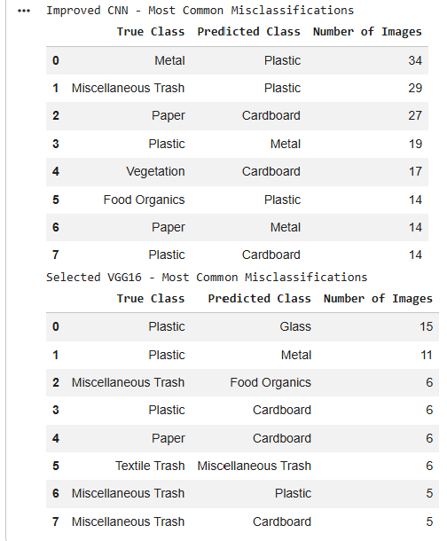
The improved CNN made several recurring mistakes between visually similar waste categories.
Its most common error was predicting Metal as Plastic, which occurred 34 times. It also predicted Miscellaneous Trash as Plastic 29 times and Paper as Cardboard 27 times.

These errors suggest that the CNN still relied heavily on broad visual similarities between materials. Reflective surfaces, similar object shapes and overlapping colours can make Metal and Plastic difficult to separate, while Paper and Cardboard can share similar textures and flat rectangular shapes.

The Miscellaneous Trash errors are also expected because this class contains a wider variety of objects. Some of these objects may visually resemble one of the more clearly defined material classes, which makes the category harder to model consistently.

VGG16 made fewer repeated mistakes overall. Its most common error was predicting Plastic as Glass, which occurred 15 times, followed by Plastic as Metal with 11 cases.

These mistakes are still understandable because transparent or reflective plastic objects can resemble Glass or Metal depending on lighting, shape and surface appearance.

Compared with the improved CNN, the lower error counts suggest that VGG16 learned more discriminative visual representations between the waste categories.
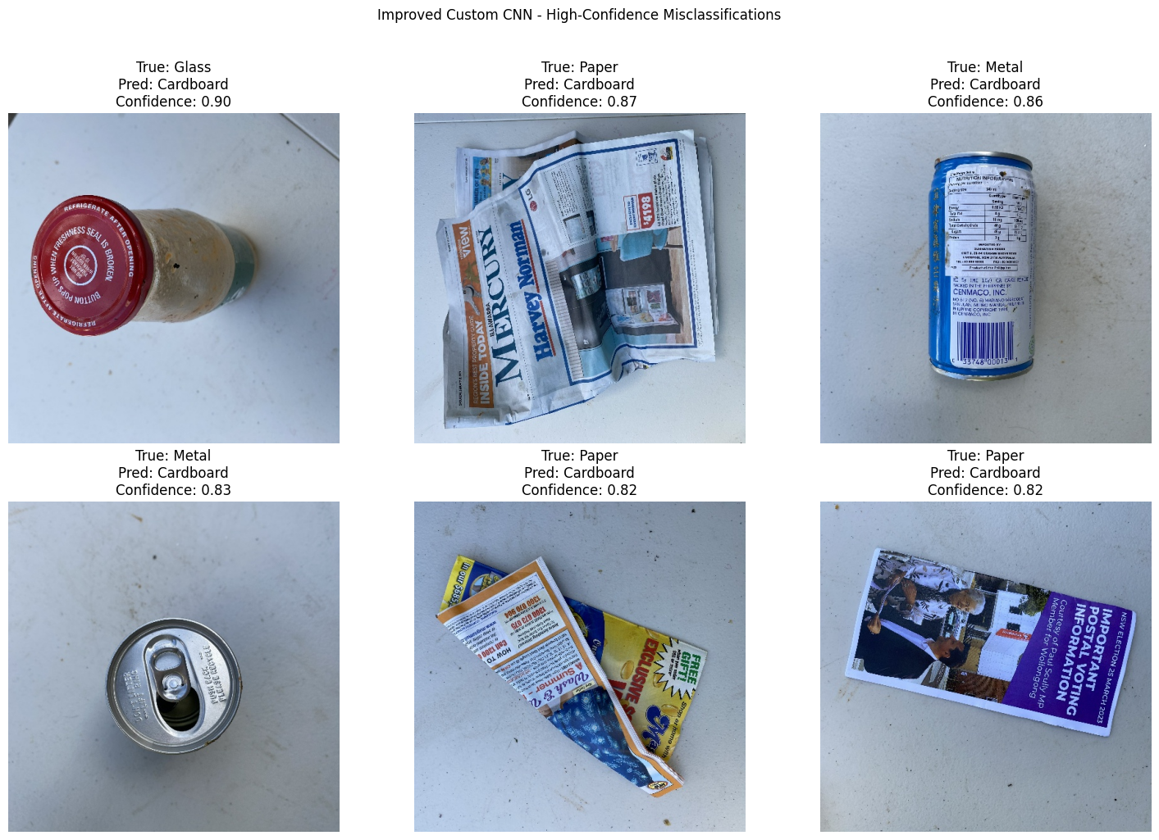
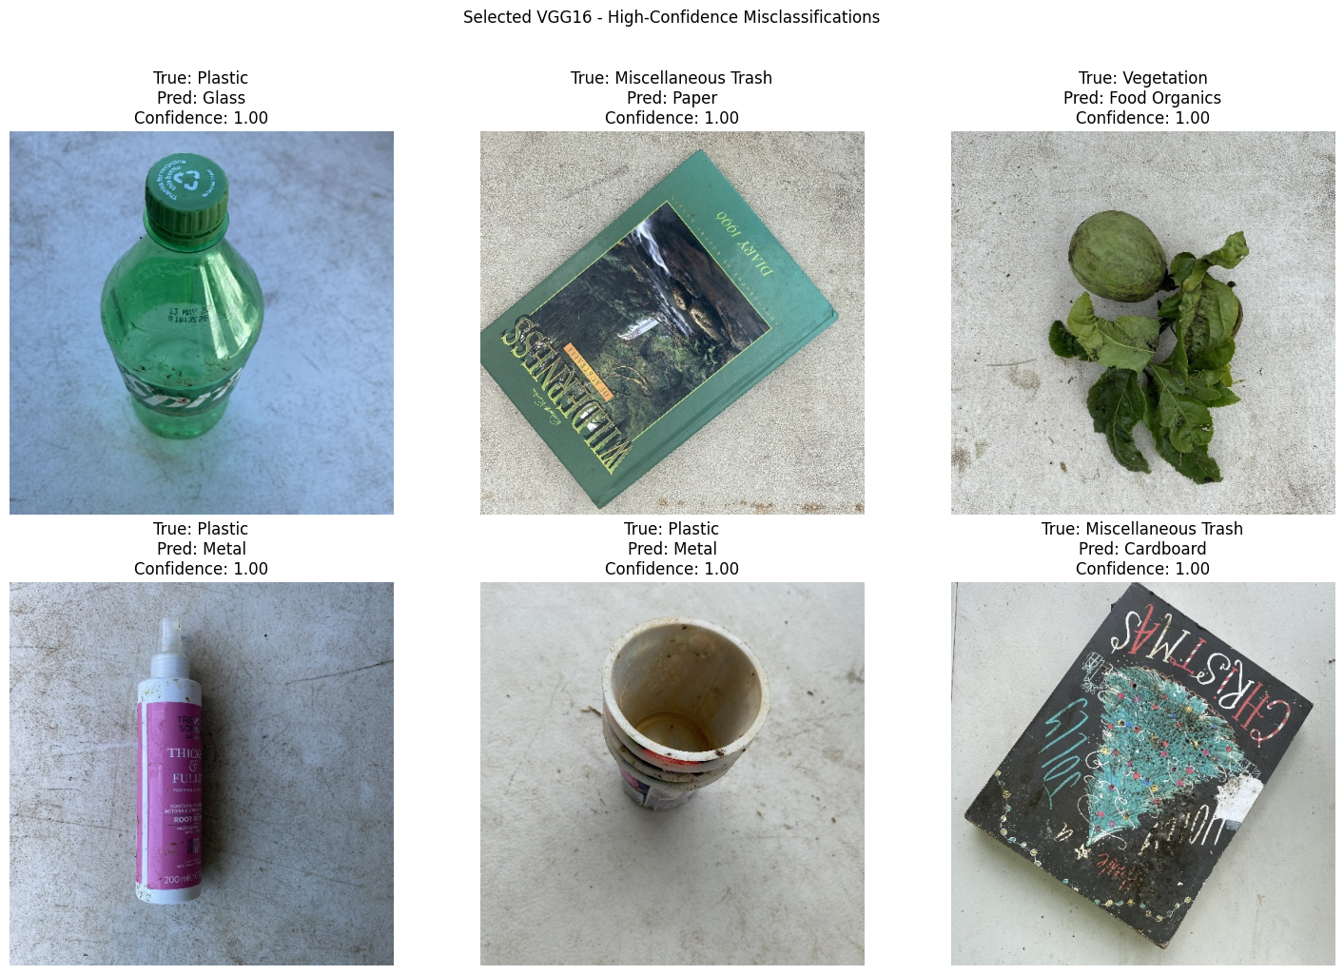
The qualitative examples also show that some incorrect predictions were made with relatively high confidence. For the improved CNN, several of the highest-confidence mistakes were predicted as Cardboard, with confidence values of roughly 0.82 to 0.90. This suggests that the model can sometimes become strongly influenced by surface textures or shapes that resemble cardboard even when the true class is different.

VGG16 produced fewer mistakes overall, but some incorrect predictions were still made with very high confidence. This shows that stronger classification accuracy does not necessarily mean that every confidence score is well calibrated.

A possible future improvement would therefore be to examine prediction calibration in addition to accuracy and F1-score, especially if the model were used in a practical waste-sorting system where highly confident wrong predictions could be costly.

Overall, the error analysis supports the class-level results. The improved CNN was able to learn useful visual patterns, but it still confused several categories with similar appearance. VGG16 reduced many of these errors and produced a more consistent separation between the nine classes, although some ambiguity remained for materials such as Plastic, Glass and Metal.

2.8 Discussion, Trade-offs and Possible Improvements
The Part 1 experiments show that model design had a major effect on performance. The original CNN contained a very large number of parameters, but this did not translate into strong learning. After redesigning the architecture, the parameter count was reduced by 95.58% while best validation accuracy increased from 19.21% to 54.70%. This shows that a more compact model can perform better when its capacity is used more effectively.

The improved CNN also demonstrated the value of using validation performance to guide model development. GlobalAveragePooling2D reduced the parameter-heavy classification stage, while the lower learning rate and validation-based callbacks helped produce more stable training. Even so, the final test accuracy of 51.05% shows that learning all visual features from the RealWaste dataset alone remained challenging.

VGG16 produced much stronger results because it started with pretrained visual representations instead of learning every feature from random initialisation. The frozen VGG16 model already achieved 71.39% validation accuracy, and selective fine-tuning increased this further to 83.03%. The final fine-tuned model reached 81.49% test accuracy with a macro F1-score of 0.8180, substantially outperforming the improved CNN.

Selective fine-tuning also provided a useful compromise between fully freezing and fully retraining the network. Only the highest VGG16 block was unfrozen, which allowed the later features to adapt to the RealWaste images while preserving the more general visual representations learned in the earlier layers.

However, the stronger VGG16 performance comes with a clear trade-off. The improved CNN contains only 571,881 parameters, while VGG16 contains approximately 14.78 million parameters. VGG16 is therefore much more computationally demanding, even though it provides a large improvement in classification performance. If computational resources or deployment size were important constraints, the smaller CNN could still be useful, although its lower accuracy would need to be accepted.

The class-level results also show that some categories remain more difficult than others. In particular, Miscellaneous Trash remained the weakest VGG16 class, while confusion still occurred between visually similar materials such as Plastic, Glass and Metal. These errors suggest that some classes do not have clearly separated visual characteristics, especially when lighting, transparency, shape and background conditions vary.

Several future improvements could be explored. Additional labelled examples for the harder classes may improve their representation during training. More targeted augmentation could also be tested for classes that show frequent confusion, provided that the transformations remain realistic.

A newer pretrained architecture such as EfficientNet or ResNet could also be compared with VGG16. These models may provide a better balance between accuracy and computational efficiency. Further fine-tuning experiments could also test how many upper layers should be unfrozen and whether a different learning rate produces better validation performance.

Finally, the qualitative error analysis showed that some incorrect predictions were made with high confidence. Examining model calibration could therefore provide additional insight beyond accuracy and F1-score. This would be particularly useful in a real waste-sorting system, where a highly confident incorrect prediction may be more problematic than a low-confidence uncertain prediction.

Overall, the strongest approach for Part 1 was the selectively fine-tuned VGG16 model. The experiments show that transfer learning is especially useful when the available labelled dataset is relatively small, while careful architectural redesign and validation-based optimisation can still produce substantial improvements for a model trained from scratch.

3. Part 2 – News Article Classification

3.1 Dataset Exploration
Before preprocessing and model development, the AG News dataset was explored to understand its structure, class distribution and the type of text contained in each category. The provided training dataset contains 120,000 articles, while the official test dataset contains 7,600 articles. Each sample contains a class index, article title and article description.
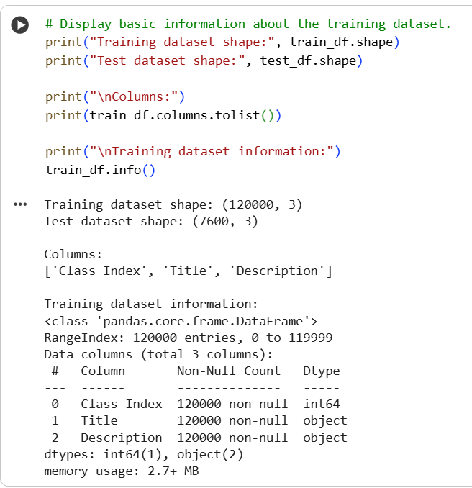
The training samples were counted across the four categories to check whether the dataset was balanced.
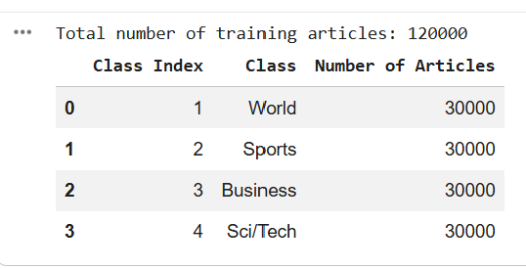

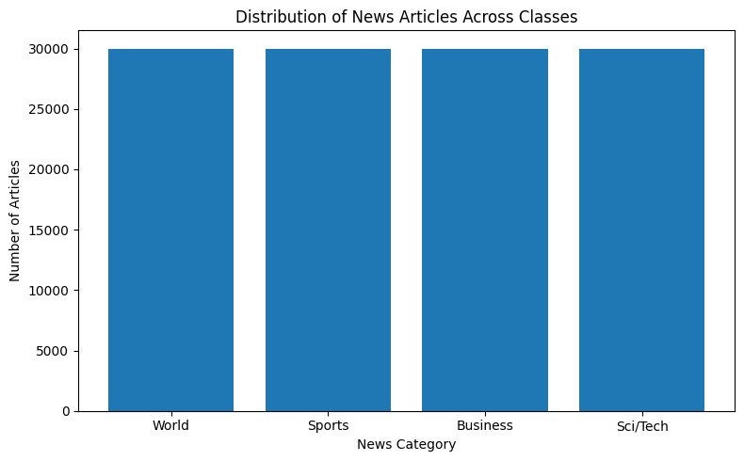
Each category contains exactly 30,000 training articles, meaning that World, Sports, Business and Sci/Tech are equally represented. Unlike the RealWaste dataset in Part 1, there is no class imbalance to correct here. Class weighting is therefore unnecessary because each category contributes the same number of training examples.

One article from each category was also inspected to get a better idea of the type of language used in the different topics.
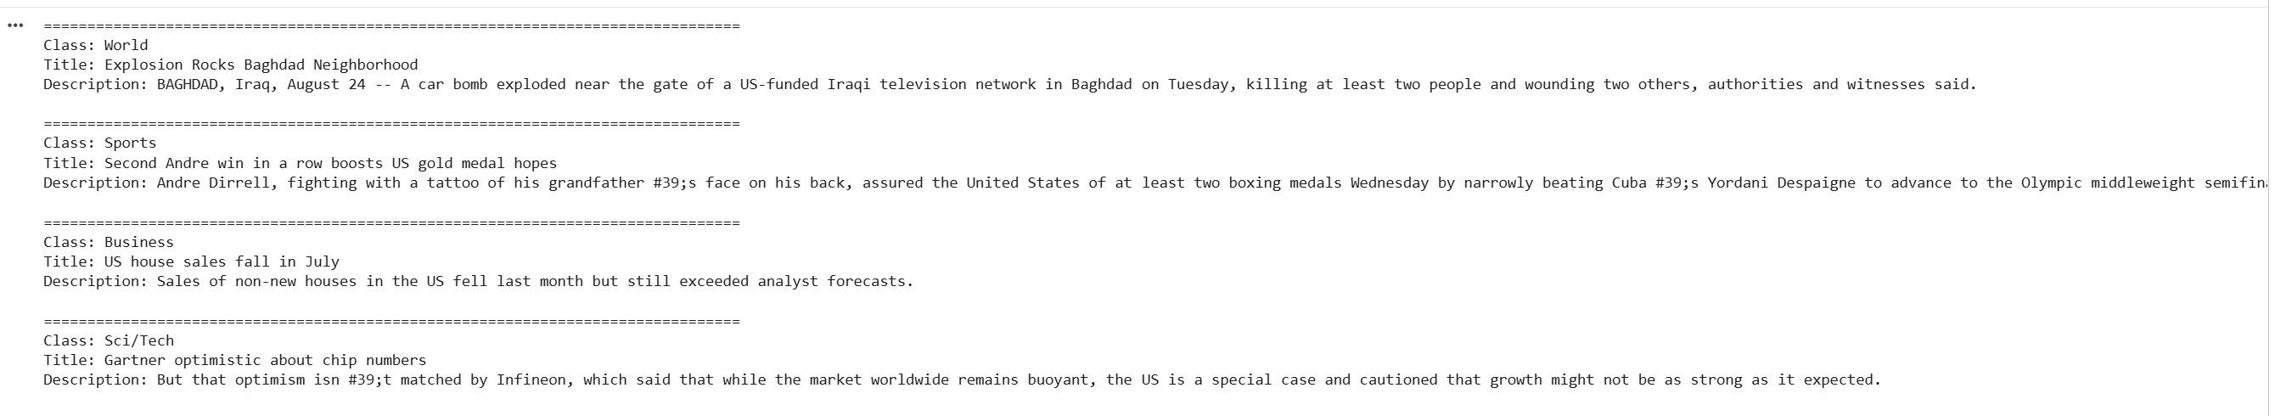
The examples show some clear topic-related language. Sports articles frequently contain references to athletes, teams or competitions, while Business articles often mention companies, markets or economic activity.

However, individual keywords are not always enough to separate the categories. For example, an article about a technology company may contain both Business and Sci/Tech language, while an international sporting event may include terms that could also appear in World news.

Therefore, the models need to consider the surrounding words and overall article context rather than relying only on a small number of obvious keywords.

3.2 Data Pre-processing
Before training, the text data was checked and prepared so that both models could use the same training, validation and test samples. Only minimal manual cleaning was applied. This was deliberate because the BiLSTM and DistilBERT use different tokenization methods, and aggressive preprocessing such as removing stop words, stemming or lemmatization could remove wording or context that is useful for classification. Keeping the text close to its original form also allows both models to make use of word order and surrounding information.

3.2.1 Missing Value Check
The class index, title and description columns were checked for missing values in both the training and official test datasets.
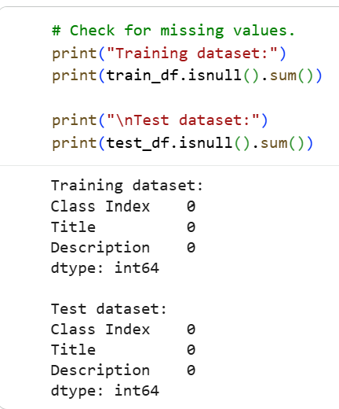
No missing values were found in any of the required fields. Therefore, no articles need to be removed or filled, and all 120,000 training articles and 7,600 test articles were retained.

3.2.2 Combining and Cleaning the Text
The article title and description were combined into a single text input. This allows the models to use information from both fields when deciding the article category instead of relying only on the headline or description.

During inspection, backslash characters were also found within a noticeable number of articles. These appeared to be formatting artefacts rather than meaningful parts of the text.
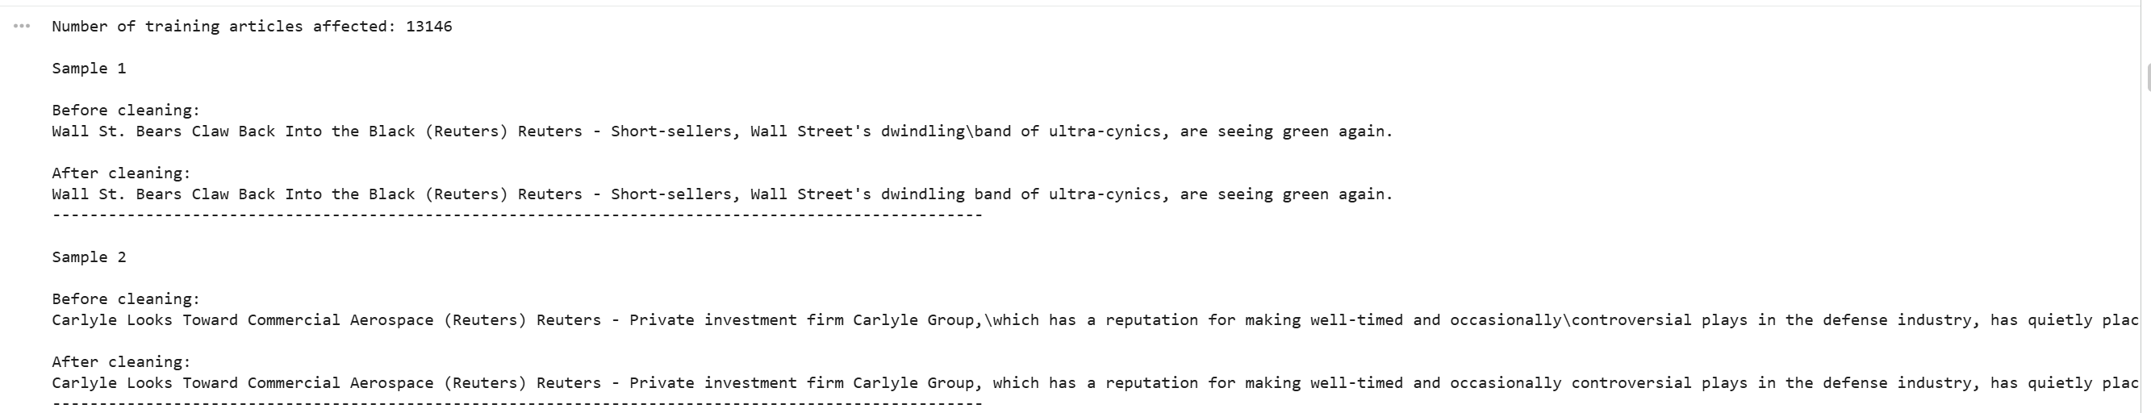
In total, 13,146 training articles contained these backslash formatting artefacts. The backslashes were replaced with spaces so that neighbouring words would not be incorrectly joined during tokenization. For example, text separated by a backslash remains as two readable words after cleaning.

No aggressive cleaning was applied beyond this formatting issue. Punctuation, sentence structure and the original wording were otherwise preserved so that useful contextual information remained available to the models.

3.2.3 Label Encoding
The original AG News labels range from 1 to 4. These were converted to 0 to 3.
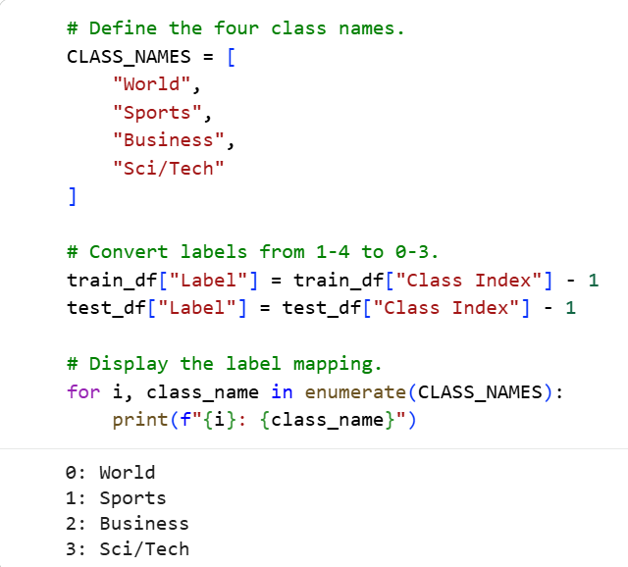
This allows the integer labels to be used directly with sparse categorical crossentropy without needing to convert them into one-hot encoded vectors.

3.2.4 Training and Validation Split
The original training dataset was divided into 80% training and 20% validation data using stratified sampling. The official AG News test.csv dataset was not included in this split and was kept separate throughout model development.
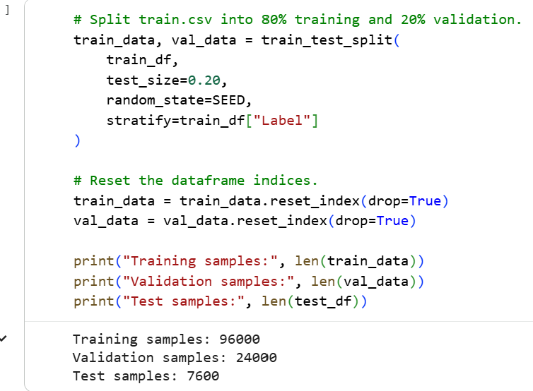
This produced 96,000 training articles, 24,000 validation articles and the original 7,600 test articles.
The training set was used to learn the model parameters, while the validation set was used for model development and selection. Keeping the official test set untouched until the final evaluation reduces the risk of selecting a model based on its test performance and provides a fairer estimate of generalisation.

3.2.5 Class Distribution After Splitting
The class distribution was checked again after the split.
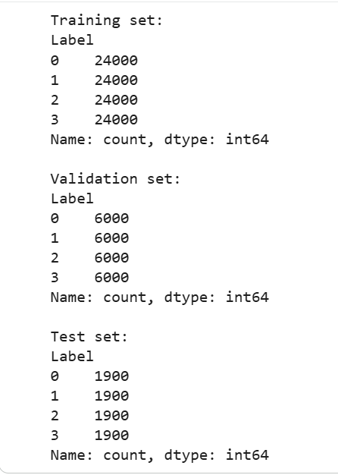
The stratified split preserved the balanced distribution of the original dataset. Each category contains 24,000 training samples, 6,000 validation samples and 1,900 test samples. This means that all four categories remain equally represented in every subset. Since there is no class imbalance after splitting, class weighting was not required during training.

3.2.6 Article Length Analysis
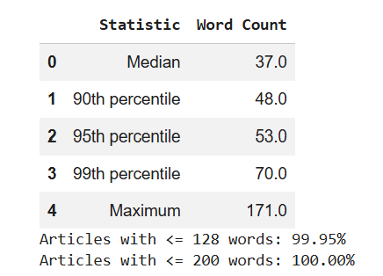
The articles are generally short. The median article contains 37 words, while the 90th and 95th percentiles are 48 and 53 words respectively. Even at the 99th percentile, an article contains only 70 words, while the longest article contains 171 words.

These results help justify the sequence lengths used later. A sequence length of 200 tokens is used for the BiLSTM, which is sufficient to cover all articles based on the whitespace word-count analysis.
DistilBERT uses a shorter maximum length of 128 tokens to reduce memory and computation. Approximately 99.95% of articles contain 128 words or fewer, so this limit still covers nearly the entire dataset by word count.

DistilBERT uses WordPiece subword tokenization, so its exact token counts may be slightly higher than these whitespace word counts. However, the length analysis still shows that 128 is a reasonable balance between retaining article content and controlling the computational cost of transformer fine-tuning.

3.2.7 Model-Specific Tokenization
The two models require different ways of converting text into numerical inputs, so their tokenization pipelines were kept separate.
For the BiLSTM, Keras TextVectorization was adapted using only the 96,000 training articles. The vocabulary was limited to 10,000 tokens, and each article was converted into a fixed sequence of 200 token indices. The vocabulary was not adapted using validation or test articles, preventing information from these sets from influencing the representation learned during model development.

The resulting integer sequences were then passed into a trainable embedding layer.

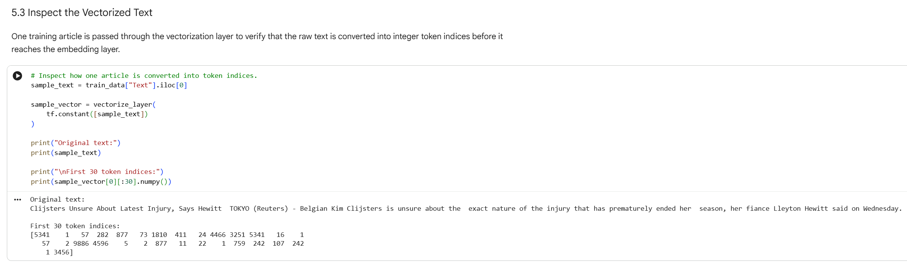
The output confirms that the BiLSTM vocabulary contains 10,000 tokens and that the raw article text is successfully converted into an integer sequence that can be processed by the embedding layer.

DistilBERT uses its own pretrained WordPiece tokenizer rather than the BiLSTM TextVectorization vocabulary. Its tokenizer contains 30,522 tokens and produces both input_ids and an attention_mask.
The tokenization example shows how DistilBERT can break unfamiliar words into smaller subword units. For example, “Clijsters” is divided into cl, ##ij and ##sters.

Special tokens such as [CLS] and [SEP] are also added automatically, while the attention mask identifies which positions contain actual input tokens.

Using separate preprocessing pipelines ensures that each model receives the form of numerical input it was designed to use, while both models still train and validate on exactly the same article samples.

3.3 Bidirectional LSTM Development
The first text-classification approach used a Bidirectional Long Short-Term Memory network with a trainable embedding layer.

A baseline BiLSTM was trained first to establish its performance and examine how it behaved over multiple epochs. Since the baseline later showed signs of overfitting, a second configuration with additional regularisation and validation-based callbacks was tested.

The two versions were then compared using validation performance before selecting the BiLSTM used for final test evaluation.
3.3.1 Baseline BiLSTM Architecture
The input text was first converted into integer sequences using the TextVectorization layer described earlier. These sequences were then passed into an Embedding layer with 128 dimensions.

The embedding layer learns a numerical representation for each token during training instead of using the token indices directly.

The embedded sequences were then passed through a Bidirectional LSTM with 64 units. Processing the text in both directions allows information from earlier and later parts of an article to contribute to the final representation.

The BiLSTM output was followed by a Dense layer with 64 neurons and a final Softmax layer with four outputs corresponding to World, Sports, Business and Sci/Tech.
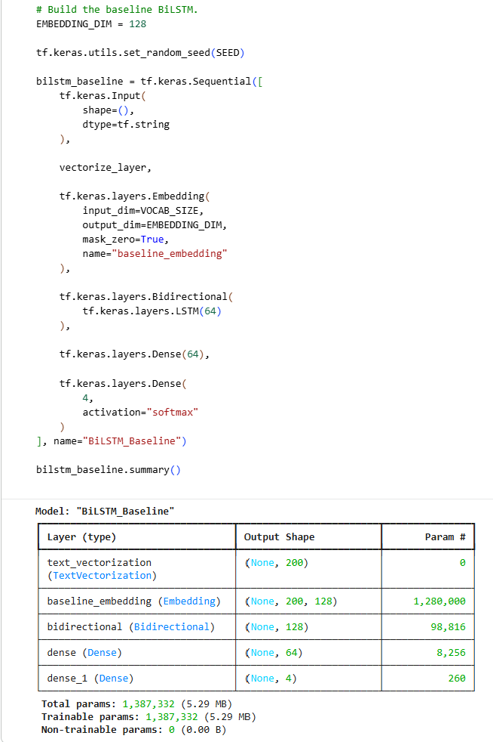
The baseline BiLSTM contains 1,387,332 trainable parameters.

Most of these parameters come from the Embedding layer, which contains approximately 1.28 million parameters. These embeddings are learned directly from the AG News training data rather than being taken from a pretrained language model.
Compared with DistilBERT which will be used later in the experiment, this makes the BiLSTM considerably smaller, although it also means that its language representation has to be learned mainly from the task-specific dataset.

3.3.2 Training Setup
The baseline BiLSTM was compiled using Adam with sparse categorical crossentropy as the loss function. Sparse categorical crossentropy was appropriate because the four news categories were represented using integer labels from 0 to 3.

Accuracy was used to monitor classification performance. The model was trained for 10 epochs using a batch size of 128. Validation accuracy and loss were recorded after every epoch so that changes in generalisation performance could be compared with the training results.
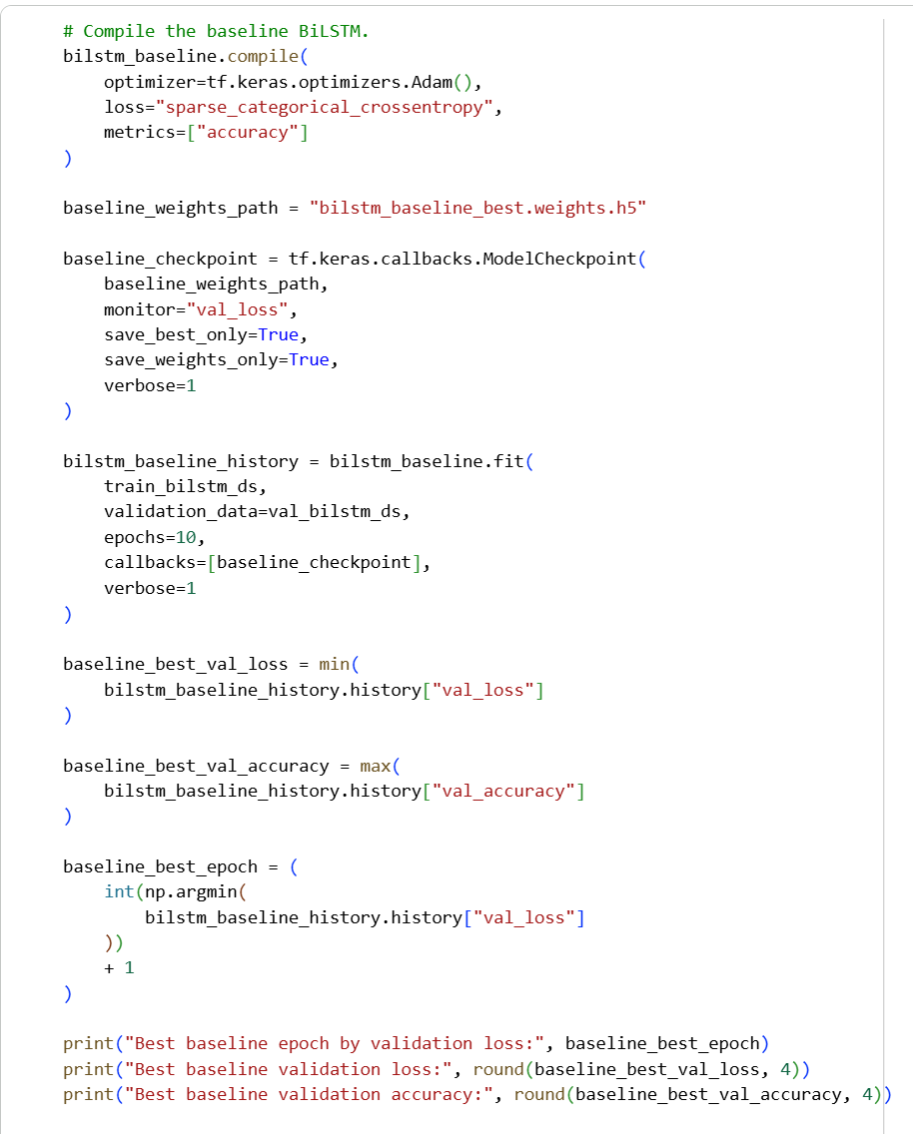
Although the full 10 epochs were run, model selection was based on validation loss rather than simply taking the final epoch. The best-performing weights were therefore saved during training for later evaluation.

3.3.3 Baseline BiLSTM Training Performance
The training and validation curves were examined to understand how the baseline BiLSTM learned across the 10 epochs.
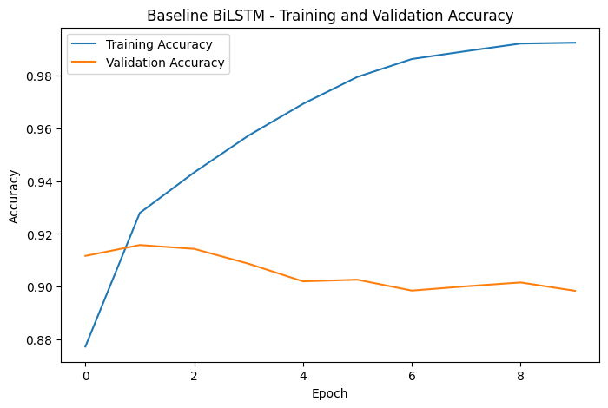 | 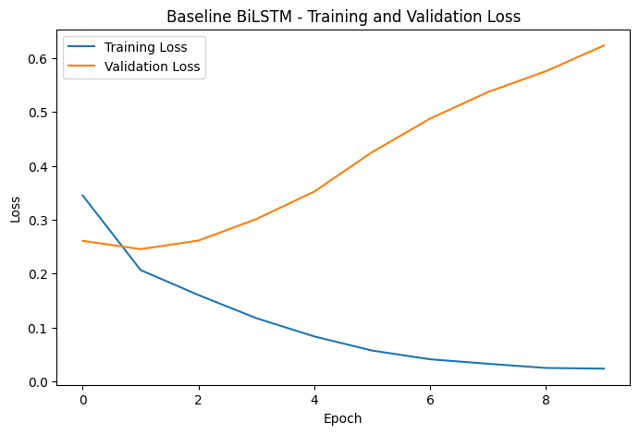
The BiLSTM learned the training data quickly during the first few epochs. Training accuracy increased from 87.74% in epoch 1 and continued rising until it reached approximately 99.24% by epoch 10.

Validation performance followed a different pattern. The highest validation accuracy was 91.58% at epoch 2, which was also the point where the lowest validation loss of 0.2454 was recorded. After epoch 2, training accuracy continued to increase, but validation accuracy gradually declined instead of improving with it. By epoch 10, validation accuracy had fallen to approximately 89.85% even though training accuracy was above 99%. Validation loss showed the same pattern. It increased from 0.2454 at epoch 2 to 0.6236 by epoch 10, while training loss continued to decrease to approximately 0.0235.

The growing gap between the training and validation results shows clear overfitting. The model continued becoming better at fitting the training articles, but this did not translate into better performance on unseen validation articles.

Based on validation loss, epoch 2 was selected as the best baseline checkpoint rather than the final epoch. Since the main weakness was overfitting rather than poor learning, a second BiLSTM configuration was tested with additional regularisation and validation-based training controls.

3.3.4 Regularised BiLSTM Architecture and Training Strategy
The second BiLSTM kept the same main architecture and parameter count so that the effect of regularisation could be examined without introducing a completely different model.

Dropout with a rate of 0.3 was added after the Bidirectional LSTM and again after the Dense layer. During training, Dropout temporarily removes a proportion of activations, which can reduce the model's tendency to depend too strongly on specific learned features.

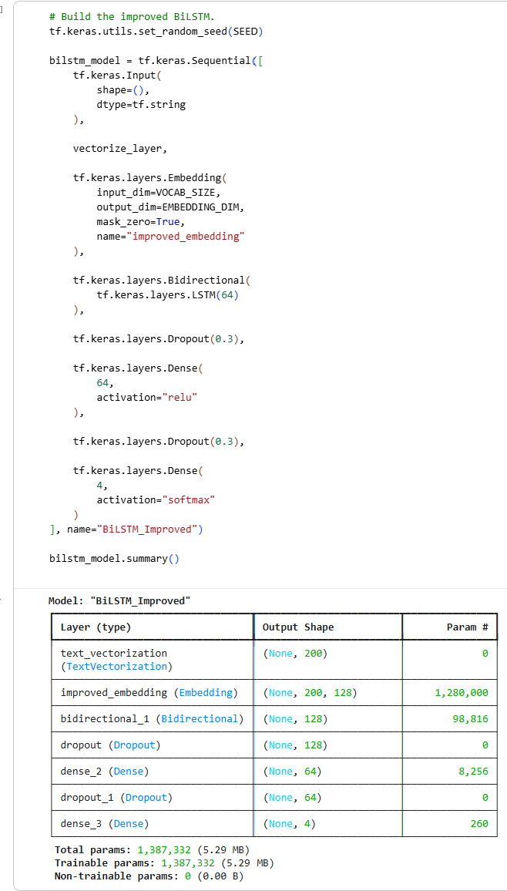
The model was again compiled using Adam and sparse categorical crossentropy. Two validation-based callbacks were also added. EarlyStopping monitored validation loss and stopped training when improvement was no longer observed, while restoring the best weights. ReduceLROnPlateau reduced the learning rate when validation loss stopped improving.
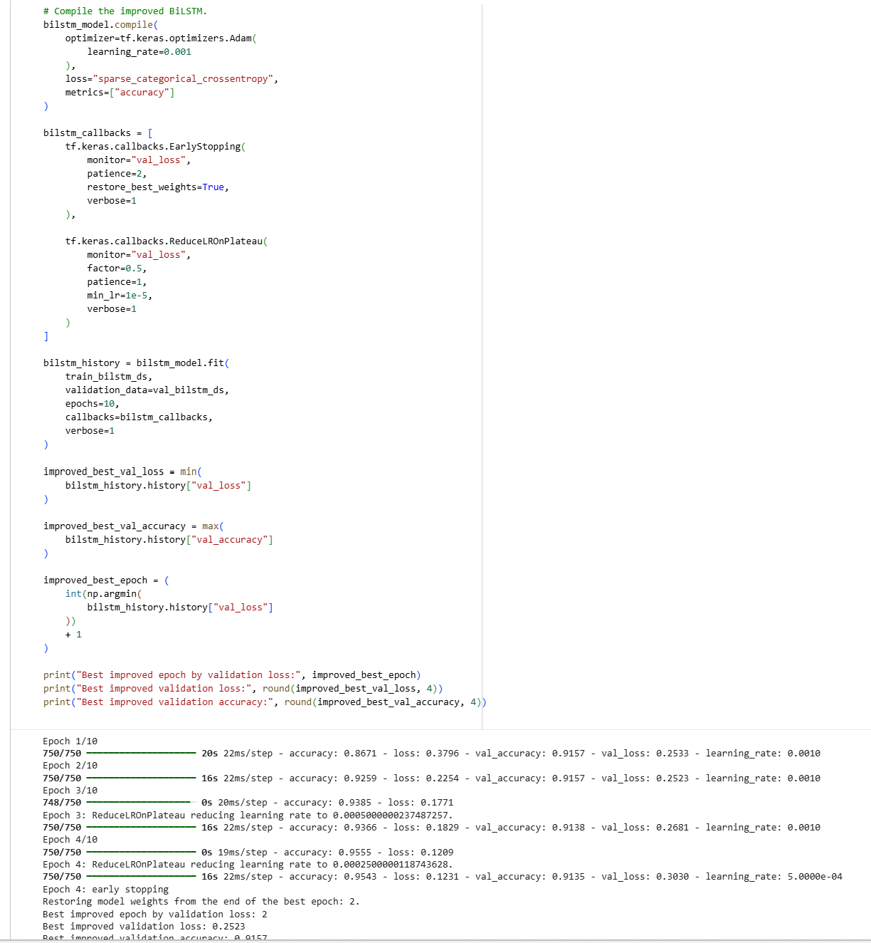
The regularised model still contained 1,387,332 parameters, so the comparison mainly tests whether the new training strategy and Dropout improve generalisation rather than whether a larger model performs better.

3.3.5 Regularised BiLSTM Training Performance
The training and validation behaviour of the regularised configuration was then examined.
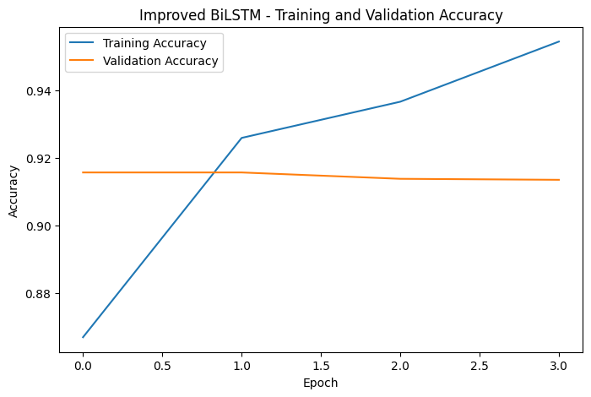 | 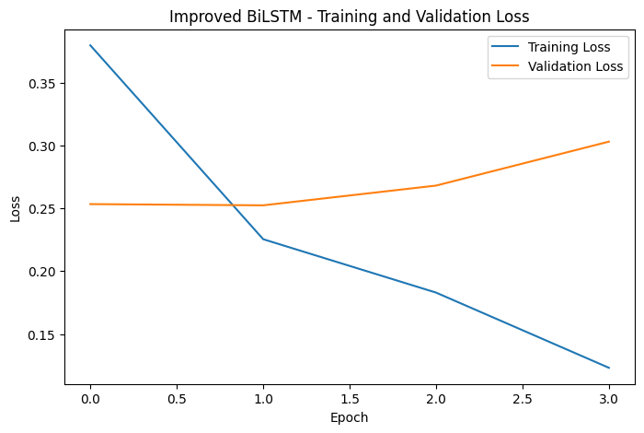
The regularised BiLSTM also learned quickly and achieved strong validation performance during the first two epochs. Its best validation accuracy was approximately 91.57%, while the lowest validation loss was 0.2523 at epoch 2. Validation loss increased in the following epochs, causing the learning rate to be reduced. Early stopping then ended training at epoch 4 and restored the weights from epoch 2.
This avoided continuing through a long period of overfitting like the baseline model. However, preventing unnecessary training did not automatically produce a better best validation result.
The regularised model's lowest validation loss of 0.2523 was slightly higher than the baseline's 0.2454, while their best validation accuracies were almost identical.

3.3.6 Baseline vs Regularised BiLSTM
The two BiLSTM configurations were compared using their best validation results before deciding which model to evaluate on the official test set.
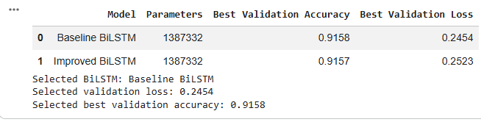
Both models achieved almost the same best validation accuracy, at approximately 91.58% for the baseline and 91.57% for the regularised model. However, the baseline achieved the lower validation loss, with 0.2454 compared with 0.2523 for the regularised configuration.

The regularisation strategy was still useful because it reduced unnecessary training and demonstrated that the overfitting behaviour could be controlled. However, it did not improve the strongest validation checkpoint. For this reason, the baseline BiLSTM checkpoint from epoch 2 was selected for the final test comparison.

This selection was based on validation evidence rather than assuming that the more complicated training setup must perform better. The result also shows that optimisation changes should be evaluated experimentally, since reasonable modifications such as additional Dropout do not always improve generalisation.

3.4 DistilBERT Fine-Tuning
The second approach used distilbert-base-uncased, a pretrained transformer model. Unlike the BiLSTM, which learns its word embeddings directly from the AG News training data, DistilBERT starts with language representations learned during pretraining and then adapts them to the four news categories.
3.4.1 Tokenization and Model Setup
DistilBERT uses its own WordPiece tokenizer rather than the TextVectorization layer used by the BiLSTM. The tokenizer has a vocabulary of 30,522 tokens and converts each article into input_ids together with an attention_mask.

A maximum sequence length of 128 tokens was used. Shorter sequences were padded while longer sequences were truncated. The earlier article-length analysis showed that almost all articles are short enough to fit within this limit, while keeping the sequence length at 128 also reduces the memory required during transformer fine-tuning.

The tokenized articles were grouped into batches of 16, which is smaller than the BiLSTM batch size because DistilBERT has much higher memory requirements.
The tokenizer can also divide unfamiliar words into smaller subword units rather than treating every word as a completely separate token. For example, the word “Clijsters” was represented using cl, ##ij and ##sters. This allows the pretrained vocabulary to represent words that may not exist as complete entries in the tokenizer.
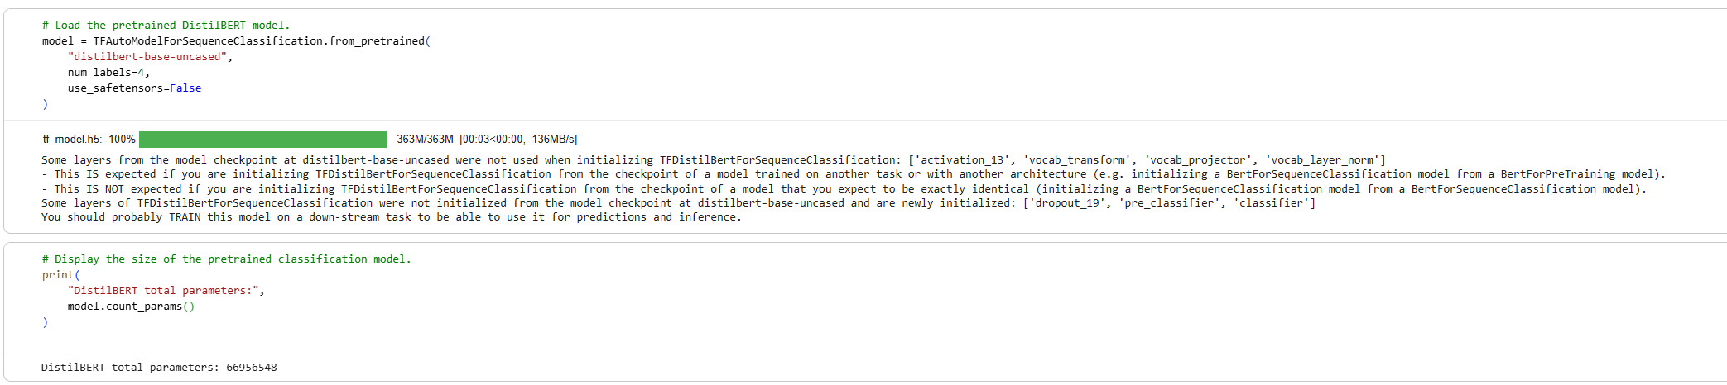
The DistilBERT model contains 66,956,548 parameters, making it considerably larger than the BiLSTM. The main advantage is that these parameters already contain pretrained language information before fine-tuning begins.

3.4.2 Compilation and Fine-Tuning Setup
DistilBERT was fine-tuned using Adam with an initial learning rate of 0.00005. A learning-rate schedule gradually reduced the learning rate during training. A relatively small learning rate was used because the model already contains pretrained weights. The aim is to adapt these existing representations to AG News without making unnecessarily large changes to the pretrained model.

Sparse categorical crossentropy was used with from_logits=True because DistilBERT produces raw class scores, known as logits, rather than Softmax probabilities directly. The model was fine-tuned for one epoch, which corresponds to 6,000 training batches.
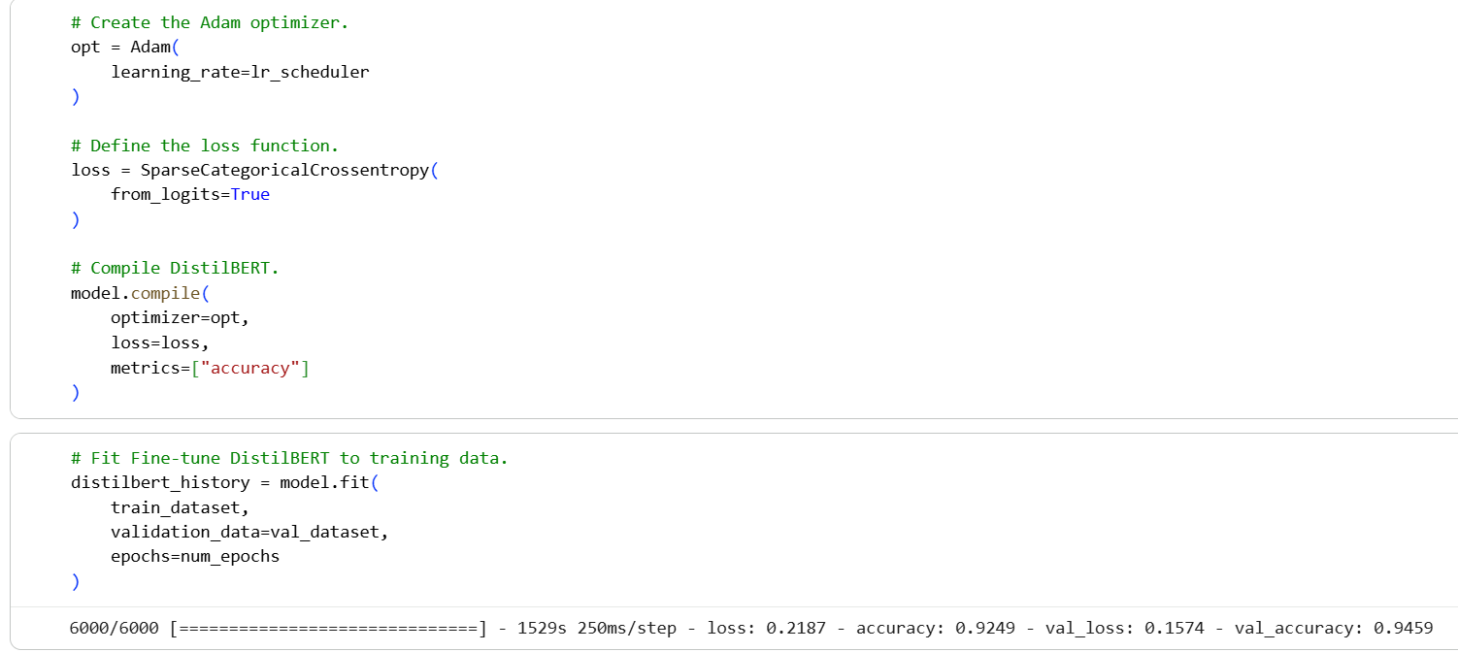

3.4.3 Training and Validation Performance
After one epoch of fine-tuning, DistilBERT achieved 92.49% training accuracy with a training loss of 0.2187. Validation performance was slightly higher, reaching 94.59% accuracy with a validation loss of 0.1574. The validation accuracy being higher than the training accuracy does not suggest overfitting. The training metric is accumulated throughout the epoch while the model weights are still being updated and training-time regularisation such as Dropout is active. Validation is measured afterwards using the final weights with training-time regularisation disabled.

The validation classification results were also strong across all four categories. Sports achieved an F1-score of approximately 0.99, followed by World at around 0.96, while Business and Sci/Tech both reached approximately 0.92.

Business and Sci/Tech remained the slightly more difficult categories, which is consistent with the earlier observation that these topics can contain overlapping language. Since DistilBERT was trained for only one epoch, there is not enough evidence to describe a longer-term training or overfitting trend. The important result is that strong validation performance was already achieved after a single fine-tuning pass.

Therefore, the selected BiLSTM and fine-tuned DistilBERT were evaluated next on the untouched official AG News test set.

3.5 Final Test Performance Comparison
After model development was completed, the selected BiLSTM checkpoint and fine-tuned DistilBERT were evaluated on the untouched 7,600 articles from the official AG News test set. Each category contains 1,900 test articles, so the comparison is not affected by class imbalance.
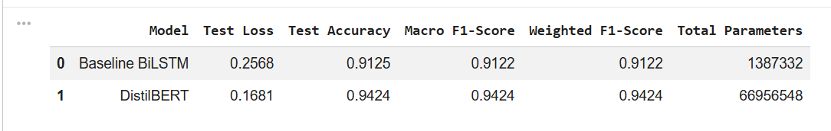
Both models performed strongly on unseen test articles, although DistilBERT achieved the better overall result. The selected BiLSTM achieved a test accuracy of 91.25%, while DistilBERT achieved 94.24%. This gives DistilBERT an improvement of 2.99%.

A similar difference can be seen in the F1-scores. The BiLSTM achieved a macro F1-score of 0.9122, compared with 0.9424 for DistilBERT. Their weighted F1-scores were almost identical to their macro F1-scores because the four test categories contain the same number of articles.

DistilBERT also achieved a lower test loss of 0.1681, compared with 0.2568 for the BiLSTM. Taken together, the accuracy, loss and F1-score results show that DistilBERT produced the stronger overall classification performance.

The test results were also close to the validation results. BiLSTM accuracy decreased only slightly from 91.58% validation accuracy to 91.25% test accuracy, while DistilBERT decreased from 94.59% to 94.24%. These small gaps suggest that both selected models generalised well to the unseen test data rather than depending heavily on the validation set.

However, the improvement from DistilBERT comes with much greater model complexity. The BiLSTM contains approximately 1.39 million parameters, while DistilBERT contains approximately 66.96 million, making DistilBERT about 48 times larger. Therefore, the results show a clear trade-off. DistilBERT provides a higher classification performance, while the BiLSTM achieves above 91% accuracy using a much smaller model.

The overall metrics show which model performed better, but class-level results are needed to see whether the improvement was consistent across all four news categories.

3.6 Class-Level Performance
The F1-score for each category was compared to determine whether DistilBERT's improvement came from only one class or was seen more consistently across the dataset.
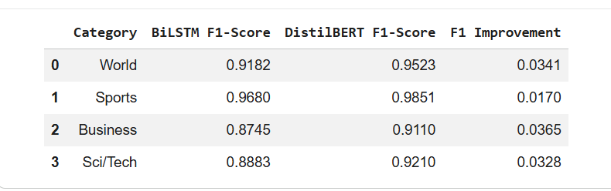
DistilBERT achieved a higher F1-score than the BiLSTM for all four categories. Sports was the strongest category for both models. Its F1-score increased from 0.9680 with the BiLSTM to 0.9851 with DistilBERT. World improved from 0.9182 to 0.9523, while Sci/Tech improved from 0.8883 to 0.9210.

The largest improvement was seen for Business, where the F1-score increased from 0.8745 to 0.9110. This is an improvement of approximately 0.0365, suggesting that DistilBERT was particularly useful for this more difficult category.

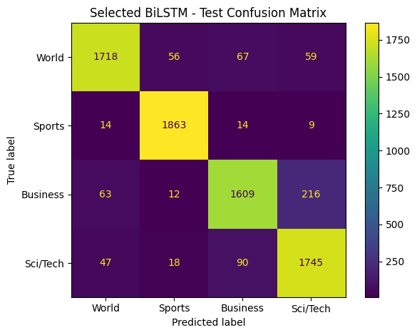 | 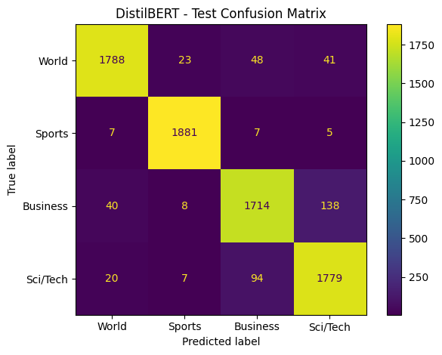
The confusion matrices show that both models classified Sports particularly well, with relatively few errors compared with the other categories. The main area of confusion was between Business and Sci/Tech. This is understandable because articles about technology companies, product launches, financial results or technology markets can contain language associated with both categories.

DistilBERT reduced several of these errors, which helps explain its stronger Business and Sci/Tech F1-scores. Its improvement was therefore not limited to the easier categories, but was also seen where the class boundaries were less clear.

Overall, the class-level results support the macro F1 comparison. DistilBERT's advantage was spread across all four categories rather than being caused by unusually strong performance on only one class.

3.7 Error Analysis
The most common misclassification directions were examined to understand where the remaining errors came from.
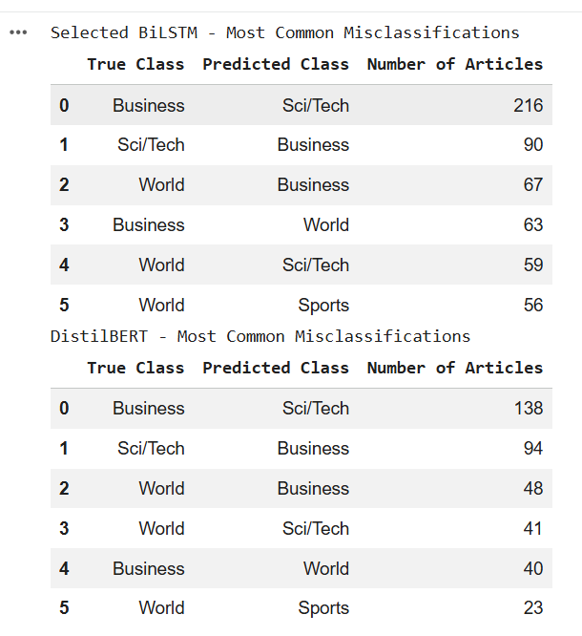
The most frequent BiLSTM error was Business being predicted as Sci/Tech, which occurred 216 times. The reverse confusion, Sci/Tech being predicted as Business, occurred 90 times. Other repeated errors included World being predicted as Business 67 times, Business as World 63 times, World as Sci/Tech 59 times, and World as Sports 56 times. DistilBERT reduced several of these mistakes. Business being predicted as Sci/Tech fell from 216 to 138 cases, while World being predicted as Sports decreased from 56 to 23 cases.

Not every error direction improved but Sci/Tech being predicted as Business increased slightly from 90 cases with the BiLSTM to 94 with DistilBERT. This is useful because it shows that DistilBERT is not uniformly better for every individual confusion direction, even though its overall class-level and test performance is stronger.

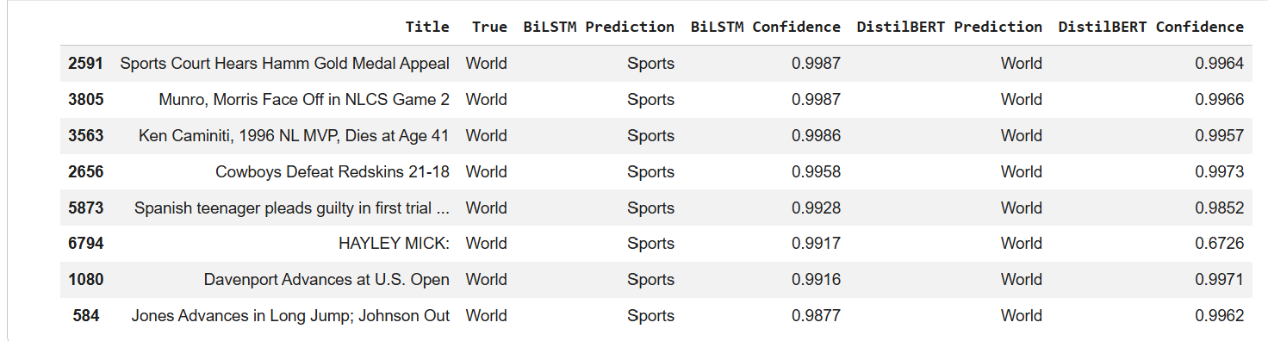
The qualitative examples give some insight into why these errors occur. Several World articles that were incorrectly classified by the BiLSTM contained strongly sports-related titles, such as articles about medal appeals, football matches or sporting competitions.

In these examples, the BiLSTM predicted Sports with very high confidence, even though the true category was World. Since the model receives both the title and description, this suggests that strong surface-level topic words can sometimes dominate its decision.
DistilBERT correctly classified these examples as World more often, suggesting that its contextual representations were better able to use the wider article content rather than relying mainly on obvious topic words.

These examples also show why overall accuracy alone is not enough to understand model behaviour. Looking directly at misclassified articles helps reveal the kinds of language that cause each model to make mistakes.

3.8 Discussion, Trade-offs and Possible Improvements
The Part 2 experiments show that both models are suitable for AG News classification, but they achieve their performance in different ways.

The BiLSTM produced a strong final result despite learning its word embeddings directly from the AG News training data. The selected checkpoint achieved 91.25% test accuracy and a macro F1-score of 0.9122.

Its main weakness was the clear overfitting seen after the early epochs. Training accuracy continued to increase above 99%, while validation performance stopped improving after epoch 2.
A regularised version with additional Dropout, early stopping and learning-rate reduction was therefore tested. This configuration controlled the training process more effectively and stopped after only four epochs, but its best validation loss of 0.2523 was slightly worse than the baseline value of 0.2454.

For this reason, the original BiLSTM checkpoint was retained. This result shows that adding more regularisations does not automatically improve performance and that model changes should be selected according to validation evidence rather than complexity alone.

DistilBERT achieved the stronger final performance, reaching 94.24% test accuracy and a macro F1-score of 0.9424. Unlike the BiLSTM, DistilBERT begins with pretrained contextual language representations. This appears to be especially useful when different categories contain overlapping vocabulary.

The class-level and error results support this. DistilBERT achieved a higher F1-score for all four categories and reduced the important Business → Sci/Tech confusion from 216 to 138 cases. It also handled several World articles with misleading sports-related wording better than the BiLSTM.
However, this improvement comes with a significant model-size trade-off. DistilBERT contains approximately 66.96 million parameters, compared with only 1.39 million for the BiLSTM. DistilBERT is therefore about 48.3 times larger. If memory, model size or deployment resources were limited, the BiLSTM could still be a reasonable choice because it provides strong accuracy with a much smaller architecture.

There are several possible directions for further improvement. The BiLSTM vocabulary size, embedding dimension and number of LSTM units could be tuned further, while different Dropout rates could be tested instead of assuming that 0.3 is optimal.

For DistilBERT, different learning rates or a small number of additional fine-tuning epochs could also be investigated. These experiments should continue to be selected using validation performance, since additional training does not necessarily lead to better generalisation.
The remaining Business and Sci/Tech errors could also be examined in more detail. Articles involving technology companies, financial results or technology products may naturally contain features of both categories, so some errors may be caused by genuine overlap in article content rather than a simple model failure.

Overall, DistilBERT was the strongest model for the news-classification task. The BiLSTM provided a much smaller alternative with strong performance, while DistilBERT achieved the best overall and class-level results by making use of pretrained contextual language representations.

4. Overall Conclusion
This assignment investigated different deep learning approaches for image and text classification, with the models developed and compared using validation performance before final evaluation on unseen test data.

For waste image classification, the original CNN performed poorly despite having almost 13 million parameters. Redesigning the architecture reduced the parameter count by 95.58%, from 12,940,489 to 571,881 parameters, while increasing best validation accuracy from 19.21% to 54.70%. The improved CNN eventually achieved 51.05% test accuracy with a macro F1-score of 0.5053.

Transfer learning produced a much stronger result. Frozen VGG16 already achieved 71.39% validation accuracy, and selectively fine-tuning its highest convolutional block increased this to 83.03%. On the unseen test set, the fine-tuned VGG16 achieved 81.49% accuracy and a macro F1-score of 0.8180. This shows that pretrained visual representations were particularly useful for the relatively small RealWaste dataset, while selective fine-tuning allowed the higher-level features to adapt further to the waste images.

For news classification, the selected BiLSTM achieved 91.25% test accuracy and a macro F1-score of 0.9122. Although a regularised version was tested to address the overfitting seen after the early epochs, it did not improve the best validation result. The original epoch-2 checkpoint was therefore retained based on validation performance.

DistilBERT achieved the strongest text-classification result, with 94.24% test accuracy and a macro F1-score of 0.9424. Its advantage was also seen across all four news categories rather than being limited to a single class. In particular, the error analysis showed that it reduced several important confusions between Business, Sci/Tech and World articles.

A common result across both parts is that the models using pretrained representations achieved the strongest final performance. VGG16 benefits from visual features learned from ImageNet, while DistilBERT begins with pretrained contextual language representations. In comparison, the custom CNN and BiLSTM had to learn much more of their feature representations directly from the task-specific datasets.

However, the pretrained models also come with greater complexity. The improved CNN contains only about 0.57 million parameters, compared with approximately 14.78 million for VGG16, while the BiLSTM contains about 1.39 million parameters compared with 66.96 million for DistilBERT. This means that the highest-performing model is not automatically the most suitable model when memory, computation or deployment size are important constraints.

Overall, the experiments show that strong deep learning performance depends not only on choosing a model architecture, but also on examining training behaviour, selecting models using validation evidence, applying suitable preprocessing and investigating class-level errors. For the tasks in this assignment, the selectively fine-tuned VGG16 was the strongest model for waste classification, while DistilBERT was the strongest model for news classification.

5. References
- Ahmad, G., Aleem, F. M., Alyas, T., Abbas, Q., Nawaz, W., Ghazal, T. M., Aziz, A., Aleem, S., Tabassum, N., & Ibrahim, A. M. (2025). Intelligent waste sorting for urban sustainability using deep learning. Scientific Reports, 15(1), 27078. https://www.nature.com/articles/s41598-025-08461-w
- Awan, A. A. (2022, November). A complete guide to data augmentation. DataCamp. https://www.datacamp.com/tutorial/complete-guide-data-augmentation
- GeeksforGeeks. (2022, March). Convolutional neural network (CNN) in TensorFlow. https://www.geeksforgeeks.org/deep-learning/convolutional-neural-network-cnn-in-tensorflow/
- GeeksforGeeks. (2026, May 2). Introduction to deep learning. https://www.geeksforgeeks.org/deep-learning/introduction-deep-learning/
- Global Tech Council. (n.d.). How deep learning works. https://www.globaltechcouncil.org/ai/how-deep-learning-works/
- Google. (2024). Overfitting. Google for Developers. https://developers.google.com/machine-learning/crash-course/overfitting/overfitting
- Hamza, A., Muhammad, A., Abbas, M. S., et al. (2026). Contextual deep learning for accurate news article categorisation with pre-trained embeddings. Scientific Reports, 16, Article 17976. https://doi.org/10.1038/s41598-026-38998-3
- Hugging Face. (n.d.). DistilBERT. Transformers documentation. https://huggingface.co/docs/transformers/model_doc/distilbert
- Kaggle. (n.d.). AG News classification dataset. https://www.kaggle.com/datasets/amananandrai/ag-news-classification-dataset
- Keras. (n.d.). Embedding layer. Keras API documentation. https://keras.io/api/layers/core_layers/embedding/
- Matplotlib Development Team. (n.d.). Matplotlib documentation. https://matplotlib.org/stable/
- NLTK. (n.d.). Natural language processing with Python: Processing raw text. https://www.nltk.org/book/ch03.html
- Rosebrock, A. (2020, April 20). Detect and remove duplicate images from a dataset for deep learning. PyImageSearch. https://pyimagesearch.com/2020/04/20/detect-and-remove-duplicate-images-from-a-dataset-for-deep-learning/
- Scikit-learn Developers. (n.d.). CountVectorizer. Scikit-learn documentation. https://scikit-learn.org/stable/modules/generated/sklearn.feature_extraction.text.CountVectorizer.html
- Scikit-learn Developers. (n.d.). Metrics and scoring: Quantifying the quality of predictions. Scikit-learn documentation. https://scikit-learn.org/stable/modules/model_evaluation.html
- Scikit-learn Developers. (n.d.). Scikit-learn documentation. https://scikit-learn.org/stable/
- Single, S., Iranmanesh, S., & Raad, R. (2023). RealWaste [Data set]. UCI Machine Learning Repository. https://doi.org/10.24432/C5SS4G
- Stack Overflow. (2017). Python script to detect broken images. https://stackoverflow.com/questions/46854496/python-script-to-detect-broken-images
- TensorFlow. (n.d.). TensorFlow Keras documentation. https://www.tensorflow.org/api_docs/python/tf/keras
- TensorFlow. (n.d.). TextVectorization. TensorFlow API documentation. https://www.tensorflow.org/api_docs/python/tf/keras/layers/TextVectorization
- TensorFlow. (n.d.). Transfer learning with a pretrained ConvNet. TensorFlow Core. Retrieved August 28, 2026, from https://www.tensorflow.org/tutorials/images/transfer_learning
- Thakur, R. (2023, March 9). Beginners guide to VGG16 implementation in Keras. Built In. https://builtin.com/machine-learning/vgg16
- UpGrad. (n.d.). Deep learning vs. NLP: Difference between deep learning & NLP. https://www.upgrad.com/blog/deep-learning-vs-nlp/
- IT3381 Lecture 1–6 slides
- IT3381 Practical 1–6 notebooks

