Hi everyone in team 8,

I created a configuration file to help format code automatically. I hope it will help everyone.

The configuration file named team8_code_style.xml in the documentation folder.

The following step is used to show how to use it:

1. Go to the menu Project -> properties

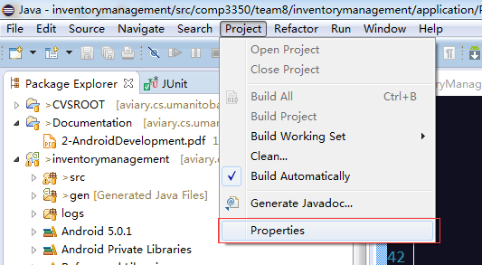

1. Choose the Java Code Style -> Formatter ->import, enable project specific setting

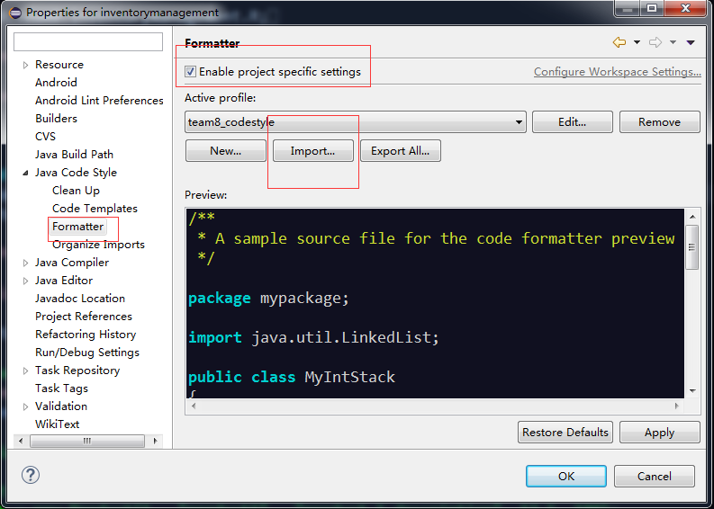

1. Select the configuration file, and click Apply -> Ok

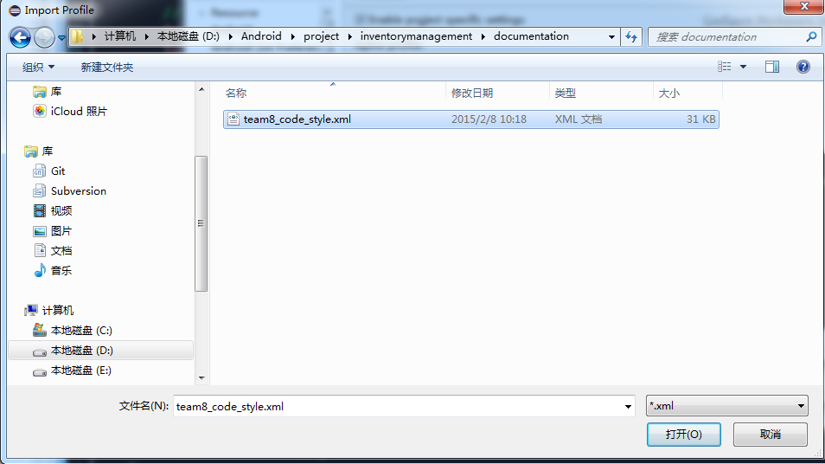

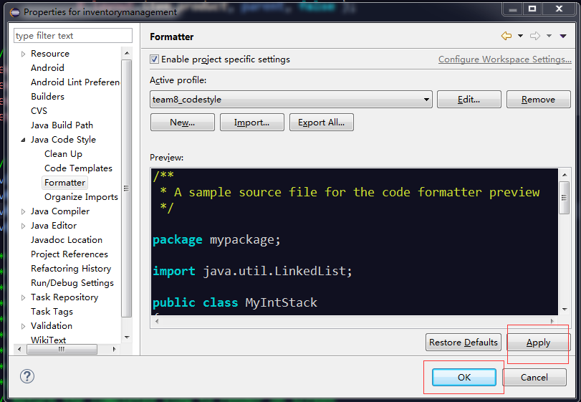

1. Restart the eclipse
2. Now, we can use the functionality of code formatting. For any code file,

use **ctrl shift + f** to format the code to standard style.

I hope it is helpful.

Yang