Preston Bruce

1. Consider the following Relation CAR(License_Number, Engine_Number, Make, model, Year) and its instances. (20)
   1. Are there any multivalued attributes in relation CAR? What is the rationale for your conclusion?
      1. If you are registering a car in multiple states License_Number could function as a multivalued attribute. As it could regigetered illegally.
   2. What is(are) the primary key(s) for the relation CAR? Explain the reason(s) for your answer. (10)
      1. The primary keys for CAR are License_Number and Engine_Number. Both of these values can be used to identify a car. License_Number has to be unique within a state and Engine_Number is unique within a car.
2. Represent the following database schema by an ERD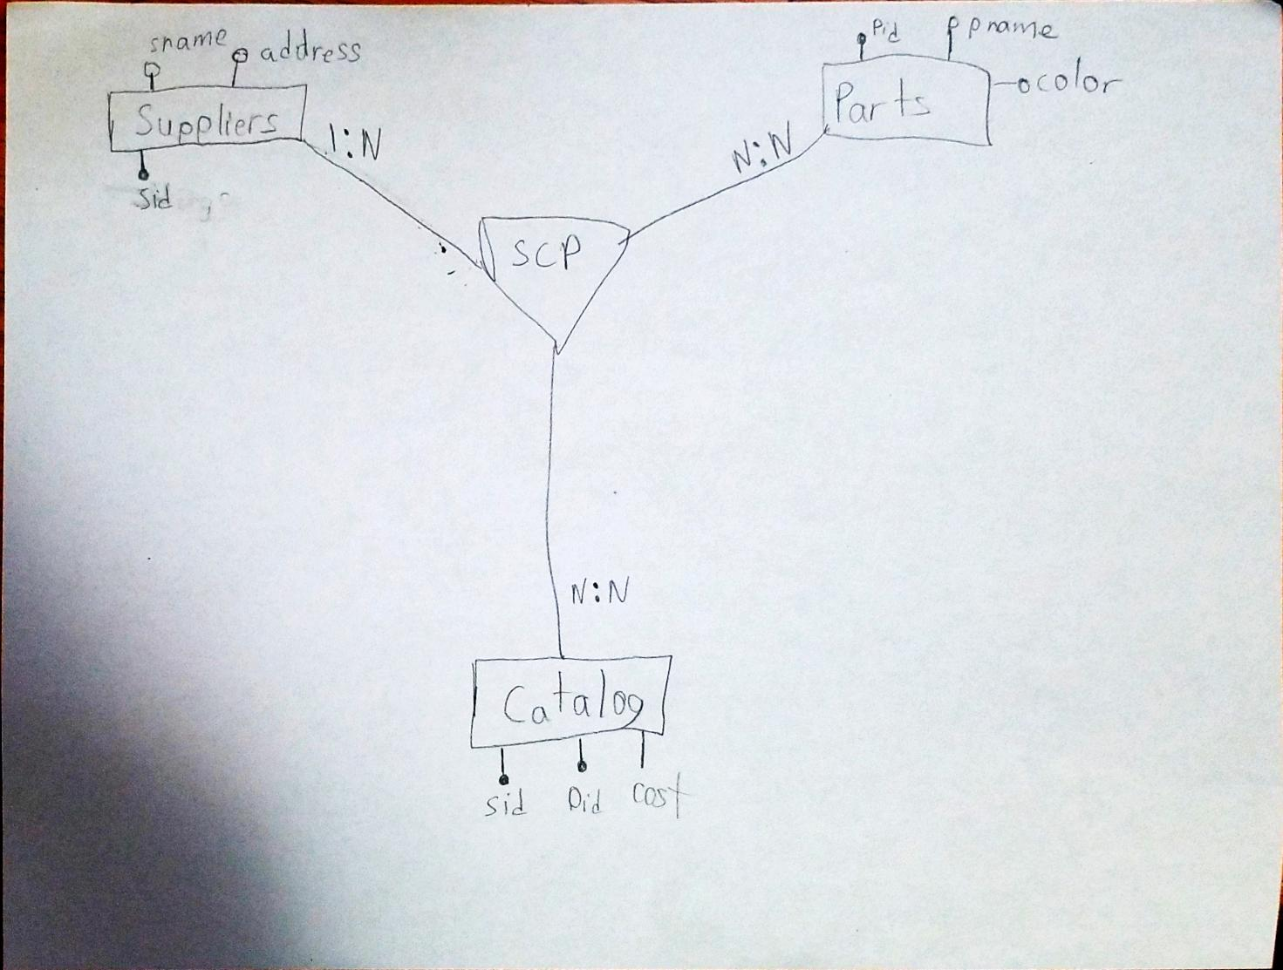
3. Review the following CREATE Table commands
   1. What is a Foreign Key?
      1. A foreign key is when one of more primary keys are used to create an identified in another table
      2. When used in combinations with other keys to create an identifier a primary key is counted as primary even when it is used in a table to where it function as the primary key alone
      3. It is a composite key because it combines multiple keys
4. Describe the two alternatives for specifying structural constraints on relationship types. What are the advantages and disadvantages of each?
   1. The two types of constrains are based on cardinality and participation.
      1. Cardinality: This is showing the relationship in forms such as 1:1, N:1, etc. This is good for quickly determining how entities are in relationship with one another.
      2. Participation: This is best used to understand how the different entities interact with each other, not the in terms of numbers
5. Using the instance diagram depicting the ternary relationship Orders shown below, answer the following questions
   1. Identify an error seeded in the diagram and correct the error
      1. Both the Charlotte and Galveston warehouses are both sending an order of pencils to Ives.
      2. To correct remove the relation between Galveston and r2
   2. Which customers order pens from the Galveston warehouse?
      1. There is not a customer ordering pens from Galveston
   3. Which items are ordered by customers from both warehouses?
      1. No items are being order by customers from both warehouse.
   4. Which warehouse fills one or more orders of items from both customers?
      1. Galveston fills orders for one or more items for both customers.
   5. Describe orders filled from both warehouses
      1. r1,r2,r3,r4
   6. What changes must be made to the instance diagram for order r1 to involve both pencils and pens?
      1. Draw a line from pencils to r1.