Preston Bruce

# Needs Requirements

### Overview

The purpose of this project is to create a mobile game similar to flappy bird in the Godot Game Engine. For the sake of this school project a large number of levels will omitted for the purpose of speed and ease of testing the product.

For the specific goals to work on a functional score tracker is the most important thing after core gameplay. This prototype will not be saving complex data for profiles for the purpose of the online data score comparison.

The major demographic audience for this project would be Google Play users. Mostly looking for a younger age group, found either through attracting kids with graphics or parents with the “Family Friendly” appearance

### Outline

1. This game targets a casual game user face. App store/Google Play users looking for a simple game.
2. Core gameplay loop
   1. Player taps/clicks game
   2. Player character (PC) Icon moves vertically
   3. Obstacles move form right to left
   4. Players must time the PC gravity and vertical ascent to navigate obstacles
3. This game will be built in the [Godot Engine](https://godotengine.org/). An open source game engine.

# Major Constraints

* 1. Aside from the original constraint of time the most major constraint for the project would be matter of lack of funding to acquiring unique assets. While they’ll be somewhat assets acquired from the Internet that are licensed under for use. The game will function more as a test concept and be able to be something that can be on the marketplace.
  2. This especially means that features such as leader boards are not be considered. As is required to set up an online database and servers to keep track of all these affirmations and compare them.

## Stakeholders

1. Major stakeholders of this project are user of the game. As such feedback was given to see on what exact needs people will want any in a small mobile game. Attached below would be a blank copy of one of the surveys use along with a couple of filled out versions.

Blank Form

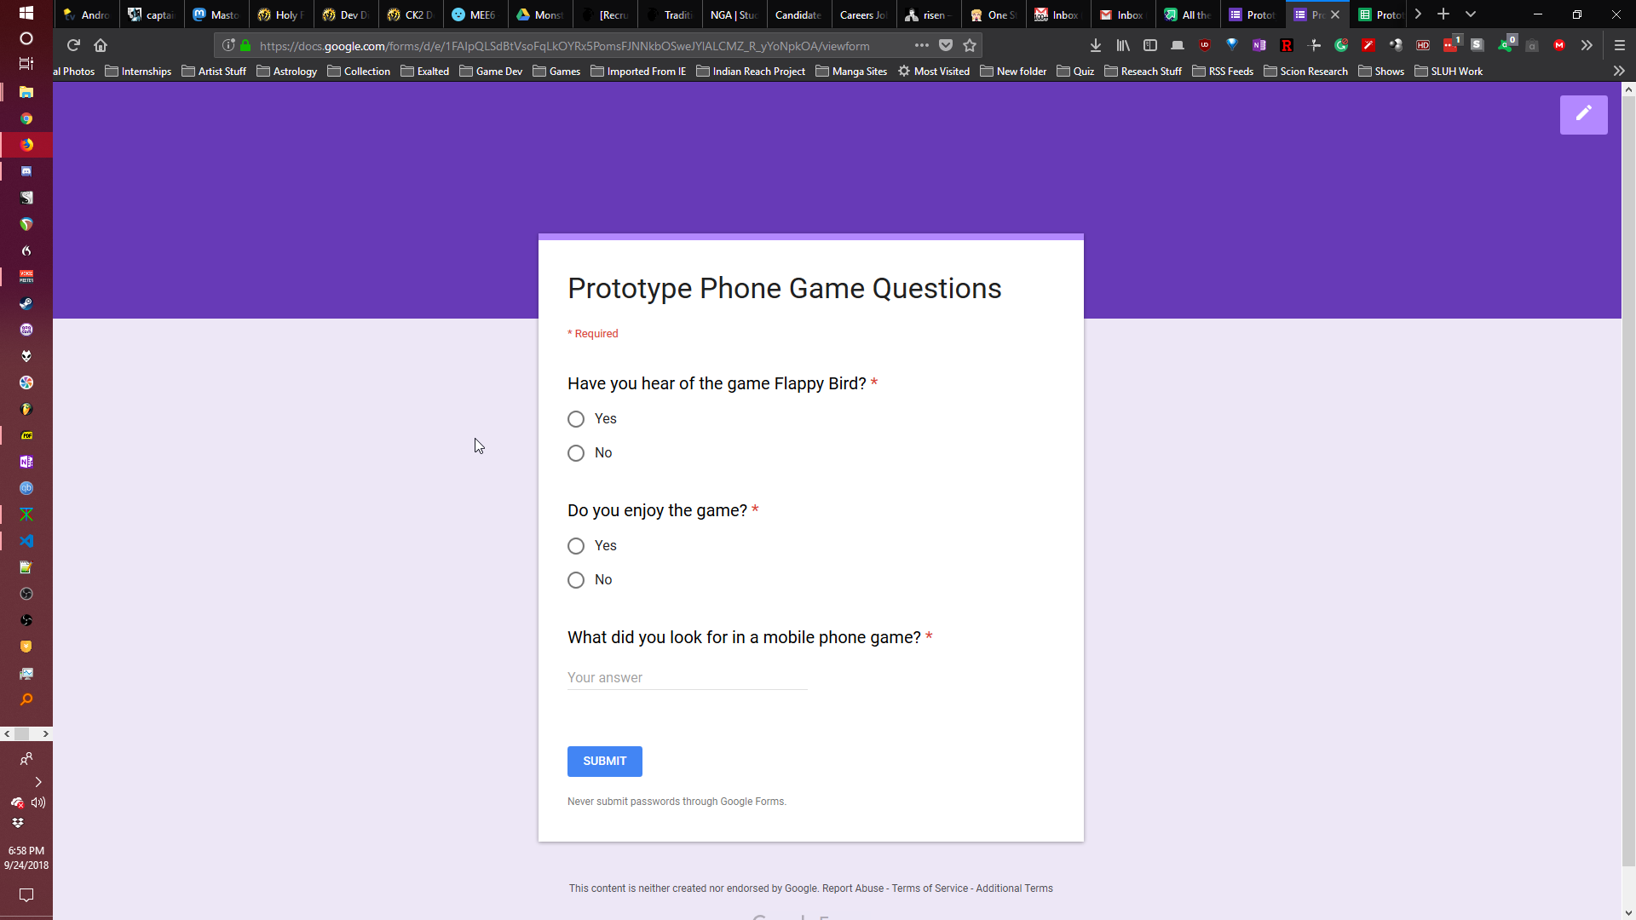

Filled Form

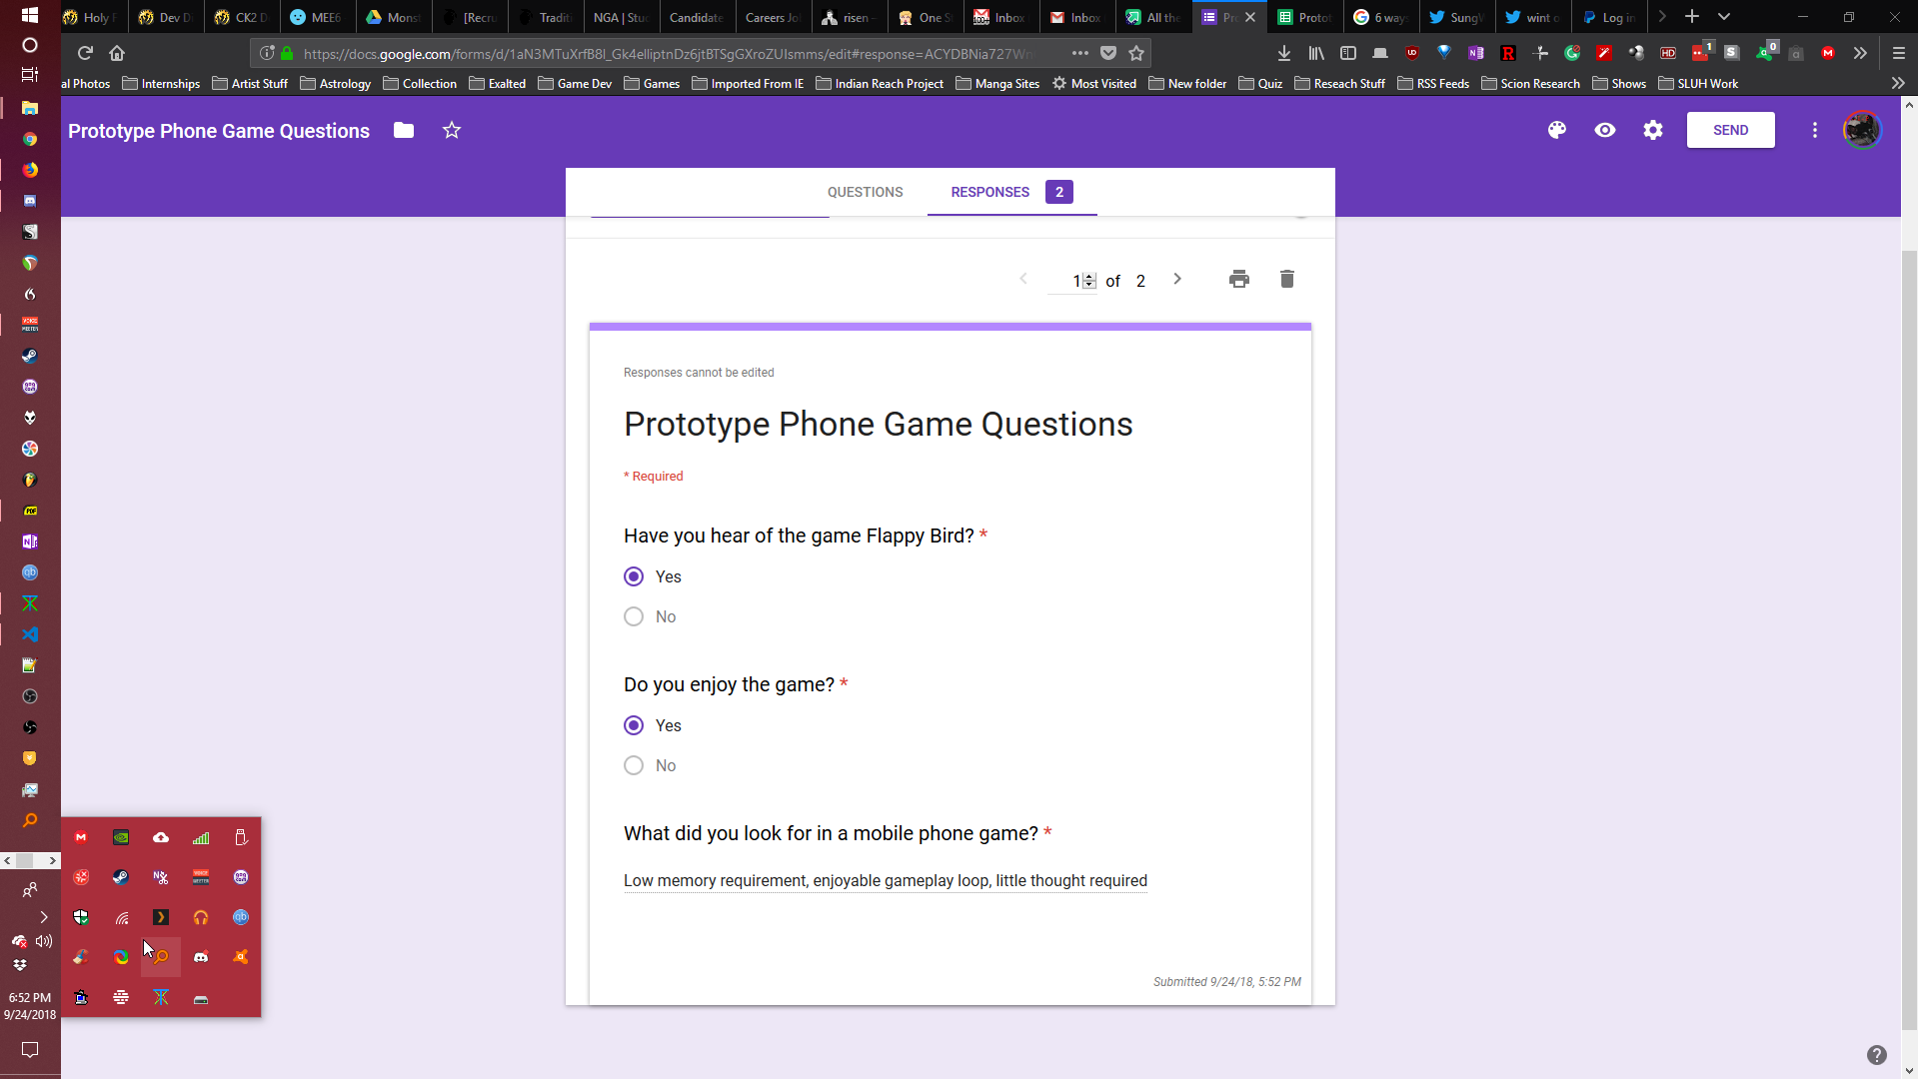

User Summary

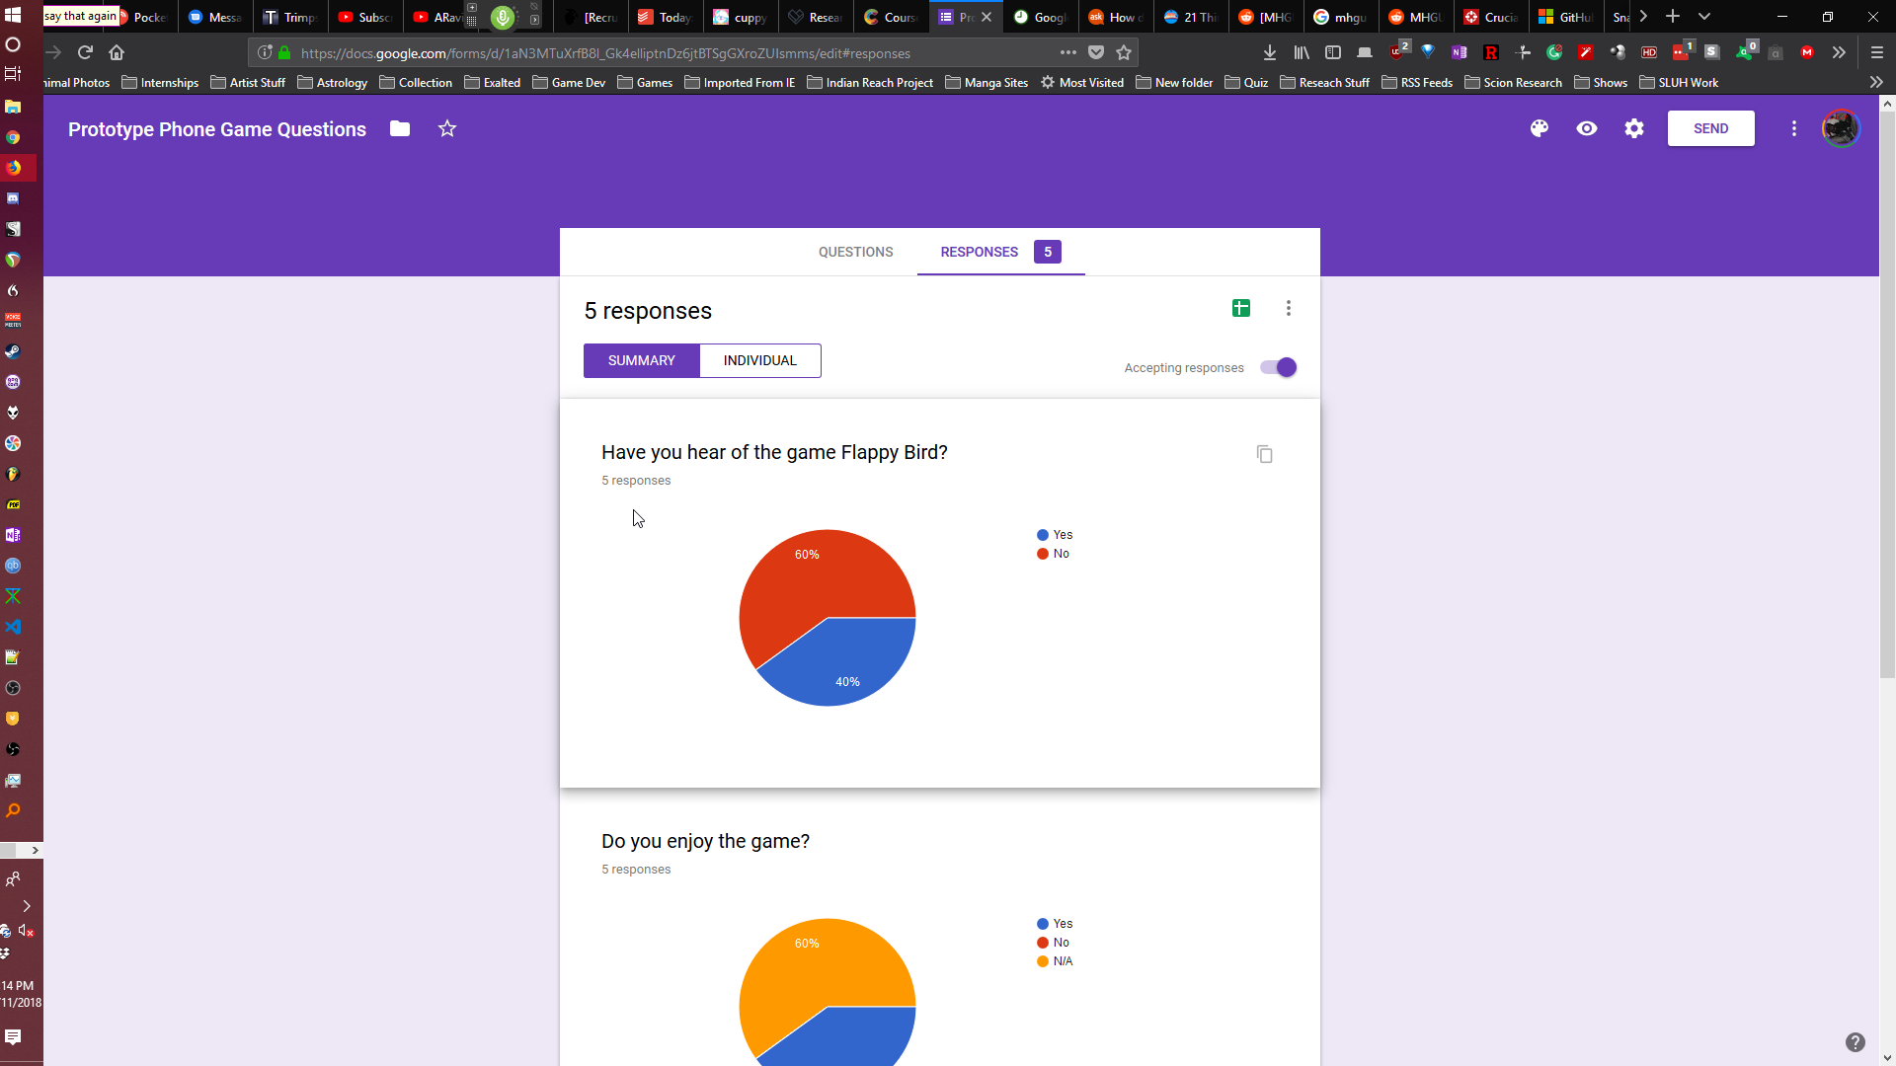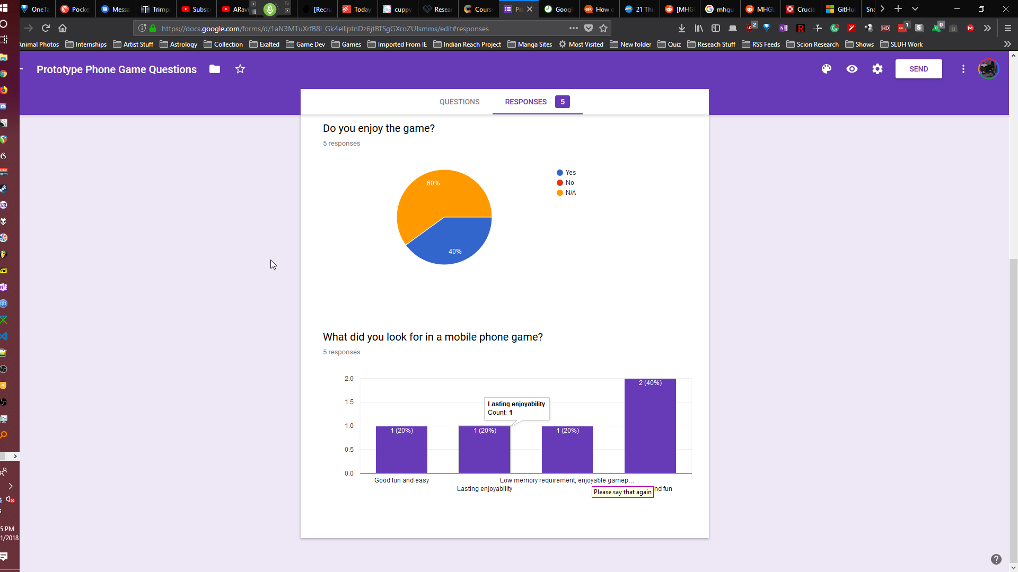

# Use Case

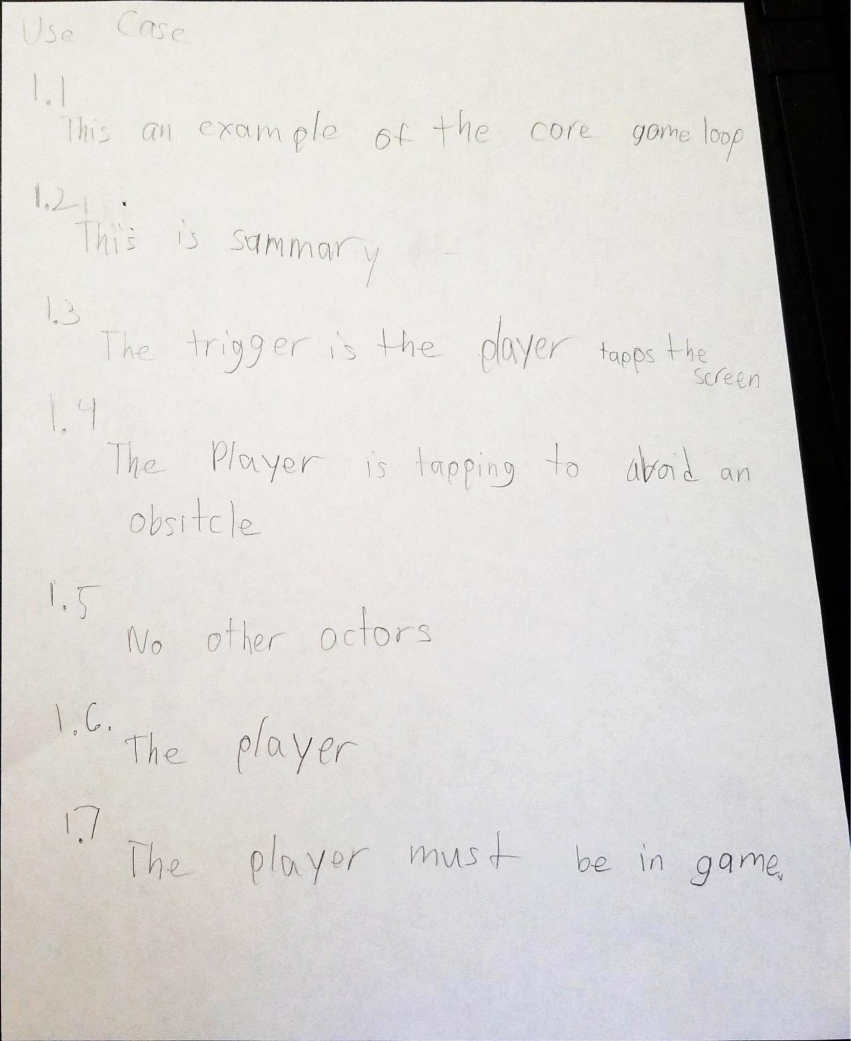

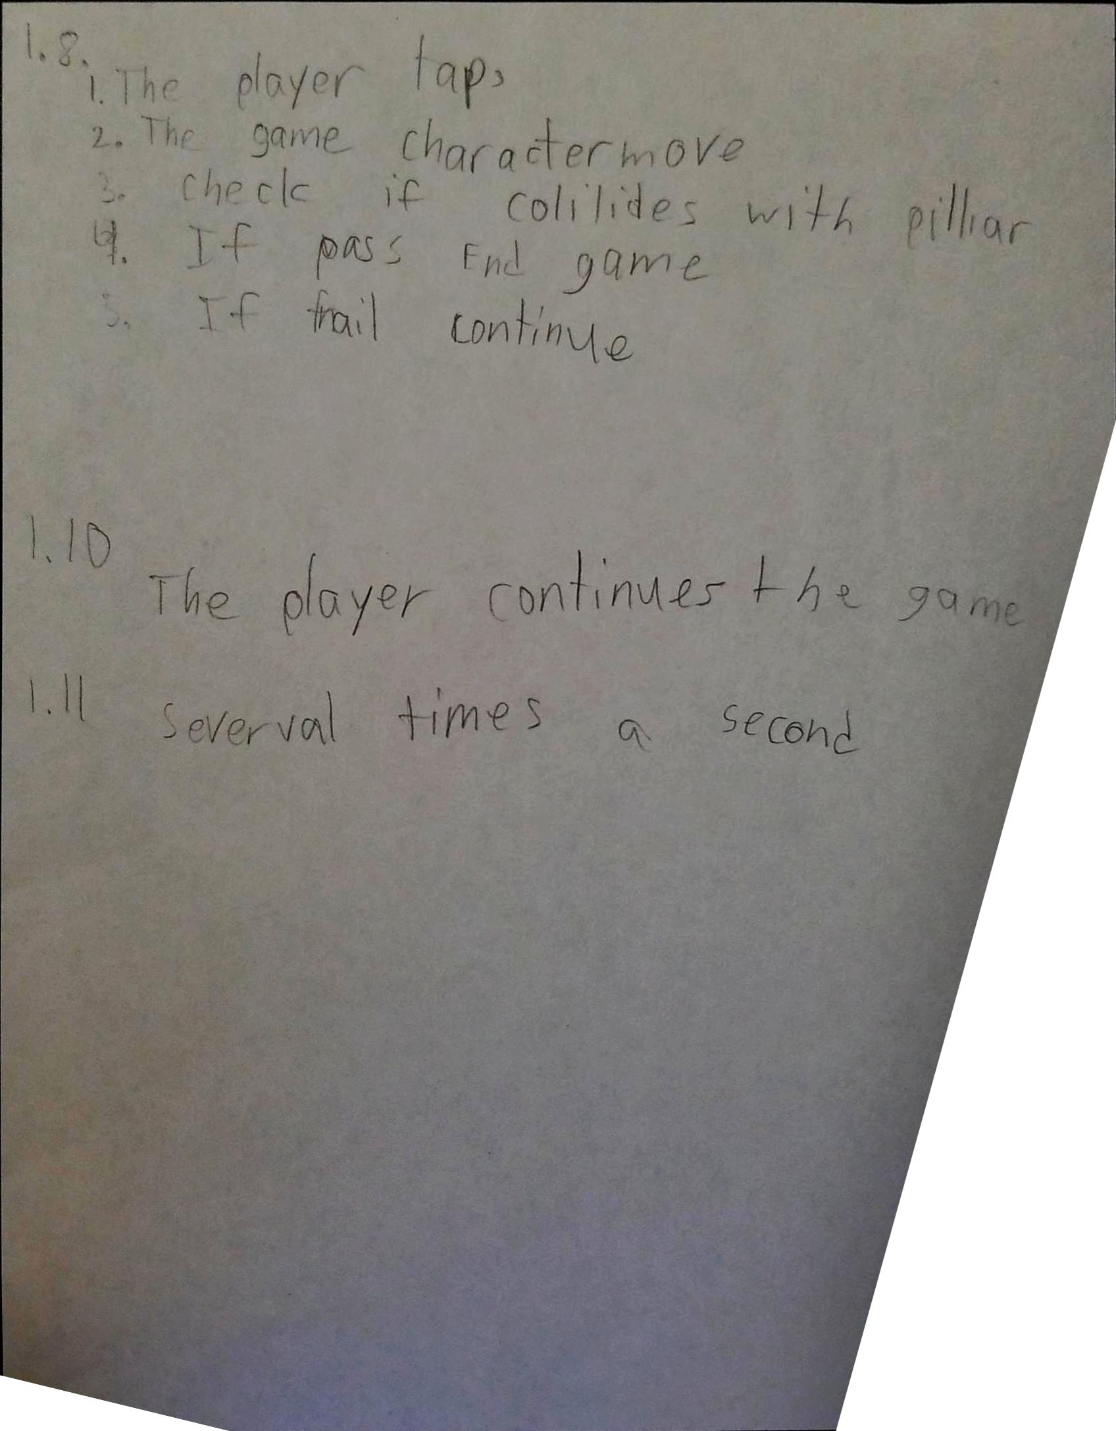

# Data Flow

General

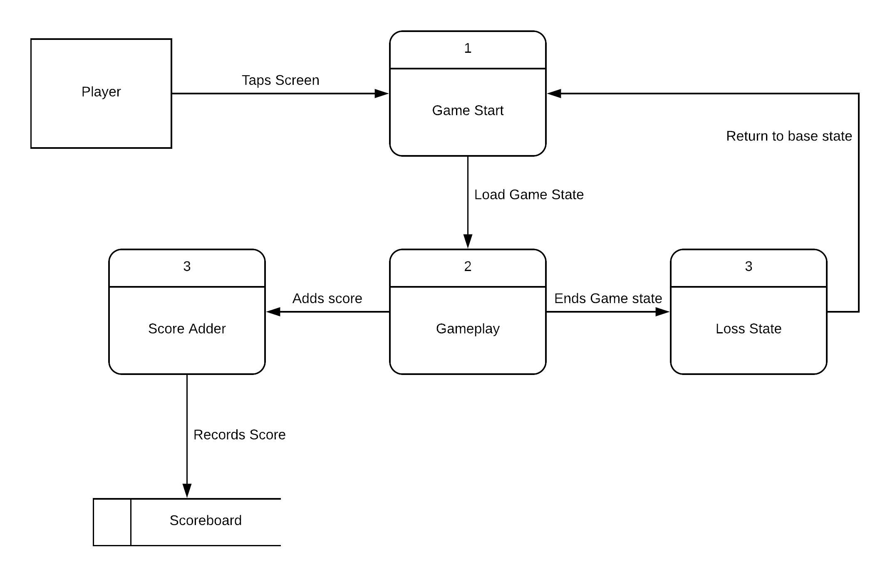

Gameplay Loop

