# Preston Bruce

## Needs Requiements

### Overview

The purpose of this project is to create a mobile game similar to flappy bird in the Godot Game Engine. For the sake of this school project a large number of levels will omitted for the purpose of speed and ease of testing the product.

For the specific the of goals to work on a functional score tracker is the most important thing after core gameplay. This prototype will not be saving complex data for profiles for the purpose of the online data score comparison.

The major demographic audience for this project would be Google Play users. Mostly looking for a younger age group, found either through attracting kids with graphics or parents with the “Family Friendly” appearance

### Outline

1. This game targets a casual game user face. App store/Google Play users lookning for a simple game.
2. Core gameplay loop
   1. Player taps/clicks game
   2. Player character (PC) Icon moves vertically
   3. Obsticals move form right to left
   4. Players must time the PC gravity and vertical ascent to navigate obsitcales
3. This game will be built in the [Godot Engine](https://godotengine.org/). An open source game engine.

### Feedback Mechanism

[General feedback Form](https://goo.gl/forms/WSsEBfVFIgi6RtfU2)

Blank Form

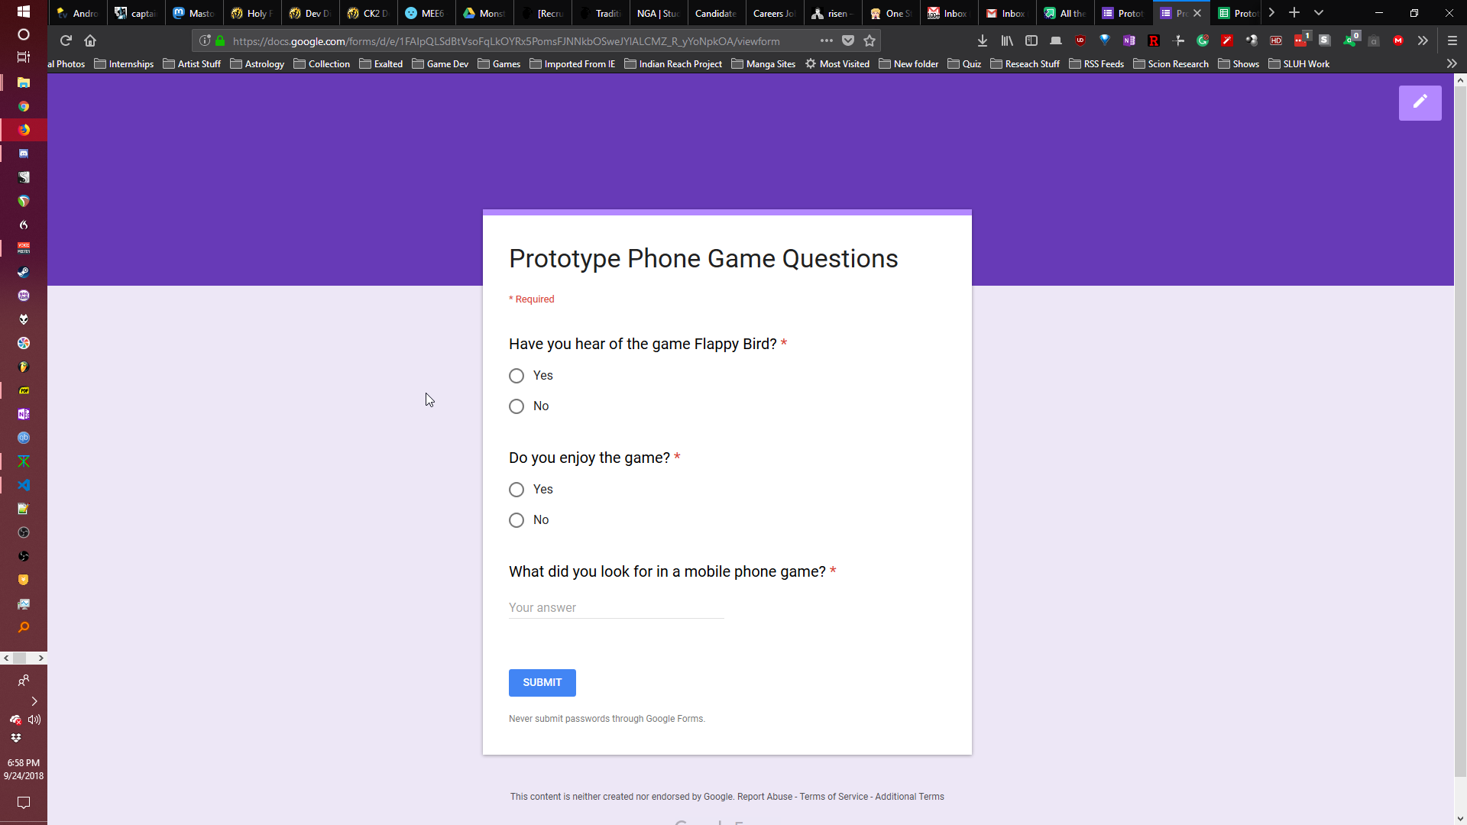

Filled Form

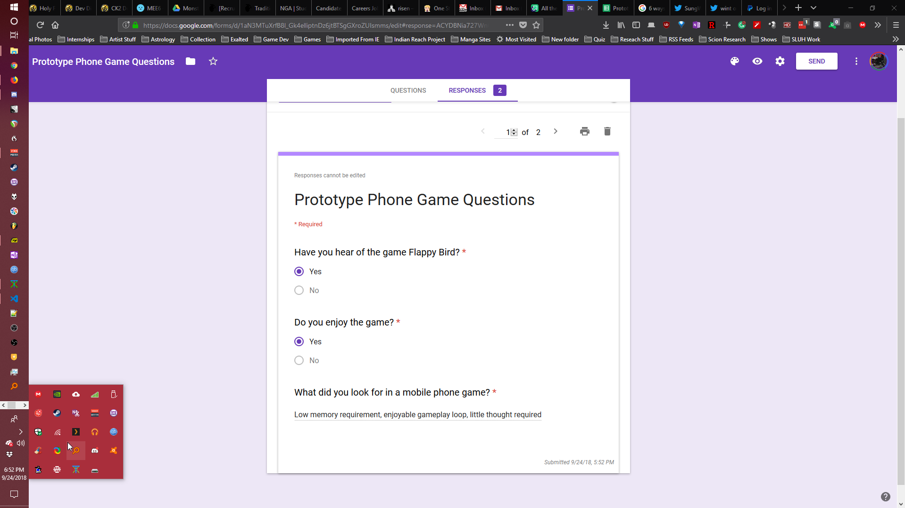

### Example Case Document

