EduLend
1. Introduction
EduLend is a React-based library management frontend that allows students to browse a catalog of books, borrow them, and track their loans via a personal dashboard. The system is connected to a full-stack Spring Boot backend, utilizing a real REST API and robust data persistence.
2. System Overview
Property | Value
Framework | React 18+ Vite
Styling | Tailwind CSS
Routing | React Router v6
HTTP Client | Axios (axiosClient with JWT interceptors)
State | React Context API (AuthContext, BorrowContext)
Persistence | PostgreSQL/H2 via Spring Boot
Auth | JWT-based Authentication via Spring Boot

3. Architecture
src/
├── api/
│ └── axiosClient.js # Axios instance + JWT interceptors
├── components/
│ ├── books/
│ │ └── BookCard.jsx # Book display + borrow action
│ ├── layout/
│ │ └── Layout.jsx # Header, footer, <Outlet />
│ └── routing/
│ └── ProtectedRoute.jsx # Auth guard
├── context/
│ ├── AuthContext.jsx # User state, login, register, logout
│ └── BorrowContext.jsx # Borrow state + localStorage persistence
├── hooks/
│ └── useBooks.js # Book data + search filter
├── pages/
│ ├── auth/
│ │ ├── Login.jsx
│ │ └── Register.jsx
│ ├── catalog/
│ │ └── Catalog.jsx
│ └── dashboard/
│ └── Dashboard.jsx
├── services/
│ └── tokenService.js # localStorage token abstraction
└── App.jsx # Router + Provider tree
4. Components Description
BookCard.jsx
Displays a single book. Reads isBorrowed() from BorrowContext to show correct state. Calls borrowBook() on click. Navigates to /login if user is not authenticated.

Catalog.jsx
Renders the full book list from useBooks hook. Passes each book to BookCard. Includes search input.

Dashboard.jsx
Reads borrowedBooks from BorrowContext. Displays borrow date (parsed from ISO string). Allows returning books via returnBook().

Layout.jsx
Shared shell: Header with nav links + user info, <Outlet /> for page content, Footer.

ProtectedRoute.jsx
Redirects unauthenticated users to /login. Shows nothing during loading to prevent flash.

5. Data Flow
useBooks (hook)
└── MOCK_BOOKS array
└── Catalog.jsx
└── BookCard.jsx
└── useBorrow() → borrowBook()
└── BorrowContext state
└── localStorage
└── Dashboard.jsx reads borrowedBooks
Auth flow:
Login.jsx → useAuth().login() → AuthContext
→ validates against localStorage['library_users']
→ tokenService.setTokens()
→ localStorage['activeUser']
→ setUser(userData)
6. Borrowing Logic ("Půjčit knihu")
• Entry point: BookCard.jsx → handleBorrow()
• Steps:
- Check if user is logged in; redirect to /login if not.
- Call borrowBook(book) from BorrowContext.
- Inside borrowBook:
  - If the book is not available or already borrowed by the user, the app alerts with an error or warning.
  - If available, the React app makes an axios.post() call to the /books/{id}/borrow Spring Boot endpoint.
  - The backend handles the decrementing of available quantities and creates the official Borrowing database record.
  - Upon a successful response from the server, the React app updates its local state.
  - BookCard re-renders: button shows "Již vypůjčeno", badge shows "Vypůjčeno vámi".
  - Dashboard is updated to reflect the new borrow by fetching the latest data.

7. Authentication Logic
Register:
- The application makes an axios.post() request to the /auth/register Spring Boot endpoint.
- The backend validates email uniqueness in the database and assigns the default 'MEMBER' role.
- Auto-logs in after successful registration.
Login:
- The application makes an axios.post() request to the /auth/login endpoint.
- The backend verifies the email and password against the database.
- Upon success, the server returns a JWT UserToken, which is then stored for the active session.
Session restore:
- On mount, AuthContext useEffect reads the token and activeUser state.
- Sets user state without requiring re-login.
Logout:
- Clears activeUser, tokens, and user state.
Token layer (axiosClient.js):
- Attaches Authorization: Bearer <token> to every outgoing request.
- On 401: attempts token refresh; on failure, dispatches auth:logout event.

8. Diagrams
A) Use Case Diagram
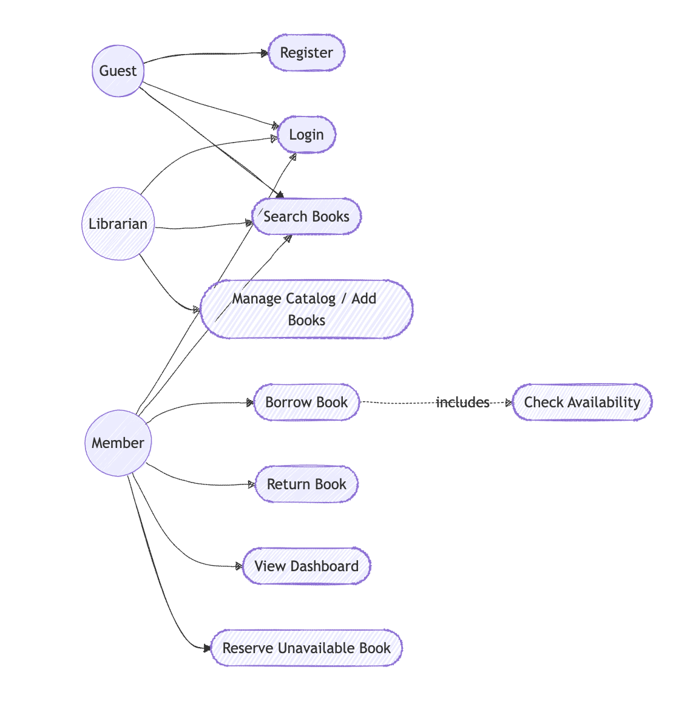

B) BPMN — Borrow Book Process
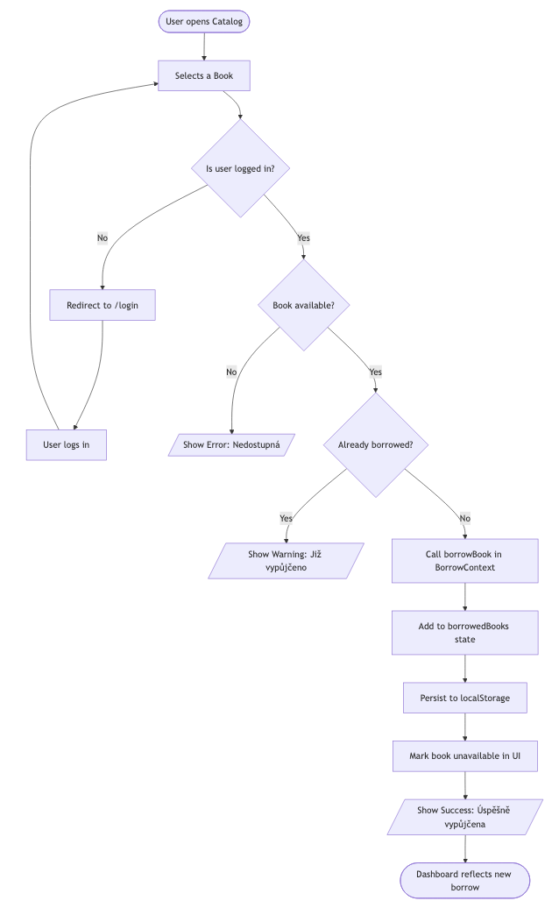
C) Deployment Diagram
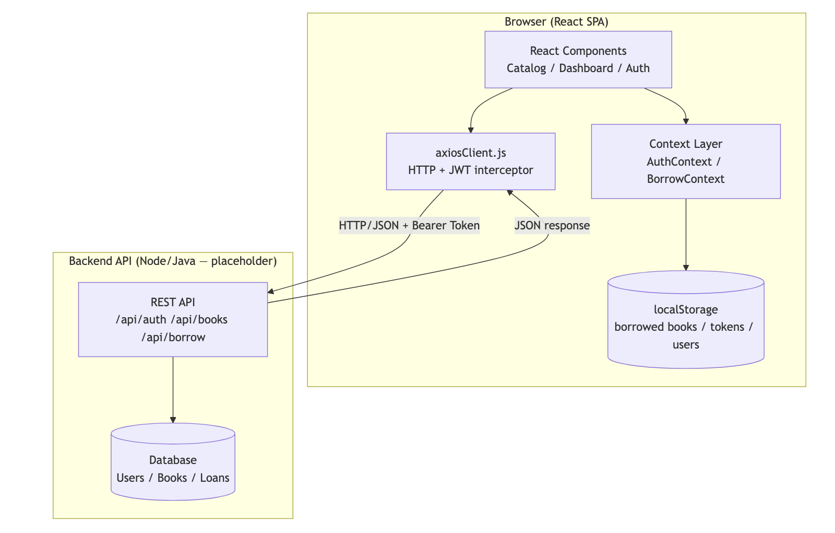

9. SWOT Analysis
Internal | Strengths (Silné stránky)  • Simple and fast UI  • Clean Context architecture  • Integration with a real REST API  • JWT-ready axiosClient setup | Weaknesses  • Passwords currently stored in plaintext  • Missing pagination and error boundaries
External | Opportunities  • Implementation of a book reservation system  • Addition of due dates and late penalties  • Creation of an admin role for librarians | Threats  • Vulnerability to XSS attacks  • Lack of CSRF protection  • No automatic session expiry

11. Backend API Architecture
The application has been upgraded from a frontend mock prototype to a full-stack architecture. The backend is built with Java and Spring Boot, utilizing Spring Data JPA for database interactions and exposing a RESTful API for the React frontend.

11.1. Package Structure
- .config: Contains WebSecurityConfig for global CORS mapping, allowing the React SPA to communicate with the API.
- .controller: REST API endpoints mapping HTTP requests to service logic.
- .service: Core business logic and transactional operations.
- .model.entity: JPA database entities mapping Java objects to relational tables.
- .model.repository: Spring Data interfaces for database querying.
- .model.dto: Data Transfer Objects for clean API payloads.

11.2. Data Models (Entities & Enums)
The system uses UUIDs for primary keys to enhance security.
- AppUser: Represents a system user. Contains userId, name, email, password, and a specific Role. One user can have multiple Borrowing records.
- Role: Defines user authorization levels: GUEST, MEMBER, LIBRARIAN.
- Book: Represents a catalog item. Tracks overall quantity and dynamically managed availableQuantity. Also stores price, originalPrice, and a coverUrl for UI rendering.
- Borrowing: The joining entity representing a loan. Links an AppUser to a Book and tracks borrowedAt, returnedAt, and dueDate.

11.3. Core Business Logic
- UserService:
  - Handles /register: Validates email uniqueness before creating a new AppUser with a default MEMBER role.
  - Handles /login: Validates credentials and returns a UserToken. (Note: Passwords currently use plain-text comparison, pending hashing implementation).
- BookService:
  - Search: Allows querying books by title, author, or category (ignoring case) and returns a distinct list.
  - Borrow Logic: Validates availableQuantity. If > 0, it decrements the available quantity and creates a new Borrowing record with a 30-day dueDate.
  - Return Logic (@Transactional): Finds the active borrowing record, marks returnedAt with the current date, and safely increments the book's availableQuantity.
- BorrowingService: Fetches the borrowing history for specific users to populate the React Dashboard.

11.4. REST Endpoints (Controllers)
Endpoint | Method | Payload / Params | Description
/auth/register | POST | RegisterRequest DTO | Registers a new user and returns a token.
/auth/login | POST | LoginRequest DTO | Authenticates a user and returns a token.
/books | GET | ?query=string (Optional) | Fetches the catalog, optionally filtered.
/books/{id}/borrow | POST | ?userId=UUID | Executes the borrowing process.
/books/{id}/return | POST | None | Executes the return process.
/borrowings/{userId} | GET | Path Variable userId | Fetches active and past loans for the user dashboard.

11.5. Database Initialization (data.sql)
The backend is pre-configured with seed data to populate the catalog upon startup. This includes a default member account (student@osu.cz) and several books across different categories (Sci-Fi, Programming, Productivity) with predefined quantities and static cover image URLs served locally.
12. Future Improvements
Priority Improvement
🔴 High Hash passwords — never store plaintext
🟡 Medium Add error boundaries (<ErrorBoundary>) around pages
🟡 Medium Add due date + overdue penalty system
🟡 Medium Admin role: manage books, view all loans
🟢 Low Add book detail page (/books/:id)
🟢 Low Reservation queue for unavailable books
🟢 Low Email notifications for due dates

