EduLend
Contents
Frontend 3
Introduction 3
System Overview 3
Architecture 4
Components Description 5
BookCard.jsx 5
Catalog.jsx 5
Dashboard.jsx 5
Layout.jsx 5
ProtectedRoute.jsx 5
Data Flow 6
Borrowing Logic ("Půjčit knihu") 7
Authentication Logic 8
Diagrams 9
Use Case Diagram 9
BPMN — Borrow Book Process 10
Deployment Diagram 11
SWOT Analysis 12
Future Improvements 13
Backend 14
Diagrams 14
Architecture diagram 14
Class Diagram 14
Sequence Diagram (Regular) 15
Sequence Diagram (System) 15
Entities 16
Role 16
AppUser 16
Book 16
Borrowing 17
Data Transfer Object 18
LoginRequest 18
RegisterRequest 18
UserToken 18
Repositories 19
AppUserRepository 19
BookRepository 19
BorrowingRepository 19
Service layer 20
UserService 20
BookService 20
BorrowingService 22
Controllers 23
AuthController 23
BookController 23
DashboardController 23
Configuration 24
WebSecurityConfig 24

Frontend

Introduction
EduLend is a React-based library management frontend that allows students to browse a catalog of books, borrow them, and track their loans via a personal dashboard. The system uses localStorage for persistence and mock authentication — designed as a frontend prototype ready to connect to a real backend.

System Overview
Property Value
Framework React 18 + Vite
Styling Tailwind CSS
Routing React Router v6
HTTP Client Axios (axiosClient with JWT interceptors)
State React Context API (AuthContext, BorrowContext)
Persistence localStorage
Auth Mock (localStorage-based), JWT-ready

Architecture
src/
├── api/
│ └── axiosClient.js # Axios instance + JWT interceptors
├── components/
│ ├── books/
│ │ └── BookCard.jsx # Book display + borrow action
│ ├── layout/
│ │ └── Layout.jsx # Header, footer, <Outlet />
│ └── routing/
│ └── ProtectedRoute.jsx # Auth guard
├── context/
│ ├── AuthContext.jsx # User state, login, register, logout
│ └── BorrowContext.jsx # Borrow state + localStorage persistence
├── hooks/
│ └── useBooks.js # Book data + search filter
├── pages/
│ ├── auth/
│ │ ├── Login.jsx
│ │ └── Register.jsx
│ ├── catalog/
│ │ └── Catalog.jsx
│ └── dashboard/
│ └── Dashboard.jsx
├── services/
│ └── tokenService.js # localStorage token abstraction
└── App.jsx # Router + Provider tree

Components Description

BookCard.jsx
Displays a single book. Reads isBorrowed() from BorrowContext to show correct state. Calls borrowBook() on click. Navigates to /login if user is not authenticated.

Catalog.jsx
Renders the full book list from useBooks hook. Passes each book to BookCard. Includes search input.

Dashboard.jsx
Reads borrowedBooks from BorrowContext. Displays borrow date (parsed from ISO string). Allows returning books via returnBook().

Layout.jsx
Shared shell: Header with nav links + user info, <Outlet /> for page content, Footer.

ProtectedRoute.jsx
Redirects unauthenticated users to /login. Shows nothing during loading to prevent flash.

Data Flow
useBooks (hook)
└── MOCK_BOOKS array
└── Catalog.jsx
└── BookCard.jsx
└── useBorrow() → borrowBook()
└── BorrowContext state
└── localStorage
└── Dashboard.jsx reads borrowedBooks
Auth flow:
Login.jsx → useAuth().login() → AuthContext
→ validates against localStorage['library_users']
→ tokenService.setTokens()
→ localStorage['activeUser']
→ setUser(userData)

Borrowing Logic ("Půjčit knihu")
Entry point: BookCard.jsx → handleBorrow()

Steps:
Check if user is logged in → redirect to /login if not
Call borrowBook(book) from BorrowContext
Inside borrowBook:
If !book.available → alert error, return false
If isBorrowed(book.id) → alert warning, return false
Else → append to borrowedBooks with borrowedDate: new Date().toISOString()
useEffect in BorrowContext writes updated array to localStorage['borrowedBooks']
BookCard re-renders: button shows "Již vypůjčeno", badge shows "Vypůjčeno vámi"
Dashboard immediately reflects the new borrow

Authentication Logic
Register:
- Validates email uniqueness in localStorage['library_users']
- Assigns role: 'MEMBER'
- Auto-logs in after registration
Login:
- Matches email + password against localStorage['library_users']
- Sets mock tokens via tokenService
- Stores active user in localStorage['activeUser']
Session restore:
- On mount, AuthContext useEffect reads accessToken and activeUser from localStorage
- Sets user state without re-login
Logout:
- Clears activeUser, tokens, and user state
Token layer (axiosClient.js):
- Attaches Authorization: Bearer to every request
- On 401: attempts token refresh; on failure, dispatches auth:logout event

Diagrams
Use Case Diagram
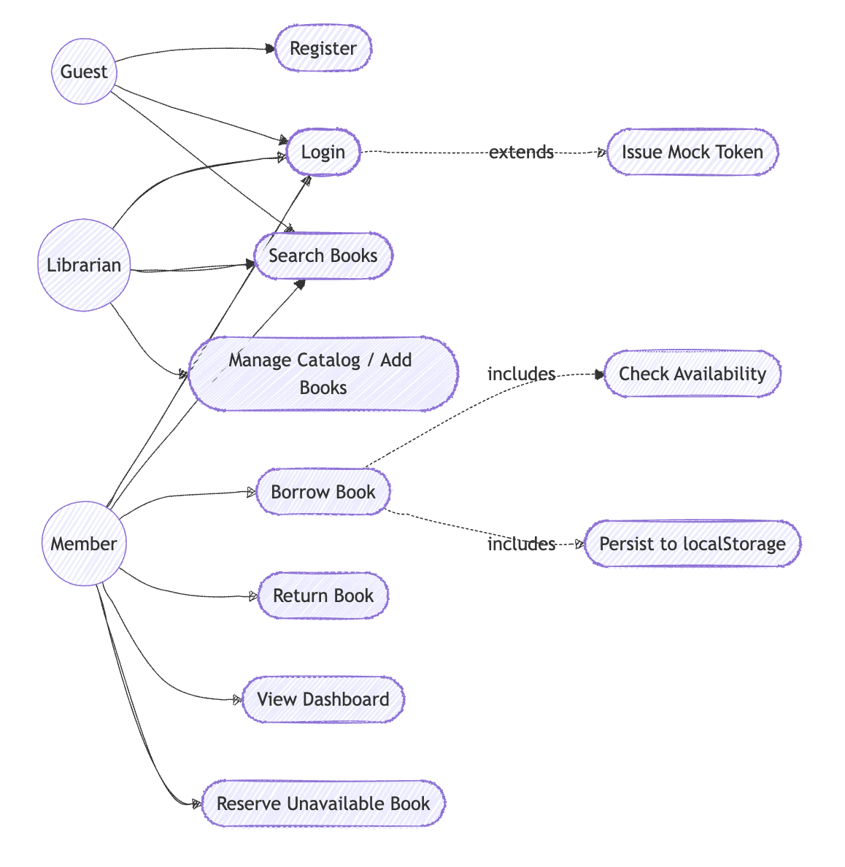

BPMN — Borrow Book Process
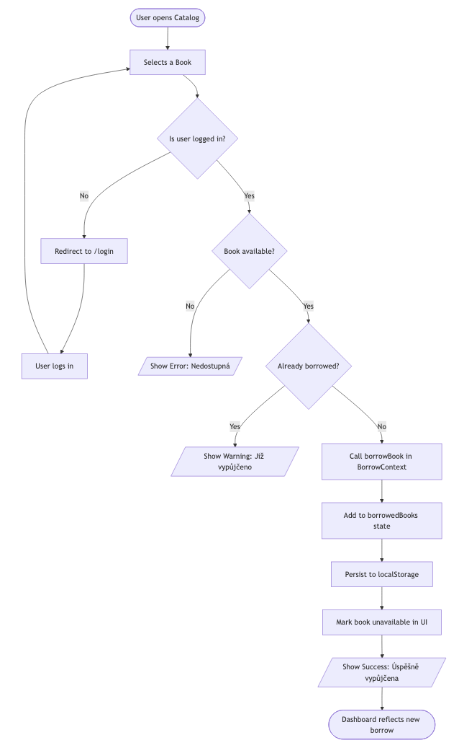
Deployment Diagram
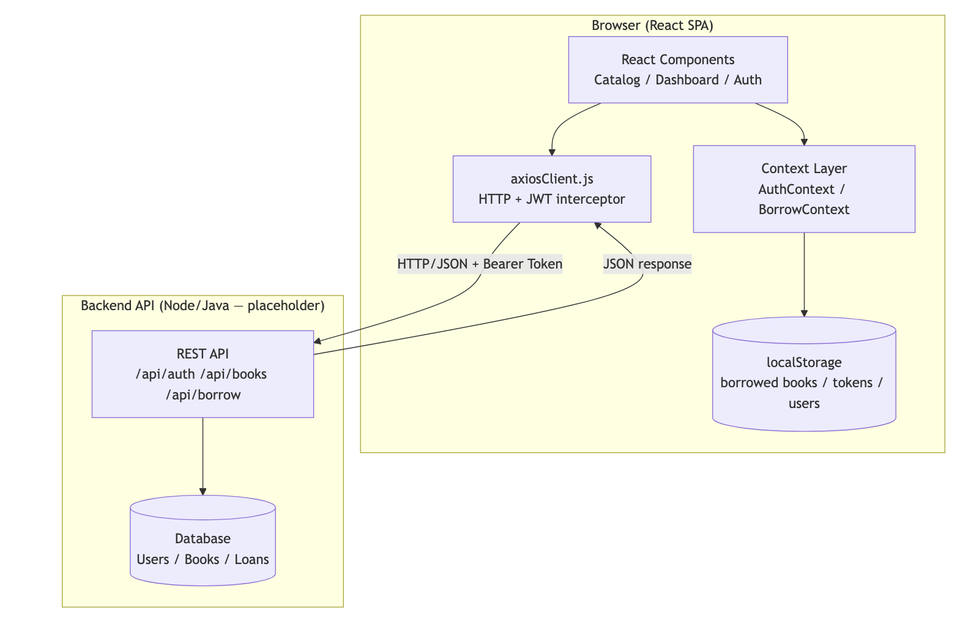

SWOT Analysis
 | Helpful (Kladné faktory) | Harmful (Záporné faktory)
Internal  (Vnitřní) | Strengths (Silné stránky)  • Simple and fast UI  • Clean Context architecture  • localStorage persistence  • JWT-ready axiosClient setup  • Zero backend dependency for rapid prototyping | Weaknesses (Slabé stránky)  • Passwords stored in plaintext in localStorage  • Lack of a real backend database  • Mock authentication is inherently insecure  • Missing pagination and error boundaries
External  (Vnější) | Opportunities (Příležitosti)  • Integration with a real REST API (Spring Boot / Node.js)  • Implementation of a book reservation system  • Addition of due dates and late penalties  • Creation of an admin role for librarians | Threats (Hrozby)  • Data loss if localStorage is cleared by the user  • Vulnerability to XSS attacks (could expose tokens)  • Lack of CSRF protection  • No automatic session expiry

Future Improvements
Priority Improvement
🔴 High Hash passwords — never store plaintext
🟡 Medium Add error boundaries (<ErrorBoundary>) around pages
🟡 Medium Add due date + overdue penalty system
🟡 Medium Admin role: manage books, view all loans
🟢 Low Add book detail page (/books/:id)
🟢 Low Reservation queue for unavailable books
🟢 Low Email notifications for due dates

Backend

Diagrams

Architecture diagram
Frontend (React application)
|
| REST API (HTTP / JSON)
V
Backend (Spring Boot application)
Controllers (API endpoints)
Services (business logic)
Repositories (database access)
|
V
PostgreSQL Database

Class Diagram
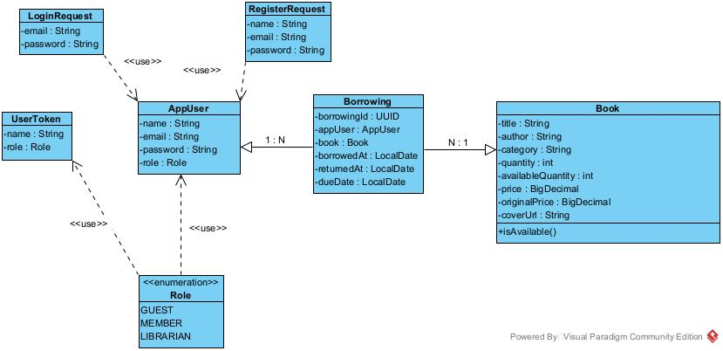

Sequence Diagram (Regular)
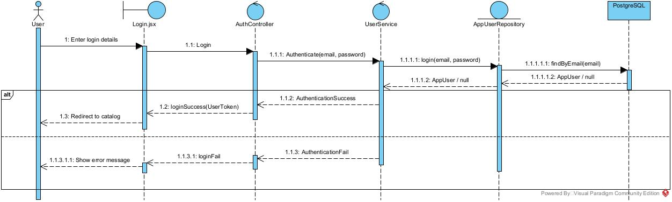

Sequence Diagram (System)
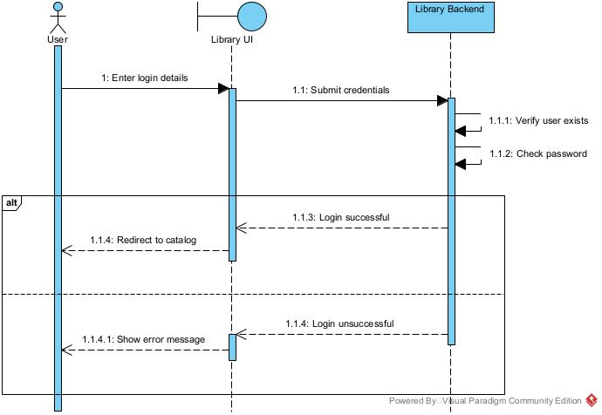

Entities

Role
It’s an enum.
Values: GUEST, MEMBER, LIBRARIAN.

AppUser
Represents a library user. The role field defaults to MEMBER. Until guest mode is implemented, MEMBER will remain the default. A user can have multiple borrowings.
@Id
@GeneratedValue(strategy = GenerationType.UUID)
private UUID userId;
@Column(nullable = false)
private String name;
@Column(nullable = false, unique = true)
private String email;
@Column(nullable = false)
private String password;
@Column(nullable = false)
@Enumerated(EnumType.STRING)
private Role role = Role.MEMBER;
@OneToMany(mappedBy = "appUser", cascade = CascadeType.ALL)
@com.fasterxml.jackson.annotation.JsonIgnore
private List<Borrowing> borrowings = new ArrayList<>();

Book
Represents a book in the library catalog. Availability is tracked via availableQuantity. The method isAvailable() returns true if availableQuantity is larger than 0.
@Id
@GeneratedValue(strategy = GenerationType.UUID)
private UUID bookId;
@Column(nullable = false)
private String title;
@Column(nullable = false)
private String author;
@Column(nullable = true)
private String coverUrl;
@Column(nullable = false)
private String category;
@Column(nullable = false)
private int quantity;
@Column(nullable = false)
private int availableQuantity;
@Column(nullable = false)
private BigDecimal price;
@Column(nullable = true)
private BigDecimal originalPrice;
@OneToMany(mappedBy = "book", cascade = CascadeType.ALL)
@com.fasterxml.jackson.annotation.JsonIgnore
private List<Borrowing> borrowings = new ArrayList<>();

public boolean isAvailable() {
return this.availableQuantity > 0;
}

Borrowing
Join entity between AppUser and Book. Records who borrowed which book and when.
@Id
@GeneratedValue(strategy = GenerationType.UUID)
private UUID borrowingId;
@ManyToOne
@JoinColumn(name = "user_id", nullable = false)
private AppUser appUser;
@ManyToOne
@JoinColumn(name = "book_id", nullable = false)
private Book book;
@JsonProperty("borrowedDate")
@Column(nullable = false)
private LocalDate borrowedAt;
@Column(nullable = true)
private LocalDate returnedAt;
@Column(nullable = false)
private LocalDate dueDate;

Data Transfer Object
DTOs are used to transfer data between frontend and backend.

Borrow Request
Used to receive borrow data.
private UUID userId;

LoginRequest
Used to receive login data.
private String email;
private String password;

RegisterRequest
Used to receive registration data.
private String name;
private String email;
private String password;

UserToken
Used to send user information back to the client.
private String name;
private String email;
private Role role;

Repositories
They are used to access the database, taking care of CRUD operations for entities.

AppUserRepository
boolean existsByEmailIgnoreCase(String username);
AppUser findByEmailIgnoreCase(String username);

BookRepository
List<Book> findByTitleContainingIgnoreCase(String title);
List<Book> findByAuthorContainingIgnoreCase(String author);
List<Book> findByCategoryContainingIgnoreCase(String category);
List<Book> findByTitleContainingIgnoreCaseOrAuthorContainingIgnoreCaseOrCategoryContainingIgnoreCase(
String title, String author, String category
);

BorrowingRepository
List<Borrowing> findByAppUser_UserId(UUID userId);
List<Borrowing> findByBook_BookId(UUID bookId);

Service layer

UserService
Handles user authentication and registration. Depends on UserAppRepository.
Registration checks if the input email is already in use. Throws an exception if yes, otherwise it creates and saves the new user, and then sends returns a new user token.
Login checks if a user with the input email exists. Throws an exception if not, otherwise it confirms if the passwords match. Should they not, an exception is thrown. After both checks pass, returns a new user token.
public UserToken register(String name, String email, String password) {
if (userRepository.existsByEmailIgnoreCase(email)) {
throw new IllegalArgumentException("User with this email already exists.");
}
AppUser user = new AppUser();
user.setName(name);
user.setEmail(email);
user.setPassword(password);
user.setRole(Role.MEMBER);
userRepository.save(user);
return new UserToken(user.getUserId(), name, email, Role.MEMBER);
}
public UserToken login(String email, String password) {
AppUser user = userRepository.findByEmailIgnoreCase(email);
if (user != null) {
if (user.getPassword().equals(password)) {
return new UserToken(user.getUserId(), user.getName(), user.getEmail(), user.getRole());
} else {
throw new RuntimeException("Wrong password!");
}
} else {
throw new IllegalArgumentException("User does not exist!");
}
}

BookService
Handles catalog search and borrow/return logic. Depends on UserAppRepository, BookRepository, BorrowedRepository.
To search for books, use getBooks(). If no query is provided, it returns all books. If a query is provided, it performs three separate searches (Title, Author, Category). It then combines these lists into one.
Borrowing is handled by borrowBook(). First, it checks if available quantity is more than zero. Otherwise, it throws an exception. After decrementing availability, it links book to user. Finally, it sets return date to be 30 days from then on.
For returning books, there is returnBook(). It throws an exception if all copies of a book are accounted for. If they are not, it increases the quantity and updates the borrow record’s return date.
public List<Book> getBooks(String query) {
if (query == null || query.isBlank()) {
return (List<Book>) bookRepository.findAll();
}
List<Book> byTitle = bookRepository.findByTitleContainingIgnoreCase(query);
List<Book> byAuthor = bookRepository.findByAuthorContainingIgnoreCase(query);
List<Book> byCategory = bookRepository.findByCategoryContainingIgnoreCase(query);
return java.util.stream.Stream.of(byTitle, byAuthor, byCategory)
.flatMap(List::stream)
.distinct()
.toList();
}
@Transactional
public void borrowBook(String id, UUID userId) {
UUID bookId = UUID.fromString(id);
Book book = bookRepository.findById(bookId)
.orElseThrow(() -> new IllegalArgumentException("Book not found"));
boolean alreadyBorrowed =
borrowingRepository
.existsByAppUser_UserIdAndBook_BookIdAndReturnedAtIsNull(userId, bookId);
if (alreadyBorrowed) {
throw new IllegalStateException("User already borrowed this book");
}
if (book.getAvailableQuantity() <= 0) {
throw new IllegalStateException("No copies available");
}
book.setAvailableQuantity(book.getAvailableQuantity() - 1);
bookRepository.save(book);
AppUser user = appUserRepository.findById(userId)
.orElseThrow(() -> new IllegalArgumentException("User not found"));
Borrowing borrowing = new Borrowing();
borrowing.setAppUser(user);
borrowing.setBook(book);
borrowing.setBorrowedAt(LocalDate.now());
borrowing.setDueDate(LocalDate.now().plusDays(30));
borrowingRepository.save(borrowing);
}
@Transactional
public void returnBook(String id, UUID userId) {
UUID bookId = UUID.fromString(id);
Book book = bookRepository.findById(bookId)
.orElseThrow(() -> new IllegalArgumentException("Book not found"));
Borrowing borrowing = borrowingRepository.findByAppUser_UserId(userId).stream()
.filter(b -> b.getBook().getBookId().equals(bookId) && b.getReturnedAt() == null)
.findFirst()
.orElseThrow(() -> new IllegalStateException("This user does not have this book borrowed"));
borrowing.setReturnedAt(LocalDate.now());
borrowingRepository.save(borrowing);
book.setAvailableQuantity(book.getAvailableQuantity() + 1);
bookRepository.save(book);
}

BorrowingService
Retrieves borrowing history for the dashboard. Depends on BorrowingRepository.
public List<Borrowing> getBorrowingsForUser(UUID userId) {
return borrowingRepository.findByAppUser_UserId(userId);
}

Controllers
Controllers serve as entry points for HTTP requests and forward them to the appropriate services for processing.

AuthController
Handles these:
- Registers a new user and returns basic user information.
- Authenticates a user and returns basic user information.
@PostMapping("/register")
public UserToken register(@RequestBody RegisterRequest request) {
return userService.register(request.getName(), request.getEmail(), request.getPassword());
}
@PostMapping("/login")
public UserToken login(@RequestBody LoginRequest request) {
return userService.login(request.getEmail(), request.getPassword());
}

BookController
Handles these:
- Returns all books or filters them by the given search query.
- Borrows the specified book for the given user.
- Returns a previously borrowed book.
@GetMapping
public List<Book> getBooks(@RequestParam(required = false) String query) {
return bookService.getBooks(query);
}
@PostMapping("/{id}/borrow")
public ResponseEntity<Void> borrowBook(
@PathVariable String id,
@RequestBody BorrowRequest request
) {
bookService.borrowBook(id, request.getUserId());
return ResponseEntity.noContent().build();
}
@PostMapping("/{id}/return")
public ResponseEntity<Void> returnBook(
@PathVariable String id,
@RequestBody BorrowRequest request
) {
bookService.returnBook(id, request.getUserId());
return ResponseEntity.noContent().build();
}

DashboardController
Returns all borrowing records for the specified user.
@GetMapping("/{userId}")
public List<Borrowing> getBorrowings(@PathVariable UUID userId) {
return borrowingService.getBorrowingsForUser(userId);
}

Configuration

SecurityConfig
Enables CORS to allow the frontend application to communicate with the backend via HTTP requests.

