Construction Budget Estimate

Project Design
Tommy Bruner
Brandon Bartee
Mark Gray

Introduction
This Project Plan is to layout the development overview of the Construction Budget Estimate software project. The Project Plan will define the project's requirements,
expectations and schedule. This is a living document and will be updated as required until completion of the project.
Objective:
A construction company is considering building homes, and they need an application that provides a materials list estimation. The application will allow the user to enter materials with a unit cost and quantity, and these values will be displayed, will be able to be saved, and will be editable throughout the construction project.
Constraints: The system will run on Windows in a fix window size with only 1 save file type due to prototyping requirements and time constraints.
Program Architecture
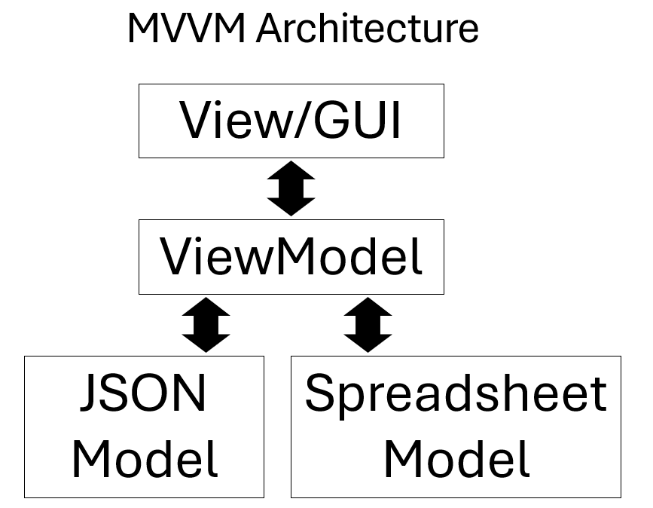

Use Case Diagram
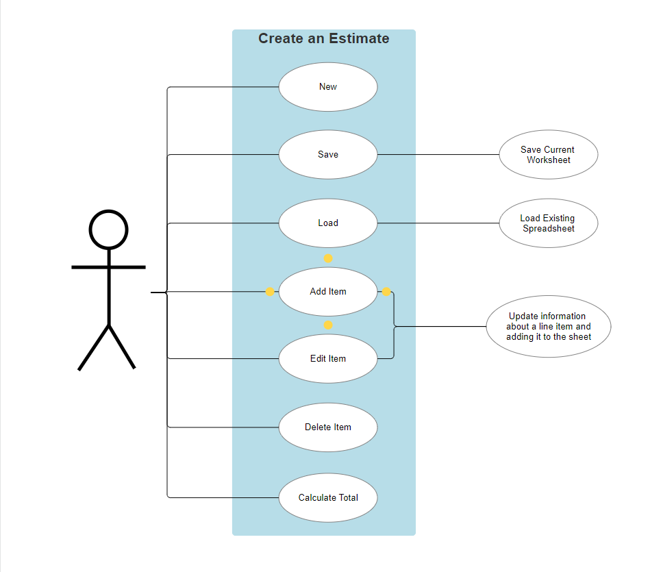

UML Diagram
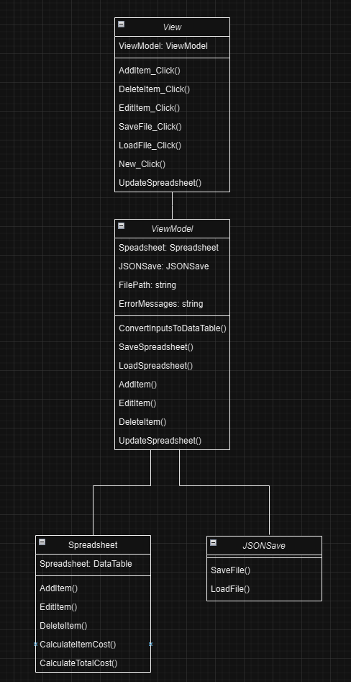

Test Cases
- Save empty spreadsheet
- Try to save file with disallowed Windows characters in file name (? for example)
- Load empty Json file
- Load file with incorrect filetype
- Load file with bad data
- Input non-numeric characters into unit cost
- Input non-numeric characters into unit count
- Input negative number into unit cost
- Input negative number into unit count
- Input line item with same name as already entered item
- Input string with excessive characters to name/description fields
- Input int larger than max int value to unit count field
- Input decimal value into unit count (maybe this is allowed?)
- Repeat tests 6-13 while editing line item

Summary
This software will just be a more constrained version of a simple spreadsheet software like Excel. Goal is to be very limited in scope due to time constraints. User will just be able to use the project to build an budget estimate for a project, although we are focusing on a construction project to start. The layout has been determined, and the GUI is being started now. By starting with the interface and building out for there, testing of the software should be able to be conducted throughout the programming process.

