Construction Budget Estimate

Project Plan
Tommy Bruner
Brandon Bartee
Mark Gray

Introduction
This Project Plan is to layout the development overview of the Construction Budget Estimate software project. The Project Plan will define the project's requirements,
expectations and schedule. This is a living document and will be updated as required until completion of the project.
Objective:
A construction company is considering building homes, and they need an application that provides a materials list estimation. The application will allow the user to enter materials with a unit cost and quantity, and these values will be displayed, will be able to be saved, and will be editable throughout the construction project.
Constraints: The system will run on Windows in a fix window size with only 1 save file type due to prototyping requirements and time constraints.

Project Organization
Program Manager: Tommy Bruner
Responsibilities: Documentation, scheduling, review, and sign-offs
Lead Programmer: Brandon Bartee
Responsibilities: Code architecture and programming
Quality and Testing: Mark Gray
Responsibilities: Testing, bug reporting, and troubleshooting

Hardware/Software Requirements
Operating System:
Windows 10 version 1809 (build 17763) or later
Windows 11 (all versions supported)
Hardware (minimum):
Processor: 1 GHz or faster, 2+ cores, x64 or ARM64
RAM: 4 GB (8 GB recommended for development)
Storage: At least 8 GB free space for runtime + app
Graphics: DirectX 9 or later with WDDM 1.0 driver (for UI rendering)

Work Breakdown Schedule
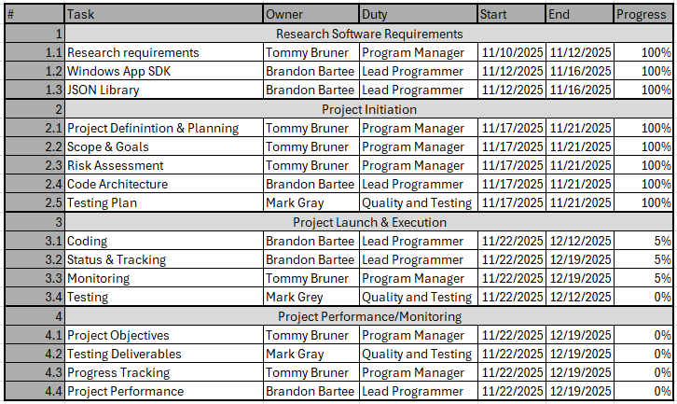

Process Flow Diagram
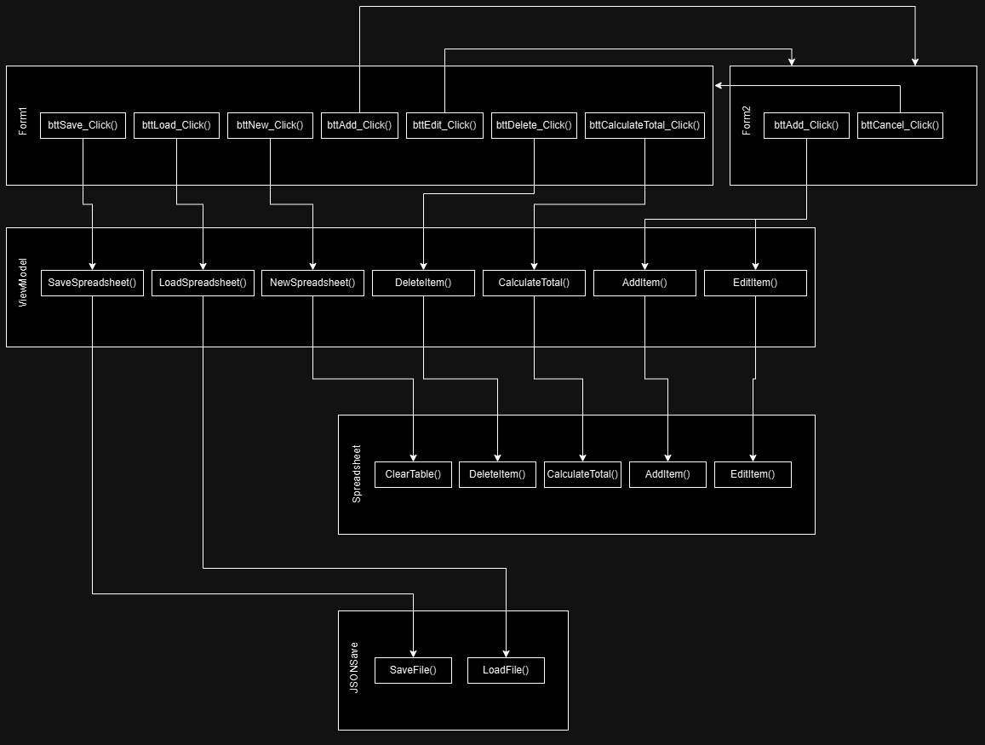

Project Schedule
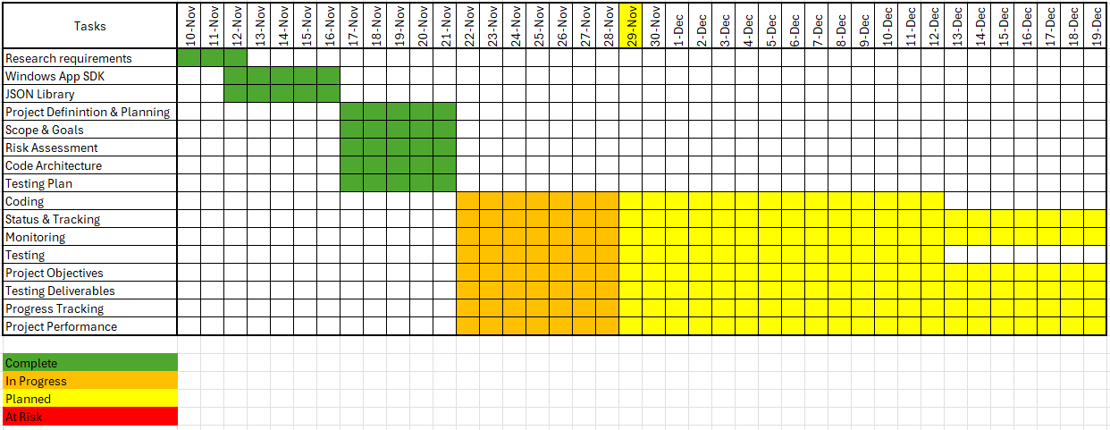

Monitoring and Reporting Mechanisms
Meeting:
Text on Discord.
Voice on Discord as needed for deliverables review.
Deliverables:
Determined by project schedule.
Code Review:
GitHub shared repo with merge and commit reviews.

Appendix
- PFD to determine data flow
A sketch showing how to interact with the program, outline to start with to plan future work.
Time Estimate: Finished
Dependencies: None
- Architecture control
  - View (GUI/Windows)
  - View Code (handles inputs, passing data to View Model)
  - Model (logic for actual functionality, handles saving data, parses user inputs)
  - View Model (go-between code to handle Model and View communicating)
Goal is to keep the code segmented properly. Code in the views will be very simple and will focus on layout, rendering, and inputs. Models will only handle their specific task, mainly saving the estimate table as a class object and a JSON (or possibly CSV) class to handle saving the data out.
Time Estimate: 1 day
Dependencies: PFD
- Sketch/prototype of View design
This is just a rough layout of the different pages/forms/views used. Serves as a prototyping launching point for the programmer to start implementing.
Time Estimate: 1 day
Dependencies: PFD and Architecture

- Prototype GUI, start adding code to View Model
Build GUI frontend to render data, entries, and buttons. Connect communication between views and view model. Show events activate correctly.
Time Estimate: 1 week
Dependencies: Architecture and View Prototyping
- Program Model Classes to implement functionality
Implement the spreadsheet logic, the Json save functions, and data structures to parse and store user inputs.
Time Estimate: 1 week
Dependencies: Architecture and View Prototyping
- Testing, bug squashing, finalize project
Finalize the continuous task that is been progressing throughout the project schedule. Continue testing, implement any changes to the final report, and prepare final submission.
Time Estimate: 3 weeks
Dependencies: In parallel with all activities

