华 中 科 技 大 学
《面向对象的程序设计》
上机实验报告

专业班级：人工智能本硕博2101班
学 号：U202115203
学生姓名：张伟业
专业班级：人工智能本硕博2101班
学 号：U202115195
学生姓名：赵为之

- 实验名称
双人五子棋（Visual Studio 2019编写）
- 实验需求分析
- 设计精美的用户交互界面
- 完成用户点击下棋的操作功能
- 构建黑棋白棋的胜负判定算法
- 增添“悔棋”“重新开始”的附加功能
- 增添“上一颗棋子”所在位置的提示
- 实验分工
为了快速高效地完成实验内容，对小组成员进行了必要的分工，促进成员的相互合作和交流，提高工作效率。具体的分工如下：
表1 成员的具体分工
姓 名 | 任务描述 | 完成情况
张伟业 | - 使用easyX图形库设计主界面  - 编写自己的鼠标操作函数  - 设计黑白棋胜负判定算法  - 实现上一棋子位置提示功能 | 全部完成
赵为之 | - 完成主函数并确定整体框架  - 实现悔棋与重新开始功能  - 构建了函数所需的类与对象  - 填补程序漏洞并改进算法 | 全部完成

- 概要设计
本工程的主要架构如下：
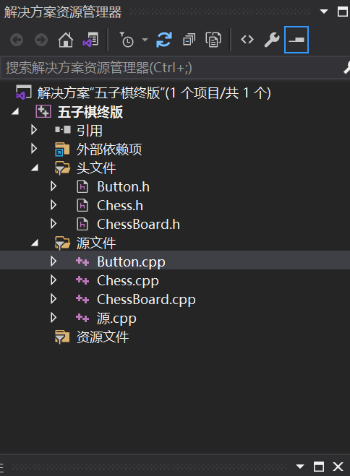
本工程所构建的函数如下：
void draw_ResetButton(int x, int y, int width, int height);//实现重新开始操作

void draw_TakeBackButton(int x, int y, int width, int height);//实现悔棋操作

void draw_ChessBoard(int x, int y, int width, int height);//实现画棋盘操作

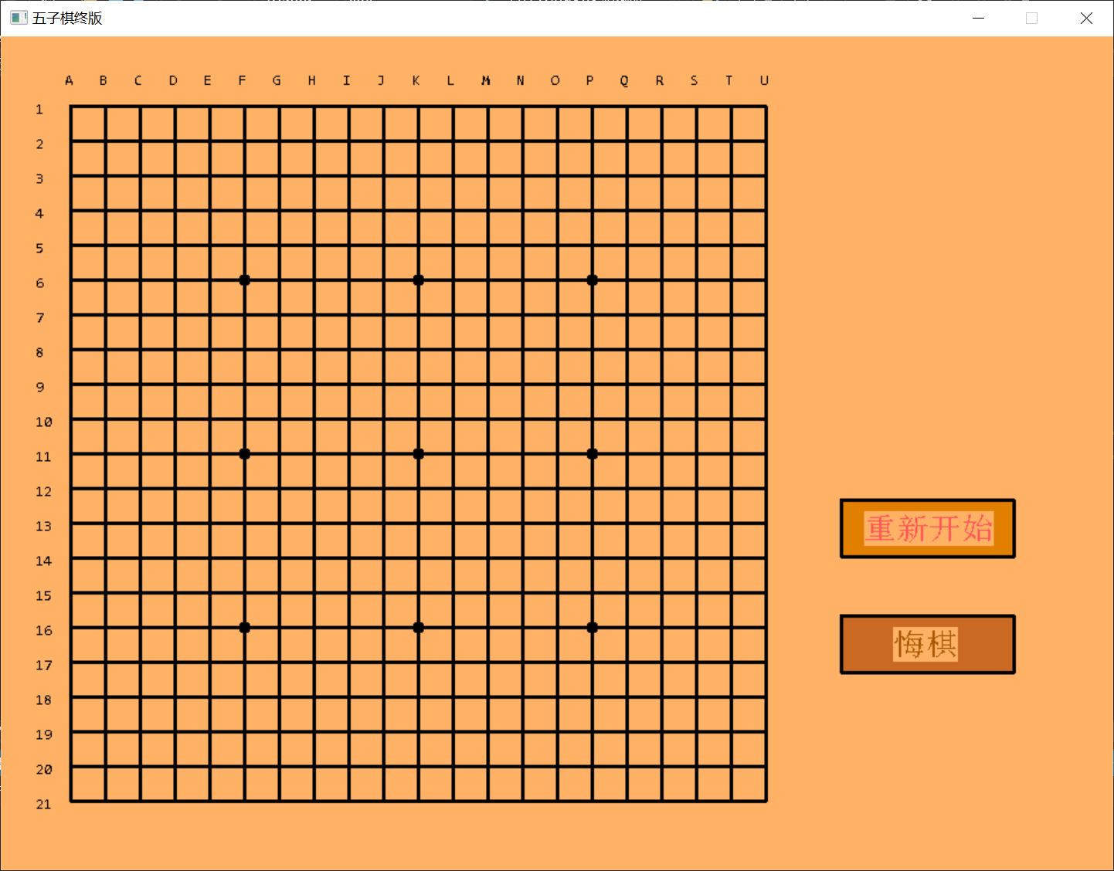
本工程所用类的定义如下：
（1）交互界面的按钮Button
class Button
{
private:
int x, y; //按钮右上角的坐标
int width, height; //按钮的宽度和高度
COLORREF bgcolor, textcolor; //背景颜色和文字颜色
TCHAR* text;
void (*drawButton)(int x, int y, int width, int height);

public:
Button(int x, int y, int width, int height, void (*drawButton)(int x, int y, int width, int height)) :
x(x), y(y), width(width), height(height), drawButton(drawButton)
{

}

bool clicked(MOUSEMSG& m) const; //检测按钮是否被按下

void draw();
};
（2）用户所下的棋子Chess
class Chess
{
private:
int x;
int y;
int tag;//-1 is black,1 is white
static int numberBlack;
static int numberWhite;
public:
Chess(int position_x, int position_y, int chess_tag);
~Chess();

void draw();

void drawCursor(COLORREF color);

static void draw(int x, int y, int tag);

int Getx()
{
return x;
}

int Gety()
{
return y;
}

int Gettag()
{
return tag;
}

static int GetNumBlack()
{
return numberBlack;
}

static int GetNumWhite()
{
return numberWhite;
}
};
（3）棋盘Chessboard
class ChessBoard :
public Button //公有继承Button类
{
private:
int board[21][21]; //-0=null,-1=black,1=white
stack<Chess> sta;
int turn;
int win;

void judge();

public:
void takeBack();

void reset();

void draw_hint();

ChessBoard(int x, int y, void (*drawChessBoard)(int x, int y, int width, int height))
: Button(x, y, 601, 601, drawChessBoard), turn(-1), win(0)
{
for (int i = 0; i < 21; i++)
{
for (int j = 0; j < 21; j++)
{
board[i][j] = 0;
}
}
}

bool click(MOUSEMSG& m);
};

- 详细设计
用户操作界面：
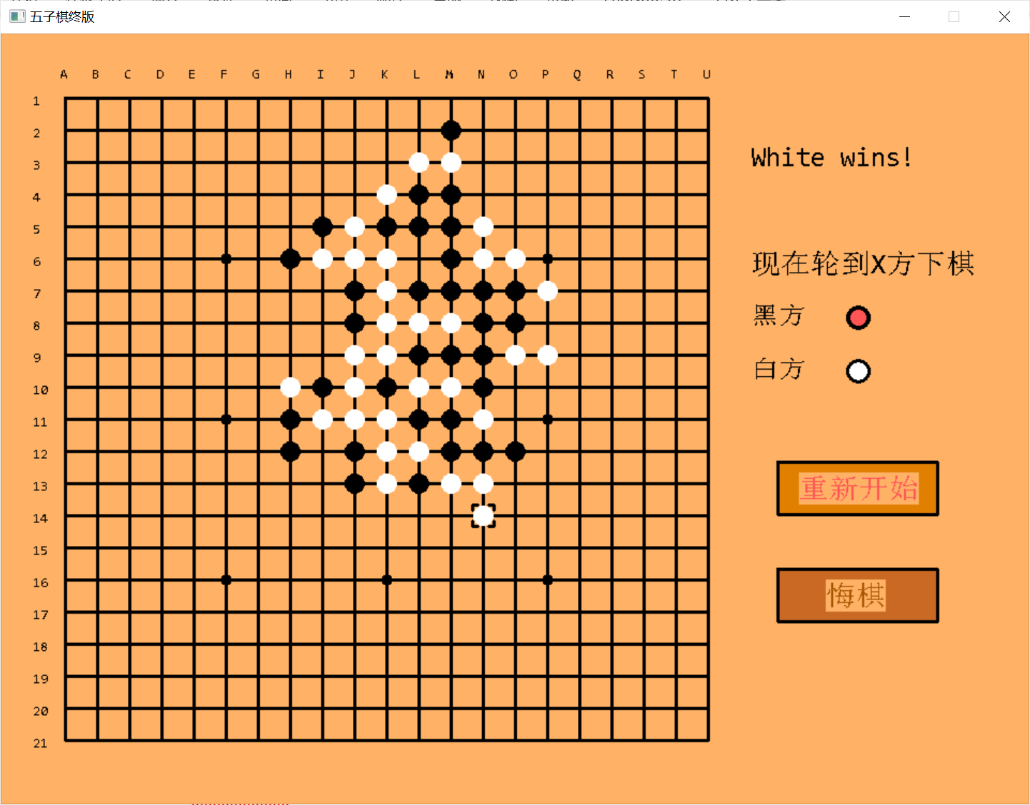
源代码如下：
  - 源.cpp
#include <iostream>
#include<easyx.h>
#include<graphics.h>
#include<stack>

#include "Button.h"
#include "Chess.h"
#include "ChessBoard.h"

using namespace std;

void draw_ResetButton(int x, int y, int width, int height);

void draw_TakeBackButton(int x, int y, int width, int height);

void draw_ChessBoard(int x, int y, int width, int height);

int main()
{
MOUSEMSG m;
int win = 0;//0无人获胜，-1黑方获胜，1白方获胜

//创建棋盘和两个按钮
ChessBoard chessBoard(60, 60, draw_ChessBoard);
Button takeBack(725, 500, 150, 50, draw_TakeBackButton); //悔棋
Button reset(725, 400, 150, 50, draw_ResetButton);

initgraph(960, 720);
setbkcolor(RGB(255, 178, 102));
cleardevice();

//绘制界面
chessBoard.draw();
takeBack.draw();
reset.draw();

while (1)
{
m = GetMouseMsg();

//放置棋子
chessBoard.click(m);

//悔棋
if (takeBack.clicked(m))
{
chessBoard.takeBack();
}
//重新开始
if (reset.clicked(m))
{
chessBoard.reset();
}
}

closegraph();
return 0;
}

void draw_ResetButton(int x, int y, int width, int height)
{
//重新开始
setfillstyle(BS_SOLID);
setfillcolor(RGB(225, 128, 0));
fillrectangle(x, y, x + width - 1, y + height - 1);
settextcolor(LIGHTRED);
settextstyle(30, 0, _T("Consolas"));
outtextxy(x + 20, y + 10, _T("重新开始"));
}

void draw_TakeBackButton(int x, int y, int width, int height)
{
//悔棋
setfillstyle(BS_SOLID);
setfillcolor(RGB(202, 105, 36));
fillrectangle(x, y, x + width - 1, y + height - 1);
settextcolor(BROWN);
settextstyle(30, 0, _T("Consolas"));
outtextxy(x + 45, y + 10, _T("悔棋"));
}

void draw_ChessBoard(int x, int y, int width, int height)
{
setfillcolor(RGB(255, 178, 102));
setcolor(RGB(255, 178, 102));
fillrectangle(x - 50, y - 60, x + width - 1 + 11, y + height - 1 + 50);

setcolor(BLACK);
setlinestyle(PS_SOLID, 3);
rectangle(x, y, x + width - 1, y + height - 1);//chess board from(60,60) to (660,660)

//draw chessboard line and number
settextcolor(BLACK);
settextstyle(15, 0, _T("Consolas"));
for (int i = x; i <= x + width - 1; i += 30)//every 30 steps is a point
{
TCHAR ci[3];
_stprintf_s(ci, _T("%d"), (i - 60) / 30 + 1);
outtextxy(30, i - 5, ci);
line(60, i, 660, i);
}

for (int j = y; j <= y + height - 1; j += 30)//add all lines equal 21
{
char cj = 'A' + (j - 60) / 30;
outtextxy(j - 5, 30, cj);
line(j, 60, j, 660);
}

//draw important points,7,11,15
for (int i : {6, 11, 16})
for (int j : {6, 11, 16})
{
setfillcolor(BLACK);
setfillstyle(BS_SOLID);
fillcircle(30 * (i + 1), 30 * (j + 1), 4);
}
}
（二）Chess.cpp
#include "Chess.h"

int Chess::numberBlack = 0;
int Chess::numberWhite = 0;

//绘制上一个棋子的标志
void Chess::drawCursor(COLORREF color)
{
setcolor(color);
int x = 30 * (this->x + 2);
int y = 30 * (this->y + 2);
line(x - 10, y - 10, x - 10 + 5, y - 10);
line(x - 10, y - 10, x - 10, y - 10 + 5);
line(x + 10, y - 10, x + 10 - 5, y - 10);
line(x + 10, y - 10, x + 10, y - 10 + 5);
line(x - 10, y + 10, x - 10 + 5, y + 10);
line(x - 10, y + 10, x - 10, y + 10 - 5);
line(x + 10, y + 10, x + 10 - 5, y + 10);
line(x + 10, y + 10, x + 10, y + 10 - 5);
}

//绘制棋子
void Chess::draw()
{
if (tag == -1)
{
setfillcolor(BLACK);
setcolor(BLACK);
fillcircle(30 * (x + 2), 30 * (y + 2), 8);

}
else if (tag == 1)
{
setfillcolor(WHITE);
setcolor(WHITE);
fillcircle(30 * (x + 2), 30 * (y + 2), 8);
}
}

//在指定位置绘制棋子
void Chess::draw(int x, int y, int tag)
{
if (tag == -1)
{
setfillcolor(BLACK);
setcolor(BLACK);
fillcircle(30 * (x + 2), 30 * (y + 2), 8);

}
else if (tag == 1)
{
setfillcolor(WHITE);
setcolor(WHITE);
fillcircle(30 * (x + 2), 30 * (y + 2), 8);
}
}

Chess::Chess(int position_x, int position_y, int chess_tag)
{
x = position_x;
y = position_y;
tag = chess_tag;
if (tag == -1) numberBlack++;
else if (tag == 1)numberWhite++;
}

Chess::~Chess()
{
if (tag == -1)
{
numberBlack--;
}
else if (tag == 1)
{
numberWhite--;
}
}
（三）Chessboard.cpp
#include "ChessBoard.h"

void ChessBoard::draw_hint()//turn stands for the next player
{
settextstyle(30, 0, _T("Consolas"));
outtextxy(700, 200, _T("现在轮到X方下棋"));
//black player
settextstyle(27, 0, _T("Consolas"));
outtextxy(700, 250, _T("黑方"));
setfillcolor(WHITE);
setfillstyle(BS_SOLID);
fillcircle(800, 265, 10);
//white player
settextstyle(27, 0, _T("Consolas"));
outtextxy(700, 300, _T("白方"));
fillcircle(800, 315, 10);
//output hint
if (turn == -1)//it is time for black player
{
setfillcolor(LIGHTRED);
setfillstyle(BS_SOLID);
fillcircle(800, 265, 9);
}
else if (turn == 1)//it is time for white player
{
setfillcolor(LIGHTRED);
setfillstyle(BS_SOLID);
fillcircle(800, 315, 9);
}
}

//清空棋盘
void ChessBoard::reset()
{
for (int i = 0; i < 21; i++)
for (int j = 0; j < 21; j++)
board[i][j] = 0;
while (!sta.empty())
sta.pop();

turn = -1;
win = 0;

draw_hint();

draw();
}

//悔棋
void ChessBoard::takeBack()
{
if (!sta.empty())
{
//用背景覆棋子
setcolor(RGB(255, 178, 102));
setfillcolor(RGB(255, 178, 102));
setfillstyle(PS_SOLID);
fillrectangle(30 * (sta.top().Getx() + 2) - 10, 30 * (sta.top().Gety() + 2) - 10
, 30 * (sta.top().Getx() + 2) + 10, 30 * (sta.top().Gety() + 2) + 10);

//填补黑色十字线
setcolor(BLACK);
setlinestyle(PS_SOLID, 3);
line(30 * (sta.top().Getx() + 2), max(60, 30 * (sta.top().Gety() + 2) - 11)
, 30 * (sta.top().Getx() + 2), min(660, 30 * (sta.top().Gety() + 2) + 11));
line(max(60, 30 * (sta.top().Getx() + 2) - 11), 30 * (sta.top().Gety() + 2)
, min(660, 30 * (sta.top().Getx() + 2) + 11), 30 * (sta.top().Gety() + 2));

//填补关键点
for (int i : {6, 11, 16})
{
for (int j : {6, 11, 16})
{
if (i == sta.top().Getx() + 1 && j == sta.top().Gety() + 1)
{
setfillcolor(BLACK);
setfillstyle(BS_SOLID);
fillcircle(30 * (i + 1), 30 * (j + 1), 4);
fillcircle(30 * (i + 1), 30 * (j + 1), 1);
}
}
}

board[sta.top().Getx()][sta.top().Gety()] = 0;
sta.pop();
turn = -turn;
if (!sta.empty()) sta.top().drawCursor(BLACK);

win = 0;
settextstyle(30, 0, _T("Consolas"));
outtextxy(500, 0, _T(" "));

draw_hint();
}
}

//判断胜负
void ChessBoard::judge()
{
int i, j;
int check[4] = { 0,0,0,0 };//0-横向,1-纵向,2-左上右下,3-左下右上
Chess star(sta.top());

int x = star.Getx();
int y = star.Gety();
int tag = star.Gettag();

//no one wins,out of number restiction
if (star.GetNumBlack() + star.GetNumWhite() >= 441)
{
return;
}
else
{
//获胜条件

//横向
for (i = 1; 0 <= x + i < 21 && 0 <= y < 21 && i <= 4; i++)
{
if (board[x + i][y] == tag)
check[0]++;
else
break;
}
for (i = -1; 0 <= x + i < 21 && 0 <= y < 21 && i >= -4; i--)
{
if (board[x + i][y] == tag)
check[0]++;
else
break;
}
//纵向
for (j = 1; 0 <= x < 21 && 0 <= y + j < 21 && j <= 4; j++)
{
if (board[x][y + j] == tag)
check[1]++;
else
break;
}
for (j = -1; 0 <= x < 21 && 0 <= y + j < 21 && j >= -4; j--)
{
if (board[x][y + j] == tag)
check[1]++;
else
break;
}
//左上右下
for (i = -1, j = 1; 0 <= x + i < 21 && 0 <= y + j < 21 && i >= -4 && j <= 4; i--, j++)
{
if (board[x + i][y + j] == tag)
check[2]++;
else
break;
}
for (i = 1, j = -1; 0 <= x + i < 21 && 0 <= y + j < 21 && i <= 4 && j >= -4; i++, j--)
{
if (board[x + i][y + j] == tag)
check[2]++;
else
break;
}
//左下右上
for (i = 1, j = 1; 0 <= x + i < 21 && 0 <= y + j < 21 && i <= 4 && j <= 4; i++, j++)
{
if (board[x + i][y + j] == tag)
check[3]++;
else
break;
}
for (i = -1, j = -1; 0 <= x + i < 21 && 0 <= y + j < 21 && i >= -4 && j >= -4; i--, j--)
{
if (board[x + i][y + j] == tag)
check[3]++;
else
break;
}
//judge
for (int k = 0; k < 4; k++)
{
if (check[k] >= 4)
{
settextstyle(30, 0, _T("Consolas"));
if (tag == 1)
outtextxy(700, 100, _T("White wins!"));
else if (tag == -1)
outtextxy(700, 100, _T("Black wins!"));

win = tag; //设置赢家
return;
}
}
win = 0; //没有赢家
}
}

bool ChessBoard::click(MOUSEMSG& m)
{
if (clicked(m) && win == 0)
{
//判断鼠标是否在棋盘内，并且是否在交叉点周围
if (((m.x % 30 <= 9) || (m.x % 30 >= 20)) && ((m.y % 30 <= 9) || (m.y % 30 >= 20)))
{
int x = int(m.x + 10) / 30 - 2;
int y = int(m.y + 10) / 30 - 2;

if (!board[x][y])
{
board[x][y] = turn;

if (!sta.empty())
{
sta.top().drawCursor(RGB(255, 178, 102));
}

sta.push(Chess(x, y, turn));
sta.top().draw();

sta.top().drawCursor(BLACK);

turn = -turn;

judge();

draw_hint();
return true;
}
}
}

return false;
}
（四）Button.cpp
#include "Button.h"

//检测按钮是否被按下
bool Button::clicked(MOUSEMSG& m) const
{
if (x <= m.x && m.x <= x + width - 1 && y <= m.y && m.y <= y + height - 1 && m.uMsg == WM_LBUTTONDOWN)
{
return true;
}
return false;
}

void Button::draw()
{
drawButton(x, y, width, height);
}
（五）Chess.h
class Chess
{
private:
int x;
int y;
int tag;//-1 is black,1 is white
static int numberBlack;
static int numberWhite;
public:
Chess(int position_x, int position_y, int chess_tag);
~Chess();

void draw();

void drawCursor(COLORREF color);

static void draw(int x, int y, int tag);

int Getx()
{
return x;
}

int Gety()
{
return y;
}

int Gettag()
{
return tag;
}

static int GetNumBlack()
{
return numberBlack;
}

static int GetNumWhite()
{
return numberWhite;
}
};

（六）Chessboard.h
class ChessBoard :
public Button
{
private:
int board[21][21]; //-0=null,-1=black,1=white
stack<Chess> sta;
int turn;
int win;

void judge();

public:
void takeBack();

void reset();

void draw_hint();

ChessBoard(int x, int y, void (*drawChessBoard)(int x, int y, int width, int height))
: Button(x, y, 601, 601, drawChessBoard), turn(-1), win(0)
{
for (int i = 0; i < 21; i++)
{
for (int j = 0; j < 21; j++)
{
board[i][j] = 0;
}
}
}

bool click(MOUSEMSG& m);
};

（七）Button.h
class Button
{
private:
int x, y; //按钮右上角的坐标
int width, height; //按钮的宽度和高度
COLORREF bgcolor, textcolor; //背景颜色和文字颜色
TCHAR* text;
void (*drawButton)(int x, int y, int width, int height);

public:
Button(int x, int y, int width, int height, void (*drawButton)(int x, int y, int width, int height)) :
x(x), y(y), width(width), height(height), drawButton(drawButton)
{

}

bool clicked(MOUSEMSG& m) const; //检测按钮是否被按下

void draw();
};

- 调试与改进
- 单步调试
点击“本地Windows调试器”运行程序，可以点击代码行号左侧添加断点。从而方便的调试程序。例如在一次调试中，我发现程序一进入就会卡死，于是我在按钮的clicked()方法处增加了断点，最后发现是clicked方法出了问题，bug是没有判断鼠标是否点击，只要鼠标滑过按钮就会触发回调函数。
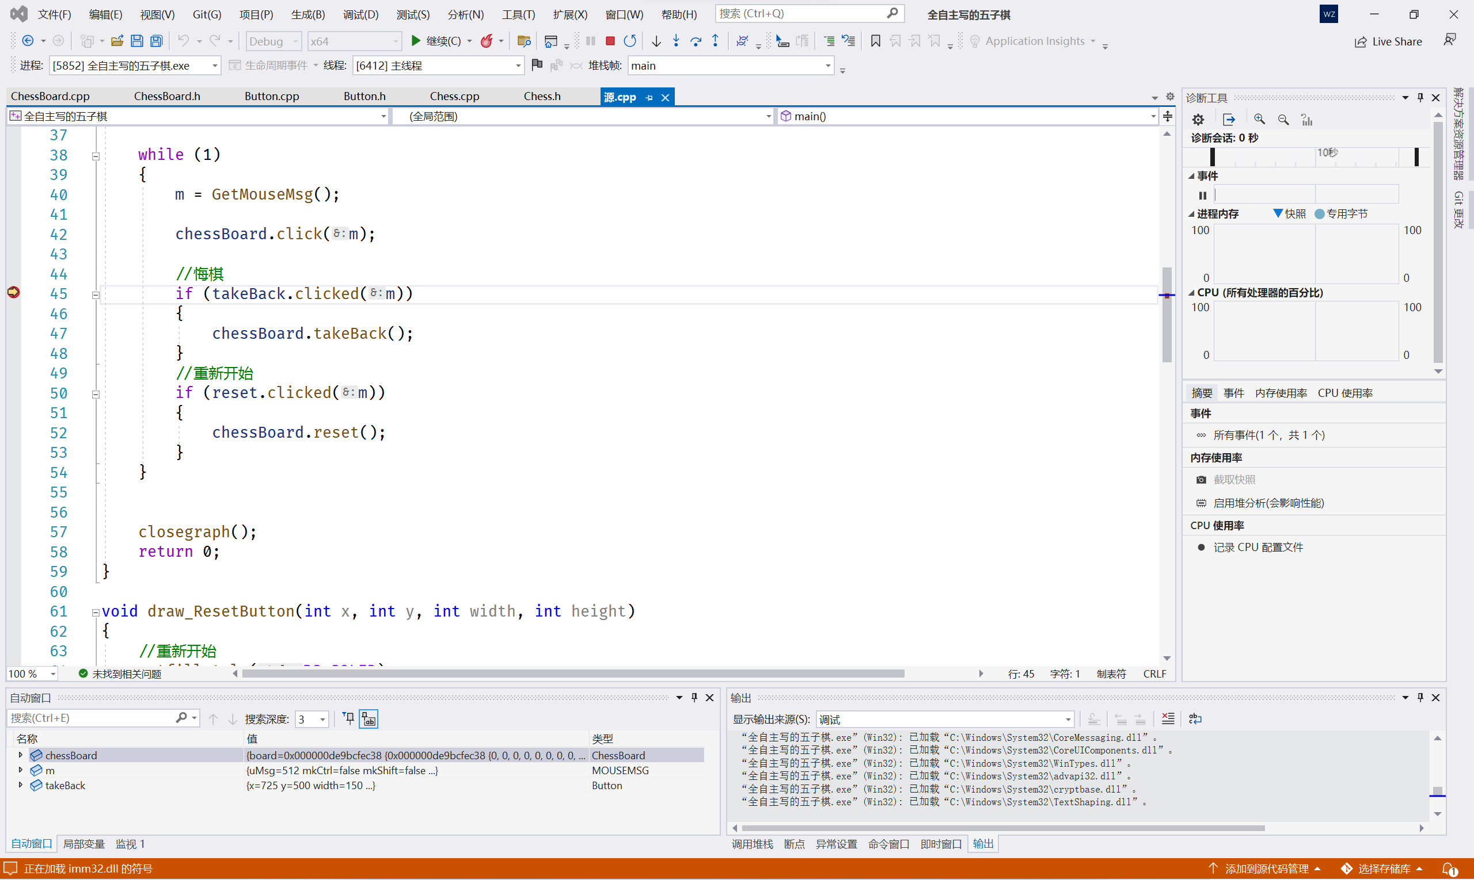
- 注意空栈
空栈调用top()方法非常容易出错。因此可以在要用到top()的时候先判断empty()。
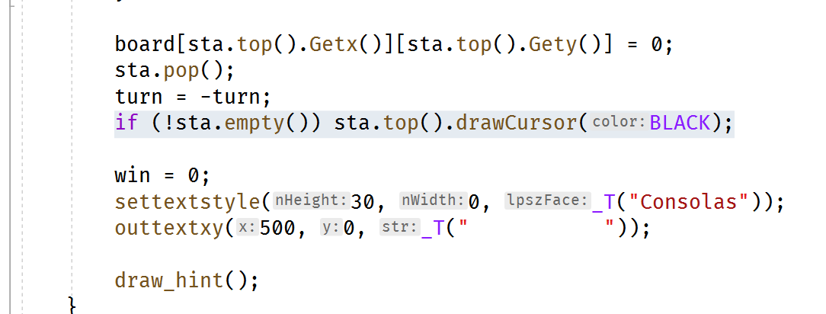
- 使用继承减少代码耦合
棋盘和按钮都需要xy坐标和长宽，也都需要检测鼠标点击。因此棋盘类继承按键类，可以有效减少代码量，方便编程。
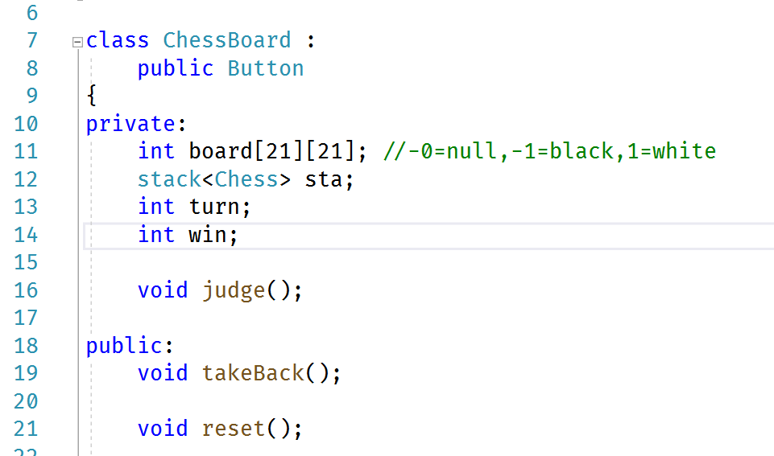

- 参考文献
1.EasyX Graphics Library for C++

