THE MAP.  themaptoadulthood.com | 100% FREE — NO SIGN UP NEEDED

Nobody taught you this stuff.
Now you can learn it yourself.
The Map to Adulthood is a free guide to the practical things most people figure out the hard way. Budgeting, taxes, finding a place to live, landing a job, and more. It’s written in plain language, organized so you can find what you need, and completely free to use at any time.
WHAT YOU’LL FIND THERE
💰 Money  Budgeting, taxes, credit cards, insurance, and how to start saving. |  | 💼 Career  Building a resume, job hunting, interviews, and negotiating pay. |  | 📚 Education  College, trade school, financial aid, and how to keep learning. |  | 🏠 Life Skills  Finding housing, cooking, car care, laundry, and staying safe online.
45+ guides. All free. Start anywhere.

You don’t have to read everything. Just look up what you need, when you need it.
NOT SURE WHERE TO START?  ● Need money basics?  Go to the Money section — start with Financial Literacy Overview.  ● Looking for a job?  Head to Career and start with Building a Strong Resume.  ● Thinking about college or a trade?  Check the Education section and start with Choosing a Major or Trade.  ● Moving out soon?  The Life Skills section has guides on finding housing and setting up your first place. |  | SCAN TO VISIT  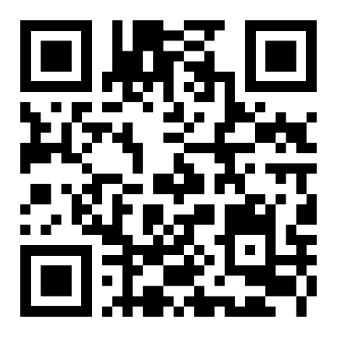  themaptoadulthood.com  Free. No account needed.

Guided Pathways: Starting College · Landing Your First Job
Getting Your Finances in Order · Moving Out · Healthcare Literacy
Not sure where to begin?
Each pathway walks you through a specific situation step by step.

The Map to Adulthood · themaptoadulthood.com
Free to use and share. Not a substitute for professional financial, legal, or medical advice.
© 2026

