Electromyography (EMG) signals captivate a quintessential role in deducing muscular activities, providing a biometric window into the nuances of neuromuscular dynamics 1 2, which is essential for a plethora of applications across diverse scientific domains. Rooted in capturing the electrical potential generated by muscle cells when electrically or neurologically activated, EMG signals have become a linchpin in biomechanics, physiotherapy, neurology, and ergonomics, providing critical insights into muscular function and neuromuscular pathology 3 4.

In clinical practice, EMG signals have been paramount for diagnosing, planning, and tracking the progression of various neuromuscular disorders, such as amyotrophic lateral sclerosis, myopathies, and peripheral neuropathies. Furthermore, they play a pivotal role in the rehabilitation domain 5, where clinicians leverage EMG signals to gauge and enhance muscle recovery following trauma or surgery. Similarly, EMG is utilized in sports science to unravel the underpinnings of muscular coordination, fatigue, and performance, thereby aiding in refining athletes' training and recovery regimes6. In prosthetics and orthotics, EMG signals facilitate the development of biofeedback systems that empower individuals with lost limbs to regain functional capabilities through prosthesis control. 7

Despite the rich informational content and wide application of EMG, the effective analysis of these signals remains steeped in a myriad of signal processing and computational challenges. These involve denoising, filtering, normalization, and various forms of computational analyses8, all to distill the latent, meaningful metrics and insights pertinent to understanding muscular activity and conditions. Moreover, the encapsulation of these technical processes within a user-friendly and open-source interface remains an unmet need, especially for professionals like clinicians, therapists, and sports scientists, who might not possess an in-depth knowledge of computational programming.

This manuscript introduces a Shiny application designed to disentangle the complexities of EMG signal analysis by offering a user-friendly, interactive, and web-based platform, thereby seamlessly connecting users with diverse backgrounds to nuanced EMG analysis. The application supports an array of computational functionalities, including, signal filtering, envelope creation, power spectral analysis, integrated EMG (iEMG), mean, and peak EMG calculations, and more critically, features to detect the onset and offset times of EMG signals, enabling latency analysis across user-defined time windows.

Our Shiny app emerges as a conduit, synthesizing technical depth with user accessibility, propelling simplified yet intricate EMG analyses to a wider spectrum of researchers, clinicians, and sports scientists. Through providing a platform that amalgamates essential and advanced EMG analysis functionalities within a non-technical interface, it stands poised to enhance and expedite research and applications across multiple disciplines, while fostering an inclusive, open-source tool for the widespread research community.

**Statement of Need**

The extraction of nuanced insights from EMG signals, including detection of onset/offset and performing latency analysis, remains fundamental in understanding muscle activation dynamics, which is crucial across myriad disciplines including clinical diagnostics, rehabilitation, sports science, and ergonomics. However, this extraction is oftentimes entwined with substantial computational and technical prerequisites. The existing landscape, while populated with numerous tools, often demands a depth of programming and signal processing expertise, which may not be accessible to all potential users, thereby limiting the widespread adoption and application of EMG analyses.

Our Shiny application addresses this palpable need by intertwining simplicity with analytical prowess, enabling users to execute a plethora of analyses, from basic filtering to advanced latency and spectral analyses, without necessitating computational expertise. Through ensuring that the technical complexities do not overshadow the analytical processes, the application stands to bolster research and practical applications of EMG analyses across various domains, enhancing the quality and efficiency of resultant insights, and more importantly, making such analyses accessible to a more diverse and multidisciplinary user base.

**Side Panel**

Users can upload EMG data using the side panel's 'Browse' button. The dataset should lead with a 'Time' column (in seconds) followed by columns containing raw EMG signals. Multiple EMG channels are supported, selectable through the 'EMG channel' input. Analysis range is customizable via the 'Time frame for analysis' tool. After parameter configuration, pressing 'Update Plots' refreshes all visualizations.

The app employs a band-pass filter on raw EMG data to target frequencies representative of muscular activity, primarily between 20 and 450 Hz. This process isolates EMG signals from potential noise sources such as electrical interference and other physiological signals. It enhances signal quality and fortifies the reliability of further analyses. Users have the flexibility to adjust EMG sampling frequency and set the desired band-pass filter range. (Figure 1)

Post band-pass filtering, the application transforms the EMG signal into an envelope via low-pass filtering. This refined representation, smoother and more coherent, enables clearer insights into muscle activation patterns, intensities, and durations. Additionally, this enveloped signal paves the way for in-depth comparative analyses across different muscles or conditions, emphasizing a deeper understanding of muscular dynamics rather than just the raw electrical activity.

A app also allows users to manually input an amplitude obtained from a maximal voluntary contraction, enabling the normalization of EMG amplitude to facilitate comparative and standardized analyses across varying conditions or sessions.

**Time Domain**

In this tag, users are presented with three distinct plots that illustrate the raw EMG signal, band-passed EMG signal and the EMG envelope. This tag equips with the capability to calculate key metrics, including mean and peak EMG amplitudes, at the simple click of a button. Additionally, a data download feature ensures users can effortlessly carry the analyzed EMG data into their preferred computational and analytical environments, facilitating a seamless blend of visual exploration and in-depth analysis of muscular electrical activity.

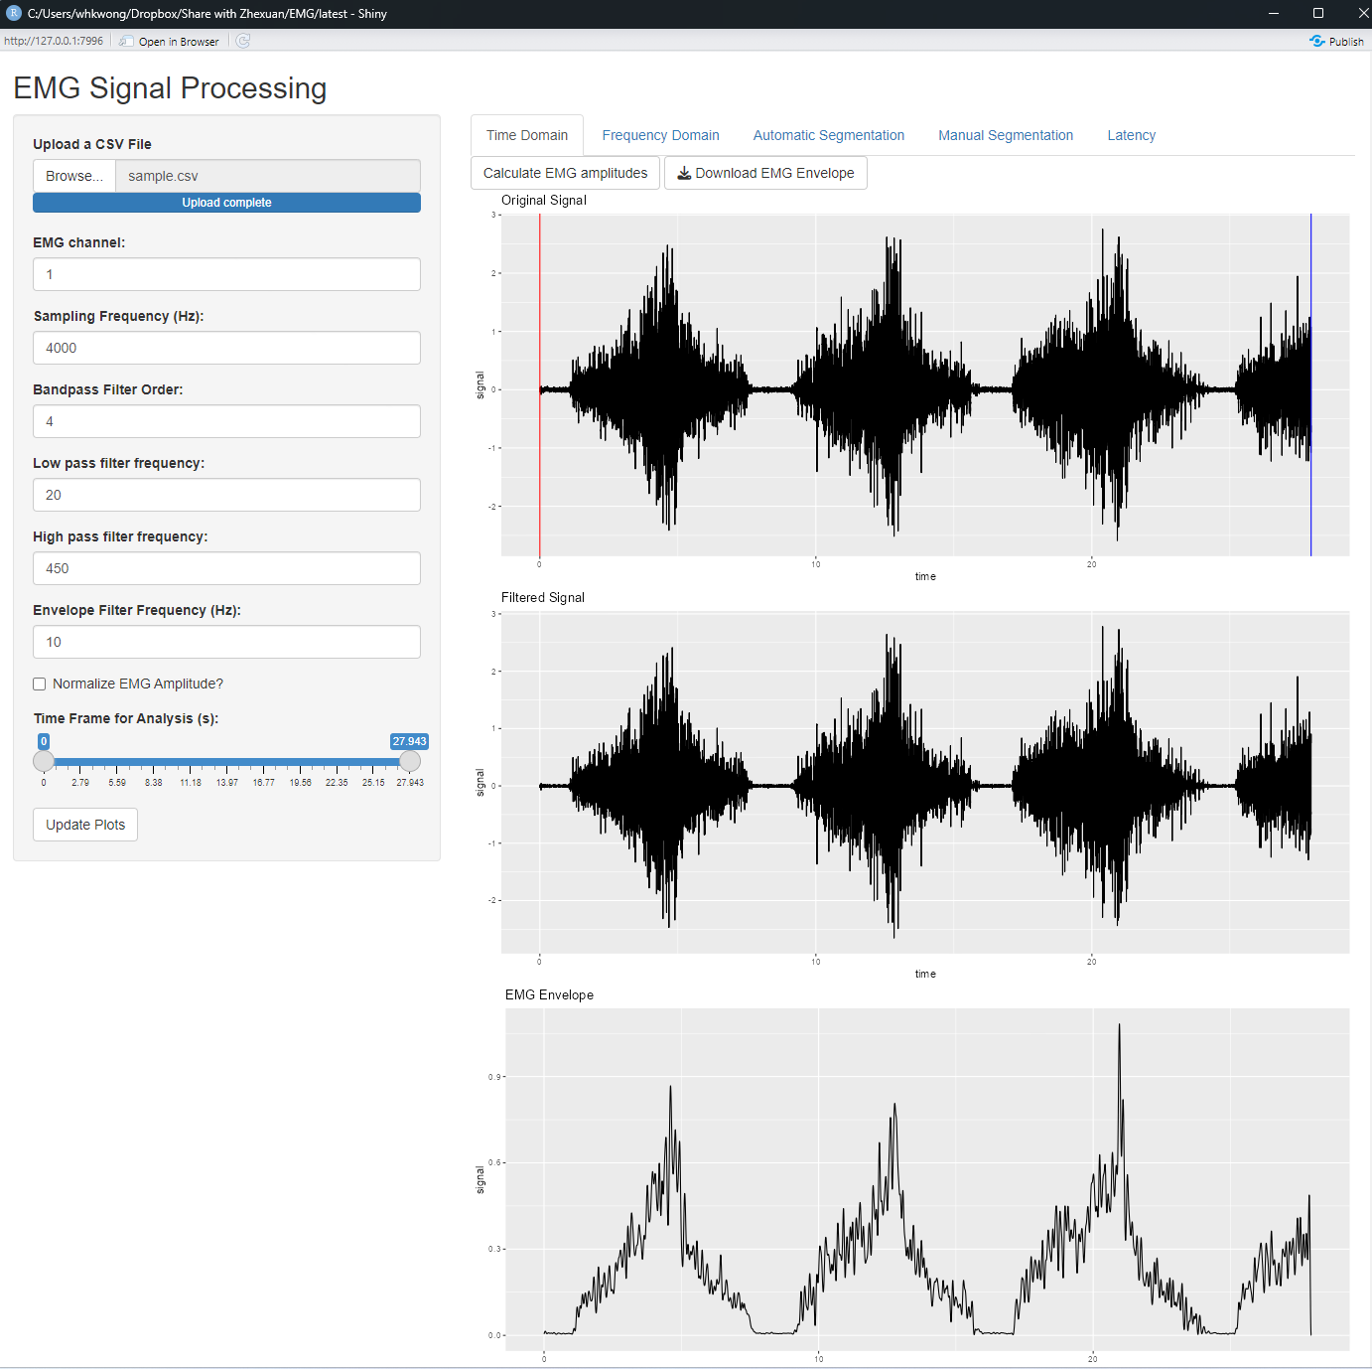

**Frequency Domain**

The tag for power spectrum analysis (figure 3) essentially allows users to decipher how the power of the EMG signal is distributed across various frequency components, thereby providing a nuanced understanding of muscle fiber recruitment strategies and potential alterations in neuromuscular control under different conditions. The application not only visualizes the power spectrum but also allows users to computationally extract and analyze critical parameters, such as median frequency and median frequencies for each 1 second interval.

Add in FFT and formula for calculate the median frequency

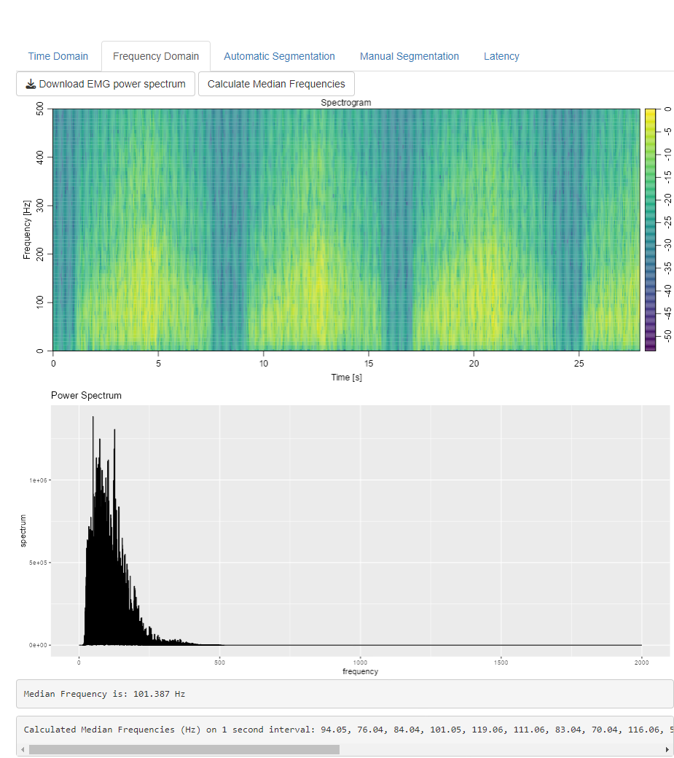

Automatic Segmentation

The auto segmentation functions scrutinize an input EMG signal, identifying points where the signal surpasses and falls below a specified threshold, indicative of muscle activation and relaxation, respectively. Leveraging a defined window size, it ensures that the identified onset and offset events are sustained over a minimal duration, mitigating the potential impact of transient spikes or noise. This dual-threshold method encapsulated within the function affords a simplistic yet effective strategy for delineating periods of muscle engagement and rest. The application also allow the user to perform block averaging to analysis EMG of a cyclic activities.

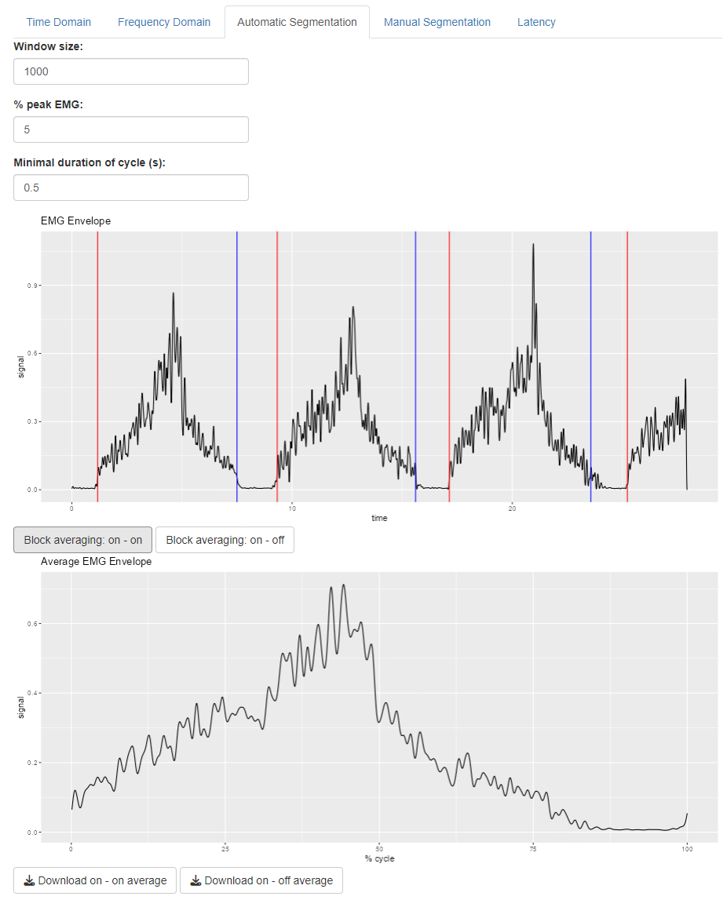

**Manual Segmentation**

Users can manually input specific time frames, when a stimulation or event happened. The tool not only visualizes but also calculates the average EMG signal across the defined segments, providing a clear snapshot of the selected event. Additionally, with functionality to download the resultant average signal.

**Latency**

This tag offers a latency detection function, which empowers users to manually input a time point indicative of an external stimulus, such as an electrical impulse. Subsequently, the function meticulously calculates the temporal span until the EMG signal onset and further to the point of peak EMG amplitude, thereby providing a comprehensive overview of the muscle’s response latency.

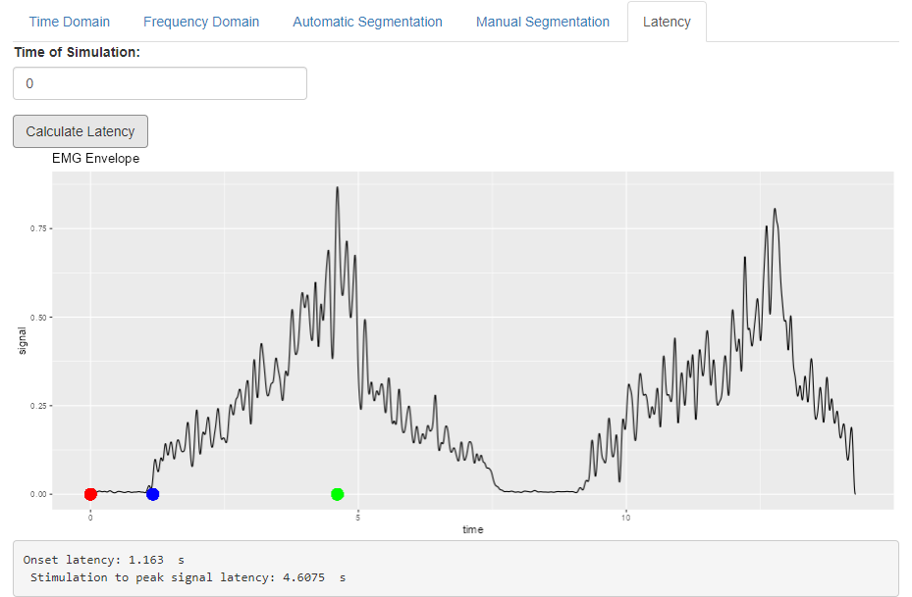1. Smith AG. Electromyography and Neuromuscular Disorders Clinical-Electrophysiologic Correlations. *Neurology* 2006;67(7):1317-17. doi: 10.1212/01.wnl.0000215006.71387.d1

2. Chowdhury RH, Reaz MB, Ali MA, et al. Surface electromyography signal processing and classification techniques. *Sensors (Basel)* 2013;13(9):12431-66. doi: 10.3390/s130912431 [published Online First: 2013/09/21]

3. Kang P, Jiang S, Shull PB. Synthetic EMG Based on Adversarial Style Transfer Can Effectively Attack Biometric-Based Personal Identification Models. 2022 doi: 10.1101/2022.10.14.512221

4. C. D A, N A. Emg Based Diagnosis of Myopathy and Neuropathy Using Machine Learning Techniques. *International Journal of Engineering Technology and Management Sciences* 2020;4(4):38-45. doi: 10.46647/ijetms.2020.v04i04.007

5. Zhang S, Xu Y, Han X, et al. Functional and Morphological Changes in the Deep Lumbar Multifidus Using Electromyography and Ultrasound. *Sci Rep* 2018;8(1):6539. doi: 10.1038/s41598-018-24550-5 [published Online First: 2018/04/27]

6. Maffiuletti NA, Martin A, Babault N, et al. Electrical and mechanical H(max)-to-M(max) ratio in power- and endurance-trained athletes. *J Appl Physiol (1985)* 2001;90(1):3-9. doi: 10.1152/jappl.2001.90.1.3 [published Online First: 2001/01/03]

7. Van Netten JJ, Jarl G, Postema K, et al. A toolkit for prosthetists and orthotists to facilitate progress in professional communication over the next 50 years. *Prosthet Orthot Int* 2020;44(6):408-15. doi: 10.1177/0309364620962325 [published Online First: 2020/10/14]

8. Chowdhury RH, Reaz MBI, Ali M, et al. Surface Electromyography Signal Processing and Classification Techniques. *Sensors* 2013 doi: 10.3390/s130912431