Week 1 – Layered Network Architecture
Layer | Primary Role | Key Concepts
Transport Layer | Process-to-process communication | Uses port numbers to deliver data to the correct application. Examples include TCP and UDP. Handles reliability, flow control, and multiplexing.
Network Layer | Host-to-host communication | Uses logical addressing (IP) to deliver packets across networks. Responsible for routing decisions and packet forwarding.
Data Link Layer | Node-to-node communication | Uses MAC addresses for delivery on the same physical link. Handles framing, error detection, and medium access control.
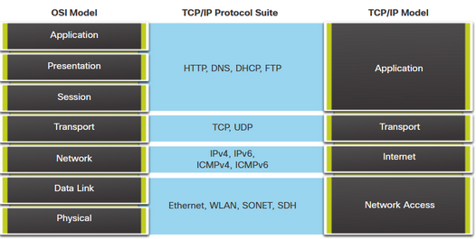
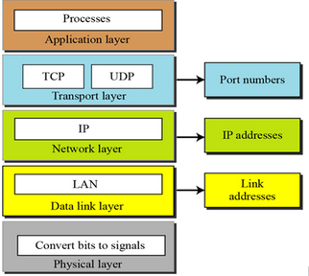
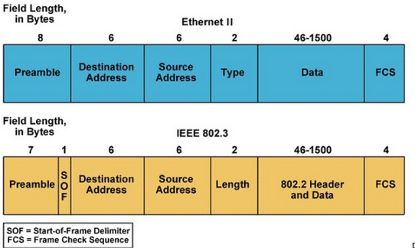
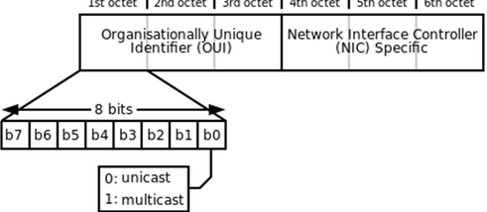

Week 2 – Ethernet & Data Link Layer Concepts
Topic | Key Concepts
Ethernet Frame Size | Minimum payload of 46 bytes ensures CSMA/CD collision detection in early Ethernet. Maximum payload of 1500 bytes chosen for historical cost and fairness reasons. Jumbo frames exist today but standard MTU remains 1500 bytes.
Ethernet II vs IEEE 802.3 | Values ≤1500 interpreted as length (IEEE 802.3). Values ≥1536 interpreted as type (Ethernet II). IP traffic uses Ethernet II (e.g. 0x0800).
Ethernet Topology | Modern Ethernet uses star or extended star topology. Hubs create shared collision domains; switches isolate collision domains per port.
MAC Protocol (CSMA/CD) | Required only in half-duplex shared media. Disabled in full-duplex switched Ethernet. Collisions are not expected in modern networks.
Ethernet Multicast Address | Multicast MAC addresses have the least significant bit of the first octet set to 1. Used for one-to-many Layer 2 delivery.
Collision Domain | Area where frames can collide. Reduced by switches; eliminated per switch port.
Broadcast Domain | Area where broadcast frames are received by all nodes. Defined by VLANs and broken by routers or Layer-3 boundaries.
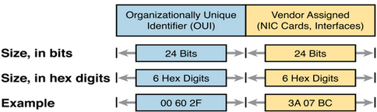

Week 3 – Network Layer & IPv4
Topic | Key Concepts
Core Functions of IP | Addressing identifies hosts, routing determines next hop, fragmentation allows packets to traverse links with smaller MTUs. Reassembly occurs only at the destination.
IP Characteristics | Connectionless, best-effort, no guarantees of delivery, order, or duplication. Reliability handled by higher layers such as TCP.
IPv4 Header – Version & Length | Version field identifies IPv4. Header length specifies header size in multiples of 4 bytes (minimum 20 bytes).
IPv4 Header – TTL | Prevents infinite routing loops by decrementing at each hop. Packet is discarded when TTL reaches zero.
IPv4 Header – Protocol | Identifies upper-layer protocol (ICMP = 0x01, TCP = 0x06, UDP = 0x11).
IPv4 Packet Size | Total length field allows up to 65,536 bytes, but practical size limited by MTU.
IPv4 Address Types | Includes public, private (RFC 1918), loopback, link-local, multicast, and broadcast addresses.
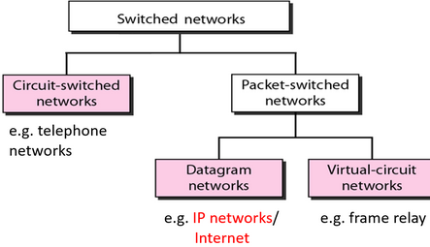
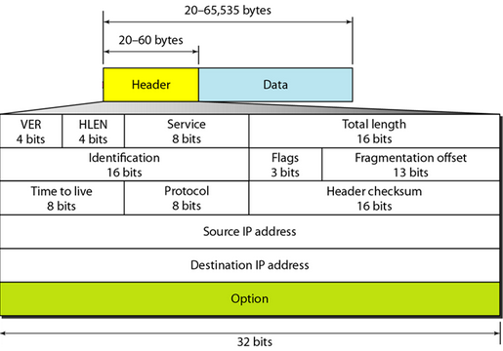
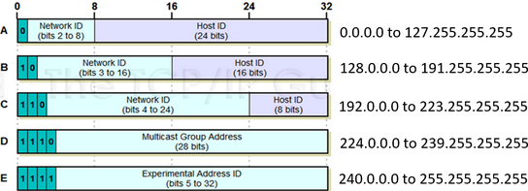
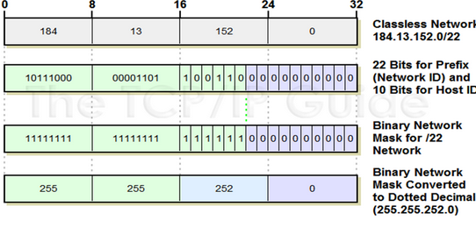
Week 4 – Network Design, VLANs & Inter-VLAN Routing
Topic | Key Concepts
Hierarchical Network Model | Access layer connects end devices. Distribution layer handles routing and policy. Core layer provides high-speed backbone connectivity.
Collapsed Core Design | Combines core and distribution layers. Common in small to medium networks to reduce cost and complexity.
VLAN Concept | VLANs logically segment a network at Layer 2, reducing broadcast domains without changing physical topology.
VLAN Tagging (802.1Q) | Frames are tagged when traversing trunk links. Sending switch inserts tag; receiving switch removes it.
Native VLAN | Allows untagged frames on trunks for backward compatibility. Native VLAN mismatch can cause security and traffic leakage issues.
Access vs Trunk Ports | Access ports carry one VLAN. Trunk ports carry multiple VLANs between switches.
Dynamic Trunking Protocol (DTP) | Dynamic auto waits passively. Dynamic desirable actively negotiates trunking. Best practice is to disable DTP where possible.
Legacy Inter-VLAN Routing | One physical router interface per VLAN. Poor scalability and rarely used today.
Router-on-a-Stick | Single trunk link with router subinterfaces. Cost-effective but limited by router throughput.
Layer-3 Switch Inter-VLAN Routing | Uses SVIs for each VLAN. Fastest and most scalable solution in modern networks.

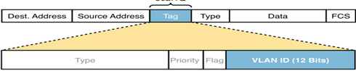
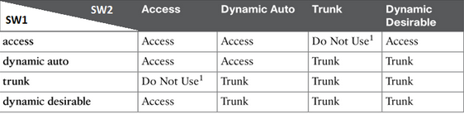
Week 5 – Address Resolution Protocol (ARP)
Topic | Key Concepts
Purpose of ARP | Resolves an IP address to a MAC address so Layer-3 packets can be delivered on Ethernet.
ARP Request | Broadcast message sent to all devices in the broadcast domain asking for the MAC address of a target IP.
ARP Reply | Unicast response sent by the device that owns the target IP, providing its MAC address.
ARP Packet Structure | Includes hardware type, protocol type, hardware length, protocol length, operation code, sender and target addresses. Same format for request and reply.
ARP Cache | Temporarily stores IP-to-MAC mappings to reduce broadcast traffic. Entries age out over time.
Hop-to-Hop vs End-to-End | MAC addresses change at every hop. IP addresses remain constant from source to destination. Switching is hop-to-hop; routing is end-to-end.
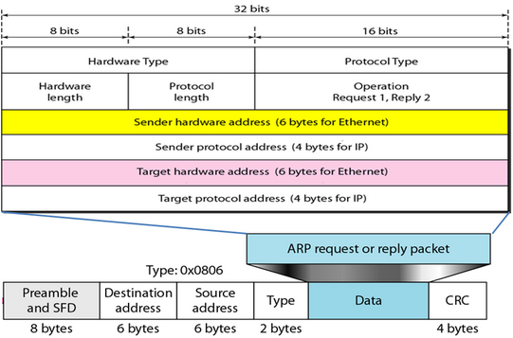
Type of EtherChannel configs
EtherChannel Method |  | Negotiation? | Standard/Proprietary |  | Key Notes
Static (Manual) |  | No | Vendor-specific configuration |  | Interfaces are manually forced into a channel-group; no protocol checks/negotiation.
PAgP |  | Yes | Cisco proprietary |  | Uses PAgP to negotiate channel formation; both ends must support PAgP.
LACP |  | Yes | IEEE 802.3ad |  | Standards-based negotiation; preferred for multi-vendor interoperability.
EtherChannel Type | Typical Topology Use |  |  | Interface Mode |  | What It Carries / How It’s Used
Layer 2 EtherChannel | Access ↔ Distribution |  |  | Trunk (switchport) |  | VLAN-tagged traffic across multiple VLANs (supports inter-VLAN designs).
Layer 3 EtherChannel | Distribution ↔ Core |  |  | Routed port (no switchport) |  | Point-to-point routed connectivity; interfaces behave like router interfaces and can be assigned IP addresses.
Rapid Spanning tree protocol (RSTP)
Election Process
What is Being Elected | Primary Decision Metric | Tie-Breakers (in order) | Resulting Role/Outcome
Root Bridge (Root Switch) | Lowest Bridge ID (BID) (priority + VLAN ID + MAC) | Lowest priority → lowest MAC address | One switch becomes Root and originates the “best” BPDUs (root info).
Root Port (per non-root switch) | Lowest total path cost to root: (received BPDU root path cost + local interface cost) | 1) Lowest sender BID (of received BPDU) → 2) Lowest sender port priority (Port ID) → 3) Lowest sender port number (Port ID) | Each non-root switch selects one Root Port (best upstream path).
Designated Port (per segment/link) and Alternate Port | Port that advertises lower root path cost (better BPDU) | If cost ties: lower BID wins Designated | Designated forwards for that segment; the other side becomes Alternate and goes Discarding/Blocking (loop prevention, standby).
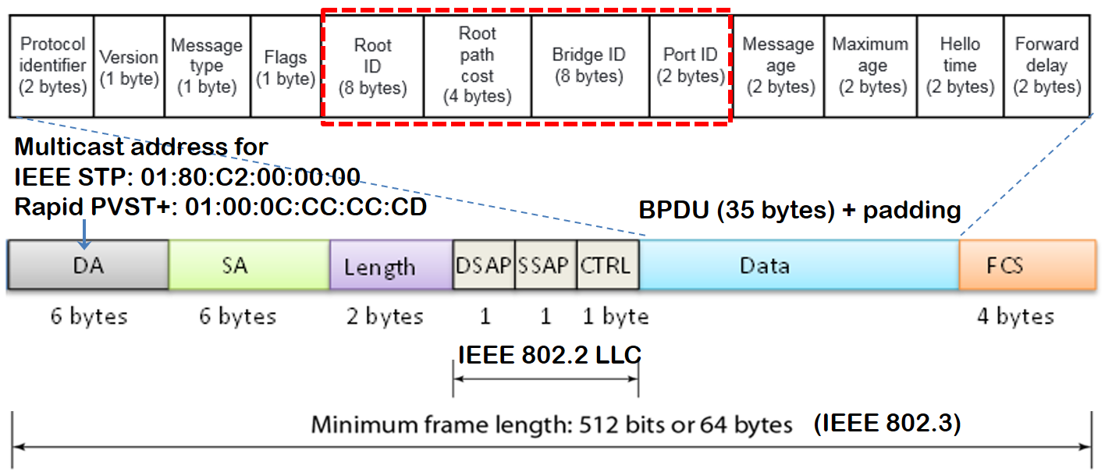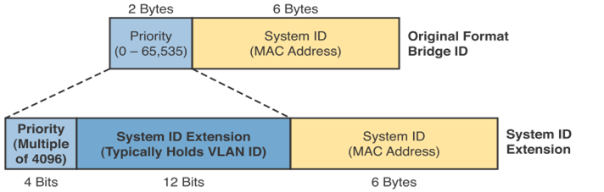
Port Roles
Port Role | Where It Exists | What It Does | Typical State
Root Port (RP) | Non-root switches only | Best path toward the Root Bridge (one per non-root switch, per VLAN) | Forwarding
Designated Port (DP) | Root + non-root switches | Forwards for a segment; best port away from root on that LAN segment | Forwarding
Alternate Port (AP) | Non-root switches only | Backup path toward root; prevents loops by standing by | Discarding (often shown as BLK)
Backup Port (BP) (rare) | Non-root switches (uncommon) | Backup to a designated port on the same switch for the same segment | Discarding

Port States
STP (802.1D) States | Closest RSTP (802.1w) Equivalent
Blocking + Listening | Discarding
Learning | Learning
Forwarding | Forwarding
Disabled | (Not a defined RSTP state; effectively non-participating/administratively down)

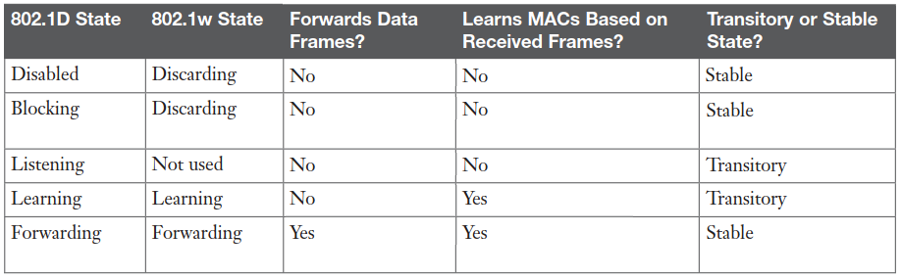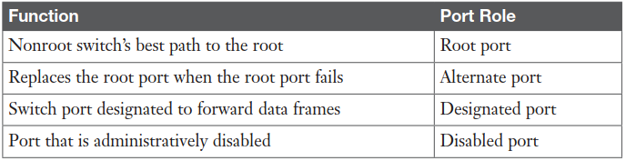

FHRP generic properties
Property | What It Means | Key Notes / Typical Values
Full Name | First-Hop Redundancy Protocol (FHRP) | A category of protocols (not a single protocol)
Primary Purpose | Default gateway redundancy | Prevents loss of upstream connectivity if the gateway device/link fails
Network Layer Focus | Layer 3 gateway function (with Layer 2 impact) | Hosts route to a gateway IP; switches forward to a gateway MAC
Core Mechanism | Virtual gateway identity | Presents a Virtual IP (VIP) (and usually Virtual MAC (VMAC)) shared by multiple devices
Host Configuration Model | Hosts point to the VIP as default gateway | Hosts do not reconfigure during failover
Device Roles | Active/Standby (or Master/Backup) | One forwards traffic; others monitor and are ready to take over (some FHRPs can do load-balancing)
Failover Trigger | Loss of protocol hellos / timers (or tracked object failure) | If the active stops advertising, a standby takes over; many designs also track uplinks
Failover Behavior | Standby assumes VIP/VMAC ownership | Often uses gratuitous ARP (or equivalent) so switches relearn the VMAC location quickly
Traffic Forwarding | Usually only the active forwards for that VIP | Depends on protocol: some support per-host/per-flow distribution (e.g., GLBP)
Common Deployment Point | Distribution layer SVI/gateway per VLAN | Frequently used as the default gateway for VLANs in campus designs
Load Sharing Option | Possible, depending on protocol/design | Common method: make different devices active for different VLANs (HSRP/VRRP); or protocol-native (GLBP)
Typical Examples | HSRP, VRRP, GLBP | HSRP/GLBP are Cisco; VRRP is standards-based
Convergence Goal | Minimal downtime and transparent recovery | Keeps gateway identity stable so users “don’t notice” a gateway failure

HSRP properties
Property | What It Is | Key Values / Notes
Protocol Type | First-Hop Redundancy Protocol (FHRP) | Provides default-gateway redundancy at the first hop
Vendor / Standard | Cisco-proprietary | HSRP is Cisco-specific (commonly deployed on Cisco networks)
Core Concept | Virtual default gateway | Hosts use a Virtual IP (VIP) as their default gateway
Virtual IP (VIP) | Shared gateway IP address | Stays the same during failover (no host reconfiguration)
Virtual MAC (VMAC) | MAC address mapped to the VIP | Auto-generated by HSRP; used by hosts/switches at Layer 2
Router Roles | Active / Standby | Active forwards gateway traffic; Standby monitors and takes over on failure
Failure Detection | Periodic HSRP packets (hellos) | If the active stops sending, standby assumes failure and becomes active
Failover Method | Gratuitous ARP (GARP) | New active sends unsolicited ARP reply to claim VIP/VMAC ownership
Switch Table Impact | CAM/MAC table update | Switches relearn VMAC → new port, redirecting traffic instantly
Host Impact | Minimal / transparent | Default gateway remains VIP; ARP mapping typically remains consistent
Common Deployment | Distribution layer default gateway for VLANs | Often paired with redundant distribution switches
Load Balancing Approach | Active role split across VLANs | Make one switch active for some VLANs and the other active for others to share load

Week 7
OSPF overview
Item | Key Point | Notes
Protocol type | Link-state IGP | Routers learn topology, then compute best paths using Dijkstra (SPF)
Version (IPv4) | OSPFv2 | OSPFv3 is for IPv6 (not covered here)
IP transport | Runs directly over IPv4 | IP Protocol number = 89
Multicast destinations | 224.0.0.5 (All OSPF routers), 224.0.0.6 (All DR/BDR) | Used for Hello and other OSPF control traffic
Administrative Distance | 110 | Shown in routing table as [110/metric]
Core phases | 1) Neighbor discovery 2) Topology exchange 3) SPF calculation | Matches your notes structure
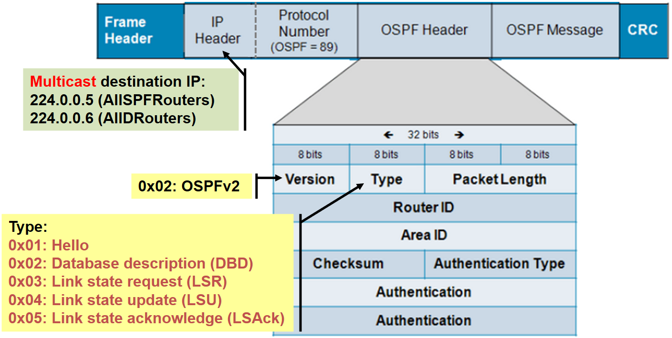
Packet Types
OSPF Type | Name | Purpose (What It Does)
1 | Hello | Discover/maintain neighbors; DR/BDR election on multiaccess networks
2 | DBD (Database Description) | Summarizes LSDB contents using LSA headers only (efficient comparison)
3 | LSR (Link State Request) | Requests missing/newer LSAs from a neighbor
4 | LSU (Link State Update) | Sends LSAs (full details) requested or flooded
5 | LSAck (Link State Acknowledge) | Acknowledges receipt of LSUs/LSAs
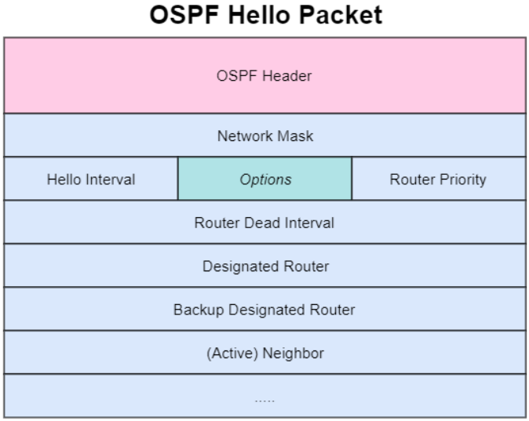
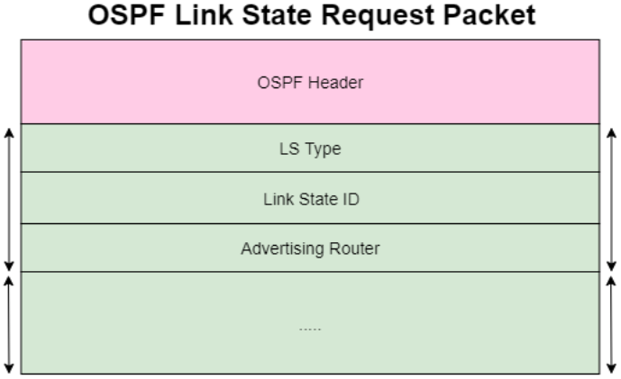
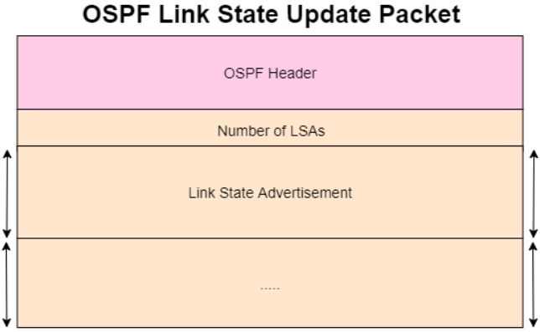
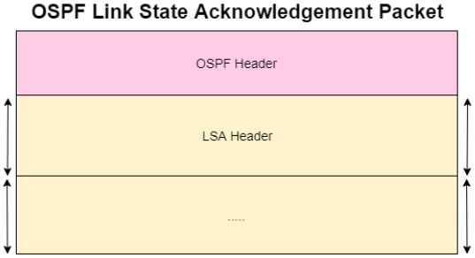
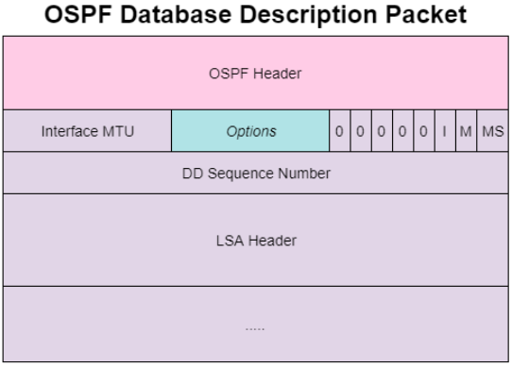

Phase 1: Discover Adjacent Neighboring Routers
- Enable OSPF on interfaces (via network … wildcard … area … or ip ospf … area …).
- Interface state transitions Down → Init and starts sending Type 1 Hello packets.
- Hello neighbor discovery logic
  - If no Hellos received yet: sends Hello with no neighbor list.
  - After receiving Hellos: includes neighbor Router IDs in the Hello Neighbor field.
  - When a router receives a Hello that lists its own Router ID, it reaches 2-Way state.
- Multiaccess Ethernet optimization (DR/BDR)
  - To reduce excessive exchanges, routers elect a Designated Router (DR) and Backup Designated Router (BDR).
  - Non-DR routers (DROTHER) primarily exchange OSPF info with DR/BDR.
  - Election criteria: highest OSPF priority wins (default 1), then highest Router ID if tied.
  - Election is non-preemptive after completion (new arrivals don’t take over).

Phase 2: Learn Network Topology
- Routers move from 2-Way → ExStart → Exchange to begin database synchronization.
- Exchange Type 2 DBD (Database Description) packets:
  - DBD contains LSA headers (summaries) so routers can compare databases efficiently.
- If differences exist, routers enter Loading:
  - Type 3 LSR requests missing/newer LSAs.
  - Type 4 LSU sends the requested LSAs (updates).
  - Type 5 LSAck acknowledges LSUs.
- When link-state databases are synchronized, neighbors reach Full state.

Phase 3: Compute Lowest-Cost Paths to Remote Subnets
- Each router independently runs Dijkstra (SPF) on the learned topology (LSDB).
- Computes lowest-cost paths based on summed interface costs.
- Installs best routes into the routing table:
  - OSPF-learned routes marked O.
  - Metric shown as [110/cost] where 110 is OSPF administrative distance and cost is total path cost.
- If multiple equal-cost best paths exist, OSPF can install multiple routes (ECMP) for load balancing.
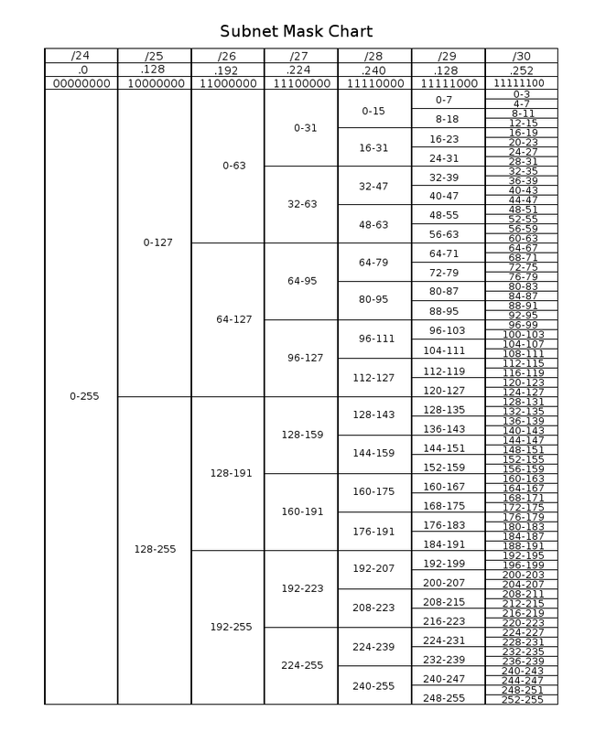

Topic (from doc) | Configuration Commands | Verify / Debug / Clear Commands
Access vs Trunk Ports + DTP | Access port: int gi0/1switchport mode accessswitchport access vlan 10  Trunk port: int gi0/24switchport mode trunkswitchport trunk allowed vlan 10,20switchport trunk native vlan 99  Disable DTP: int gi0/24switchport nonegotiate | show vlan briefshow interfaces trunkshow interfaces gi0/24 switchport
Inter-VLAN Routing (Router-on-a-Stick / L3 Switch SVIs) | Router-on-a-stick: int g0/0.10encapsulation dot1q 10ip address 10.10.10.1 255.255.255.0  SVI (L3 switch): vlan 10int vlan 10ip address 10.10.10.1 255.255.255.0no shutip routing | show ip interface briefshow interfaces trunkshow ip route
ARP | (Normally no “enable” config; ARP is automatic on IPv4 Ethernet) | show ip arpclear ip arpping <ip> (forces ARP if needed)
EtherChannel (Static / PAgP / LACP) + L2 vs L3 | Member links (common pre-req): int range gi0/1-2switchport (for L2 EC)  Static: channel-group 1 mode on  PAgP: channel-group 1 mode desirable (or auto)  LACP: channel-group 1 mode active (or passive)  Port-channel (L2 trunk): int po1switchport mode trunkswitchport trunk allowed vlan 10,20  Port-channel (L3 routed): int range gi0/1-2no switchportchannel-group 1 mode activeint po1no switchportip address <ip> <mask> | show etherchannel summaryshow etherchannel port-channelshow interfaces port-channel 1show lacp neighbor / show pagp neighbor
RSTP (Rapid Spanning Tree) + roles/states | Enable rapid-PVST (Cisco): spanning-tree mode rapid-pvst  Set root (per VLAN): spanning-tree vlan 10 root primaryspanning-tree vlan 10 root secondary (or priority <value>)  Edge port hardening: int gi0/10spanning-tree portfastspanning-tree bpduguard enable | show spanning-tree summaryshow spanning-tree vlan 10show spanning-tree interface gi0/2 detaildebug spanning-tree events (use carefully)
FHRP / HSRP (default gateway redundancy) | HSRP on SVI/interface: int vlan 10standby 10 ip 10.10.10.1standby 10 priority 110standby 10 preempt  Track uplink (optional): standby 10 track gi0/49 20 | show standby briefshow standbydebug standby (use carefully)show ip arpshow mac address-table dynamic
Static Routing (standard/default/floating/summary) (topic referenced in your notes set) | Next-hop: ip route 172.16.2.0 255.255.255.0 172.16.4.2  Exit-interface (ptp/serial): ip route 172.16.2.0 255.255.255.0 s0/0/0  Fully specified: ip route 172.16.2.0 255.255.255.0 s0/0/0 172.16.4.2  Default route: `ip route 0.0.0.0 0.0.0.0 <next-hop | exit-int><br>**Floating default**: ip route 0.0.0.0 0.0.0.0 5<br>**Summary**: ip route 200.23.16.0 255.255.240.0 `
OSPFv2 (phases, packet types, DR/BDR) | Enable OSPF (network cmd): router ospf 1network 10.0.0.0 0.255.255.255 area 0  Enable per-interface: int gi0/0ip ospf 1 area 0  Set router-id: router ospf 1router-id 1.1.1.1  Passive interface: router ospf 1passive-interface gi0/1  Inject default route: router ospf 1default-information originate  Reference bandwidth: router ospf 1auto-cost reference-bandwidth 10000 | show ip ospfshow ip ospf interface briefshow ip ospf neighborshow ip ospf databaseshow ip route ospfdebug ip ospf adj (use carefully)

