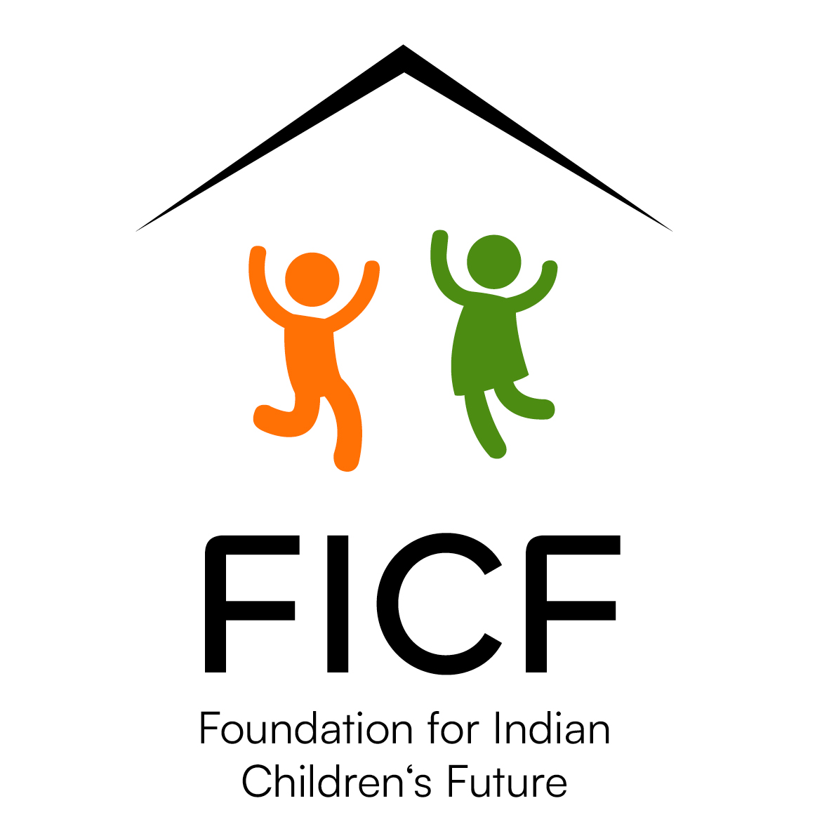
FICF — 20 YEARS
Touching Hearts and Transforming Lives and Communities
WAYS YOU CAN SUPPORT FICF
Unit of Support shows how many children, people, camps or other units your contribution can support.
Choose monthly, annual or one-time giving.
Area | You can support… |  | Unit of Support | Monthly | Annual | One-time
Education |  | School education – Child Care Program | 1 child | CHF 30 | CHF 360
Education |  | Tuition & Nutrition Program | 25 children | CHF 50 | CHF 600
Education |  | University education | 1 needy student |  | CHF 500
Education |  | Health Care Institution student | 1 needy student |  | CHF 500
Health |  | Medical camps in rural India | 4 camps |  | CHF 1,000
Livelihood |  | Seed supply for farmers | 50 farmers |  | CHF 500
Education |  | School bags for rural children | 100 children |  | CHF 1,000
Education |  | School kits / stationery | 100 children |  | CHF 1,000
Community |  | Winter blankets / bedsheets | 100 people |  | CHF 3,000
Education |  | Clothes / footwear for tribal children | 200 children |  | CHF 2,000
Health |  | Essential medical treatment | 10 needy people |  | CHF 2,000
Education |  | Summer camp | 50 children / 2 weeks |  | CHF 800
Livelihood |  | Sustainable income through vocation | 10 people | CHF 70 | CHF 840
Community |  | Livelihood for destitute elderly & widows | 10 people | CHF 10 | CHF 120
Relief |  | Monsoon flood relief | 100 people |  | CHF 1,000
Relief |  | Aid to internally displaced people – North-East | 100 people |  | CHF 2,000
Education |  | School for tribal children – North-East | 100 children |  | CHF 1,000
Ficf Support |  | Children's library at FICF office | 1 library |  |  | CHF 500
Ficf Support |  | Safety equipment for FICF activities | 1 set |  |  | CHF 1,000
Ficf Support |  | Electronics & electrical equipment | 1 set |  |  | CHF 500
Ficf Support |  | Furniture for FICF office | 1 set |  |  | CHF 500
Community |  | Village community support – park, trees & local needs | 1 village |  | CHF 300
Every contribution matters.
Your support helps FICF place quality education at the heart of its mission while responding to nutritional,
health, livelihood and community needs.
FICF Switzerland • 20 years of partnership with FICF India • 2006–2026
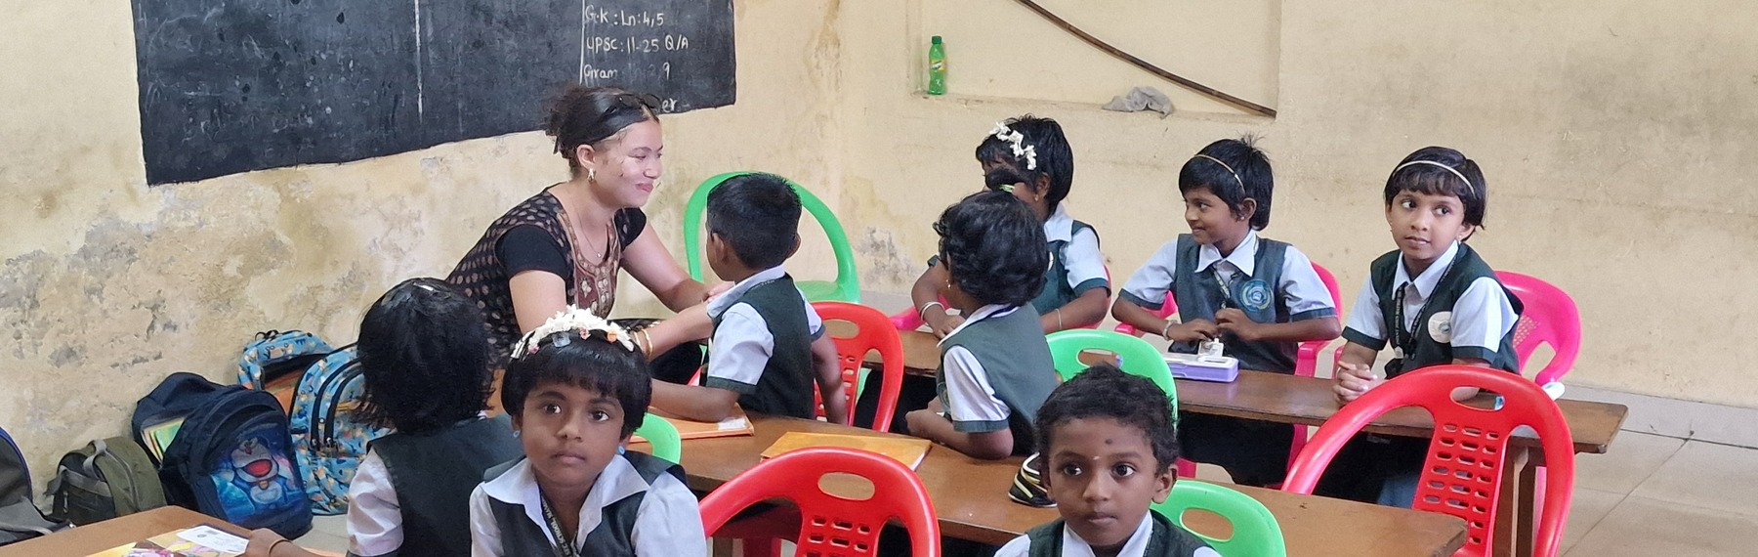 | 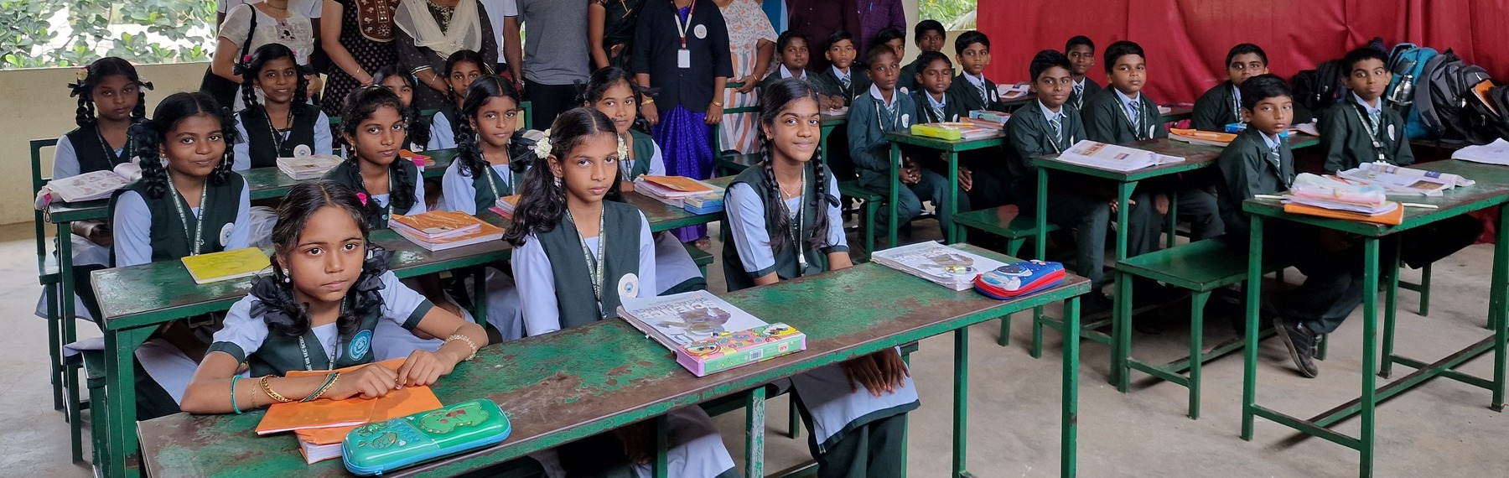
WAYS TO GIVE
VIA BANK  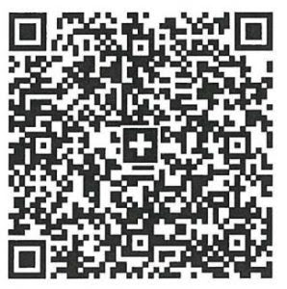  Scan for payments  from Switzerland | PAYPAL  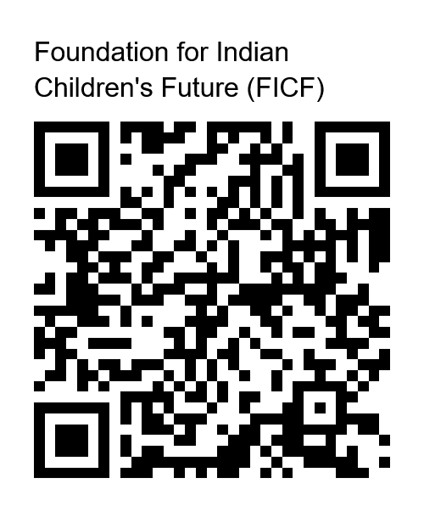  Scan to pay  via PayPal | CREDIT / DEBIT CARD  Scan to pay  by card | TWINT  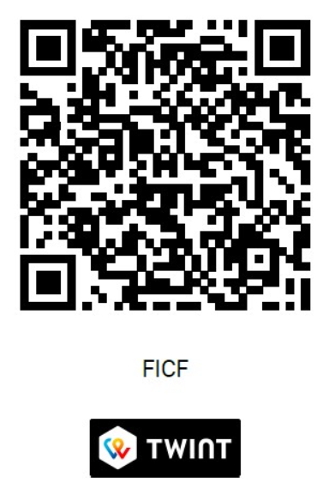  Scan to pay  via TWINT
FICF – Foundation for Indian Children’s Future • Stockera 3, 3186 Duedingen • Fribourg • Switzerland
IBAN: CH13 8080 8008 3100 4933 1
www.ficf.in

