Data-Information-Knowledge

Data:

* raw facts about events

Information:

* Result of processing raw data
* Processed/re-organized data with meaning

Knowledge:

* Further refined data/information based on expertise of the recipient

Analytics:

* Discovery, interpretation, and communication of meaningful patterns in data by using mathematics, statistics, and computer software

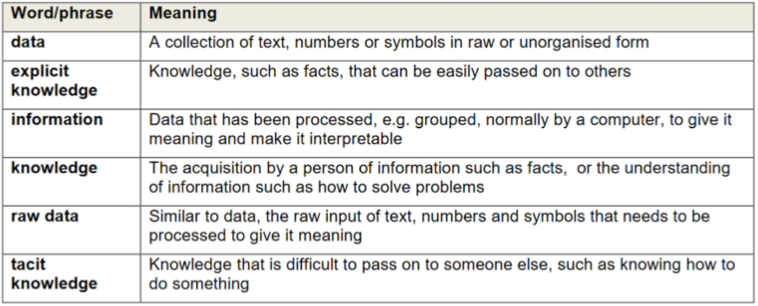

Random numbers or words are meaningless sets of data. They could be the first four answers in the 3 x table, a list of household pets and the heights of 15-year-old students but without a context we don’t know what to do with it.

The concept of data as it is used in the syllabus is commonly referred to as ‘raw’ data - a collection of text, numbers and symbols with no meaning. Data therefore has to be processed, or provided with a context, before it can have meaning.

Data on its own has no meaning. It only takes on meaning and becomes information when it is interpreted. Data consists of raw facts and figures. When that data is processed into sets according to context, it provides information.

Data refers to raw input that when processed or arranged makes meaningful output. Information is usually the processed outcome of data. When data is processed into information, it becomes interpretable and gains significance. In IT, symbols, characters, images, or numbers are data.

These are the inputs an IT system needs to process in order to produce a meaningful interpretation. In other words, data in a meaningful form becomes information. Information can be about facts, things, concepts, or anything relevant to the topic concerned. It may provide answers to questions like who, which, when, why, and how. If we put information into an equation it would look like this:

Data + Meaning = Information

When someone memorizes information, this is often referred to as ‘rote-learning’ or ‘learning by heart’. We can then say that they have acquired some knowledge. Another form of knowledge is produced as a result of understanding information that has been given to us and using that information to gain knowledge of how to solve problems.

Knowledge can therefore be:

* Acquiring and remembering a set of facts
* Or the use of information to solve problems

The first type is often called explicit knowledge. This is knowledge that can be easily passed on to others. Most forms of explicit knowledge can be stored in certain media. The information contained in encyclopedias and textbooks are good examples of explicit knowledge.

The second type is called tacit knowledge. It is the kind of knowledge that is difficult to pass on to another person just by writing it down.

For example, saying that Paris is the capital of France is explicit knowledge that can be written down, passed on, and understood by someone else.

However, the ability to speak a foreign language, bake bread, program a computer or use complicated machinery requires additional pieces of knowledge (such as that gained through experience) that are not always knows explicitly and are difficult to pass on to other users.

Assumptions:

* Loves Shopping
* Is American
* No kids
* Owes Money



Assumptions:

* Makes more money
* Lives more leisurely
* Has more savings

