Game Design Documentation

Monster
Dungeon

Monster Dungeon
Version 1.2
Context
1. Game Core
2. Game Program Structure
3. Player
4. Enemy
5. Map
6. UI
7. Game Story
8. Market Survey
9. Publicity & Advertisement
10. Version
11. Appendix

1. Game Core
This is a dungeon level-up game. The player collects what they need to clear each level, and the final goal is to defeat the Boss.
1.1 The most significant design in the game
Before reading this chapter, let’s think about what makes a game fun and keeps players playing. A fun game comes from these things:
1. The Core: Decision.
2. The heartbeat around the core: Uncertainty.
3. The decoration of the decision: the density of decisions and their consequences.
A fun game is packed with interesting decisions. The character, eye-catching visuals, and UI are the decoration around those decisions.
The decisions serve the core loop: beat enemies, feel your growth, and take on challenges that never seem to end.
1.2 The Core Design Applied in my Game
The game has several systems: Player, Fog of War, Task, Random Dungeon, Enemy, and more.
First, Decision: the core loop is that the player collects equipment, enters the dungeon, defeats enemies, reaches the exit portal, and chooses to extract or enter the next, harder level. The player’s final goal is to defeat the Boss.
Second, Uncertainty: to create uncertainty, I added a Fog of War system and used an algorithm to generate the random dungeon map.
Third, the decoration: to make decisions more interesting, I added the Task System, wrote some story, and designed various weapons, monsters, and chest loot, giving players more choices. I also optimized the dungeon generation algorithm to make maps more balanced and create more decision points in combat.
2. Game Program Structure
The game uses a message bus + Game Message to decouple its systems. Each system manages its own scripts. One system handles one object type, and one script handles one function. Different systems connect through the message bus.
Before this structure, I tried a Game Manager / Director pattern to control the whole game system, but it lost the battle: different functions became coupled together. Then I combined the Game Manager with a state machine and a message bus to organize the code. But this defect surfaced as the code grew past about 13k lines. The Game Manager and the state machine could be separated into one independent system that publishes the game state. At September 30, 2026, I completed the new code structure.
Designer Note:
2.1 Message Bus + Game Message & Field Distribution
The Message Bus + Game Message base class system send messages and completed data for different systems or fields, different fields owns different message bus and The Supreme Message Bus manages messages among different fields.
Distribute functions into these fields: Game State, Player, Enemy, Item, Inventory, World and independent function module names ‘Execution & Static Scripts’.
2.2 Ports
1. Directly Quote: In modules, deal with massive data with high speed.
2. Message Bus: Event Communication that publish significant events.
3. Shared Data: modules one another with massive data communications.
2.3 Game State
1. Communication: Only Message Bus.
2. Responsibility: Declare the Game State
3. State types: Main World, Dungeon + Layer.
4.
2.4 Player
2.5 Enemy
2.6 Item
2.7 Inventory
2.8 World
3. Player
Player is the main character through the whole game.
3.1 What Can the Player Do?
Principle: the controls are simple enough for players to get immersed easily.
Move: WASD to move; Shift + direction keys to sprint.
Check details: Q opens a simple stats panel showing ATK (Attack), DEF (Defense), CRT (Critical Chance), SPD (Speed).
ESC opens the Status Panel, where players check their inventory and armor. This panel lets players manage their gear.
T opens the Task Panel, showing the player’s unfinished tasks.
Left mouse is the interaction key: attack enemies, open chests, pick up items, and talk to NPCs.
Right mouse cancels an action, or aims the weapon.
E shows the attack range of the weapon you are holding.
P pauses the game.
3.2 Structure
Player module is the biggest module in the project
3.3 Data Flow
Data Origin:
Player Config (Assets\PlayerUnit\PlayerConfig): The player unit data.
Player Properties:
Description of the index: Properties(Player Properties), Module Path(The File Path), PlayerConfig(The data extract from the PlayerConfig), Function(The Properties’ function).
Properties | Module Path | PlayerConfig | Function
Health | Assets\PlayerUnit\PlayerHealth | MaxHealth, Defense, InvincibleDuration | Register the player health
Attack | ..\PlayerAttack | Lots^{[1]} | Register the Player Attack
Movement | ..\PlayerMoveLogic | Lots^{[2]} | Administer the players movement
Stamina | ..\PlayerStamina | Lots^{[3]} | Player sprint stamina
KnockBack | Movement | KnckbackResistance | Apply Knock-back on Monsters
Hand Feels | Attack, Movement, Stamina | Lots^{[4]} | Upgrade the Game Feel-ings
Camera | None | Lots^{[5]} | Control the camera mov-ing
[1] AttackCoolDown, AttackRange, KnockDownForce, Attack, AttackAngle, DamageMaxMultiplier, DamageMinMultiplier.
[2] MoveSpeed, RunSpeed.
[3] MaxStamina, StaminaDrainRate, StaminaRegenRate, StaminaRegenDelay, StaminaMinThreshold, StaminaLowThreshold, StaminaRecoverThreshold, Stamina-LowThreshold, StaminaHideDelay
[4] MoveAccelK, MoveDecelK, MoveStopThreshold, BrakeDuration, Blink-Interval, AttackSlowSpeed, AttackSlowLerp, AttackSlowThreshold.
[5] CameraSmoothSpeed, CameraInutSmooth, CameraTrunDelay, CameraDead-zoneX, CameraDeadzoneY, CameraFreeRadius.
The introduction of the parameters explaination is in the Appendix [1].
3.4 Function: Camera
3.5 Function: Status Panel
1. Animation: panels open and close with sliding animations for a smoother feel.
2. Description 1: Health Bar — shows the player’s current health.
3. Description 2: PP Bar — shows whether the player can hold Shift to sprint.
4. Description 3: Gold — spend it on various equipment or other useful items.
5. Description 4: Armor Column— where the player equips and manages their gear.
6. Description 5: Equipment Detail Slots — players manage these slots to equip or drop their gear.
7. Description 6: Storage Slots — players use or clear these slots.
8. Description 7: Storage Column — the right panel of the Status Panel, where players manage their gadgets.
9. Description 8: Empty Hint — shows “Empty” when no item is equipped in a slot.
10. Description 9: Safe Column — stores and protects the player’s gadgets if the player dies in the dungeon.
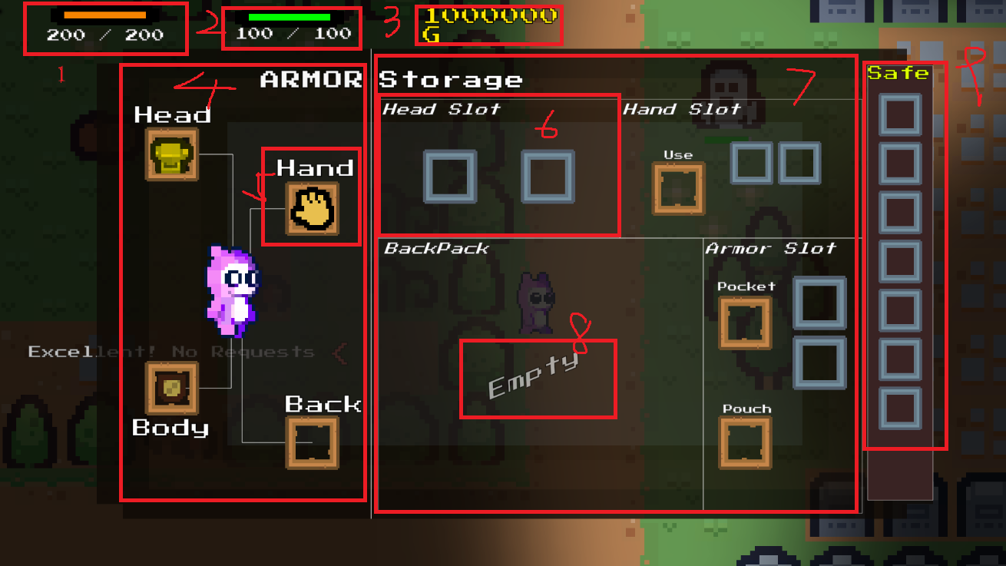
3.6 Function: Task Panel
3.7 Function: Inventory
Here shows the code structure that convenient to reconstruct.
1.InventoryDirector
3.8 Function: Statistic Panel
3.9 Function: ItemPickingUp
4. Fog of War
As described above, the Fog of War increases uncertainty.
4.1 How to Implement Fog of War?
Use League of Legends (LOL) as the main reference. The simplest way to achieve this is a shader; the Built-in rendering pipeline is enough.
The logic of the Fog of War system (design decisions made by myself):
1. Cast rays: 30 rays from the camera (started with 360, but that was unnecessary and costly). If a ray hits no obstacle, it reaches the view radius of 10; the end points connect into a fan shape.
2. Render the shape into a small image: a fog camera renders the visible and invisible areas into a 256×256 texture.
3. Make the fog feel like LOL: apply Gaussian blur to the small image, then use the Interpolate shader to blend between the old and new shapes smoothly. I learned this step from Bilibili (BV1Wr421K7Zf, 5:40).
Before this, I tried a transitional zone, but it looked bad. I tried a multi-layer transitional zone too, but it was still bad. Finally, I found the Gaussian blur method on Bilibili and applied it to the project — it worked!
4. Hide enemies but not the scene: the Fog Overlay shader samples the scene. Where the fog is dim (alpha = 0.8), the scene is hidden; where it is clear, the scene stays visible.
5. Extend the visible area 0.6 units beyond each obstacle, so the obstacle itself stays visible. This improves readability.
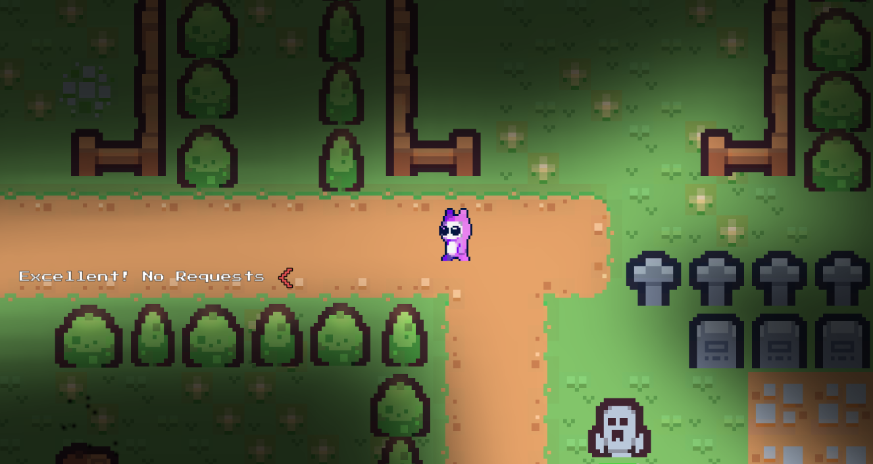
4.2 How to Optimize the Fog of War?
1. Cut down the rays. 360 or 180 rays are unnecessary and costly. I tried 15–45 rays — that was enough, and the experience improved a lot. Below that, uncertainty drops; above that, the cost becomes too heavy for other computers.
2. Detect the player’s movement: when the player stops moving, skip recomputing the fog. I tried computing the shape only once in a while (every 0.2 s) to save CPU, but it failed because the shape could not follow the camera center.
Designer's Note: The fog is a complete system — not because it's hard to render, but because it turns every step into a choice. I cut the rays from 360 to 30; the players never notice the difference, but the CPU does.
5. Random Dungeon Map
The random dungeon map is the biggest source of uncertainty and the reason players keep coming back to the same dungeon level.
5.1 Dungeon Map Randomization Principles
A random dungeon map should follow these principles:
1. The road between the exit portal and the spawn point must be accessible.
2. The terrain must be playable: it needs walls, plenty of open space for walking and fighting, and random obstacles that force players to use strategy.
5.2 How to Generate a Proper Dungeon Map?
To generate a proper map, I recommend the steps below — I have tried them, and they work (The new method is complete and working). This is the design I am most proud of, because it directly supports my core gameplay loop.
New Method:
1. Use the cellular automaton algorithm to dig the terrain.
2. Keep the biggest open area generated by the algorithm. (This is the core optimization step.)
3. Place the Spawn Point and the Exit Portal randomly inside the open area. Put the spawn point in an open spot, and put the exit as far away as possible, also in an open spot.
4. Scatter obstacles around the map.
5. Check that the road between the exit portal and the spawn point stays accessible. If obstacles block the main road, scatter fewer obstacles.
6. Make sure the Spawn Point and the Exit Portal sit on ground tiles; if not, re-run step 3.
7. Tile the map and place the prefabs.
Here Shows the effects of the algorithm.
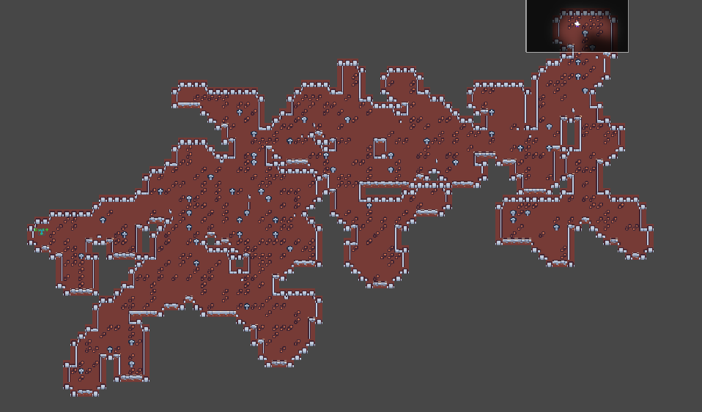
Old Method:
1. Initialize the elements. Set the map scale first: the map is a square with a fixed border. Then place a spawn point and an exit portal in the right spots. In my design, the distance between them should be at least 80% of the border length, and the exit portal should sit within 95% of the border length so it never spawns on the border itself.
2. Guarantee that the road between the exit portal and the spawn point is accessible. The A* algorithm can guarantee a spine road, but it needs optimization — if we generate the spine road with A* first, the road has no randomization.
3. Cellular automaton is a good fit for terrain generation. Use it at this step to generate random terrain. Its flaw: it tends to create karst-like terrain with stalactites, and the stalactites make wall generation awkward — walls look strange when a stalactite has a pointed top.
4. Cellular automaton may cover the spine road and break the path between the spawn point and the exit portal. This step needs optimization — it becomes unnecessary when the earlier steps are handled properly.
5. Once the spine road is generated, use BFS to inject more uncertainty into the map, giving players more adventurous decisions. Because of BFS’s nature, it creates many side roads unrelated to the spine road, which can confuse the player.
6. Dig rooms for the spawn point, the exit portal, combat, and chests. But rooms shouldn’t sit right beside the spawn or exit points — that would reduce the adventure uncertainty.
7. Scatter random obstacles along the accessible roads. This step has no trick to it, but don’t block the essential path with obstacles.
8. Run an accessibility check — the road must stay accessible. But this step is redundant if checking is already done in steps 2 and 4. To optimize: check the road once, and prepare a fallback plan in case the road is blocked.
9. To make wall generation more reliable, cut off the stalactite’s pointed top — otherwise the walls cannot connect properly.
10. Build the topology of the dungeon map and tile the map. Define each map element as an inside dot, a border dot, or an outside dot. This helps scripts understand tile locations: inside dots render floor, border dots render walls, outside dots render nothing.
11. Create the exit portal prefab and the enemy spawn area. The enemy spawn area is described in section 5.3.
12. Send messages to the state machine and the player. When the state machine receives the message, it changes its status to ‘dungeon’; the player is placed at the spawn point.
13. Add Collider2D to walls and obstacles.
Tips: the steps above have several defects, so I will reorder them to optimize the pipeline — using fewer compute resources and generating a more playable dungeon map. The picture below shows version 1.0 of the random dungeon map.
Description of the picture elements:
1. Player: the player’s spawn point.
2. Exit: the exit portal’s location
3. Defect 1: the walls don’t connect properly, so the player can walk out of the dungeon.
4. Defect 2: walls appear in the wrong places, making the map look strange.
5. Defect 3: the exit’s location is fixed, so the map doesn’t show its randomness.
6. Defect 4: the open areas are too small, so the player can’t fight comfortably in the map.
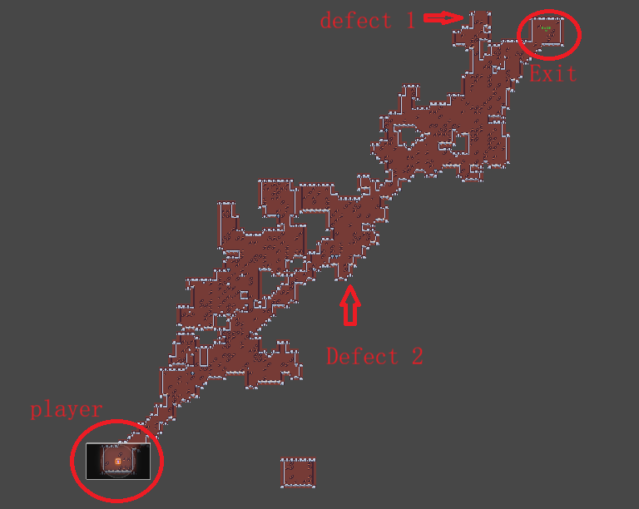
5.3 Enemy/Enemy Difficulty Randomize
5.4 Treasure Randomize
10. Enemy
10.1 Module Description
Divided the system into these modules.
Spawn Enemy: The only express way to contact the message in the each other modules.
Initialization: Store the Monsters’ template information.
Core Spawn: Generate the Monsters with distinct properties.
Public Area: Generate the Monsters with public properties
10.2 Data Flow
Logic:
1.Spawn Enemy get the monster-generate quest data: Which Monster? Where to generate? How many?
2. Core Spawn begins to generate the monster with distinctive properties.
3. After Step 2, Public Area begins to generate the monster with public properties.
4.When the monster is Completely generated, release the data and renderer the monster on the screen.
Data Constructure:

10.3 Scripts with Data Flow
1. Assets\Enemy\EnemySpawn\EnemySpawn.cs: The message transportation port.
2. Assets\Enemy\EnemyGenerate
19.Version
1. Version 1.0: Published the primary demo but unfit for playing because the dragging function and sell items function not be inserted. The game code structure, optimizing are not completed and the task, game story has not set. Updated at September 24, 2026.
2. Version 1.1: Reconstruct the code structure: Applied the new structure to consolidate the structure so as to add new function(Dragging Function & Sell Items Function) in the game. Optimized the code structure and system pipelines. Completed the Game Design Documentation. Updated at September 30, 2026
3. Version 1.2: Added the Dragging Function & Sell Items Function in the game.
Appendix
1.Hierarchy
EventSystem
ParticleSystem
PlayerUnit
SpriteRenderer
PlayerAttack
Weapon
PlayerMovement
PlayerHealth
Plug_HealthBar
PlayerStamina
Plug_StaminaBar
EnemyUnit
EnemyPrefab (Example)
SpriteRenderer
Animation
SpecialAl (If any)
EnemyMovement
EnemyAttack
EnemyHealth
DamagePopUp
2.Player
[1] Player Main Config parameters explaination.
Path: Assets\PlayerUnit\PlayerConfig\PlayerConfig.cs
SubModule: PlayerHealth
Parameters | Function | Data First Read
MaxHealth | skim | PlayerHealth.cs: cs.44
Defense | skim | PlayerHealth.cs: cs.45
InvincibleDuration | Invincible time | PlayerHealth.cs: cs.152
Plug (PlayerHealth): PlayerHealthBar
Path: Assets\PlayerUnit\PlayerHealth\Plug_HealthBar
Files Introduction:
HealthBarConfig: Control the HealthBar’s Animation.
HealthBarUI.DataTransmittion: Read the data.
HealthBarUI.Assembly: Set the UI.
HealthBarUI.Animation: Record the animation types.
HealthBarUI.Display: Display the HealthBar’s Animation.
[2] Player Juice parameters explaination (Play Feelings).
Path: Assets\PlayerUnit\PlayerConfig\PlayerConfig.cs
[3] Player Messages
Path: Assets\PlayerUnit\PlayerMessageBus
Messages SubClass:
1. PlayerHealth
Path: Assets\PlayerUnit\PlayerHealth\PlayerHealthMessage.cs
Duty: Transmit the CurrentHealth and MaxHealth from PlayHealthCache to Plug_HealthBar, in order to display the “CurrentHealth\MaxHealth” text.
Sender: Assets\PlayerUnit\PlayerHealth\PlayerHealthCache.cs: cs.53-57.
Receiver: Assets \PlayerUnit \PlayerHealth \Plug_HealthBar \HealthBarUI.Data-Transmission: cs.36.
2. PlayerAttack
Path: Assets\PlayerUnit\PlayerAttack\PlayerAttackRequestMessage.cs
Duty: Transmit three arguments: Direction, PlayerPosition, MousePosition to WeaponSettingsModule.
Sender: Assets\PlayerUnit\PlayerAttack\PlayerAttackAction.cs: cs.65-70.
Receiver: Assets\PlayerUnit\PlayerAttack\WeaponSettings\Iweapon.cs: cs.28.
3.Enemy
[1] EnemyHealth

