**SCENARIU – Formula 1: sezon competitional 2018**

In acest scenariu am sa prezint o competitie foarte draga sufletului meu si pe care o urmaresc de mai multi ani, Formula 1 sau “Marele Circ”. Aceasta competitie este alcatuita din mai multe departamente si mult mai multe persoane.

Activitatea acesteia se bazeaza pe organizarea de curse, “Mari Premii” pentru mai multe echipe inspre deliciul publicului. Pentru a putea exemplifica cum functioneaza si a da o intelegere mai amanuntita atat pentru fanii acestei competitii cat si pentru cei care acum incep sa o urmareasca vom crea urmatoarea structura:

* Vom crea 6 entitati: drivers, drivers_final_standings, teams, team_final_standings, engine_manufacturers si team_principal.
* Fiecare entitate are un numar de attribute insa acestea vor fi prezentate in continuarea acestei lucrari.
* Vor fi create relatii intre aceste 6 entitati astfel incat redundanta va fi eliminata iar rezultatul va fi cel dorit.

Pe baza acestei structuri si a paginilor urmatoare, scopul este acela de a intelege mai bine aceasta competitive si modul in care fiecare entitate comunica cu cealalta in vederea obtinerii rezultatului final.

**Diagrama ERD**

Dupa cum am amintit mai sus, fiecare entitate are un numar de attribute dupa cum urmeaza a fi prezentate in diagrama ERD:

**DRIVERS_FINAL_STANDINGS**

#pilot_number

*position

*first_name

*last_name, *total_drivers_points

**CONSTRUCTOR_FINAL_STANDINGS**

#team_name

*position

*total_constructor_points

**DRIVERS**

*pilot_number

#team_name

*first_name

*last_name

*date_of_birth

o nationality

*AustralianGP_points, *BahrainGP_points *ChineseGP_points *AzerbaijanGP_points *SpainGP_points

*MonacoGP_points *CanadaGP_points

*FranceGP_points *GreatBritainGP_points *GermanyGP_points

*HungaryGP_points *BelgiumGP_points *ItalyGP_points *SingaporeGP_points *RussiaGP_points

*JapanGP_points

*USAGP_points *MexicoGP_points *BrazilGP_points *AbuDhabiGP_points

*total_drivers_points

**TEAMS**

#team_name

*team_ID

*num_of_cars

*AustralianGP_points

*BahrainGP_points

*ChineseGP_points

*AzerbaijanGP_points

*SpainGP_points

*MonacoGP_points

*CanadaGP_points

*FranceGP_points

*GreatBritainGP_points

*GermanyGP_points

*HungaryGP_points

*BelgiumGP_points

*ItalyGP_points

*SingaporeGP_points

*RussiaGP_points

*JapanGP_points

*USAGP_points

*MexicoGP_points

*BrazilGP_points

*AbuDhabiGP_points *total_points

**TEAM_PRINCIPAL**

#team_principal_ID

*First_name

*last_name

*date_of_birth

o nationality

*team_ID

**ENGINE_MANUFACTURERS**

#eng_man_name *num_of_engines *team_principal_ID

**TEAMS**

#team_name

*team_ID

*num_of_cars

*AustralianGP_points

*BahrainGP_points

*ChineseGP_points

*AzerbaijanGP_points

*SpainGP_points

*MonacoGP_points

*CanadaGP_points

*FranceGP_points

*GreatBritainGP_points

*GermanyGP_points

*HungaryGP_points

*BelgiumGP_points

*ItalyGP_points

*SingaporeGP_points

*RussiaGP_points

*JapanGP_points

*USAGP_points

*MexicoGP_points

*BrazilGP_points

*AbuDhabiGP_points

*total_points

**Schema bazei de date normalizata**

Entitatile din diagrama ERD devin tabele, atributele devin coloane ale acestor tabele, iar relatiile devin chei externe.

1.Entitatea TEAMS

|  |  |  |  |  |
| --- | --- | --- | --- | --- |
| Nume coloana | | Optionalitate | Tip Cheie | |
| team_name | | # | Cheie primara | |
| *team_ID | | * | Cheie unica | |
| *num_of_cars | | * |  | |
| *AustralianGP_points | | * |  | |
| *BahrainGP_points | | * |  | |
| *ChineseGP_points | | * |  | |
| *AzerbaijanGP_points | | * |  | |
| *SpainGP_points | | * |  | |
| *MonacoGP_points | | * |  | |
| *CanadaGP_points | | * |  | |
| *FranceGP_points | | * |  | |
| *GreatBritainGP_points | | * |  | |
| *GermanyGP_points | | * |  | |
| *HungaryGP_points | | * |  | |
| *BelgiumGP_points | | * |  | |
| *ItalyGP_points | | * |  | |
| *SingaporeGP_points | | * |  | |
| *RussiaGP_points | | * |  | |
| *JapanGP_points | | * |  | |
| *USAGP_points | * | | |  |
| *MexicoGP_points | * | | |  |
| *BrazilGP_points | * | | |  |
| *AbuDhabiGP_points | * | | |  |
| *total_points | * | | |  |

2. Entitatea CONSTRUCTOR_FINAL_STANDINGS

|  |  |  |
| --- | --- | --- |
| Nume coloana | Optionalitate | Tip cheie |
| team_name | # | Cheie primara |
| position | * |  |
| total_points | * | Cheie straina pentru entitatea TEAMS |

3. Entitatea TEAM_PRINCIPAL

|  |  |  |
| --- | --- | --- |
| Nume coloana | Optionalitate | Tip cheie |
| team_principal_ID | # | Cheie primara |
| first_name | * |  |
| last_name | * |  |
| date_of_birth | * |  |
| nationality | o |  |
| team_ID | * | Cheie straina pentru entitatea TEAMS |

4. Entitatea ENGINE_MANUFACTURERS

|  |  |  |
| --- | --- | --- |
| Nume coloana | Optionalitate | Tip cheie |
| eng_man_name | # | Cheie primara |
| num_of_engines | * |  |
| team_principal_ID | * | Cheie straina pentru Entitatea TEAM_PRINCIPAL |

5. Entitatea DRIVERS

|  |  |  |
| --- | --- | --- |
| Nume coloana | Optionalitate | Tip cheie |
| pilot_number | # | Cheie primara |
| team_name | * |  |
| first_name | * |  |
| last_name | * |  |
| date_of_birth | * |  |
| nationality | o |  |
| AustralianGP_points | * |  |
| BahrainGP_points | * |  |
| ChineseGP_points | * |  |
| AzerbaijanGP_points | * |  |
| SpainGP_points | * |  |
| MonacoGP_points | * |  |
| CanadaGP_points | * |  |
| FranceGP_points | * |  |
| GreatBritainGP_points | * |  |
| GermanyGP_points | * |  |
| HungaryGP_points | * |  |
| BelgiumGP_points | * |  |
| ItalyGP_points | * |  |
| SingaporeGP_points | * |  |
| RussiaGP_points | * |  |
| JapanGP_points | * |  |
| USAGP_points | * |  |
| MexicoGP_points | * |  |
| BrazilGP_points | * |  |
| AbuDhabiGP_points | * |  |
| total_drivers_points | * | Cheie unica |

6. Entitatea DRIVERS_FINAL_STANDINGS

|  |  |  |
| --- | --- | --- |
| Nume coloana | Optionalitate | Tip cheie |
| pilot_number | # | Cheie primara |
| position | * |  |
| first_name | * |  |
| last_name | * |  |
| total_drivers_points | * | Cheie straina pentru entitatea DRIVERS |

**Explicatii legate de campuri, attribute**

* Tabelul “TEAMS” are campul “team_name” cheie primara si campul “Team_ID” cheie unica.
* Tabelul “CONSTRUCTOR_FINAL_STANDINGS” are campul “team_name” cheie primara si campul “total_points” cheie straina.
* Tabelul “TEAM_PRINCIPAL” are campul “team_principal_ID” cheie primara, si campul “team_ID” cheie straina.
* Tabelul “ENGINE_MANUFACTURERS” are campul “eng_man_name” cheie primara, si campul “team_principal_ID” cheie straina
* Tabelul “DRIVERS” are campul “pilot_number” cheie primara, campul total_drivers_points cheie unica, si toate campurile de tipul ___GP_points au o contrangere legata de maximul pe care il pot avea(25).
* Tabelul “DRIVERS_FINAL_STANDINGS” are campul “pilot_number” cheie primara si campul “total_drivers_points” cheie straina.

**Evidentierea legaturilor dintre tabele**

* Pentru relatia TEAMS-CONSTRUCTOR_FINAL_STANDINGS atributul total_points, relatie one-to-many:O echipa trebuie sa fie in Clasamentul final al constructorilor, Clasamentul final al constructorilor trebuie sa contina mai multe echipe.
* Pentru relatia TEAMS-TEAM_PRINCIPAL atributul team_ID: O echipa trebuie sa ai un director de echipa, fiecare director trebuie sa apartina unei echipe.
* Pentru relatia TEAM_PRINCIPAL-ENGINE_MANUFACTURERS atributul team_principal_ID: Fiecare director de echipa trebuie sa aiba un producator de motoare, fiecare producator de motoare trebuie sa aiba unul si doar unul director de cursa.
* Pentru relatia TEAMS-DRIVERS atributul team_name: Fiecare echipa trebuie sa aiba unul sau mai multi soferi, Fiecare sofer trebuie sa apartina de o singura echipa.
* Pentru relatia DRIVERS-DRIVERS_FINAL_STANDINGS atributul total_drivers_points; Fiecare sofer trebuie sa apartina unui clasament final al soferilor, Clasamentul final al pilotilor trebuie sa contina unul sau mai multi soferi.

**Constrangeri legate de campuri**

* Campul “team_ID” din tabelul TEAMS sa fie unic deoarece fiecare echipa trebuie sa aiba un numar de identificare uni. Acesta este o cheie unica insa create artificial din motive de functionalitate a bazei de date
* Campurile “____GP_points” (adica toate campurile care se termina in acest mod) din tabelul TEAMS sa aiba o valoare de maxim 60 deoarece acesta este punctajul in cadrul competitiei pentru echipele participante.
* Campurile “drivers______GP_point” (adica toate campurile de aceasta forma) din tabelul DRIVERS sa aiba o valoare de maxim 25 pentru fiecare sofer deoarece acesta este regulamentul competitiei.
* Campul “team_principal_ID” din cadrul tabelului TEAM_PRINCIPAL sa fie unic deoarece se atribui un ID artificial uni fiecarui director de echipa.

Implementarea bazei de date prin intermediul comenzilor SQL

* Pentru crearea tabelului TEAMS:

|  |
| --- |
| CREATE TABLE teams  (  team_ID NUMBER(2) CONSTRAINT teams_team_ID_uk UNIQUE,  team_name VARCHAR2(50) CONSTRAINT teams_team_name_pk PRIMARY KEY,  num_of_cars NUMBER(2) CONSTRAINT teams_numofcars_ck CHECK(num_of_cars <=2),  AustralianGP_points NUMBER(2) CONSTRAINT teams_aus_gp_pts CHECK(AustralianGP_points<=60),  BahrainGP_points NUMBER(2) CONSTRAINT teams_bhr_gp_pts CHECK(BahrainGP_points<=60),  ChineseGP_points NUMBER(2) CONSTRAINT teams_chn_gp_pts CHECK(ChineseGP_points<=60),  AzerbaijanGP_points NUMBER(2) CONSTRAINT teams_auz_gp_pts CHECK(AzerbaijanGP_points<=60),  SpainGP_points NUMBER(2) CONSTRAINT teams_spn_gp_pts CHECK(SpainGP_points<=60),  MonacoGP_points NUMBER(2) CONSTRAINT teams_mon_gp_pts CHECK(MonacoGP_points<=60),  CanadaGP_points NUMBER(2) CONSTRAINT teams_can_gp_pts CHECK(CanadaGP_points<=60),  FranceGP_points NUMBER(2) CONSTRAINT teams_frc_gp_pts CHECK(FranceGP_points<=60),  GreatBritainGP_points NUMBER(2) CONSTRAINT teams_gb_gp_pts CHECK(GreatBritainGP_points<=60),  GermanyGP_points NUMBER(2) CONSTRAINT teams_ger_gp_pts CHECK(GermanyGP_points<=60),  HungaryGP_points NUMBER(2) CONSTRAINT teams_hun_gp_pts CHECK(HungaryGP_points<=60),  BelgiumGP_points NUMBER(2) CONSTRAINT teams_bel_gp_pts CHECK(BelgiumGP_points<=60),  ItalyGP_points NUMBER(2) CONSTRAINT teams_ita_gp_pts CHECK(ItalyGP_points<=60),  SingaporeGP_points NUMBER(2) CONSTRAINT teams_sing_gp_pts CHECK(SingaporeGP_points<=60),  RussiaGP_points NUMBER(2) CONSTRAINT teams_rus_gp_pts CHECK(RussiaGP_points<=60),  JapanGP_points NUMBER(2) CONSTRAINT teams_jpn_gp_pts CHECK(JapanGP_points<=60),  USAGP_points NUMBER(2) CONSTRAINT teams_usa_gp_pts CHECK(USAGP_points<=60),  MexicoGP_points NUMBER(2) CONSTRAINT teams_mex_gp_pts CHECK(MexicoGP_points<=60),  BrazilGP_points NUMBER(2) CONSTRAINT teams_brz_gp_pts CHECK(BrazilGP_points<=60),  AbuDhabiGP_points NUMBER(2) CONSTRAINT teams_abdb_gp_pts CHECK(AbuDhabiGP_points<=60),  total_points NUMBER(5) CONSTRAINT teams_total_points_uk UNIQUE; ) |

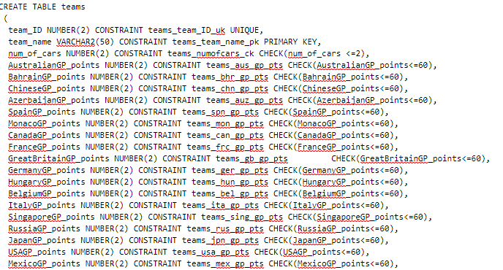

* Pentru crearea tabelului CONSTRUCTOR_FINAL_STANDINGS

CREATE TABLE constructor_final_standings

( team_name VARCHAR2(50) CONSTRAINT cons_fnl_stand_teamname_pk PRIMARY KEY,

position NUMBER(2) NOT NULL,

total_points NUMBER(5) CONSTRAINT cons_fnl_stand_totalpoints_fk REFERENCES teams(total_points) );

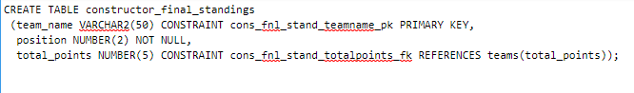

* Pentru crearea tabelului TEAM_PRINCIPAL

CREATE TABLE team_principal

(team_principal_ID NUMBER(2) CONSTRAINT team_princ_ID_pk PRIMARY KEY,

first_name VARCHAR2(30) NOT NULL,

last_name VARCHAR2(30) NOT NULL,

date_of_birth DATE,

nationality VARCHAR2(30),

team_ID NUMBER(2) CONSTRAINT team_principal_teamID_fk REFERENCES teams(team_ID) );

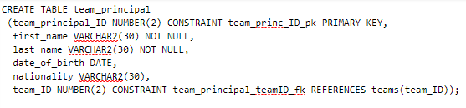

* Pentru crearea tabelului ENGINE_MANUFACTURERS:

CREATE TABLE engine_manufacturers

(eng_man_name VARCHAR2(50) CONSTRAINT eng_man_name_pk PRIMARY KEY,

num_of_engines NUMBER(2) CONSTRAINT engman_num_eng_ck CHECK(num_of_engines<=5),

team_principal_ID NUMBER(2) CONSTRAINT engman_team_princ_ID_fk REFERENCES team_principal(team_principal_ID) );

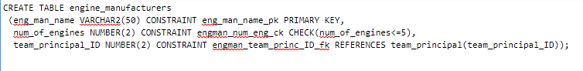

* Pentru crearea tabelului DRIVERS:

CREATE TABLE drivers

(pilot_number NUMBER(2) CONSTRAINT drivers_plt_num_pk PRIMARY KEY,

team_name VARCHAR2(50) CONSTRAINT drivers_teamname_fk REFERENCES teams(team_name),

first_name VARCHAR2(30) NOT NULL,

last_name VARCHAR2(30) NOT NULL,

date_of_birth DATE NOT NULL,

nationality VARCHAR2(30),

AustralianGP_points NUMBER(2) CONSTRAINT drivers_aus_gp_pts CHECK(AustralianGP_points<=25),

BahrainGP_points NUMBER(2) CONSTRAINT drivers_bhr_gp_pts CHECK(BahrainGP_points<=25),

ChineseGP_points NUMBER(2) CONSTRAINT drivers_chn_gp_pts CHECK(ChineseGP_points<=25),

AzerbaijanGP_points NUMBER(2) CONSTRAINT drivers_auz_gp_pts CHECK(AzerbaijanGP_points<=25),

SpainGP_points NUMBER(2) CONSTRAINT drivers_spn_gp_pts CHECK(SpainGP_points<=25),

MonacoGP_points NUMBER(2) CONSTRAINT drivers_mon_gp_pts CHECK(MonacoGP_points<=25),

CanadaGP_points NUMBER(2) CONSTRAINT drivers_can_gp_pts CHECK(CanadaGP_points<=25),

FranceGP_points NUMBER(2) CONSTRAINT drivers_frc_gp_pts CHECK(FranceGP_points<=25),

GreatBritainGP_points NUMBER(2) CONSTRAINT drivers_gb_gp_pts CHECK(GreatBritainGP_points<=25),

GermanyGP_points NUMBER(2) CONSTRAINT drivers_ger_gp_pts CHECK(GermanyGP_points<=25),

HungaryGP_points NUMBER(2) CONSTRAINT drivers_hun_gp_pts CHECK(HungaryGP_points<=25),

BelgiumGP_points NUMBER(2) CONSTRAINT drivers_bel_gp_pts CHECK(BelgiumGP_points<=25),

ItalyGP_points NUMBER(2) CONSTRAINT drivers_ita_gp_pts CHECK(ItalyGP_points<=25),

SingaporeGP_points NUMBER(2) CONSTRAINT drivers_sing_gp_pts CHECK(SingaporeGP_points<=25),

RussiaGP_points NUMBER(2) CONSTRAINT drivers_rus_gp_pts CHECK(RussiaGP_points<=25),

JapanGP_points NUMBER(2) CONSTRAINT drivers_jpn_gp_pts CHECK(JapanGP_points<=25),

USAGP_points NUMBER(2) CONSTRAINT drivers_usa_gp_pts CHECK(USAGP_points<=25),

MexicoGP_points NUMBER(2) CONSTRAINT drivers_mex_gp_pts CHECK(MexicoGP_points<=25),

BrazilGP_points NUMBER(2) CONSTRAINT drivers_brz_gp_pts CHECK(BrazilGP_points<=25),

AbuDhabiGP_points NUMBER(2) CONSTRAINT drivers_abdb_gp_pts CHECK(AbuDhabiGP_points<=25),

total_drivers_points NUMBER(5) CONSTRAINT drivers_total_points_uk UNIQUE);

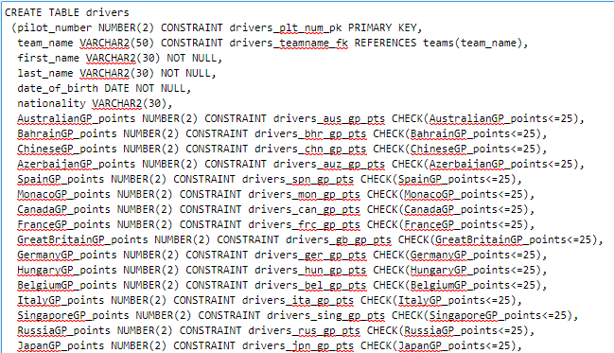

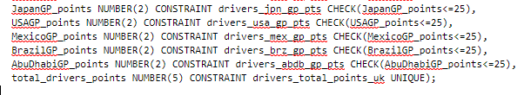

* Pentru crearea tabelului DRIVERS_FINAL_STANDINGS:

CREATE TABLE drivers_final_standings

(pilot_number NUMBER(2) CONSTRAINT drv_fnl_stand_pltnum_pk PRIMARY KEY,

position NUMBER(2) NOT NULL,

first_name VARCHAR2(30) NOT NULL,

last_name VARCHAR2(30) NOT NULL,

total_drivers_points NUMBER(5) CONSTRAINT drv_fnl_stand_total_drvpts_fk REFERENCES drivers(total_drivers_points) );

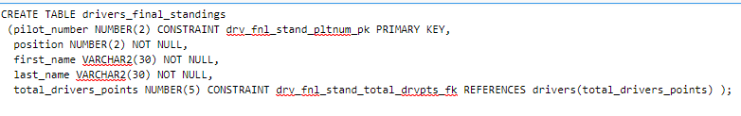

**Popularea datelor cu inregistrari**

* Tabelul TEAMS

Inserare:

INSERT INTO teams

(team_ID, team_name,num_of_cars, AustralianGP_points, BahrainGP_points,ChineseGP_points, AzerbaijanGP_points, SpainGP_points, MonacoGP_points, CanadaGP_points, FranceGP_points, GreatBritainGP_points, GermanyGP_points, HungaryGP_points, BelgiumGP_points, ItalyGP_points, SingaporeGP_points, RussiaGP_points, JapanGP_points, USAGP_points, MexicoGP_points, BrazilGP_points, AbuDhabiGP_points, total_points )

VALUES

(1, 'Mercedes AMG Petronas Motorsport', 22, 33, 30, 25, 43, 25, 28, 31, 30, 43, 35, 30, 40, 37, 43, 43, 25, 22, 35, 35, 655);

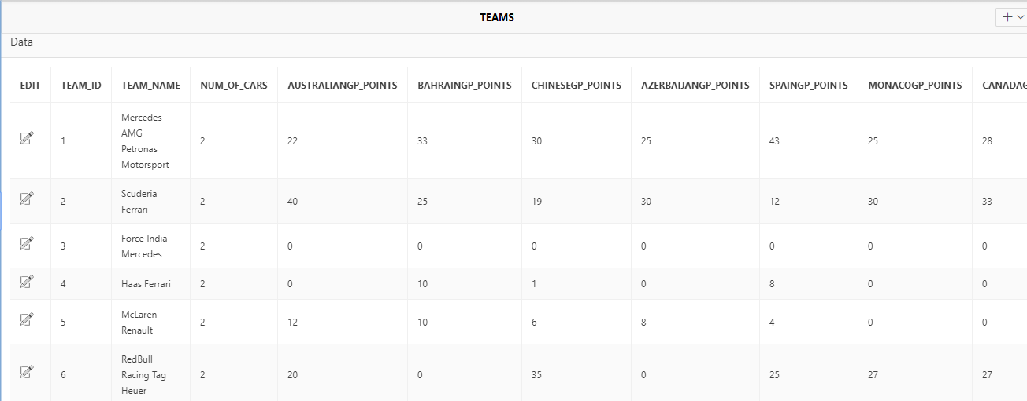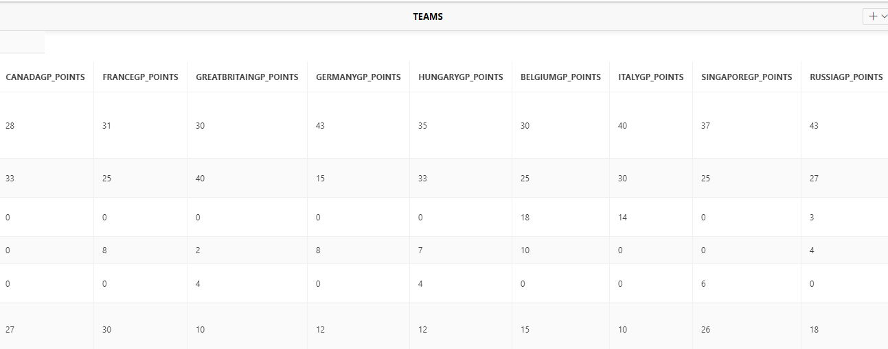

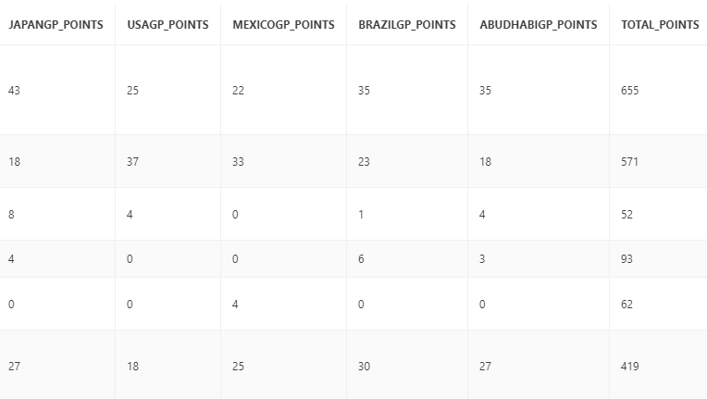

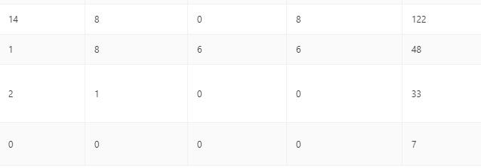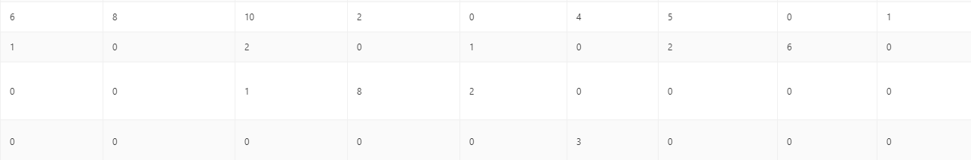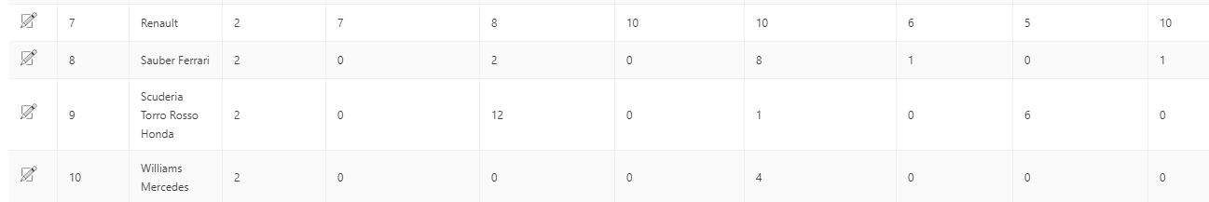

* Tabelul CONCTRUCTOR_FINAL_STANDINGS

Inserare:

INSERT INTO constructor_final_standings

(team_name, position, total_constructor_points)

VALUES

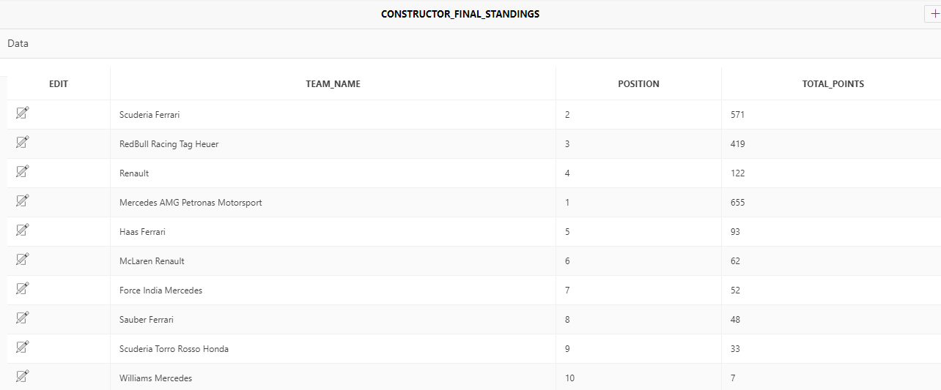('Mercedes AMG Petronas Motorsport', 1, 655);

* Tabelul TEAM_PRINCIPAL

Inserare:

INSERT INTO team_principal

(team_principal_ID, first_name, last_name, date_of_birth, nationality, team_ID)

VALUES

(1, 'Toto','Wolff','12-JAN-1972','Austrian', 1);

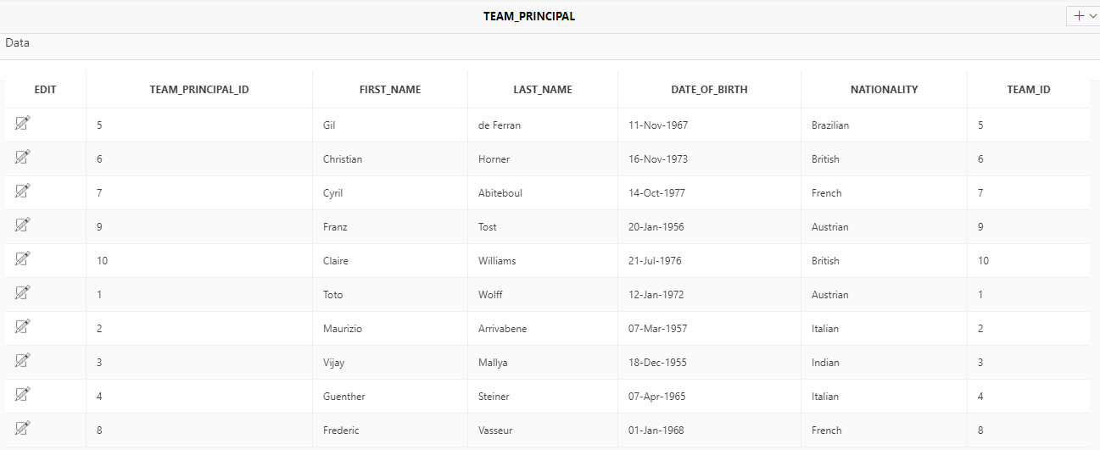

* Tabelul ENGINE_MANUFACTURERS

Inserare:

INSERT INTO engine_manufacturers

(eng_man_name, num_of_engines, team_principal_ID)

VALUES

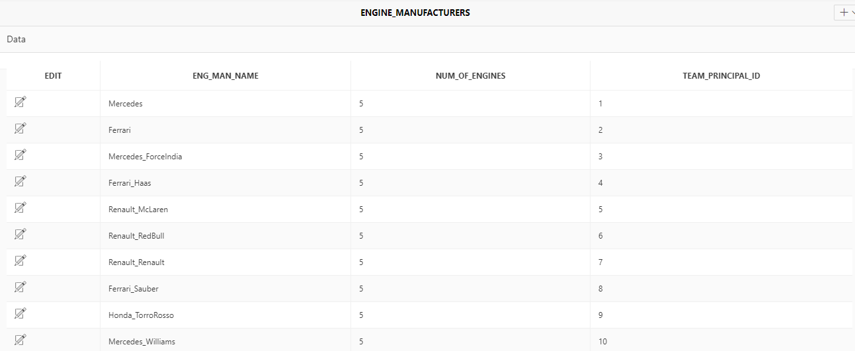('Mercedes', 5, 1);

* Tabelul DRIVERS

Inserare:

INSERT INTO drivers

(pilot_number, team_name, first_name, last_name, date_of_birth, nationality,

AustralianGP_points, BahrainGP_points, ChineseGP_points, AzerbaijanGP_points, SpainGP_points,

MonacoGP_points, CanadaGP_points, FranceGP_points, GreatBritainGP_points, GermanyGP_points, HungaryGP_points, BelgiumGP_points, ItalyGP_points, SingaporeGP_points, RussiaGP_points,

JapanGP_points, USAGP_points, MexicoGP_points, BrazilGP_points, AbuDhabiGP_points,

total_drivers_points)

VALUES

(14, 'McLaren Renault', 'Fernando', 'Alonso', '29-JUL-1981', 'Spanish', 10, 6, 6, 6, 4, 0, 0, 0, 4, 0, 4, 0, 0, 6, 0, 0, 0, 0, 0, 0, 50)

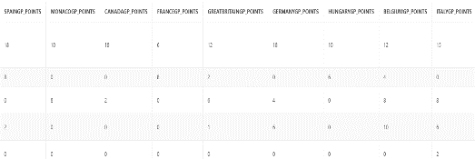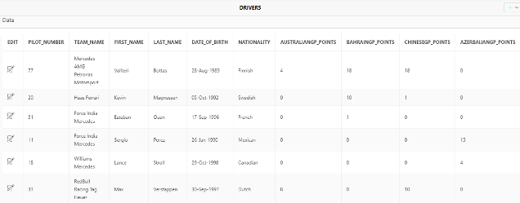

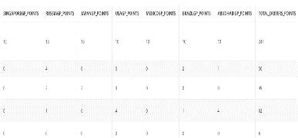

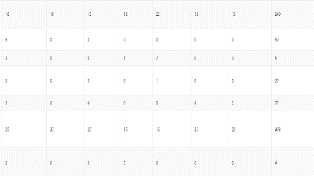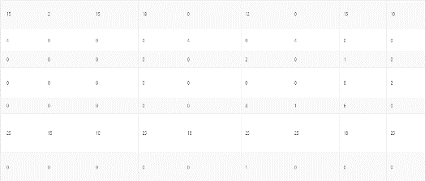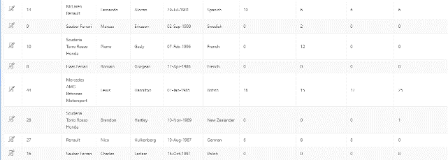

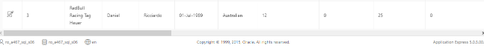

!Am aratat doar o parte din tabel insa acesta are 20 de valori, toate testate in prealabil pe platforma ORACLE!

* Tabelul DRIVERS_FINAL_STANDINGS

Inserare:

INSERT INTO drivers_final_standings

(pilot_number, position, first_name, last_name, total_drivers_points)

VALUES

(44, 1, 'Lewis', 'Hamilton', 408)

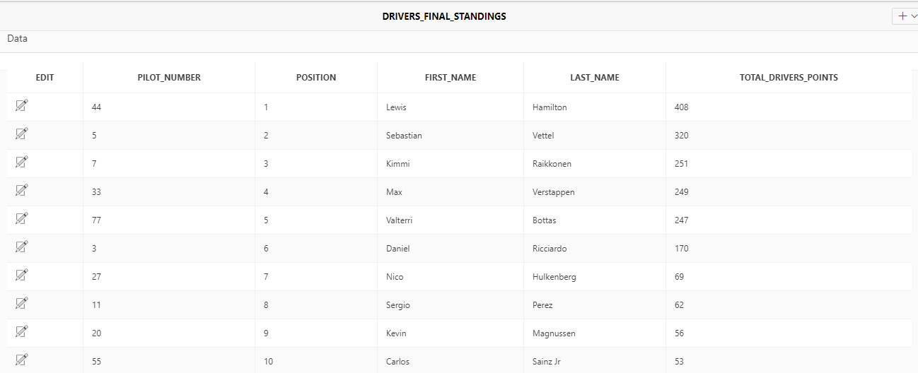

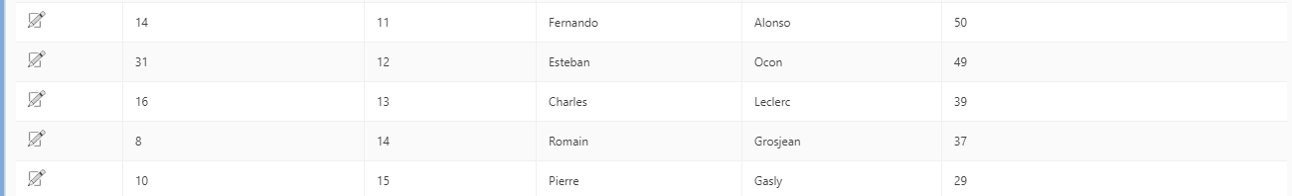

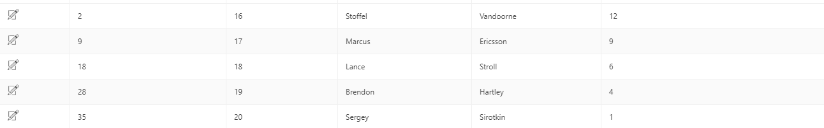

**Modificari de structura si actualizari de continut**

1. Pentru modificare de structura numarul 1 am decis modificarea tipului de variabila din cadrul team_name, am facut aceasta modificare pentru a avea in vedere cazul in care o echipa isi modifica numele iar aceste exceed limita de caractere pusa la crearea tabelului:

ALTER TABLE teams

MODIFY team_name VARCHAR2(100);

1. Pentru a doua modificare de structura a tabelului am decis adaugarea unei coloane care sa aiba in vedere nationalitatea echipelor, tara in care acestea au fost fondate:

ALTER TABLE teams

ADD team_nationality VARCHAR2(50);

1. Pentru prima actualizare de continut trebuie avuta in vedere dobandirea unei noi cetatenii si nationalitati a unui pilot astfel: Fernando Alonso a dobandit cetatenie Americana si astfel trebuie modificata nationalitatea acestuia in tabelul DRIVERS.

UPDATE drivers

SET nationality='American'

WHERE first_name='Fernando' AND last_name='Alonso';

1. Pentru a doua actualizare avem in vedere modificarea punctajului obtinut de o echipa in cadrul unei etape in urma unei erori de calcul si de introducere a datelor in baza de date, astfel: Echipa McLaren a obtinut in Marele Premiu din Australia 10 puncte iar acest lucru trebuie reflectat in tabelul TEAMS.

UPDATE teams

SET AustralianGP_points=10

WHERE team_ID=5 AND total_points=62;

1. Pentru cea de a treia modificare de continu vom avea in vedere faptul ca o echipa a schimbat producatorul motorului la jumatatea sezonului, astfel: McLaren a semnat cu Honda un nou contract iar asta trebuie actualizat in table.

UPDATE engine_manufacturers

SET eng_man_name='McLaren_Honda'

WHERE team_principal_ID=5 AND num_of_engines=5;

**2 views pe baza de tabele**

1. CREATE VIEW view_drivers_ambiguos

AS SELECT pilot_number, nationality

FROM drivers, teams;

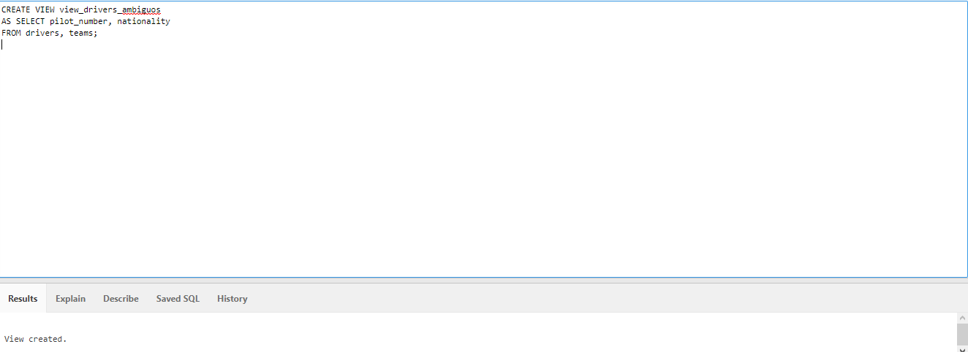

1. CREATE VIEW view_team_principals

AS SELECT team_principal_ID, team_name, eng_man_name

FROM engine_manufacturers, teams;

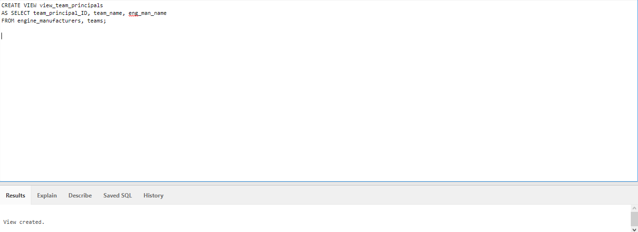

**Interogari**

1. Drivers_cu_numele_V

Sa se afieze toti pilotii al caror nume de familie incepe cu litera V

SELECT drivers.last_name AS Nume

FROM drivers

WHERE last_name LIKE 'V%'

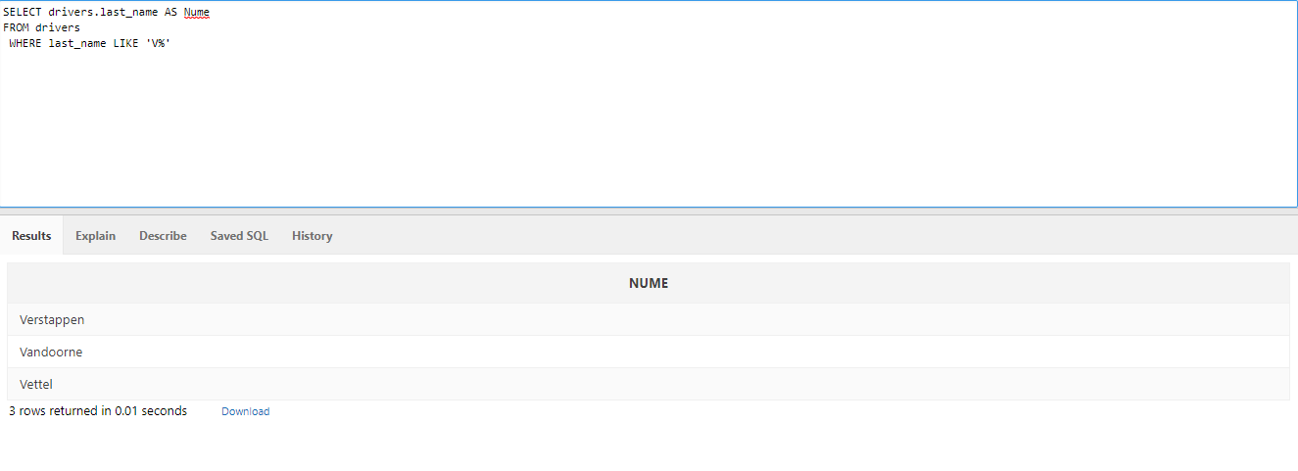

1. Echipa_S

Sa se afiseze toate echipele care au in structura lor litera s.

SELECT teams.team_name AS NumeEchipa_S

FROM teams

WHERE teams.team_name LIKE '%S%'

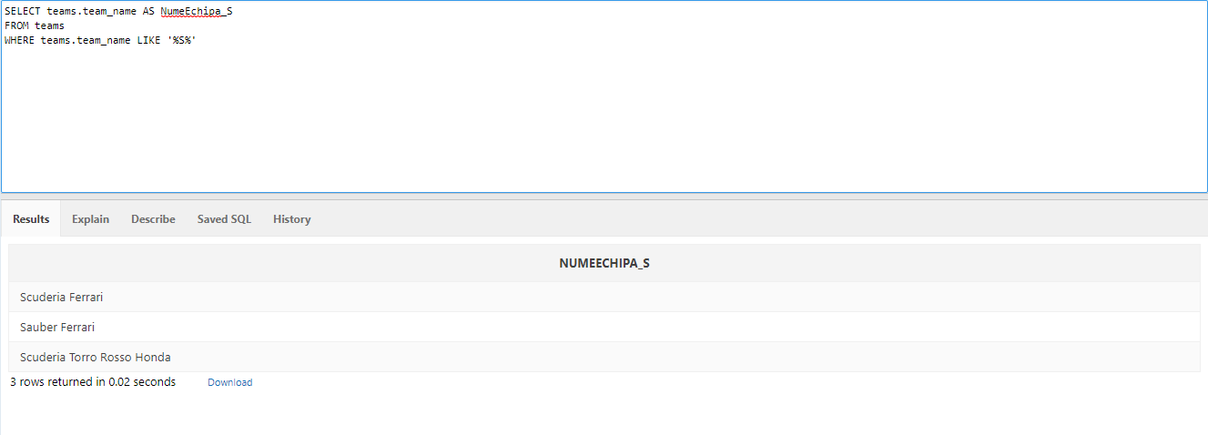

1. Nume_Piloti_7_Caractere

Sa se afiseze toate prenumele pilotilor care au exact 7 caracterea in denumirea acestora.

SELECT drivers.first_name AS Prenume

FROM drivers

WHERE drivers.first_name LIKE '_______'

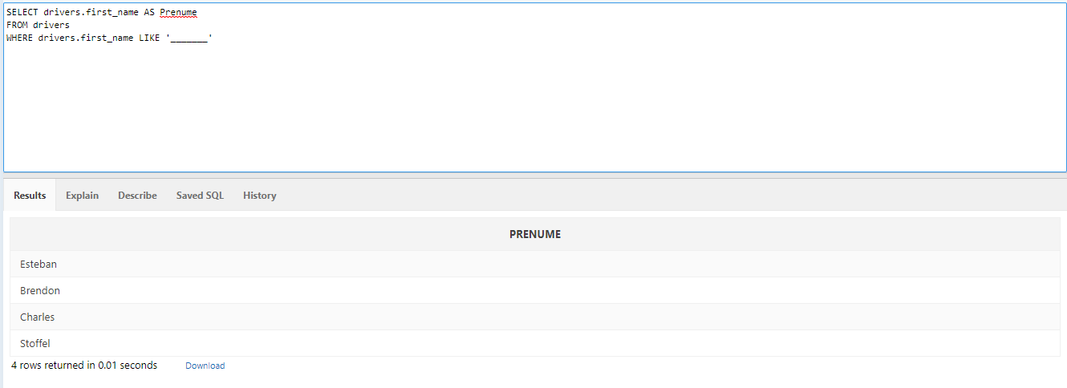

1. Echipe_100

Sa se afiseze toate echipele care au mai mult de 100 de punct in total.

SELECT teams.total_points AS puncta

FROM teams

WHERE teams.team_points>100

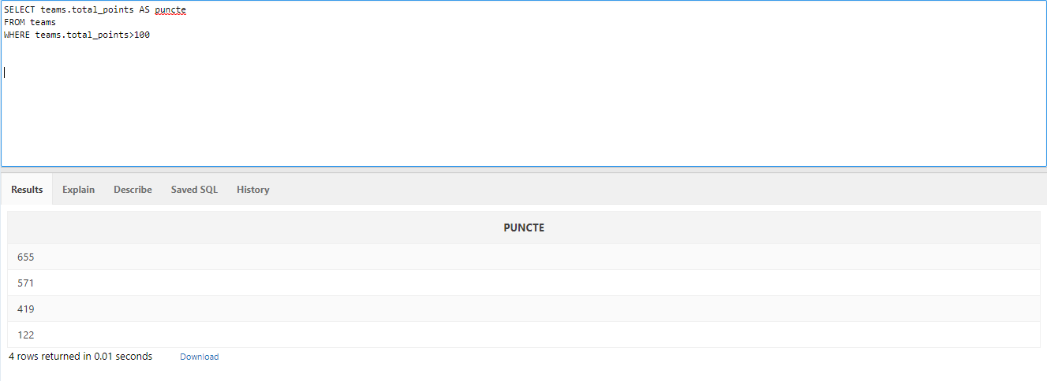

1. Puncte_echipa_peste_medie

Sa se afiseze punctele echipelor care sunt peste medie si al caror prenume al directorului de echipa este ‘Maurizio’.

SELECT team_name, total_points, first_name, last_name

FROM teams, team_principal

WHERE teams.total_points>(SELECT AVG(total_points) FROM teams) AND team_name='Scuderia Ferrari' AND first_name='Maurizio';

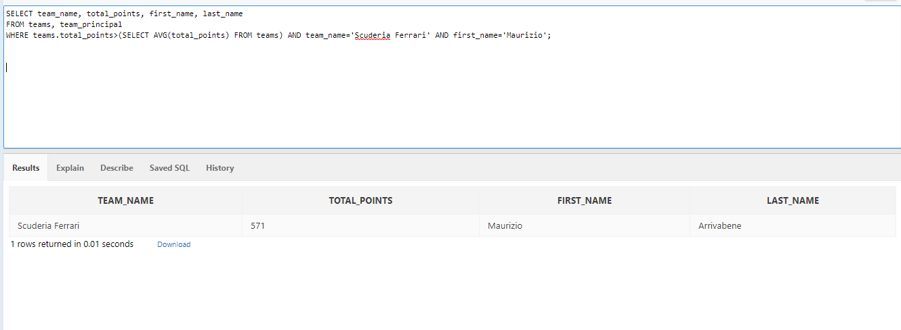

1. Puncte_echipa_sub_medie

Sa se afiseze punctele echipelor care sunt peste medie si al caror prenume al directorului de echipa este ‘Gil’.

SELECT team_name, total_points, first_name, last_name

FROM teams, team_principal

WHERE teams.total_points<(SELECT AVG(total_points) FROM teams) AND team_name='Williams Mercedes' AND first_name='Gil';

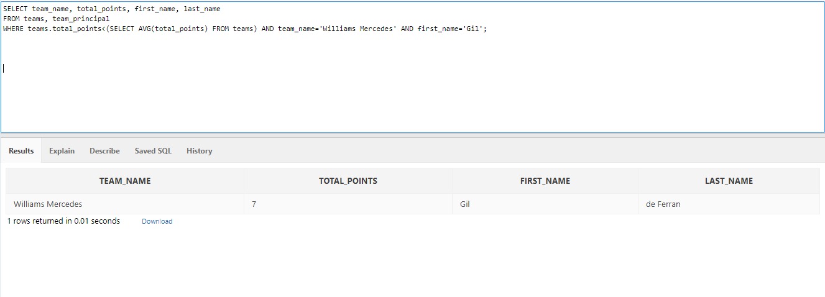

1. Sa se afiseze un table cu numele echipei, numele pilotilor, numele producatorului de motoare din sezonul competitional 2018.

SELECT team_name, first_name, last_name, eng_man_name

FROM teams, drivers, engine_manufacturers

WHERE num_of_engines=5;

1. Ordonare_piloti

Sa se ordoneze pilotii din tabelul DRIVERS in ordine descrescatoare dupa prenumele acestora.

SELECT first_name, last_name, pilot_number

FROM drivers

ORDER BY first_name DESC

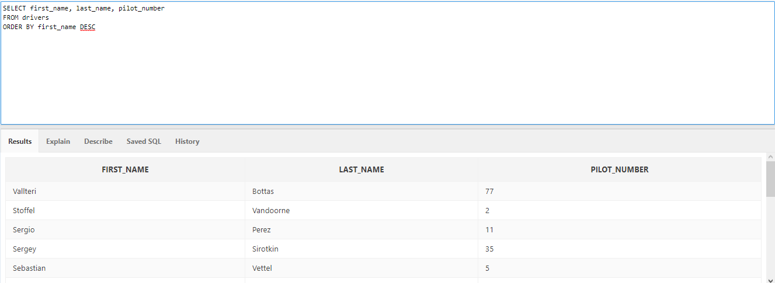

1. Puncte_intre_x_si_y

Sa se afiseze toti pilotii care au realizat punctaje intre 100 si 200.

SELECT first_name, last_name, total_drivers_points

FROM drivers

WHERE total_drivers_points BETWEEN 100 AND 200;

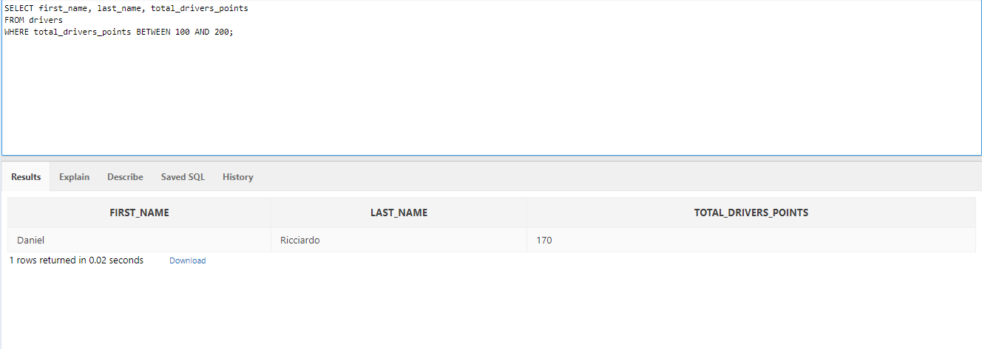

1. Echipe_ordine_crescatoare

Sa se afiseze ordinea echipelor pe baza ordonarii crescatoare a punctajelor acestora.

SELECT team_name, total_points

FROM teams

ORDER BY total_points

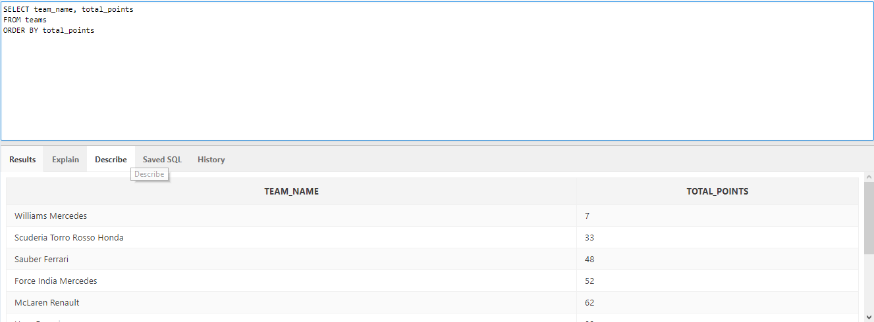

1. Numar_total_echipe

Sa se afisezze numarul total de echipe cu punctaje peste 200.

SELECT count(team_name)

FROM teams

WHERE total_points>200;

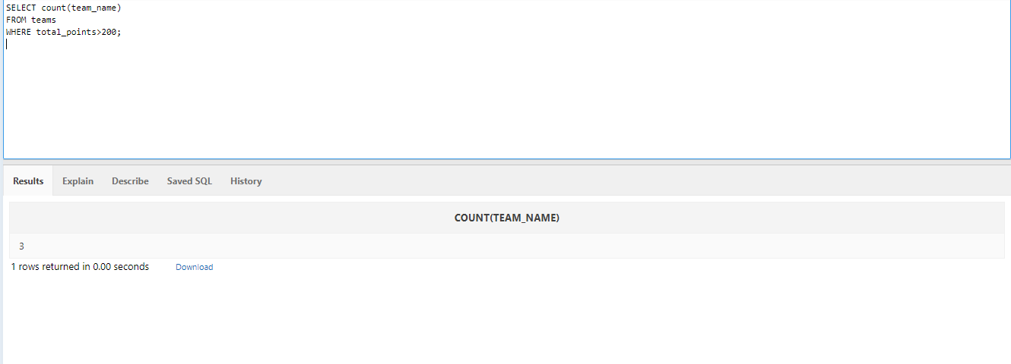

1. Data_nasterii mai mare

Sa se arate toti pilotii si echiepele lor care sunt nascuti dupa 1 Ianuarie 1990.

SELECT DISTINCT drivers.first_name AS prenume, drivers.last_name AS nume, teams.team_name AS echipa

FROM teams teams, drivers drivers

WHERE date_of_birth>'1-JAN-1990';

