The Learning Triangle

Use Case Specification: Control Triangle

Version <1.0>

# 

|  |  |  |  |
| --- | --- | --- | --- |
| **Date** | **Version** | **Description** | **Author** |
| 06.04.2017 | 1.0 | First set up | LearningTriangleTeam |
|  |  |  |  |
|  |  |  |  |

# 

# **1. Control Triangle**

## **1.1 Brief Description**

Controlling the triangles it part of the Artificial Intelligence, which will receive results from the learning algorithm. This result triggers an effect on the triangle, which moves it.

# **2. Flow of Events**

## **2.1 Basic Flow**

Activity diagram:

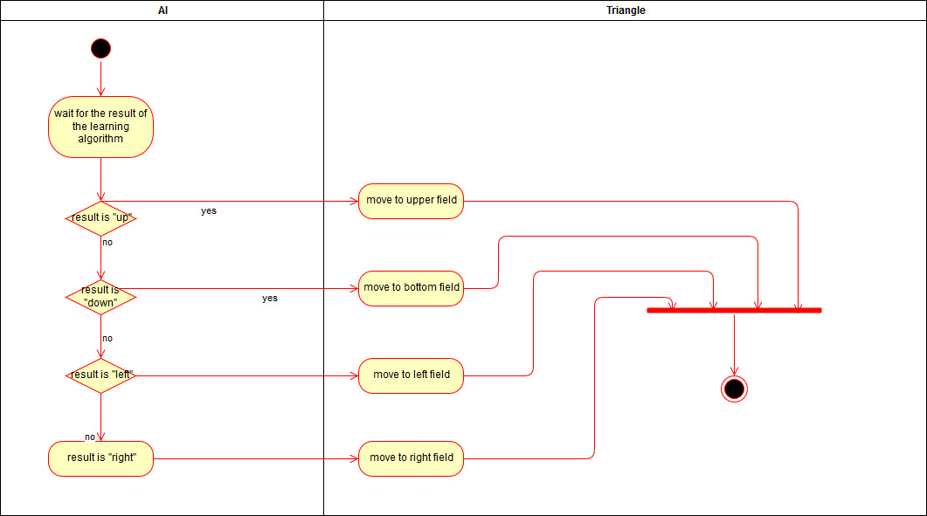

Mockup:

There isn’t an mockup.

# **3. Special Requirements**

# **4. Preconditions**

There must be a result from the neuronal network. Without it there can’t exist a decision about the next step of the triangle

# **5. Postconditions**

The triangle will move and creates new data for the neuronal network.

# **6. Extension Points**

## **n/a**