The Learning Triangle

The team members:

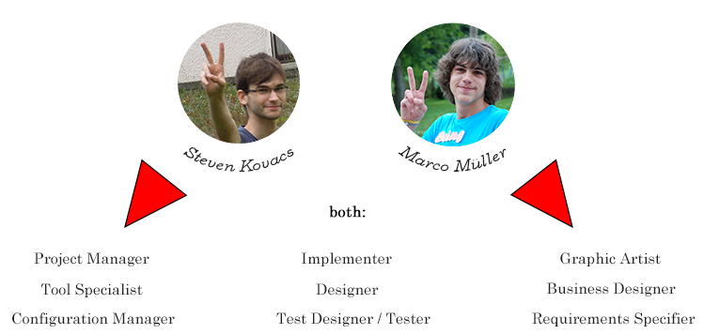

Time spent:

Steven Kovacs:

Marco Müller:

Our usecase diagram + scope:

don’t take “start/end program” for serious, there are only there to demonstrate the “nearly-zero”-interaction of the user

