The Learning Triangle

Use Case Specification: Collecting Data through Triangles

Version <1.0>

# 

|  |  |  |  |
| --- | --- | --- | --- |
| **Date** | **Version** | **Description** | **Author** |
| 06.04.2017 | 1.0 | First set up | LearningTriangleTeam |
|  |  |  |  |
|  |  |  |  |

# 

# **1. Collecting Data through Triangles**

## **1.1 Brief Description**

The neuronal network can’t be created without data. In our program we decided to use the view of each triangle for the learning algorithm.

# **2. Flow of Events**

## **2.1 Basic Flow**

Activity diagram:

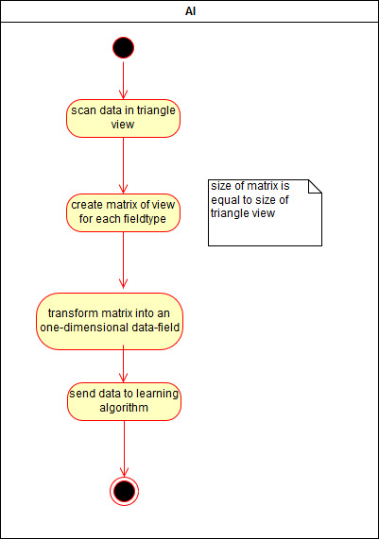

Mockup:

There isn’t a mockup.

# **3. Special Requirements**

# **4. Preconditions**

There must exist some triangles. That’s all.

# **5. Postconditions**

The created matrix is send to the learning algorithm.

# **6. Extension Points**

## **n/a**