The Learning Triangle

Use Case Specification: triangle rules

Version <1.0>

# 

|  |  |  |  |
| --- | --- | --- | --- |
| **Date** | **Version** | **Description** | **Author** |
| 25.04.2017 | 1.0 | First set up | LearningTriangleTeam |
|  |  |  |  |
|  |  |  |  |

# 

# **1. Set triangle rules**

## **1.1 Brief Description**

Every triangle has stats and values like energy, field of view or size. This Use Case describes the different rules about these values and how they are used.

# **2. Flow of Events**

## **2.1 Basic Flow**

Activity diagram:

Mockup:



If a triangle moves on an “energy field” it will gain “energy”. The amount of energy a triangle has is defined as a integer number. If a triangle steps on an “energy field” the amount of energy increases by a fixed amount.



If a triangle moves on a “poisson field” the energy consumption of this specific triangle will be increased for a certain number of turns.



If a triangle moves on a “death field” the triangle loses all of it’s energy. Therefore it will die in the next round.



This picture represents the field of view of a triangle. all fields that have contact to the red area around the triangle is considered to be in the field of view of the triangle. The field of view has a static size and its center point is the triangle itself.

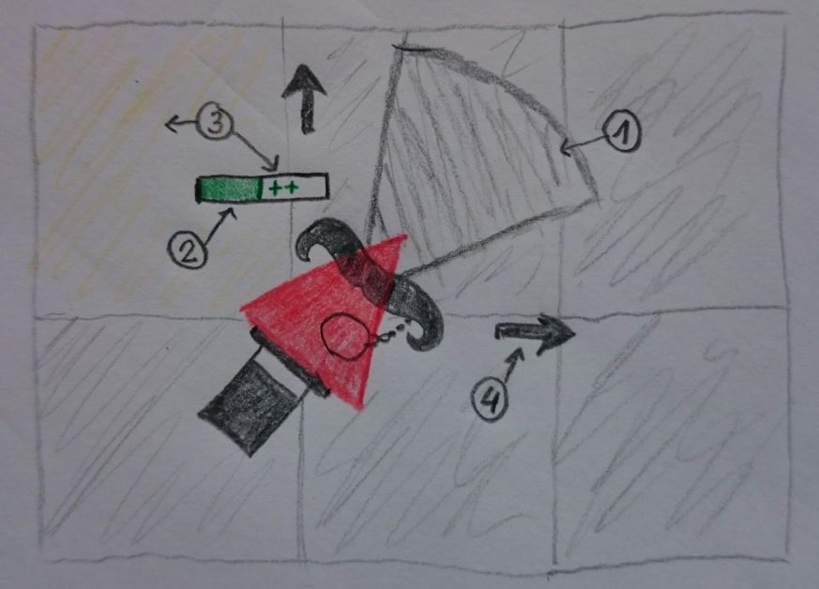

This is a first hand-drawn mock-up. It will be replaced soon.

1. field of view
2. energy
3. ins influenced from field
4. can move in any direction

Feature File:

# **3. Special Requirements**

Nothing special here.

# **4. Preconditions**

Triangles have to live and should be able to move around. That means that the world must be created.

# **5. Postconditions**

The game is over. Every triangle is dead, or the player ended the game.

# **6. Extension Points**

## n/a