The Learning Triangle

Use Case Specification: calculate score

Version <1.0>

# 

|  |  |  |  |
| --- | --- | --- | --- |
| **Date** | **Version** | **Description** | **Author** |
| 31.10.2016 | 1.0 | First set up | LearningTriangleTeam |
|  |  |  |  |
|  |  |  |  |

# 

# **1. Calculate Score**

## **1.1 Brief Description**

The score is a value for the AI to score the played game. The score is equal to the distance the existing triangles (dead or alive) moved in summary. That means that the AI receives a higher score if more triangles live as long as possible and move around.

# **2. Flow of Events**

## **2.1 Basic Flow**

Activity diagram:

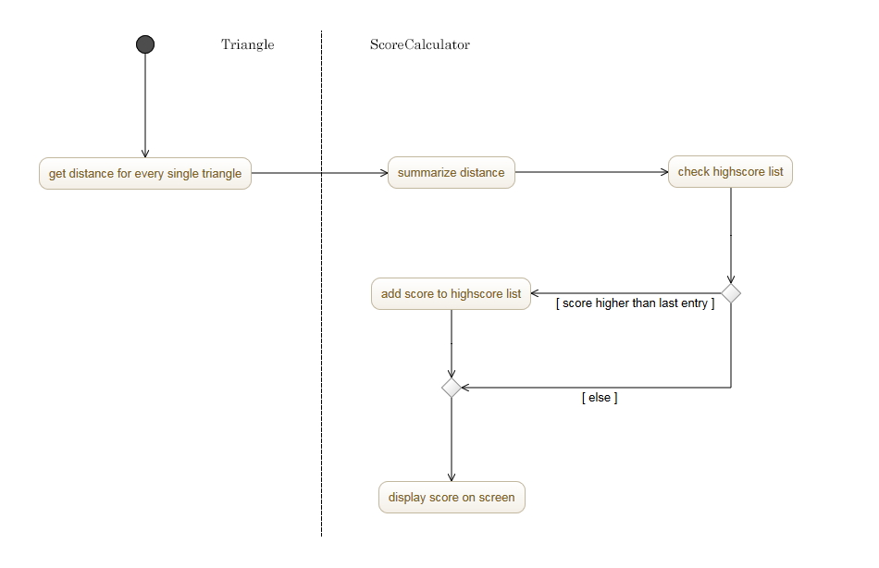

Mockup:

there is only an idea how to display the score, which will be a new window with the score and the high-score list on it.

# **3. Special Requirements**

The only thing that is necessary to calculate the score is the end of the game.

# **4. Preconditions**

The game is over. Every triangle is dead, or the player ended the game.

# **5. Postconditions**

## The score could be high enough to be a high-score. In this case, the highscore list has a new entry now, which means that an old one is deleted now.

Now a new game can be started.

# **6. Extension Points**

## n/a