**Problem 1: Mini-max Search in Game Trees. Given the game tree above, it illustrates a position reached in a mini-max game. Inside each leaf node is the estimated score of that resulting position returned by the heuristic static evaluator. It’s MIN’s turn to move.**

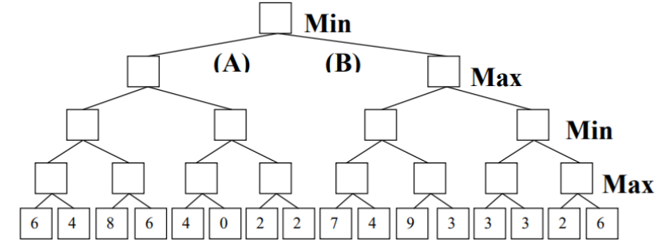

**a. Please fill in the blank squares correct values according to mini-max search.**

The black squares are filled as

7

6

3

7

2

6

6

3

9

7

2

4

88

6

**b. What’s the best move for MIN? Answer (A or B):**

The best move for Min is A

**c. Please add a cross (X) to each leaf node that will not be examined because it’s pruned by Alpha-Beta Pruning.**

7

6

X

3

7

4

6

X

X

X

X

6

3

9

7

2

4

88

6

**Problem 2: Repeat the task in problem 1 for the following**

**game. It’s MAX turn to move.**

08

28

38

38

08

78

28

3

18

38

08

28

38

08

28

78

48

28

18

3



The best move for Max is A

Add a cross (X) to each leaf node that will not be examined because it’s pruned by Alpha-Beta Pruning.

18

28

38

38

18

48

28

3

18

38

08

28

38

18

28

78

48

28

28

3

X

X

X

X

X

X

X

X