**Introduction to Artificial Intelligence**

Quiz 8

1. **Problem:**

Consider the following neuron network, which includes 3 input neurons, 2 hidden neurons and 1 output neurons.

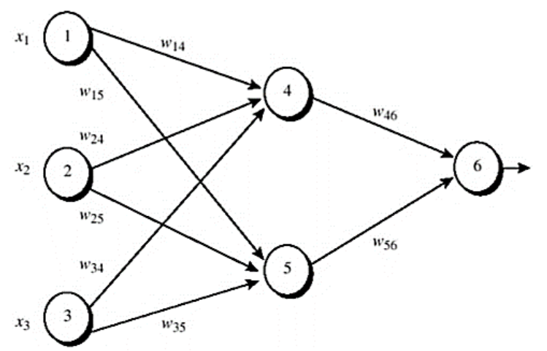

Initial input, weight and bias values are

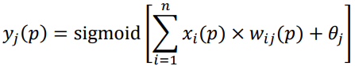The expected output value is 1. The learning rate is 0.9 Knowing that the actual output at some neuron j is calculated as follows.

where n is the number of inputs of neuron j, 𝑤𝑖𝑗 is the corresponding link from a neuron i in the previous layer to neuron j, and 𝜃𝑗 is the bias at neuron j. Present all calculations required to perform the backpropagation once (i.e., one forward pass and one backward pass) on the given neural network in the following cases

Output )

Output

a) Ignore all biases (precision to 3 decimal places).

Ignore all biases – Forward

Sum4 =

Output4

Sum5 =

Output5

Sum6 =

Output6

Ignore all biases – Backward

Error gradient at neuron 6

Error gradient at neuron 5

Error gradient at neuron 4

Updated weight:

weight46

weight56

weight14

weight24

weight34

weight15

weight25

weight35

b) Consider all biases such that each bias is treated as a neuron and thus it will be also updated (precision to 3 decimal places).

Sum 4 = + (-0.4)

Output4

Sum5 =

Output5

Sum6 =

Output6

Error gradient at neuron 6

Error gradient at neuron 5

Error gradient at neuron 4

Updated weight:

weight46

weight56

weight14

weight24

weight34

weight15

weight25

weight35