GDD Chaos

Table des matières

Core Game Loop 3

Making Money 3

Mini Games 3

Daily Rewards 3

Buying Things 3

Items 3

Food 3

Taking care of Creatures 3

Feed a Creature 3

Training Creatures 4

Creatures 4

Stats 4

Level 4

Hunger 4

Leveling up 4

The Player 4

# Core Game Loop

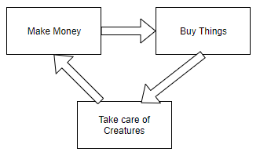

# Making Money

## Mini Games

Todo

## Daily Rewards

Todo

# Buying Things

## Items

Todo

## Food

Food are items which the Creatures can eat.

# Taking care of Creatures

See **Creatures** before.

## Feed a Creature

Drag and drop food from **Inventory** over a creature to feed it.

## Training Creatures

Todo

# Creatures

Creatures are the core aspect of the game. The entire game is based on buying/upgrading creatures.

## Stats

### Level

The creature’s level. Generally starting at 1.

### Hunger

The creature’s hunger. If at 0 for too long, the creature die. The hunger is replenish using **Food**.

Happiness

The creature’s happiness level. If at 0 for too long, the creature flew away. Other players can then find abandoned creatures.

## Leveling up

Todo

# The Player

The Player is the entity that own Creatures, Money(Inventory) and Items (Inventory).