The plugin PropertyDarawerCollection can:

* change the label in any standard field , hide the label, ask for a hint, specify the number of rows to display
* set arbitrary labels for any Enum value
* use static and dynamic selection lists of values
* call system dialogues to select the path to the file or directory
* set a mask for the entered value
* make the property not editable
* enter test values by the field type
* display a hint or a title
* make the process of EditorWindow creating easier
* help to forget about CustomEditor

For each attribute, it is created its own scene with an example of using and commentaries, as well as with an example of a real project with Unity Test Tool using.

You can see the collection of more than 20 PropertyDrawer in Sample catalog. Example folder contains examples of using, see the file ReadMe.

Using:

Let’s add to the variable the required attribute, and specify the parameters, if necessary. If you need to change the label, to ask for a hint, to hide the label, or to specify the number of rows when displaying, add to the variable one more attribute PropertyArgs and set the necessary parameters, such as:

*[SceneName(true)]*

*[PropertyArgs(label = "Scene", tip = "Select the scene to go")] // can be used instead of a colon equals*

*public string selectScene;*

where:

* *SceneName(true) –* field displaying like a selection list of active scenes, added to the player.
* *[PropertyArgs(label = "Scene", tip = "Select the scene to go")] –* *where the label and tooltip to the property are set*
* *public string selectScene; - the* variable, instead of which the field with selection will be displayed

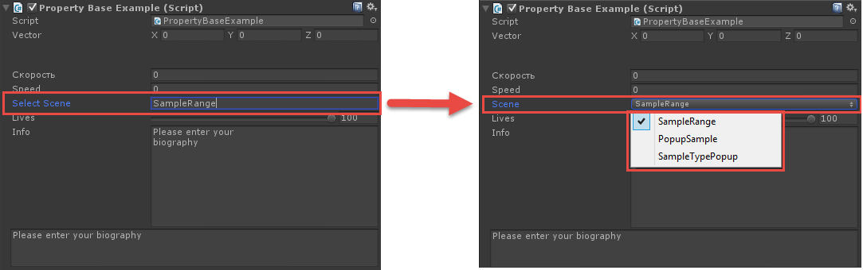

Note: For Enum it’s possible to set the attributes for each value.

All the basic attributes are listed below, for more details see the FAQ:

PropertyBase - base type for property drawing.

PropertyArgs – parameter values are used by any PropertyDrawer from the collection. It helps you specify a label or a hint, hide the label, specify the number of lines for drawing

AnimatorParameter - name selection of the animation parameter

Compact - Compact conclusion of a complex property

ConstSelect - selection of the constant value available in the class

Disable – making the property not editable

EnumLabel – displaying Enum values with their own labels

FileSelect - selection of a link to the file

FolderSelect - catalog selection

Header - title output (size, color, bold, italic) (as decorator)

Help –hints output in the editor (as decorator)

Multiline - multi-line output of the entry field

Observe - the observer, allows you to run for execution methods when making changes in the value of the parameter in the editor manually.

Password - the password field

Popup – selection from a pop-up list of available values

PreviewTexture – texture preview

PropertyPopup - name selection of the object properties

PropertyValue – field for entering values. It is similar to the same field, when the input field is used for the object properties. It can be used for storing of test values.

Range - selection of value from a range of values at a predetermined step

Regex - the entered value checking by regular expressions

SceneName – selection from a list of scenes names

SelectableLabel - label with the ability of text selection (as decorator)

Splitter - split line (as decorator)

TypePopup – name selection for value type.