UDB LAB ASSIGNMENT – 8
COLLECTION 1: flights
Schema
{
flight_id: Number, airline: String, source: String, destination: String, price: Number, duration: Number
}

Table
flight_id | airline | source | destination | price | duration
1 | Indigo | Delhi | Mumbai | 5000 | 2
2 | AirIndia | Kolkata | Chennai | 6500 | 3
3 | SpiceJet | Mumbai | Bangalore | 4000 | 1.5
4 | Vistara | Delhi | Chennai | 7000 | 3
5 | GoFirst | Mumbai | Delhi | 4800 | 2
6 | Indigo | Bangalore | Kolkata | 5500 | 2.5
COLLECTION 2: bookings
Schema
{
booking_id: Number, passenger_name: String, flight_id: Number, city: String, seats: Number, total_fare: Number
}

Table
booking_id | passenger_name | flight_id | city | seats | total_fare
101 | Aarav | 1 | Delhi | 1 | 5000
102 | Meera | 2 | Kolkata | 2 | 13000
103 | Rohan | 3 | Mumbai | 1 | 4000
104 | Sneha | 4 | Delhi | 3 | 21000
booking_id | passenger_name | flight_id | city | seats | total_fare
105 | Kunal | 5 | Mumbai | 2 | 9600
106 | Priya | 6 | Bangalore | 1 | 5500

QUESTIONS

Q1. Display all flights.

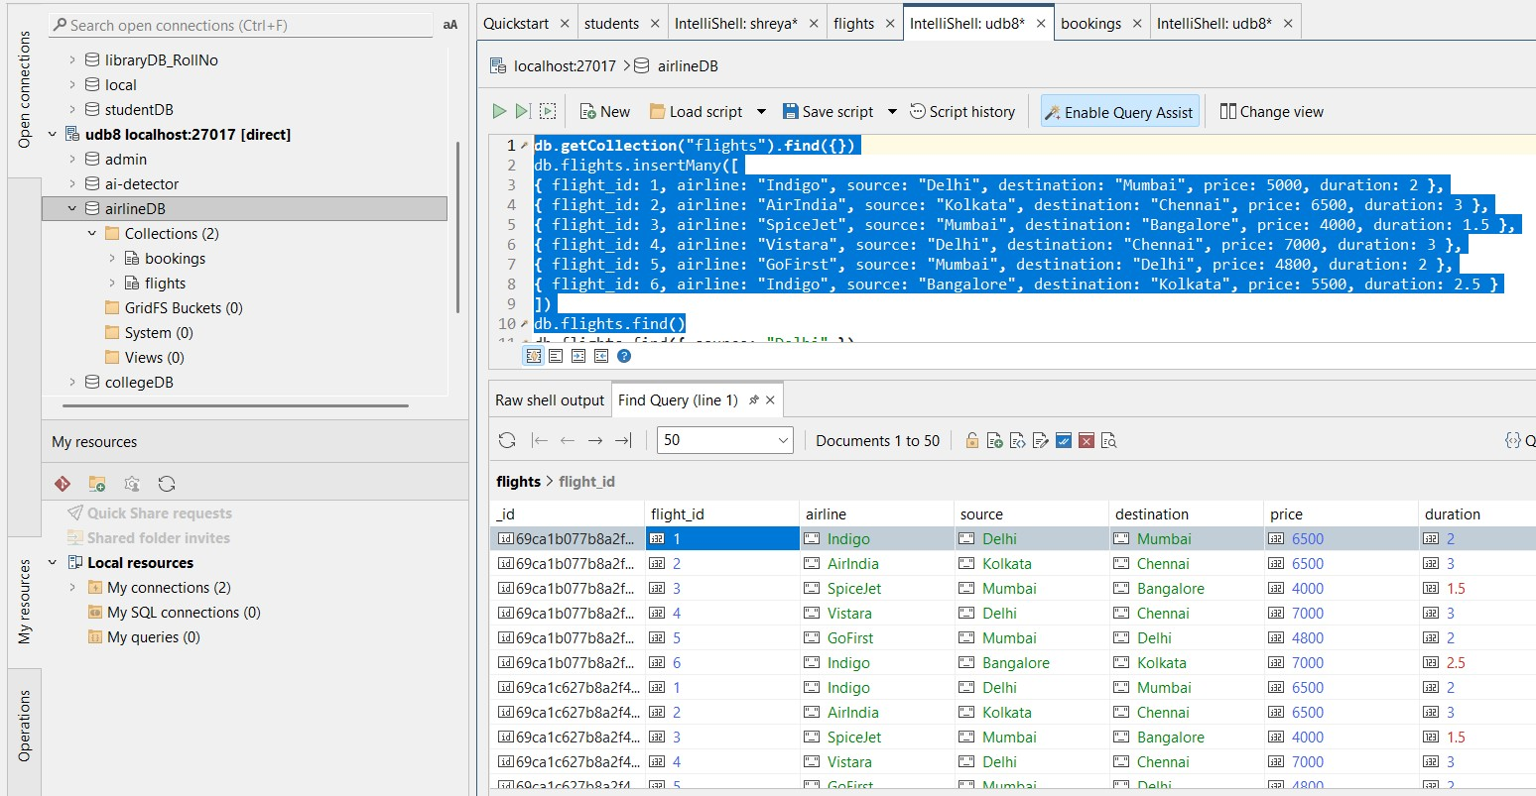

Q2. Display passenger_name and city from bookings.

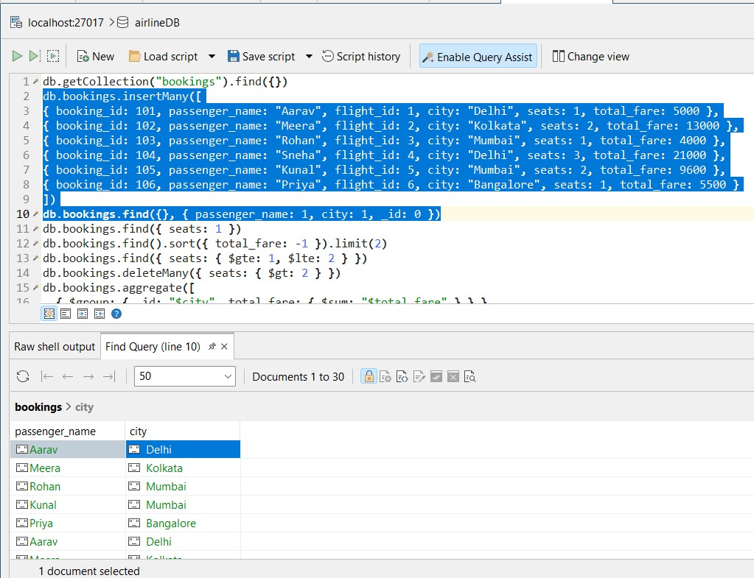

Q3. Find flights where source is Delhi.

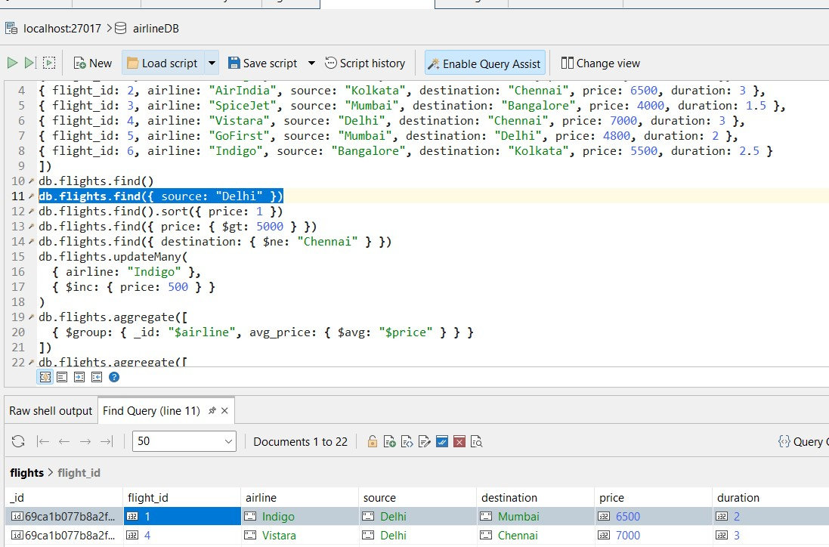

Q4. Find bookings where seats = 1.

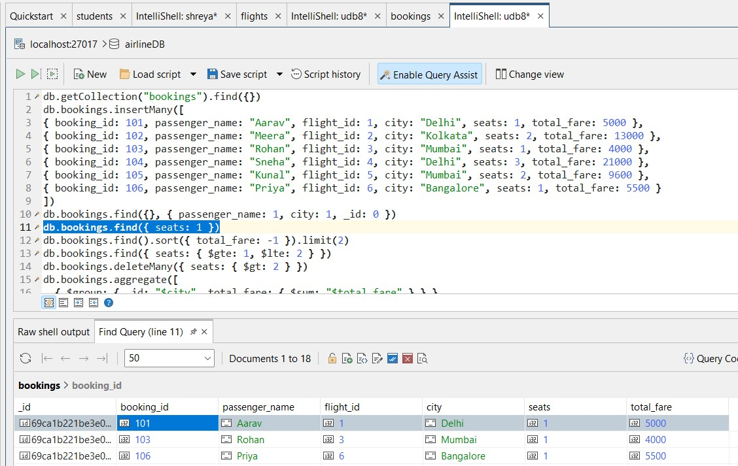

Q5. Sort flights by price in ascending order.

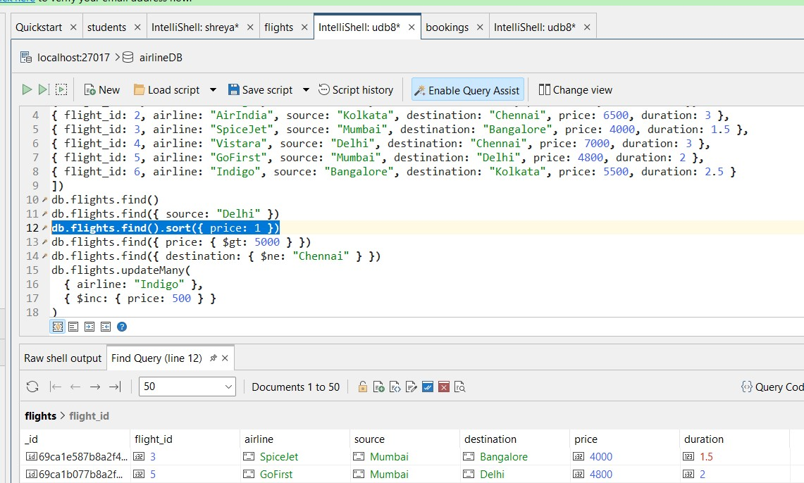

Q6. Display top 2 bookings with highest total_fare.

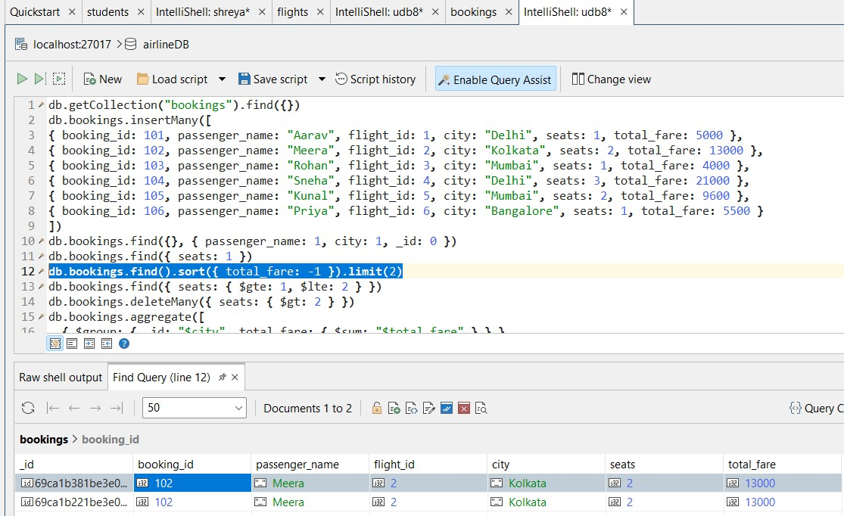

Q7. Find flights where price is greater than 5000.

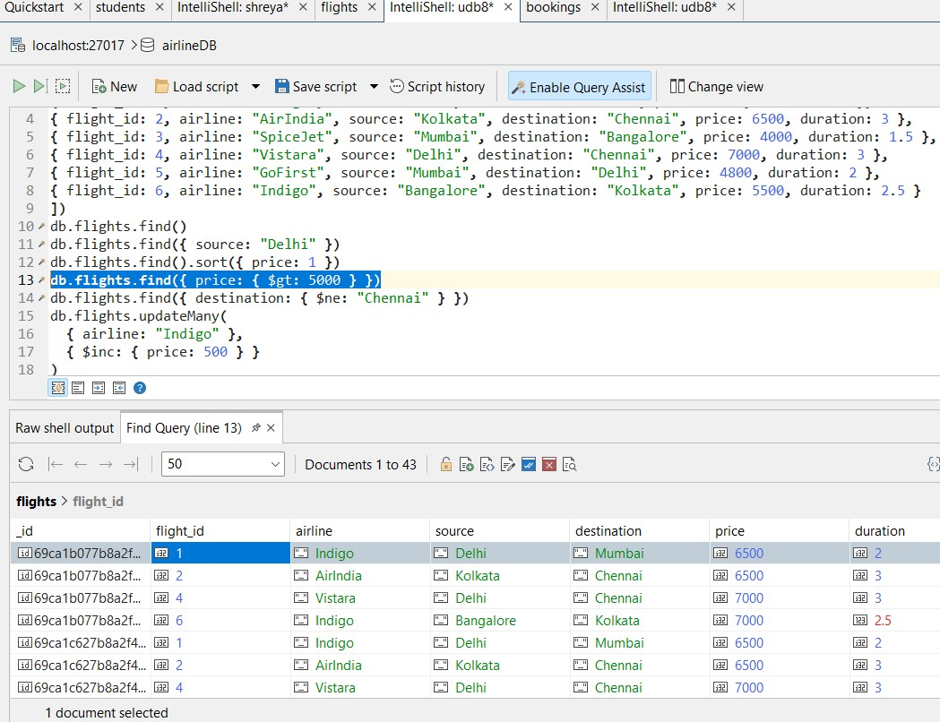

Q8. Display flights where destination is not Chennai.

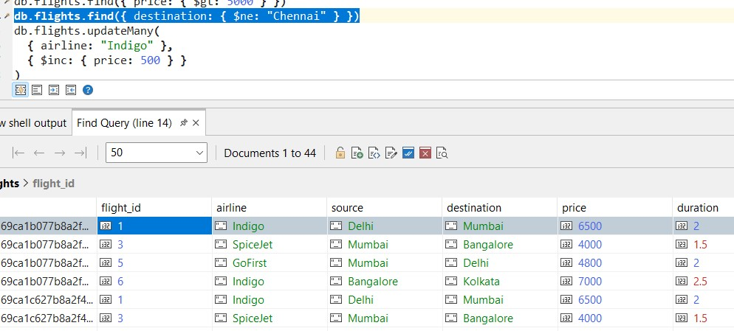

Q9. Find bookings where seats are between 1 and 2.

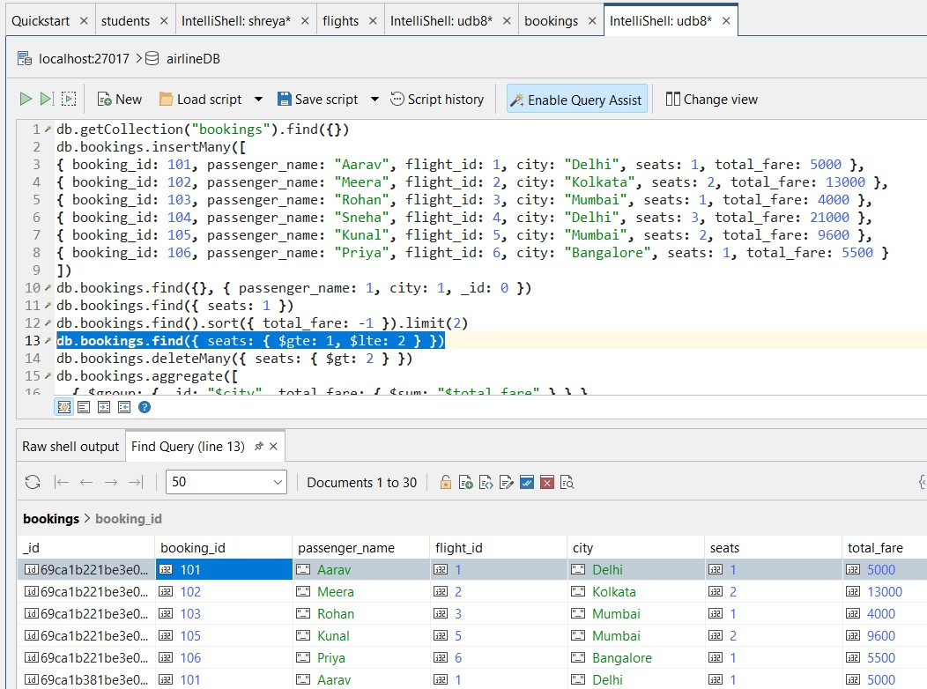

Q10. Update price by +500 for flights of airline "Indigo".

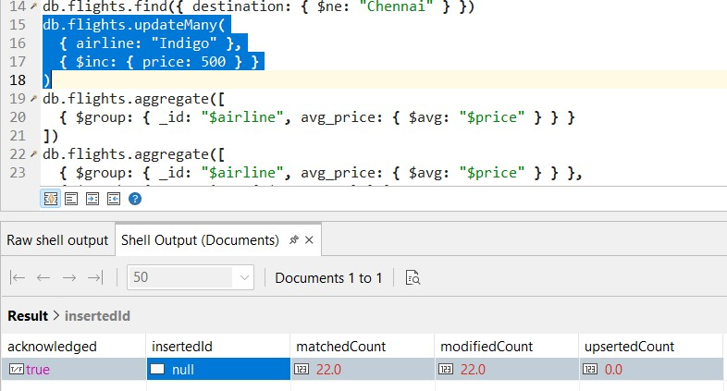

Q11. Delete bookings where seats are greater than 2.

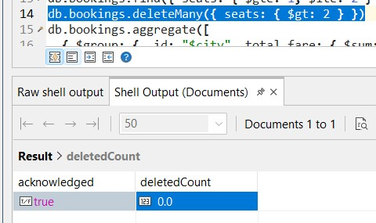

Q12. Find total fare collected city-wise. (Aggregation)

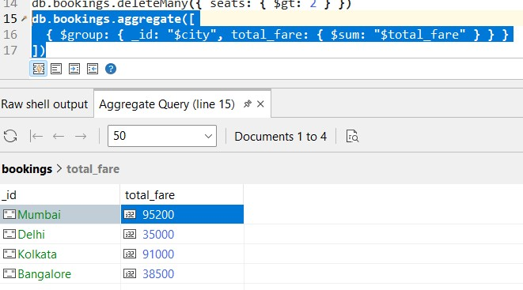

Q13. Find average flight price per airline. (Aggregation)

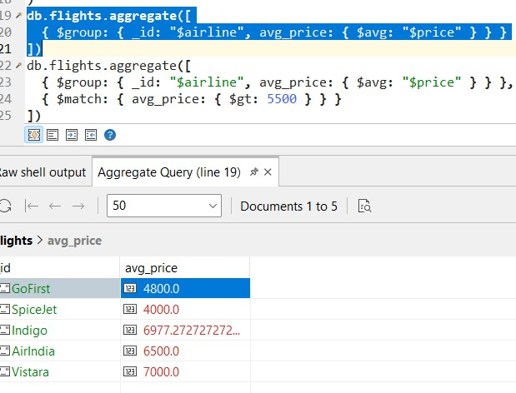

Q14. Display airlines where average price is greater than 5500. (Aggregation + filter)

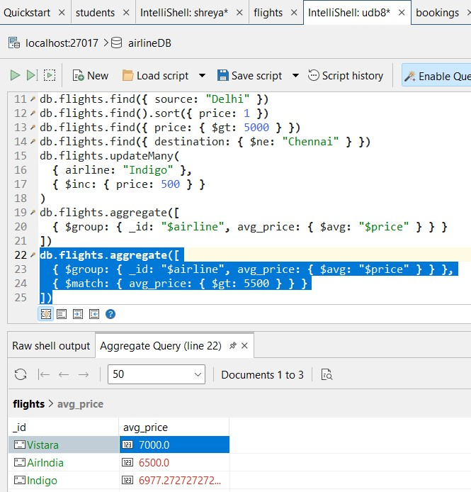

Q15. Find maximum total_fare among bookings for each city. (Aggregation)

