LAB ASSIGNMENT – 7 (Studio 3t)
Data: { roll: 1, name: "Anu", age: 22, department: "IT", marks: 85 },
{ roll: 2, name: "Riya", age: 21, department: "CSE", marks: 78 },
{ roll: 3, name: "Aman", age: 23, department: "IT", marks: 92 },
{ roll: 4, name: "Neha", age: 20, department: "ECE", marks: 74 },
{ roll: 5, name: "Raj", age: 24, department: "CSE", marks: 88 },
{ roll: 6, name: "Simran", age: 22, department: "IT", marks: 81 },
{ roll: 7, name: "Karan", age: 21, department: "ECE", marks: 69 },
{ roll: 8, name: "Priya", age: 23, department: "CSE", marks: 95 }.
Lab Questions:
Q1. Display all documents.
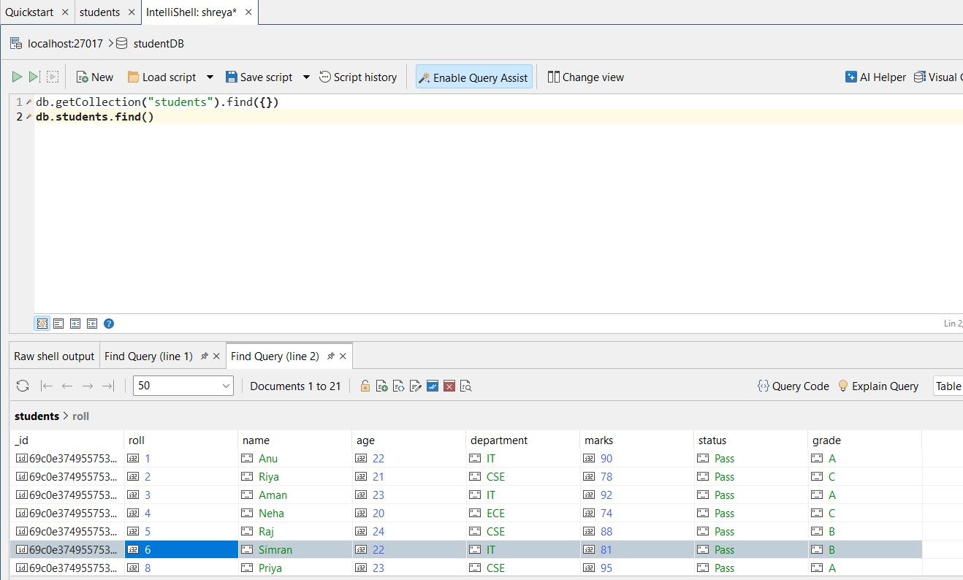

Q2. Find students from IT department.

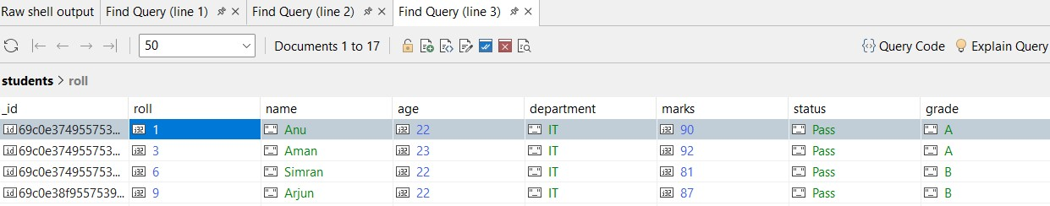

Q3. Find students with marks > 80.

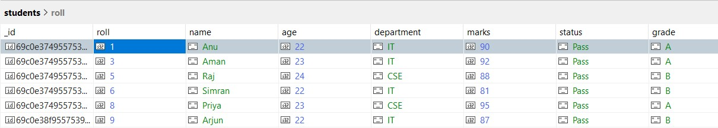

Q4. Insert one new student.

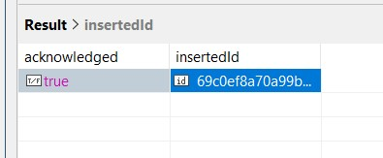

Q5. Update marks of Anu to 90.

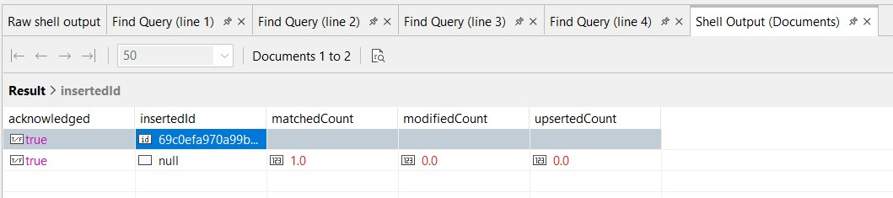

Q6. Add a new field "status: Pass" for all students.

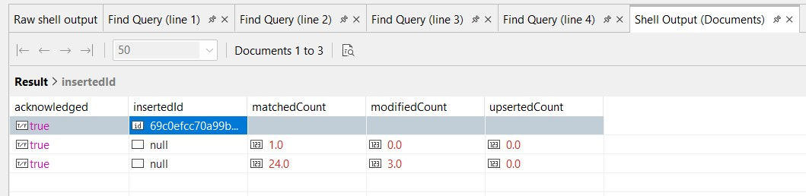

Q7. Delete all students with marks < 70.

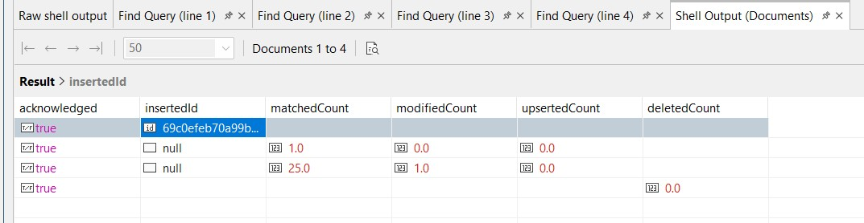
Q8. Count students in CSE department.
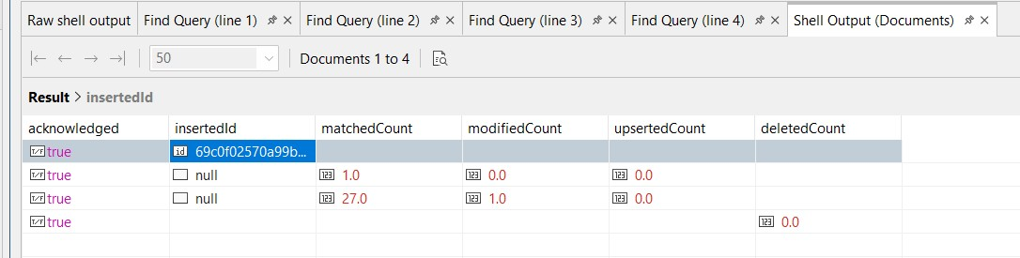
Q9. Find total students in each department.
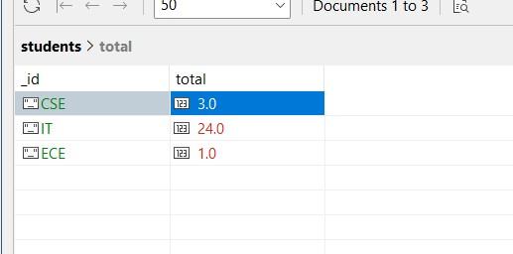
Q10. Find highest marks.
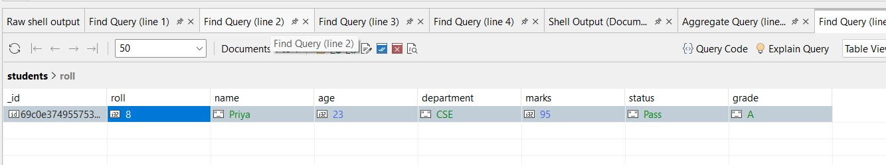

Q11. Find the second highest marks.

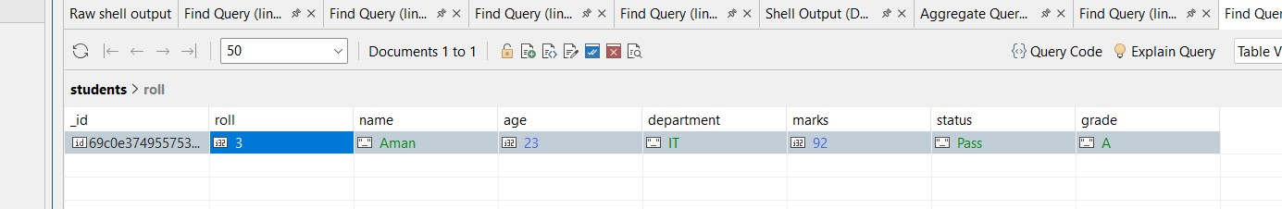

Q12. Find students whose name starts with 'A' and marks >
80.

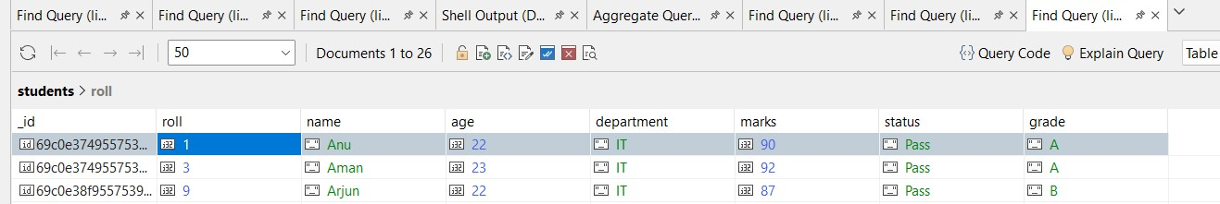

Q13. Display department-wise average marks, only for departments where avg > 80.

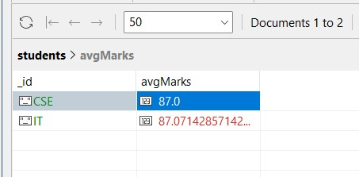

Q14. Find students with marks between 75 and 90, sorted by marks ascending.

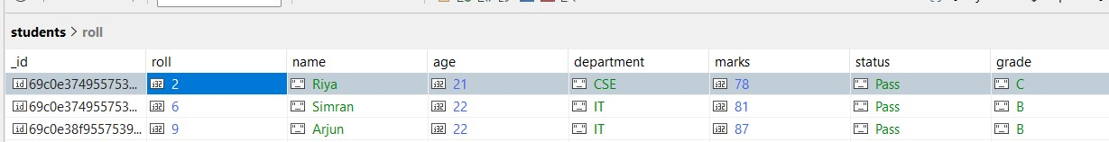

Q15. Add grade field based on marks.

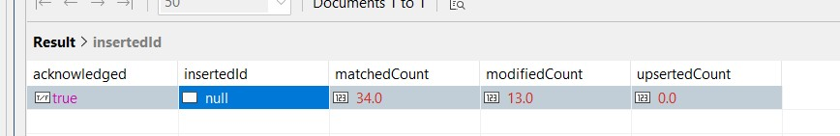
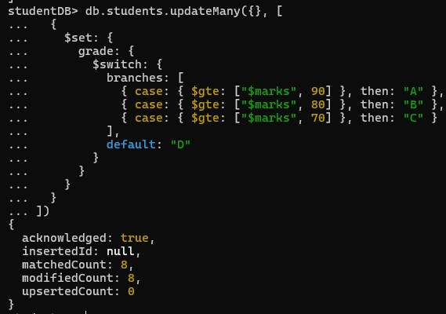

Queries:

- db.students.find()
- db.students.find({ department: "IT" })
- db.students.find({ marks: { $gt: 80 } })
- db.students.insertOne({ roll: 9, name: "Arjun", age: 22, department: "IT", marks: 87 })
- db.students.updateOne(
{ name: "Anu" },
{ $set: { marks: 90 } }
)
- db.students.updateMany({}, { $set: { status: "Pass" } })
- db.students.deleteMany({ marks: { $lt: 70 } })
- db.students.countDocuments({ department: "CSE" })
- db.students.aggregate([
{ $group: { _id: "$department", total: { $sum: 1 } } }
])
- db.students.find().sort({ marks: -1 }).limit(1)
- db.students.find().sort({ marks: -1 }).skip(1).limit(1)
- db.students.find({ name: { $regex: "^A" }, marks: { $gt: 80 }
})
- db.students.find({ marks: { $gte: 75, $lte: 90 }
}).sort({ marks: 1 })
- db.students.updateMany({}, [
{ $set: { grade: { $switch: { branches: [
{ case: { $gte: ["$marks", 90] }, then: "A" },
{ case: { $gte: ["$marks", 80] }, then: "B" },
{ case: { $gte: ["$marks", 70] }, then: "C" }
],
default: "D"
}
}
}
}
])

