**AHP-OS Quick Reference**

## 1. Session Administration

The **Session Administration Menu** allows you to open your AHP projects. You can also open a project by *clicking on the link of the session code in the project table*.



|  |  |
| --- | --- |
|  | Open project summary of selected project session. |
| C:\Users\Klaus\AppData\Local\Microsoft\Windows\INetCache\Content.Word\newProjectBut.jpg | Start a new project (hierarchy definition) – opens hierarchy page. |
|  | Back to AHP main page. |

## 2. Project Administration

The **Project Administration Menu** allows you to manage a selected AHP project.



|  |  |
| --- | --- |
|  | View result (greyed, if no result available). |
|  | Start your pairwise comparisons input as participant. |
|  | Use decision hierarchy of the selected project to define a new one. |
|  | Rename project name or edit project description. |
|  | Edit a saved project (greyed, when project has participants’ inputs). |
|  | Delete selected participant(s) (greyed, if no participant is selected.) Select participants in the participants table and refresh. |
| C:\Users\Klaus\Documents\2017\AHP-OS-2017-05-20\menus\delProjBut.jpg | Delete the whole project. |
|  | New: Toggle project status between open and closed |
|  | Close the selected project. Go back to session table. |

## 3. Decision Hierarchy

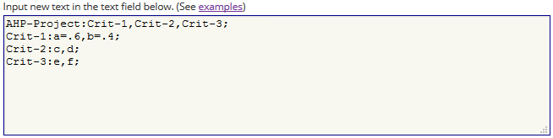

The syntax is defined as follows:

<hierarchy> → <branch>; [{<branch>;}]

<branch> → <node>**:** <leafs>**,** <leafs> [,<leafs>]

<leafs> → {<leaf> [ = <weight>]}

For all <leafs> in a <branch> the sum of <weight> has to be one. A <node> of the second and any further <branch> has to be one of the <leaf> in <leafs>. Each <node> represents a decision matrix, and the corresponding priority vector’s dimension is the number of <leafs>. The example shown has defined weights for the two criteria a (60%) and b (40%. For all other criteria weights are automatically set to the default value 1/*n*leaf.

In the **Hierarchy Input Menu** you can define a new hierarchy and save it as new project.



|  |  |
| --- | --- |
|  | Submit new hierarchy text input |
|  | Save hierarchy definition as new project |
|  | Export data as comma separated value file |
|  | Export with “,” as decimal separator when checked |
|  | Reset all priority values given within the hierarchy text input. Clears also alternative names |
|  | Reset hierarchy definition and all other session parameter |
|  | Go back to Session Administration |

## 4. Save New/Modified Projects

When you want to save a new or modified project, or rename the project name or description, the AHP Session Input Page will open. You can edit the AHP Project Name and input a Project Short Description. The project short description (max. 400 chars) will be shown to the participants/respondents.







## 5. Group Input (Participants)

Start project evaluation inputs as participant: Click on *Group Input* in the project administration menu, or follow the group link provided on the project administration page.





|  |  |
| --- | --- |
|  | Check your input (session code and participants’ name. Red outline when required. |
|  | Start: will show decision hierarchy with AHP buttons to click and start pairwise comparisons. |
|  | Reset form. |
|  | Cancel input. |

## 6. Pairwise Comparisons

|  |  |
| --- | --- |
|  | Start pairwise comparison (red) for selected node of the hierarchy. Once the comparison is done, the button outline will be green. |
|  | Check consistency of the pairwise comparison. |
|  | Submit priorities and go back to the hierarchy to continue evaluation. |

Once all judgments are completed, they can be saved to the database.



|  |  |
| --- | --- |
|  | Submit judgment for group evaluation – red outline, when all comparisons are completed. |
|  | View consolidated group results. |
|  | Exit the Group input page – red outline, when judgments are saved. |

## 7. Group Results

The **Group Result Menu** allows you to analyse the results and download them as csv text file.

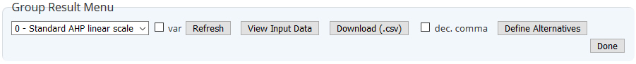

|  |  |
| --- | --- |
|  | Scale selection |
|  | Uncertainty evaluation and sensitivity analysis (alternatives). |
|  | Weighted product method instead of weighted sum method. |
|  | Refresh page – outlined red when required. |
|  | View participants input data. |
|  | Download results as csv text file. |
|  | Use hierarchy with resulting priorities for definition of alternatives. |
|  | Go back to project list. |

## 8. Define Alternative Project

Click *Use Consol. Prio* in the Group Result Menu and click on *Alternatives* in the hierarchy table. Define number and names of alternatives.



Save as new project.



|  |  |
| --- | --- |
|  | Hierarchy with consolidated priorities and defined alternatives will be saved as a new project (mode alternative evaluation). |
|  | Reset al defined alternative names to input new ones. |
|  | Go back to hierarchy page. |

## 9. Results Page

On the result page following details are shown:

|  |  |
| --- | --- |
| Project result data | Selected judgment scale, Number of judgment variation for uncertainty estimation, Weighted Product Method (WPM) if selected.  - Project summary table,  - Alternative table (if any),  - Project participants table with checkbox for selection of individual participants. |
| Hierarchy with consolidated priorities | “All” or selected participants from participant’s table, decision hierarchy table with alternatives (if any) and consolidated weights from all or selected participants. |
| Consolidated global priorities or weights of alternatives | Graph with priorities and uncertainties (if selected). |
| Sensitivity analysis | 1. Weight uncertainties overlap, 2. Robustness (for alternative evaluation). |
| Alternatives by Participants (alternative evaluation) | Group result of alternative weights, uncertainties and breakdown by participant. |
| Breakdown by nodes (Details/Hide) | Consistency Ratio CR,  AHP group consensus, Table with weights and uncertainties, Consolidated decision matrix,  Group result and weights for individual participants. |
| Global priorities (hierarchy evaluation) | Group consensus and global weights, uncertainties and breakdown by participants. |