BPMSG’s AHP Online System  
Rational Decision Making Made Easy

Klaus D Goepel - latest update 2022-02-19

**AHP-OS** is a web-based tool to support rational decision making based on the Analytic Hierarchy Process (AHP). It allows you to define a hierarchy of criteria for a decision problem, to calculate priorities and evaluate a set of decision alternatives against those criteria.

1. **Introduction**

AHP stands for Analytic Hierarchy Process. It is a method to support multi-criteria decision making, and was originally developed by Prof. Thomas L. Saaty. AHP derives ratio scales from paired comparisons of criteria, and allows for some small inconsistencies in judgments. Inputs can be actual measurements, but also subjective opinions. As a result, ratio scales (weightings) and a consistency index will be calculated. A simple introduction to the method is given here.

**Benefits of AHP**

Using AHP as a supporting tool for decision making will help to gain a better insight in complex decision problems. As you need to structure the problem as a hierarchy, it forces you to think through the problem, consider possible decision criteria and select the most significant criteria with respect to the decision objective. Using pairwise comparisons helps to discover and correct logical inconsistencies. The method also allows "translating" subjective opinions, such as preferences or feelings, into measurable numeric relations. AHP helps to makes decisions in a more rational way and to make them more transparent and better understandable.

**Method**

Mathematically the method is based on the solution of an Eigen value problem. The results of the pair-wise comparisons are arranged in a matrix. The first (dominant) normalized right eigen vector of the matrix gives the ratio scale (weighting), the Eigen value determines the consistency ratio.

**Programs**

We have developed a web based AHP solution, as a supporting tool for decision making processes. Please feel free to try it out. It can not only be helpful in your daily work for simple decision problems, but also support complex decision making problems. Internationally AHP is used in a wide range of applications, for example for the evaluation of suppliers, in project management, in the hiring process or the evaluation of company performance.

To start a program, click on one of the links in the table on the entry page:

|  |  |  |  |
| --- | --- | --- | --- |
| 1. | [AHP Projects](http://bpmsg.com/academic/ahp-session-admin.php)  (AHP-OS) | Handle complete AHP projects including group decision support | **The complete AHP online program package** Manage complete AHP projects and *group sessions*. To use the full functionality, you need to login. Please [register](http://bpmsg.com/academic/ahp-register.php) as new user, if you don't have an account yet. It's all free! |
| 2. | [AHP Priority Calculator](http://bpmsg.com/academic/ahp_calc.php) | Calculate priorities based on pairwise comparisons | The **AHP priority calculator** can be used to "translate" individual preferences into numbers. It calculates priorities or weights for a set of criteria based on pairwise comparisons. |
| 3. | [AHP Hierarchies](http://bpmsg.com/academic/ahp-hierarchy.php) | Define complete hierarchies and evaluate priorities and alternatives | With **AHP Hierarchy** it is possible to handle complete decision problems under AHP. It allows you to define a hierarchy of criteria, calculate weights for all criteria based on pairwise comparisons, and evaluate alternatives. |
| 4. | [AHP Group Session](http://bpmsg.com/academic/ahp-hiergini.php) | Participate in AHP group sessions. | Participate in **AHP group sessions** to evaluate criteria or alternatives. The group session code is provided by your session chair. |

**Please make a reference to the author and website, when you use the tool. For terms of use please see our**[user agreement and privacy policy.](http://bpmsg.com/about/user-agreement-and-privacy-policy/)

1. **User registration**

To use the full features of the program, you need to register as a user.



When you click on “Register” a registration form will appear:

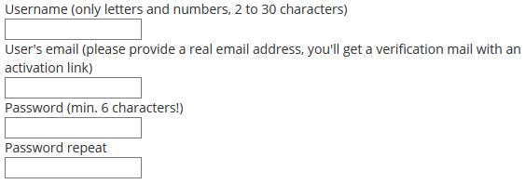

Provide a user name and your valid email address. You will receive an activation e-mail. When you click on the link in the activation e-mail, your account will be activated, und you can login.

1. **AHP project administration**

After login the AHP-OS project page is shown:

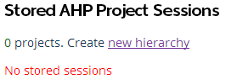

Once you have initiated new projects, they will be shown in the project table:

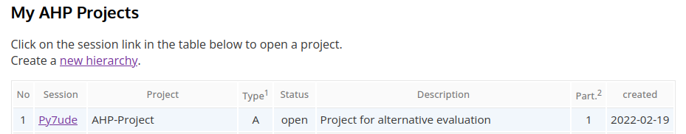

A click on the session code will open the project.

Session: Unique session code of the project  
Project: Project title  
Type: H = hierarchy priority evaluation, A = alternative evaluation  
Status: Open/Closed: for closed projects, no pairwise comparison is allowed  
Description: Short description of the project  
Part.: Number of participants  
Created: Date, when the project was created

You can also open a project by selecting the session code from the selection list in the session administration menu.



Open Project: Opens the project summary page of the selected project  
Import Project: New - Import a project from a json text file.  
New Project: Opens the hierarchy page to define a new project.

When you open a saved project, a project summary is shown:

* Project Data: session code, project name, description, etc.
* Project Participants: list of participants with name and date of their input (if any)
* Project Alternatives: list of defined alternatives (if any)
* Group Input link: link for other participants, you want to give their judgment
* Decision hierarchy
* Hierarchy definition text

Project Summary Information:

|  |  |  |
| --- | --- | --- |
|  |  |  |

AHP project Import Menu

Browse: Select json file to upload (extension json)  
Import: Import selected project

The project administration menu allows you to manage your existing projects. 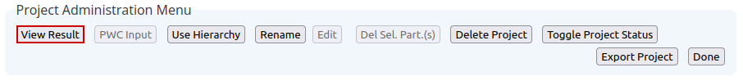

* *View Result* - view the group results if the project has participants
* *PWC Input* - Input your judgments using pairwise comparisons
* *Use Hierarchy* – use the project’s decision hierarchy to modify and save as a new project
* *Rename* – Rename project or modify short description
* *Edit* – edit hierarchy, alternatives or project description of a saved project
* *Del. sel. Participant(s)* – Remove selected participants input data
* *Delete* – delete the complete project with all its data
* *Toggle Project Status* – Toggle between open and closed. For a closed project no additional pairwise comparison inputs are possible.
* *Export Project* – New - Export current project as text file in json format.
* *Done*– close the currently opened project and go back to the project table

1. **How to use the program**

The online software is easy to use in five steps:

1. Define the objective and relevant criteria of your decision problem and structure them in a hierarchy.
2. Compare criteria in categories and sub-categories with respect to the objective to find their weights based on pairwise comparisons.
3. View the results.
4. Name a set of alternatives.
5. Compare, how good they match your decision criteria. Again pairwise comparisons based on the AHP are used.

Once completed, you will get a total weight for each alternative, which could help you to select the appropriate alternative and make the final decision.

**Step 1 – Define a hierarchy**

Hierarchies are defined in a text field using the following simple syntax:

Each branch in the hierarchy is defined by its node (the category) and the node’s leafs (the sub-categories). The node is followed by a *colon*, leafs are separated by *comma*, and a branch is closed by a *semicolon*:

**category: sub-category 1, sub-category 2, sub-category 3;**

If a sub-category branches out in further sub-categories, you add a line, repeating the sub-category’s name as a new node (followed by a colon):

**sub-category1: sub-sub-1, sub-sub-2;**

Note: Text input is case sensitive.

## Input a new hierarchy

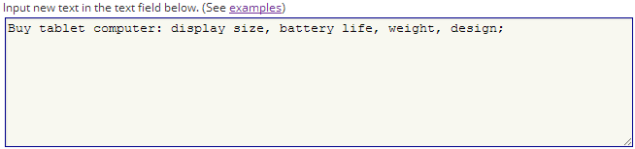



Then press *Submit new hierarchy* and the hierarchy table will be displayed:

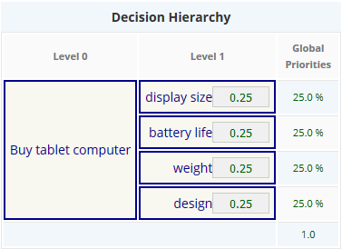

**Note:** If you have a project with already defined criteria, you can skip Step 2 (compare criteria) and go immediately to Step 5 and define your alternatives.

Predefine criteria cam be set by adding a “=” and the priority into the hierarchy definition:

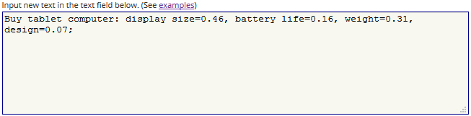

The predefined weights in each category have to sum-up to 100%.

Press *Save/Update* to save the hierarchy into your project list.



The new project session code (a unique 6 letter identifier for each project) is shown with your login name as project author.

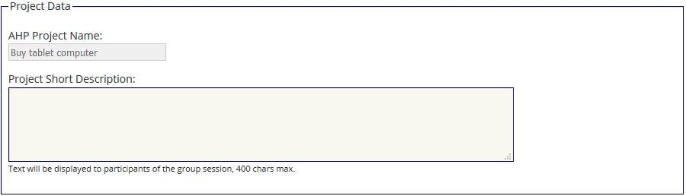

You can add a project short description in the text field below. Then press Go to save the project.



**Step 2 – Compare criteria**

Open the newly saved project from the project list. Click on *PWC Input* in the Project Administration menu.



A new page will open showing the project’s session code and your name, as well as the Participant’s Input Menu.

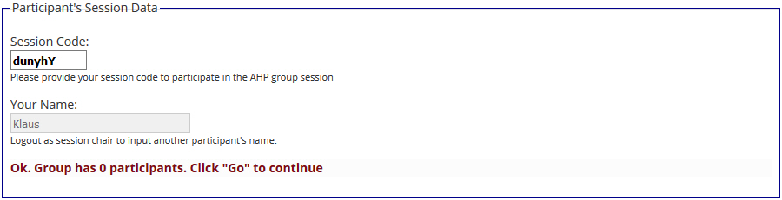

**Note:** You need to logout, if you want to input your judgment under a different name.



Click on Go. The hierarchy will now show an additional “AHP” button with red outline:

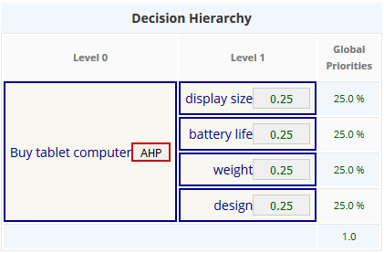

You can now start to compare the criteria.

To find the weight (importance) of criteria, click *AHP* to start pairwise comparisons. The following form is shown:

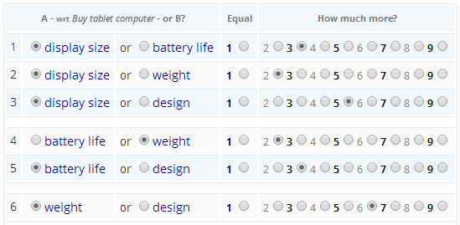

Compare each pair of criteria with respect to the project and category: which criterion in each pair is more important, and how much more on a 1 - 9 scale? Once you have finished click *Check Consistency*. A table with priorities for each criterion is shown:

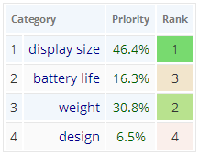

It could happen that your pairwise comparisons are not consistent; then the most inconsistent judgments are highlighted, and the consistent judgments are marked light green:

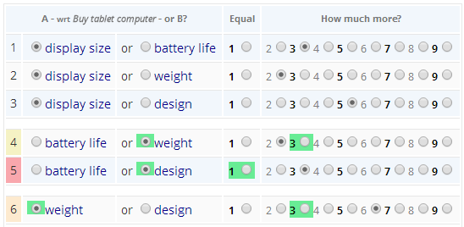

In order to improve consistency, check whether you are able to adjust your original mark by ± two points on the scale. Click *Calculate* to re-calculate. Once finished, and you are satisfied with you answers, press *Submit* to submit.



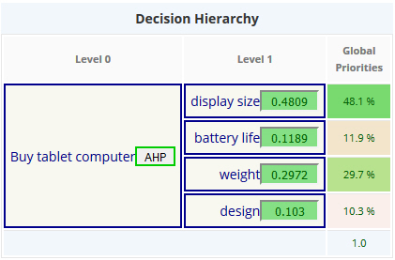

Completed branches in the hierarchy tree are marked green, and global priorities are calculated and color-coded according to their rankings.



Once you have completed the judgments, click on *Save judgments* to store them with the project.

**Step 3 – View the Results**

You then can view the (group) result.



The decision hierarchy will be shown with local and global priorities, and a breakdown by the nodes with their corresponding priority vector and their (consolidated) decision matrix. Data can be downloaded in csv format for further use in a spreadsheet program.

**Step 4 – Definition of Alternatives**

From the *Group Result Menu* it is possible to use the calculated priorities of the decision hierarchy for further alternative evaluation.

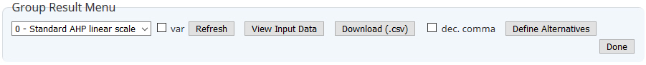

In the *Group Result Menu* click on *Define Alternatives*.

The decision hierarchy will be show with a button *Alternatives*. From there you can define the number and names of alternatives.



Enter required number of alternatives and press *Go* to get the following screen:

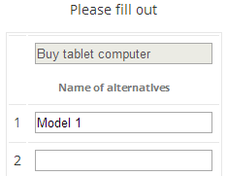

Input the names of alternatives, then press *ok*. Once defined, save the project with *Save as project* in the Alternative Menu.



The project will be stored under a new session code with Type “A” (Alternative Evaluation).

**Step 5 – Alternative Evaluation**

Open a project of Type “A” (alternative evaluation) with the group input link, or click on the *Group Input* button. A table with criteria and alternatives will be displayed:

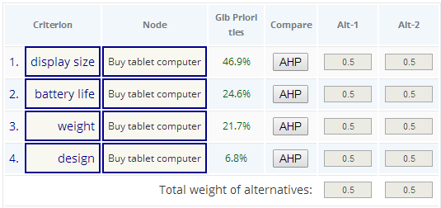

The procedure of pairwise comparisons is exactly the same as for criteria. Each completed comparison is highlighted in green:

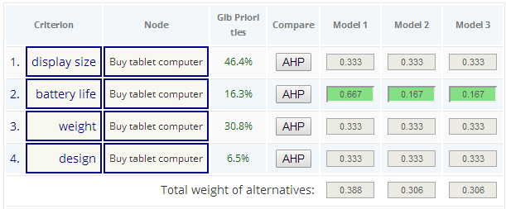

When all evaluations are done, the result is shown:

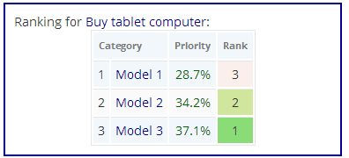

Click on *Submit for group eval* to submit and save your judgments.

In this case, alternative 1 (Model 1) gets a weight of 28.7%, alternative 2 (Model 2) 34.2%, and alternative 3 (Model 3) 37.1%.

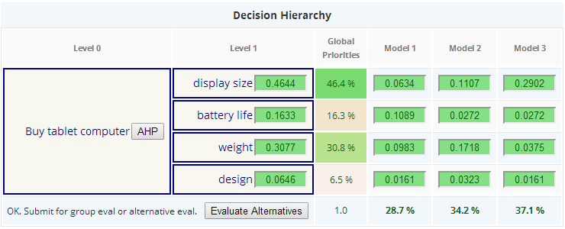

1. **Download**

You might download the data in csv format (comma separated values) for further processing in a spread sheet program.



Format:



Title line, then each row shows one criterion with the columns: (hierarchy level, local priority), global priority, alternatives (local and global priority).

All (decision) matrices are shown below, with category name as heading and criteria for the matrix rows.



Alternatives show the heading “Alternatives for” and the respective criterion:



1. **AHP Group Sessions**

The software allows for group inputs, to calculate consolidated weights for priorities or alternatives. When you open a saved project from your project list, the session code and a link is provided in the project summary:

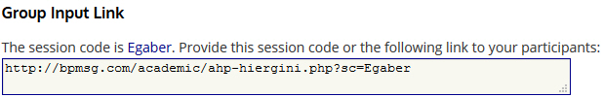

Copy and Paste the link and provide it to your participants. **Note:** Participants don’t need to register for the software. You can also just provide the session code to them.

Group members can participate by either following the given link, or going to the AHP-OS main site, and click on *AHP Group Session*, providing the session code and their name.

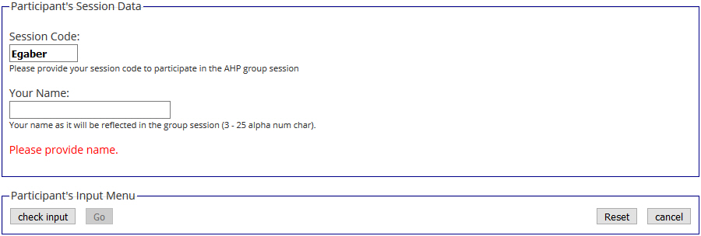

Once they have entered their name, they can start the pairwise comparisons as described under step 2 above. Results can be called from project administration menu by clicking on *View Result*.



**Selection of participants**

All participants are shown on the project summary page and the group result page. You can select individual participants and, after a click on *Refresh selection*, only the consolidated result of the selected participants is calculated.

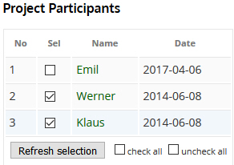

The consolidated result is shown in the hierarchy (local and global priorities), as well as in a diagram for the selected participants only. This is indicated with a message

Selected participants: Werner, Klaus

above the Decision Hierarchy.

A breakdown for each node of the hierarchy is given in table form, showing the resulting priorities for each individual group member, as well as the consolidated priorities under the node.

Click on *Download (.csv)* in the *Group Result Menu* to download the results as csv text file.



*View Input Data* will display the decision matrices from each participant and make them available for download.

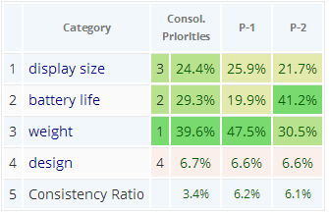

(P-1: participant 1, P-2: participant 2 etc,)

**AHP Group Consensus**

For more than one participant, the software calculates an AHP consensus indicator to quantify the consensus of the group, i.e. to have an estimate of the agreement on the outcoming priorities between participants. This indicator ranges from 0% to 100%. Zero percent corresponds to no consensus at all, 100% to full consensus. This indicator is derived from the concept of diversity based on Shannon alpha and beta entropy. It is a measure of homogeneity of priorities between the participants and can also be interpreted as a measure of overlap between priorities of the group members.

If we would categorise group consensus in the three categories low, moderate and high, I would assign the following percentages to these categories:

* Very low consensus: below 50% (disagreement)
* Low consensus: 50% to 65%
* Moderate consensus: 65% to 75%
* High consensus: 75% - 85%
* Very high consensus: above 85% (excellent agreement)

Values below 50% indicate that there is practically no consensus within the group and a high diversity of judgments. Values in the 85% – 95% range indicate a high overlap of priorities and excellent agreement of judgments from the group members.

**References**

In your work please cite:

Goepel, K.D. (2018). Implementation of an Online Software Tool for the Analytic Hierarchy Process (AHP-OS). *International Journal of the Analytic Hierarchy Process*, Vol. 10 Issue 3 2018, pp 469-487,   
<https://doi.org/10.13033/ijahp.v10i3.590>

The article describes the implementation of AHP-OS with all mathematical calculations and further references.

**Other**

**For terms of use please see our**[user agreement and privacy policy.](http://bpmsg.com/about/user-agreement-and-privacy-policy/)

## Contact and Feedback

Please feel free to leave a [comment](http://bpmsg.com/feedback/" \l "reply-title) or [contact](http://bpmsg.com/about/contact-form/) me.

**Annex 1: AHP-OS Menus**

## 1. Session Administration

The **Session Administration Menu** allows you to open your AHP projects. You can also open a project by *clicking on the link of the session code in the project table*.



|  |  |
| --- | --- |
| openProjectBut | Open project summary of selected project session. |
|  | Import project from json text file |
| C:\Users\Klaus\AppData\Local\Microsoft\Windows\INetCache\Content.Word\newProjectBut.jpg | Start a new project (hierarchy definition) – opens hierarchy page. |
|  | Back to AHP main page. |

## 2. Project Administration

The **Project Administration Menu** allows you to manage a selected AHP project.



|  |  |
| --- | --- |
|  | View result (greyed, if no result available). |
|  | Start your pairwise comparisons input as participant. |
|  | Use decision hierarchy of the selected project to define a new one. |
|  | Rename project name or edit project description. |
|  | Edit a saved project (greyed, when project has participants’ inputs). |
|  | Delete selected participant(s) (greyed, if no participant is selected.) Select participants in the participants table and refresh. |
| C:\Users\Klaus\Documents\2017\AHP-OS-2017-05-20\menus\delProjBut.jpg | Delete the whole project. |
|  | New: Toggle project status between open and closed |
|  | Import project from json text file |
|  | Close the selected project. Go back to session table. |

## 3. Decision Hierarchy

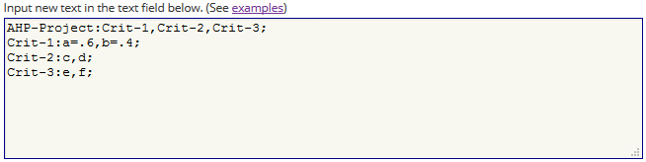

The syntax is defined as follows:

<hierarchy> → <branch>; [{<branch>;}]

<branch> → <node>**:** <leafs>**,** <leafs> [,<leafs>]

<leafs> → {<leaf> [ = <weight>]}

For all <leafs> in a <branch> the sum of <weight> has to be one. A <node> of the second and any further <branch> has to be one of the <leaf> in <leafs>. Each <node> represents a decision matrix, and the corresponding priority vector’s dimension is the number of <leafs>. The example shown has defined weights for the two criteria a (60%) and b (40%. For all other criteria weights are automatically set to the default value 1/*n*leaf.

In the **Hierarchy Input Menu** you can define a new hierarchy and save it as new project.



|  |  |
| --- | --- |
|  | Submit new hierarchy text input |
|  | Save hierarchy definition as new project |
|  | Export data as comma separated value file |
|  | Export with “,” as decimal separator when checked |
|  | Reset all priority values given within the hierarchy text input. Clears also alternative names |
|  | Reset hierarchy definition and all other session parameter |
|  | Go back to Session Administration |

## 4. Save New/Modified Projects

When you want to save a new or modified project, or rename the project name or description, the AHP Session Input Page will open. You can edit the AHP Project Name and input a Project Short Description. The project short description (max. 400 chars) will be shown to the participants/respondents.







## 5. Group Input (Participants)

Start project evaluation inputs as participant: Click on *Group Input* in the project administration menu, or follow the group link provided on the project administration page.





|  |  |
| --- | --- |
|  | Check your input (session code and participants’ name. Red outline when required. |
|  | Start: will show decision hierarchy with AHP buttons to click and start pairwise comparisons. |
|  | Reset form. |
|  | Cancel input. |

## 6. Pairwise Comparisons

|  |  |
| --- | --- |
|  | Start pairwise comparison (red) for selected node of the hierarchy. Once the comparison is done, the button outline will be green. |
|  | Check consistency of the pairwise comparison. |
|  | Submit priorities and go back to the hierarchy to continue evaluation. |

Once all judgments are completed, they can be saved to the database.



|  |  |
| --- | --- |
|  | Submit judgment for group evaluation – red outline, when all comparisons are completed. |
|  | View consolidated group results. |
|  | Exit the Group input page – red outline, when judgments are saved. |

## 7. Group Results

The **Group Result Menu** allows you to analyse the results and download them as csv text file.



|  |  |
| --- | --- |
|  | Scale selection |
|  | Uncertainty evaluation and sensitivity analysis (alternatives). |
|  | Weighted product method instead of weighted sum method. |
|  | Refresh page – outlined red when required. |
|  | View participants input data. |
|  | Download results as csv text file. |
|  | Use hierarchy with resulting priorities for definition of alternatives. |
|  | Go back to project list. |

## 8. Define Alternative Project

Click *Use Consol. Prio* in the Group Result Menu and click on *Alternatives* in the hierarchy table. Define number and names of alternatives.



Save as new project.



|  |  |
| --- | --- |
|  | Hierarchy with consolidated priorities and defined alternatives will be saved as a new project (mode alternative evaluation). |
|  | Reset al defined alternative names to input new ones. |
|  | Go back to hierarchy page. |

## Decision hierarchy (table)

|  |  |
| --- | --- |
|  | Start pairwise comparison (red) for selected node of the hierarchy, once the comparison is done, the button outline will be green. |
|  | Switch to alternative display to start definition and evaluation of alternatives (only, when pairwise comparison completed) |

## AHP Pairwise comparison menu

|  |  |
| --- | --- |
|  | Calculate priorities based on pairwise comparisons and check consistency of judgment |
|  | Submit calculated priorities for further calculation |

## 9. Results Page

On the result page following details are shown:

|  |  |
| --- | --- |
| Project result data | Selected judgment scale, Number of judgment variation for uncertainty estimation, Weighted Product Method (WPM) if selected.  - Project summary table,  - Alternative table (if any),  - Project participants table with checkbox for selection of individual participants. |
| Hierarchy with consolidated priorities | “All” or selected participants from participant’s table, decision hierarchy table with alternatives (if any) and consolidated weights from all or selected participants. |
| Consolidated global priorities or weights of alternatives | Graph with priorities and uncertainties (if selected). |
| Sensitivity analysis | 1. Weight uncertainties overlap, 2. Robustness (for alternative evaluation). |
| Alternatives by Participants (alternative evaluation) | Group result of alternative weights, uncertainties and breakdown by participant. |
| Breakdown by nodes (Details/Hide) | Consistency Ratio CR,  AHP group consensus, Table with weights and uncertainties, Consolidated decision matrix,  Group result and weights for individual participants. |
| Global priorities (hierarchy evaluation) | Group consensus and global weights, uncertainties and breakdown by participants. |

**Annex 2: AHP Hierarchy Example**

## Decision Hierarchy (table)

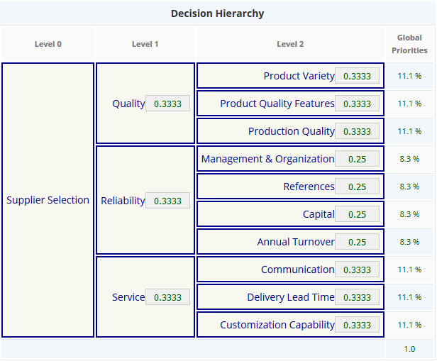

## Text field input for hierarchy above

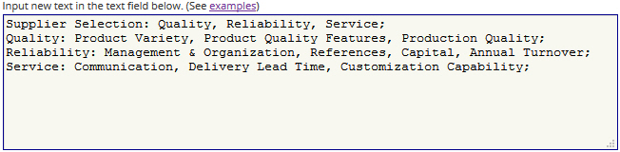

**Annex 3: Conducting a group session**

The figure below shows how a group session is conducted to determine group priorities using BPMSG’s AHP online system. The group session chair must be a registered user to initiate a group sessions. A six character session code is generated. Participants can use this session code to log into the group session and provide their judgements.

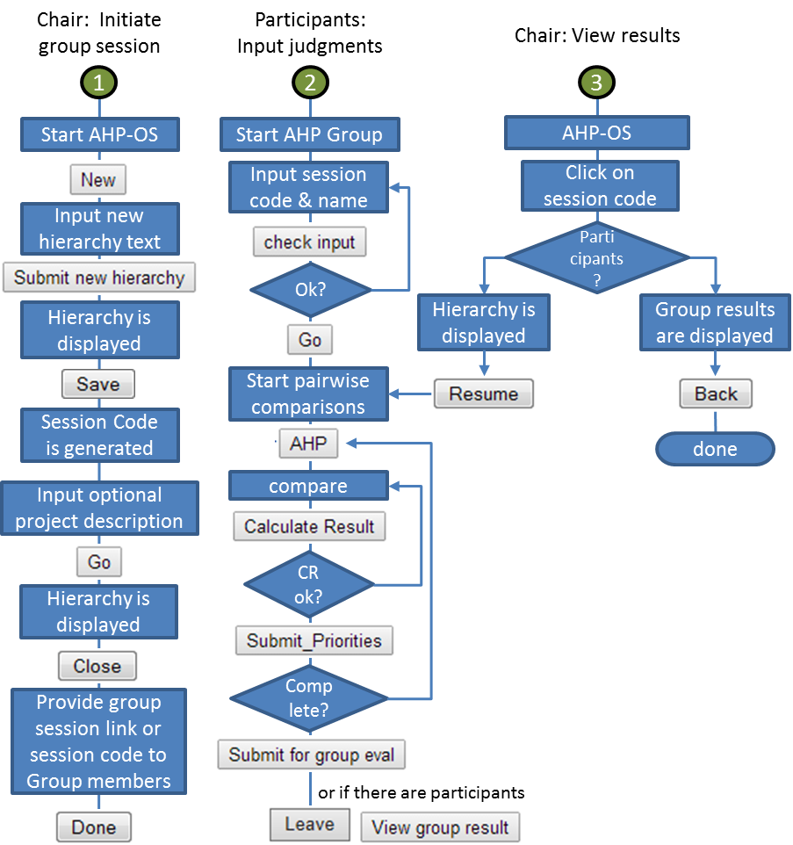

**Annex 4: Evaluation of Alternatives Example**

## Evaluation of Alternatives

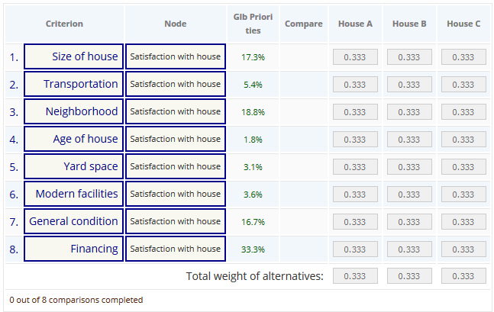

How to make a decision? The analytic hierarchy process. Saaty, European Journal of Operational Research 48 (1990) 9 - 26 - Alternative evaluation

**Annex 5: Data Structure**

**Pairwise Comparisons:**

Array[‘pwc’][$node][‘a’]{0,1,0}[‘Intense’]{3,6,2}



1. function convertPwcToString($pwc) from Array to SQL
2. function convertPwc($pwc) from SQL format to Array
3. function getPwc($sc, $participant, $nod)



Class ahpGroup

Priorities in ahpGroup->prio



Participant with index 0 contains consolidated result

CR in ahpGroup->cr



For alternatives



**Annex 6: Project Export Example**

{

"pj": [

{

"project_id": "6512",

"project_sc": "Ubates",

"project_name": "Compromise",

"project_description": "Compromise Problem 3 alternatives\r\nWPM gives the correct results",

"project_hText": "Compromise: Sales Skills=0.5, Engineering skills=0.5;",

"project_datetime": "2017-06-30 09:06:21",

"project_author": "Klaus",

"project_status": "0"

}

],

"pwc": [

{

"project_sc": "Ubates",

"pwc_part": "Klaus",

"pwc_timestamp": "1498813840",

"pwc_node": "Sales Skills",

"pwc_ab": "000",

"pwc_intense": "494",

"pwc_id": "794"

},

{

"project_sc": "Ubates",

"pwc_part": "Klaus",

"pwc_timestamp": "1498813840",

"pwc_node": "Engineering skills",

"pwc_ab": "111",

"pwc_intense": "494",

"pwc_id": "795"

},

{

"project_sc": "Ubates",

"pwc_part": "Klaus1",

"pwc_timestamp": "1560243394",

"pwc_node": "Sales Skills",

"pwc_ab": "000",

"pwc_intense": "397",

"pwc_id": "2755"

},

{

"project_sc": "Ubates",

"pwc_part": "Klaus1",

"pwc_timestamp": "1560243394",

"pwc_node": "Engineering skills",

"pwc_ab": "111",

"pwc_intense": "892",

"pwc_id": "2756"

}

],

"alt": [

{

"project_sc": "Ubates",

"alt": "A"

},

{

"project_sc": "Ubates",

"alt": "B"

},

{

"project_sc": "Ubates",

"alt": "C"

}

]

}