Josh Ting

Analyzing Developments in the Distribution of Stars around a Supermassive Black Hole Binary (SMBHB) System

# Abstract

The problem at hand is analyzing how a distribution of stars evolves in a SMBHB system. This was pursued through the programming of simulations using Interactive Data Language (IDL). The simulations included two heavy objects representing supermassive black holes (SMBHs) orbiting around each other, with a third, lighter object in the system. The simulations operate as a restricted 2+1 system under a Keplerian model, where the two heavier objects move in a perfectly circular orbit, unaffected by the gravitational pull of the lightest object. A fourth order Runge-Kutta method was implemented to estimate the motions of the objects. An adaptive-stepsize control routine was also added to optimize computational time and accuracy. The system was tested multiple times with different initial conditions for the lightest object. The lightest object was placed at the five Lagrange points, in addition to being put into orbit around each of the heavier objects. It was discovered that there exist multiple locations for the third object that would result in stable orbits. However, minute changes in velocity can potentially destabilize the system fairly quickly. These results can assist in determining whether a particular galaxy has one or two SMBHs by studying the motions of visible stars in close proximity to the black holes.

# Background

A stellar black hole results from the death of a massive star imploding in on itself. Due to the ideal gas law, *PV* = n*RT*, this transformation occurs when the star no longer has enough fuel remaining to maintain a sufficient temperature, *T*. An insufficient temperature results in an insufficient pressure, *P*, which then allows for the internal collapse of the star due to gravity.

Black holes possess an event horizon, a distinct spherical surface that surrounds it. The gravitational field within the region bounded by the event horizon is so strong, not even light can avoid spiraling into it. There is an elliptical region called an ergosphere that exists slightly beyond the event horizon, though its borders touch at the poles. Black holes with faster angular momentum have more elliptical ergospheres, and those with no angular momentum at all have no discernible ergosphere at all, because the ergosphere would be completely spherical and would occupy the same region as the event horizon. Within this region, gravity is not strong enough to prevent light or matter from escaping, but it is still strong enough that it is impossible for a physical object within to remain stationary. Approximately 10% of black holes also have an accretion disk, an orbiting disk of matter around the black hole. An accretion disk can only exist if there is a lot of matter in the surrounding area for the black hole to collect. Radiation jets can be detected emitting from the polar axes of the accretion disk (Figure 1). These are hypothesized to result from twisting magnetic fields from the accretion disk (Semenov, Dyadechkin, & Punsly, 2004).

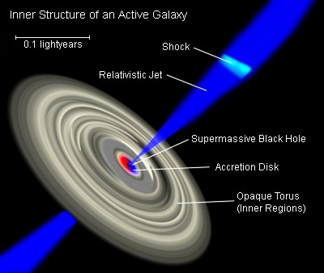

Figure 1: <http://upload.wikimedia.org/wikipedia/commons/4/40/Galaxies_AGN_Inner-Structure-of.jpg>

It is possible for one of the stars of a binary star system to collapse into a black hole, resulting in a star and a black hole orbiting each other, while the black hole sucks up matter from its partner star. If both of them turn into black holes, a black hole binary system is formed. If a single star has enough angular momentum and mass, it could theoretically become unstable enough to split into two constituents which both collapse into black holes, forming a black hole binary (Begelman, Blandford, & Rees, 1980). After absorbing vast quantities of matter and merging with the other black hole, a black hole can eventually turn into a supermassive black hole (SMBH), which can have a mass millions or billions of times greater than that of the Sun. Another theory on the formation of SMBHs is that they may have primordial origins, though that is only possible within a very limited mass distribution for the primordial black holes (Kawasaki, Kusenko, & Yanagida, 2012). Supermassive black hole binary (SMBHB) systems are also possible. SMBHBs that feature spinning black holes exhibit properties different from those with no angular momentum, such as differing gravitational waves (Vecchio, 2004). It is theorized that a SMBH exists at the center of our galaxy, as well as countless others (Ghez et al., 2008). This theory can be supported by locating stars moving at over 1000 km/s near the center of a galaxy as evidence (Yu & Tremaine, 2003). Another theory suggests that a SMBHB exists in these places instead (Sudou, Iguchi, Murata, & Taniguchi, 2003; Begelman et al., 1980).

A problem with researching black holes is that observing one requires expensive equipment. Therefore, much research on black holes is theoretical. Past research has included projects such as determining the evolution of the region around a black hole binary (Pretorius, 2005). Research has been done analyzing motions of particles around SMBHBs. Lippai, Frei, and Haiman (2008) have analyzed the motions of a gas disk surrounding a SMBHB when the SMBHs merge together. They have determined that density changes occur within weeks of the merge, following a supersonic kick in the plane. Kicks perpendicular to the gas disk are generally weaker than those parallel. The merging of two black holes can be catalyzed by dynamical friction, a process in which a moving black hole drags stars together behind it (Begelman et al., 1980). Those stars themselves then exert a gravitational force on the black hole, slowing it down. Other research has analyzed the development of a distribution of stars around an isolated massive black hole over time. Around a galactic center containing a black hole, heavy stars tend to sink towards the black hole, while lighter stars are pushed outwards (Keshet, Hopman, & Alexander, 2009).

This project is different from previous research because it focuses on the evolution of a distribution of stars around a SMBHB, rather than a single, isolated SMBH. It will involve simulating a distribution of stars around a SMBHB system with a Monte Carlo method, and then using the fourth order Runge-Kutta method to estimate the motions of each star. Adaptive stepsize control will be utilized to achieve both optimal runtime speed and simulation accuracy. Any skewness that evolves in the stars’ distribution will be analyzed using the Kolmogorov-Smirnov test, which is useful for distributions that are not expected to be normal, such as the expected star distributions in these simulations. A Keplerian model is assumed. These numerical recipes will be programmed in Interactive Data Language. Independent variables include the initial star distributions, collective mass of the SMBHB, mass ratio of the SMBHB, and the orbital separation of the SMBHB. The orbital separation will involve changing the motions and eccentricity of the SMBHs. A SMBHB can lose angular momentum from circumbinary particles and gravitational radiation, thus changing its orbital separation (Armitage & Natarajan, 2005). This project involves the restricted 3-body problem, which is a 2-dimensional situation involving three celestial objects, such as the Earth, Moon, and Sun, and their positions and momenta relative to one another. One of the three objects (in this case, the moon) is assumed to have a negligible mass, so it has no noticeable gravitational effect on the other two masses. In this project, the two masses will be the SMBHs, while the negligible mass can be represented by any of the stars distributed around the system. The project will also utilize the Lagrangian points, a set of 5 points in a 3-body system where the third, negligible mass can theoretically stay motionless (with respect to the reference frame rotating with the SMBHB) because the gravitational fields of the other two masses cancel each other out at those points. Due to losses in gravitational radiation in such systems, the Lagrange equilibrium points for black hole binaries can change over time (Schnittman, 2010). Dr. Schnittman will be the mentor overseeing this project. He has previously done work regarding the mechanics of SMBHBs, deriving a formula for calculating recoil velocity vectors in a binary system. Schnittman also determined that when the two SMBHs merge, most of the momentum that generates these vectors is generated at the end of coalescence (Schnittman & Buonanno, 2008). The information discovered from this project can be used to differentiate between a SMBHB and a single SMBH in a specified galaxy, based on how the movement of the surrounding stars is affected by the SMBHB.

# Materials & Methods

## Orbital Simulations

In order to learn how to use Interactive Data Language (IDL) and understand the astrophysics and math involved in the project, I repeatedly met with Dr. Schnittman at NASA Goddard Space Flight Center. The first simulations created in IDL modeled a Jupiter-sized mass on a circular orbit around a stationary sun-sized mass with respect to an immobile reference frame centered on the sun-sized mass. Initially the goal was to test the relative errors of the 1st, 2nd, and 4th orders of the Runge-Kutta method, using the orbit as the control and the energy gained as the amount of error. The 4th order method (RK4) was subsequently chosen for use in this project.

The next step was to create eccentricity to the simulation. This was done with the equation,

$$v=\sqrt{GM(\frac{2}{r}-\frac{1}{a})}$$

where *v* is the velocity of the orbiting Jupiter-sized mass, *G* is the gravitational constant, *M* is the mass of the sun-sized mass, *r* is the average radius of the orbit and *a* is the semimajor axis of the orbit. In these simulations, *a* is set as 7.5×1013 cm.

## Three-Body Problem

In order to change the simulations from a two-body problem to a three-body problem, equations for a second sun-sized mass were added. This also required many of the existing equations to be altered to incorporate the third body in them. The old eccentricity equation, for example, was replaced with,

$$v=\sqrt{\frac{Gm}{2r}}$$

where *v* is the velocity of one of the large masses, *G* is the gravitational constant, *m* is the mass of the other large mass, and *r* is the average radius of the orbit. In all these equations, M1 and M2 were used to indicate the sun-sized mass and M3 indicated the Jupiter-sized mass.

## Adaptive Stepsize Control

With an eccentric orbit, it was then required to implement adaptive stepsize control (ASC) in order to reduce the error of the simulation by dynamically changing the stepsize to prevent large gains in error. ASC involves estimating each data point twice (one with a fifth order Runge-Kutta method and one with an embedded RK4) and using the difference between the two estimations as the error. If the error is too large then the step is retried with a smaller timestep; otherwise, the error serves as an indication of how much to increase or decrease the next timestep.

## Numerical Experiments

The next task was to run numerical experiments to examine how the system behaves. Equations for the five Lagrange points were used to determine possible locations for the third mass. Each Lagrange point was tested for the duration of half a revolution of the larger masses. In addition to the Lagrangian points, M3 was also placed in orbit around each of the other masses, making a total of seven distinct simulations. Each simulation’s trajectories were graphed, and their timestep and energy were plotted. The next goal will be to rewrite the program so that the larger masses follow perfectly elliptical orbits, uninfluenced by the gravitational pull of the small mass.

# Results

## Trajectory of L1 system

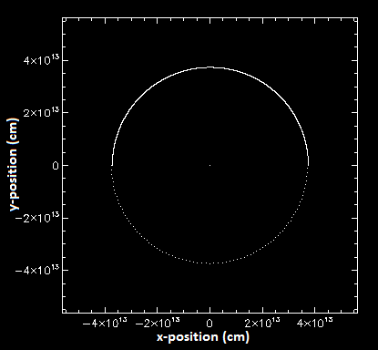

## Trajectory of L2 system

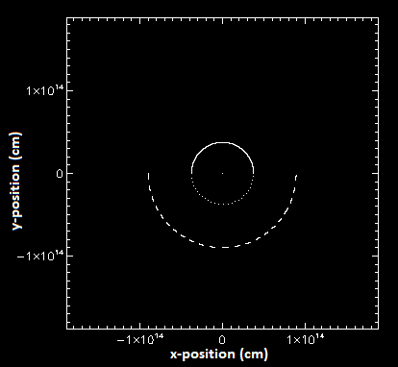

## Trajectory of L3 system

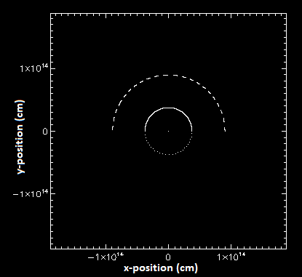

## Trajectory of L4 system

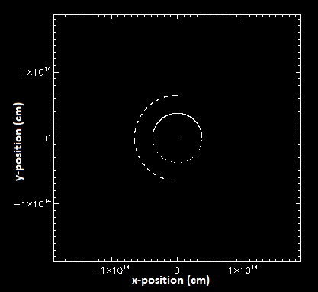

## Trajectory of L5 system

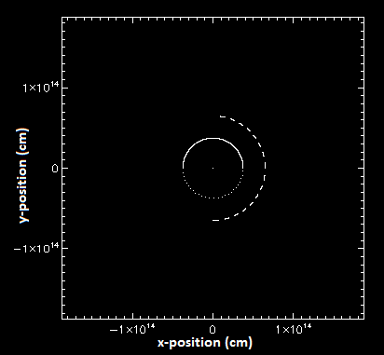

## Trajectory of Small Object in Orbit around M1

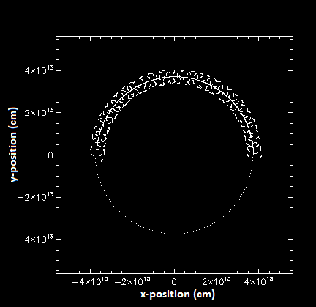

Trajectory of Small Object in Orbit around M2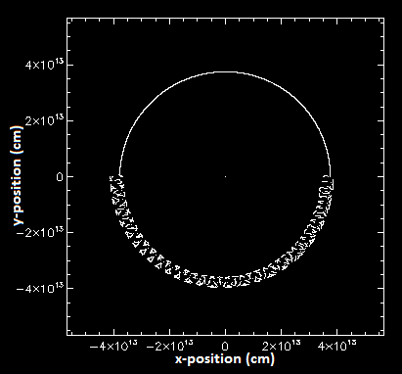

## Change in System Energy with Final Adaptive Stepsize Control

## FinalEnergyderiv.PNGChange in Stepsize with Final Adaptive Stepsize Control

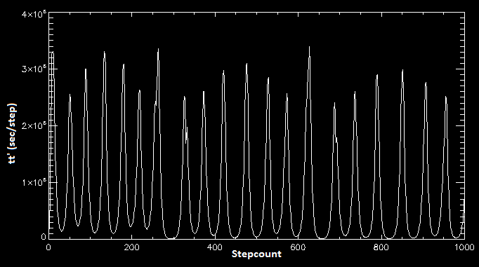

# Conclusion

Due to the nature of this project, no data was measured; rather, all data collected was calculated in the code. There is insufficient data to conduct a Kolmogorov-Smirnov test and draw a reliable conclusion. However, the data collected so far shows that the hypothesis is somewhat supported. The two simulations putting M3 in orbit around one of the larger masses appear to exhibit stable orbits. In addition, when M3 is placed at any Lagrange point and has no velocity with respect to the rotating reference frame of the binary, the system is also stable. However, if M3 had a nonzero velocity, no matter how small in magnitude it is, the system does start to destabilize (for the L1 Lagrange point).

**Two possible ideas for future research have been suggested. The first idea would be to conduct a thorough investigation of stars in close orbits with a SMBHB. This would involve, for example, further examination of how stars behave at or near the Lagrange points. Secondly, a major problem in computation and astrophysics is rounding error on coordinate planes, which computers divide up into a grid of miniscule cells. When plotting the path of a point through a coordinate plane, computers round the location to the nearest cell. In a Cartesian plane, plotting the trajectory that is a vertical or horizontal line would not have this problem; in a polar graph, a circular plot centered on the origin would likewise see no rounding error. However, for trajectories that do not trace out the plane it is being plotted on, this rounding error compounds over many steps, and can lead to significant error. The second suggestion for future research would be to determine which coordinate system yields the highest accuracy in modeling the trajectories of gas particles within a shared accretion disk of two SMBHs.**

# References

Armitage, P. J., & Natarajan, P. (2005). Eccentricity of supermassive black hole binaries coalescing from gas-rich mergers. *The Astrophysical Journal, 634*, 921-927. doi: 10.1086/497108

Begelman, M. C., Blandford, R. D., & Rees, M. J. (1980). Massive black hole binaries in active galactic nuclei. *Nature, 287*, 307-309. doi: 10.1039/287307a0

Ghez, A. M., Salim, S., Weinberg, N. N., Lu, J. R., Do, T., Dunn, J. K., . . . Naiman, J. (2008). Measuring distance and properties of the Milky Way’s central supermassive black hole with stellar orbits. *The Astrophysical Journal, 689*, 1044-1062. doi: 10.1086/592738

Kawasaki, M., Kusenko, A., & Yanagida, T. T. (2012). Primordial seeds of supermassive black holes. *Physics Letters B, 711*, 1-5. doi: 10.1016/j.physletb.2012.03.056

Keshet, U., Hopman, C., & Alexander, T. (2009). Analytic study of mass segregation around a massive black hole. *The Astrophysical Journal, 698*, L64-L67. doi: 10.1088/0004-637X/698/1/L64

Lippai, Z., Frei, Z., & Haiman, Z. (2008). Prompt shocks in the gas disk around a recoiling supermassive black hole binary. *The Astrophysical Journal, 676*, L5-L8. doi: 10.1086/587034

Pretorius, F. (2005). Evolution of binary black-hole spacetimes. *Physics Review Letters, 95*. doi: 10.1103/PhysRevLett.95.121101

Schnittman, J. D. (2010). The Lagrange equilibrium points L_4 and L_5 in a black hole binary system.*the Astrophysical Journal, 724,* 39-48. doi: 10.1088/0004-637X/724/1/39

Schnittman, J. D., & Buonanno, A. (2008). The distribution of recoil velocities from merging black holes. *The Astrophysical Journal, 662*, L63-L66. doi: 10.1086/519309

Semenov, V., Dyadechkin, S., & Punsly, B. (2004). Simulations of jets driven by black hole rotation. *Science, 305*, 978-980. doi: 10.1126/science.1100638

Sudou, H., Iguchi, S., Murata, Y., & Taniguchi, Y. (2003). Orbital motion in the radio galaxy 3C 66B: Evidence for a supermassive black hole binary. *Science, 300,* 1263-1265. doi: 10.1126/science.1082817

Vecchio, A. (2004). LISA observations of rapidly spinning massive black hole binary systems. *Physical Review D, 70*, 24-40. doi: 10.1103/PhysRevD.70.042001

Yu, Q., & Tremaine, S. (2003). Ejection of hypervelocity stars by the (binary) black hole in the galactic center. *The Astrophysical Journal, 599*, 1129-1138. doi: 10.1086/379546