Josh Ting

Dr. Crowe

5/28/14

Investigating the limits of stability of the elliptical restricted three-body problem

# Abstract

The elliptical restricted three-body problem describes a system of two heavy objects, with a lighter one in orbit around one of the heavy objects. The two heavy objects have coplanar, elliptical orbits and are unaffected by the gravitational field of the lighter object. The problem at hand was to determine the relationship between system stability and the mass ratio of the two heavy objects for systems in which the smallest object orbits around one of the other two masses. This was pursued through the programming of both retrograde and prograde simulations using Interactive Data Language (IDL). A fourth order Runge-Kutta method was implemented to estimate the motions of the objects. An adaptive-stepsize control routine was also added to optimize computational time and accuracy. The system was tested multiple times with different initial conditions for the orbital radius of the lightest object. It was discovered that retrograde orbits are always more stable than their corresponding prograde orbits, and systems in which the satellite orbits the smaller mass are less stable than those where the satellite orbits the larger mass. These results can assist in determining the realistic limits of the three-body problem, which can provide guidelines for astrophysicists in creating realistic simulations relevant to binary systems with satellites.

# Introduction

A stellar black hole results from the implosion of a massive star during its death. Due to the ideal gas law,

|  |  |  |
| --- | --- | --- |
|  |  | (1) |

*PV* = n*RT*, this transformation occurs when the star no longer has enough fuel remaining to maintain a sufficient temperature, *T*, which thereby results in an insufficient pressure, *P*, which then allows for the internal collapse of the star due to gravity.

Black holes possess an event horizon, a distinct spherical surface that surrounds it. The gravitational field within the region bounded by the event horizon is so strong, not even light can avoid from spiraling into it. Slightly beyond the event horizon is an elliptical region of space referred to as the ergosphere that touches the poles of the event horizon. Black holes with faster angular momentum have more elliptical ergospheres, and those with no angular momentum at all have no discernible ergosphere, because the ergosphere would be completely spherical and would therefore occupy the same region as the event horizon. Within this region, gravity is not strong enough to prevent light or matter from escaping, but it is still strong enough that it is impossible for a physical object within to remain at a constant radius. Approximately 10% of black holes also have an accretion disk: an orbiting disk of matter around the black hole. An accretion disk can only exist if there is a lot of matter in the surrounding area for the black hole to collect. Radiation jets emitted from the polar axes of the accretion disk can be detected (Figure 1). These are hypothesized to result from twisting magnetic fields from the accretion disk (Semenov, Dyadechkin, & Punsly, 2004).

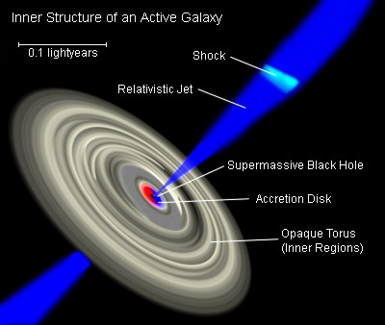

Figure 1: <http://upload.wikimedia.org/wikipedia/commons/4/40/Galaxies_AGN_Inner-Structure-of.jpg>

A binary star system is a stellar system containing two stars, orbiting around their center of mass. If one of the stars is massive enough, it can collapse into a black hole, which would then siphon matter from its companion star. A black hole binary system is formed when both stars collapse into black holes. If a single star has enough angular momentum and mass, it could theoretically become unstable enough to split into two constituents which both collapse into black holes, forming a black hole binary (Begelman, Blandford, & Rees, 1980). After absorbing vast quantities of matter and merging with the other black hole, a black hole can eventually turn into a supermassive black hole (SMBH), which can have a mass millions or billions of times greater than that of the Sun. Another theory on the formation of SMBHs is that they may have primordial origins, though that is only possible within a very limited mass distribution for these primordial black holes (Kawasaki, Kusenko, & Yanagida, 2012). Supermassive black hole binary (SMBHB) systems are also possible. SMBHBs that feature spinning black holes exhibit properties different from those with no angular momentum, such as differing gravitational waves (Vecchio, 2004). It is theorized that a SMBH exists at the center of our galaxy as well as countless others (Ghez et al., 2008). Evidence supporting this theory has included the locating of stars moving at over 1000 km/s near the center of a galaxy (Yu & Tremaine, 2003). Another theory suggests that a SMBHB exists in these places instead (Sudou, Iguchi, Murata, & Taniguchi, 2003; Begelman et al., 1980).

Due to the infeasibility of close-up studies of black holes, much research relating to black holes is theoretical. Past research has included projects such as determining the evolution of the region around a black hole binary (Pretorius, 2005). Research has been done analyzing motions of particles around SMBHBs. Lippai, Frei, and Haiman (2008) have analyzed the motions of a gas disk surrounding a SMBHB when the SMBHs merge together. They have determined that density changes occur within weeks of the merge, following a supersonic kick in the plane. Kicks perpendicular to the gas disk are generally weaker than those that are parallel. The merging of two black holes can be catalyzed by dynamical friction, a process in which a moving black hole drags stars together behind it (Begelman et al., 1980). Those stars themselves then exert a gravitational force on the black hole, slowing it down. Other research has analyzed the development of a distribution of stars around an isolated massive black hole over time. Around a galactic center containing a black hole, heavy stars tend to sink towards the black hole, while lighter stars are pushed outwards (Keshet, Hopman, & Alexander, 2009). However, the limits that these stars can be pushed outward without losing stability was not yet known.

The goal of this project was to determine the effect of the mass ratio of the two black holes on the stability of particles in prograde and retrograde orbits. Rather than simulate a plethora of particles in an accretion disk, only a single particle from the disk will be analyzed at any one time, easing the computational workload of the simulation. Therefore, each simulation will be an elliptical restricted three-body system (ER3BS). The three-body problem describes the motions of a system in which there exist three point masses. Here, the gravitational force of the small object, *m3*, has no effect on either of the other two masses. In addition, the motions of all three masses are confined to two dimensions, and the two larger objects, *M1* and *M2*, follow an elliptical orbit around one another. One notable phenomenon of the three-body problem is the five Lagrange points. These are five points in a two-body system where if *m3* was placed, it would not move relative to the other two masses. The stability of this locked system varies between Lagrange points, with L1 being the most unstable and L4 and L5 being relatively stable (Schnittman, 2010). Gravitational fields can form a twistless torus near L4, allowing for unusual yet stable orbits. It was hypothesized that the larger the mass ratio, the more stable the system. In addition, retrograde orbits are hypothesized to be more stable than corresponding prograde orbits (J. Schnittman, personal communication, April 10, 2014).

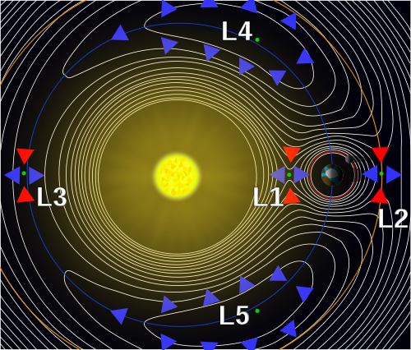

Figure 2: <http://en.wikipedia.org/wiki/Lagrange_points>

This project will be conducted using Interactive Data Language (IDL). The program will use the fourth order Runge-Kutta method to plot the motions of the masses. Adaptive stepsize control will be implemented to optimize the simulation in terms of both computation time and model accuracy (Press, Teukolsky, Vetterling, & Flannery, 1992). While the simulations will be run in sidereal Cartesian coordinates, they will by default be plotted in synodic Cartesian coordinates. Sidereal coordinates are coordinates within a fixed reference frame, while synodic coordinates are those whose frame of reference rotates with the larger masses in the simulation, so that both of the larger masses always lie on the horizontal axis. The independent variable is the mass ratio of the other two masses given by

|  |  |  |
| --- | --- | --- |
|  |  | (2) |

and the dependent variable is the maximum radius at which the system remains stable. The control is a system where *M2* and *M1* are equal.

Dr. Schnittman will be the mentor overseeing this project. His previous work regarding black hole mechanics has included the derivation of a formula for calculating recoil velocity vectors in a binary system. Schnittman also determined that when the two SMBHs merge, most of the momentum that generates these vectors is generated at the end of coalescence (Schnittman & Buonanno, 2008).

# Methods

Rather than code the entire accretion disk into a simulation, only one particle was examined at a time. Therefore, the first objective is to simulate the SMBHB as a three-body system. A fourth-order Runge-Kutta method was implemented in IDL 8.2.1 in order to model a SMBHB system with an accretion disk in sidereal Cartesian coordinates. The simulation consisted of two black holes with equal masses that orbited each other in a fixed elliptical pattern, unaffected by the gravitational pull of the small particle, *m3*. This was the *m3* mass in the elliptical restricted three-body problem and assumed the mass of a star. Adaptive stepsize control was implemented to optimize computation time and error gain (Press, Teukolsky, Vetterling, & Flannery, 1992).

Starting with an *m3* orbital radius 1/10 the size of the radius of *M2*, the simulation was iterated multiple times. The initial velocity of *m3* was set to be

|  |  |  |
| --- | --- | --- |
|  |  | (2) |

and for each iteration at this radius, vscale was increased by 0.1 (starting from 0.1) to determine if there exists a velocity at which this orbit is stable. If there was a velocity at which this orbit is stable, these simulations were repeated, incrementing the radius of the *m3* orbit by 1/10 the size of the orbital radius of *M2* until there was no possible velocity that can maintain stability at the given size of the orbit. Stability is defined here as when the eccentricity is less than 0.9 and the maximum radius of the *m3* orbit does not exceed the magnitude of the semimajor axis of *M2.* This was done for both prograde and retrograde orbits. Both the prograde and retrograde procedures were executed for mass ratios of 10, 1, and 0.1, and each mass ratio was simulated multiple times. The maximum possible orbital radius was recorded for each system.

This project was conducted using CGS units, in which distance is given in centimeters, mass is given in grams, and time is given in seconds. Therefore, all values henceforth will be presented in CGS units.

# Data

## Figure 3: Retrograde orbit for mass ratio of 1 and rscale of 0.7

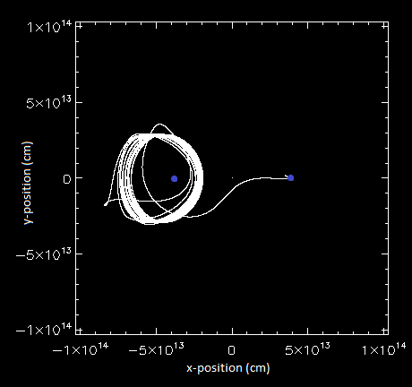

## Figure 4: Prograde orbit for mass ratio of 1 and rscale of 0.4

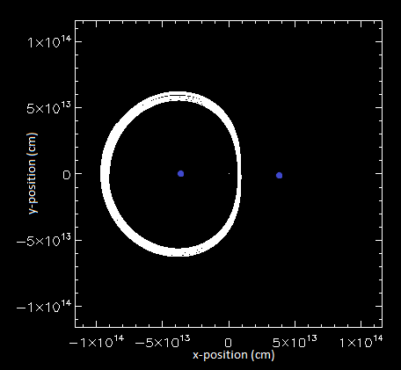

# Results

## Table 1: Maximum limits of retrograde orbits

|  |  |  |
| --- | --- | --- |
| µ | rscale | vscale |
| 10 | 0.7 | 1.1 |
| 1 | 0.7 | 1.5 |
| 0.1 | 0.5 | 0.1 |

## Table 2: Maximum limits of prograde orbits

|  |  |  |
| --- | --- | --- |
| µ | rscale | vscale |
| 10 | 0.5 | 0.2 |
| 1 | 0.3 | 0.6 |
| 0.1 | 0.2 | 0.5 |

In Tables 1 and 2, rscale is the maximum orbital radius of *m3* divided by the semimajor axis of the orbit of *M2*.

# Conclusion

Figure 3 and 4 showcase examples of unstable and stable orbits, respectively. For each mass ratio, retrograde orbits were discovered to have larger limits of stability than prograde orbits, which is in agreement with the hypothesis. In addition, a larger mass ratio does result in a more stable system, which was also hypothesized. However, according to (J. Schnittman, personal communication, May 15, 2014),

|  |  |  |
| --- | --- | --- |
|  |  | (4) |

where *r23* is the magnitude of the orbital radius of *m3* around *M2* and *a* is the magnitude of the semimajor axis of the orbit of *M2*. Neither Table 1 nor Table 2 agree with this law. Nevertheless, both hypotheses made agree with the results. This discrepancy may have resulted from use of an inadequate coordinate system.

A major problem in computation and astrophysics is rounding error on coordinate planes. A computer simulates a physical space by breaking it up into a coordinate system which it represents using grids. These grids consist of arrays of cells in the computer’s memory, where any two adjacent cells represent two sets of coordinates that are as close together as the computer can possibly distinguish. Sometimes though, this isn’t precise enough for the user’s needs. When an object’s coordinates lie between those of the two adjacent cells, the computer must round off the object’s coordinates in order to perfectly place it in a single cell. Over time this rounding error accumulates, leading to considerable overall error. One option for future research would be to determine which coordinate system yields the highest accuracy in modeling the trajectories of gas particles within a shared accretion disk of two SMBHs.

# References

Begelman, M. C., Blandford, R. D., & Rees, M. J. (1980). Massive black hole binaries in active galactic nuclei. *Nature, 287*, 307-309. doi: 10.1039/287307a0

Dullin, H. R., Worthington, J. (2014). The vanishing twist in the restricted three-body problem. *Physica D, 276*, 12-20. doi: 10.1016/j.physd.2014.03.001

Ghez, A. M., Salim, S., Weinberg, N. N., Lu, J. R., Do, T., Dunn, J. K., Matthews, K., … Naiman, J. (2008). Measuring distance and properties of the Milky Way’s central supermassive black hole with stellar orbits. *The Astrophysical Journal, 689*, 1044-1062. doi: 10.1086/592738

Kawasaki, M., Kusenko, A., & Yanagida, T. T. (2012). Primordial seeds of supermassive black holes. *Physics Letters B, 711*, 1-5. doi: 10.1016/j.physletb.2012.03.056

Keshet, U., Hopman, C., & Alexander, T. (2009). Analytic study of mass segregation around a massive black hole. *The Astrophysical Journal, 698*, L64-L67. doi: 10.1088/0004-637X/698/1/L64

Lippai, Z., Frei, Z., & Haiman, Z. (2008). Prompt shocks in the gas disk around a recoiling supermassive black hole binary. *The Astrophysical Journal, 676*, L5-L8. doi: 10.1086/587034

Press, W. H., Teukolsky, S. A., Vetterling, W. T., & Flannery, B. P. (1992). *Numerical recipes in C: The art of scientific computing.* Cambridge, MA: Press Syndicate of the University of Cambridge.

Pretorius, F. (2005). Evolution of binary black-hole spacetimes. *Physics Review Letters, 95*. doi: 10.1103/PhysRevLett.95.121101

Schnittman, J. D. (2010). The Lagrange equilibrium points L4 and L5 in a black hole binary system.*the Astrophysical Journal, 724,* 39-48. doi: 10.1088/0004-637X/724/1/39

Schnittman, J. D., & Buonanno, A. (2008). The distribution of recoil velocities from merging black holes. *The Astrophysical Journal, 662*, L63-L66. doi: 10.1086/519309

Semenov, V., Dyadechkin, S., & Punsly, B. (2004). Simulations of jets driven by black hole rotation. *Science, 305*, 978-980. doi: 10.1126/science.1100638

Sudou, H., Iguchi, S., Murata, Y., & Taniguchi, Y. (2003). Orbital motion in the radio galaxy 3C 66B: Evidence for a supermassive black hole binary. *Science, 300,* 1263-1265. doi: 10.1126/science.1082817

Vecchio, A. (2004). LISA observations of rapidly spinning massive black hole binary systems. *Physical Review D, 70*, 24-40. doi: 10.1103/PhysRevD.70.042001

Yu, Q., & Tremaine, S. (2003). Ejection of hypervelocity stars by the (binary) black hole in the galactic center. *The Astrophysical Journal, 599*, 1129-1138. doi: 10.1086/379546