大实例安装步骤
- 安装前端
- 安装Visual Studio Code；
- 安装node.js，注意下载版本应为14.21.3；
- 打开工程代码，在终端中执行命令npm ci；注意我们npm版本应为6.14.18

- 安装数据库
1，安装MySQL管理工具，在本机创建数据库服务；
2，安装Navicat，并连接本机数据库服务；
3，用Navicat创建一个数据库，命名为cms；
4，将cms.sql导入；
5，创建两个视图，分别是：
(1) view_base_user
SELECT
`base_user`.`ADDRESS` AS `ADDRESS`,
`base_user`.`BIRTH` AS `BIRTH`,
`base_user`.`DEPARTMENT_ID` AS `DEPARTMENT_ID`,
`base_user`.`EMAIL` AS `EMAIL`,
`base_user`.`FIRST_LOGIN` AS `FIRST_LOGIN`,
`base_user`.`ID_CARD` AS `ID_CARD`,
`base_user`.`JOB_ID` AS `JOB_ID`,
`base_user`.`NAME` AS `NAME`,
`base_user`.`ID` AS `ID`,
`base_user`.`IS_DELETED` AS `IS_DELETED`,
`base_user`.`NICK_NAME` AS `NICK_NAME`,
`base_user`.`PASSWORD` AS `PASSWORD`,
`base_user`.`PHONE` AS `PHONE`,
`base_user`.`POSTAL_CODE` AS `POSTAL_CODE`,
`base_user`.`REGISTER_TIME` AS `REGISTER_TIME`,
`base_user`.`REMARKS` AS `REMARKS`,
`base_user`.`SEX` AS `SEX`,
`base_user`.`THEME_COLOR` AS `THEME_COLOR`,
`base_user`.`WORK_ID` AS `WORK_ID`,
`base_user`.`ACCOUNT` AS `ACCOUNT`,
`base_user`.`CREATE_TIME` AS `CREATE_TIME`,
`base_user`.`UPDATE_TIME` AS `UPDATE_TIME`,
`base_job_position`.`NAME` AS `JOB_NAME`,
`department_getAllParentNames` ( `base_user`.`DEPARTMENT_ID` ) AS `DEPARTMENT_NAME`,
`department_getSchoolId` ( `base_user`.`DEPARTMENT_ID` ) AS `SCHOOL_ID`,
`base_user`.`CODE` AS `CODE`
FROM
((
`base_user`
LEFT JOIN `base_department` ON ((
`base_user`.`DEPARTMENT_ID` = `base_department`.`ID`
)))
LEFT JOIN `base_job_position` ON ((
`base_user`.`JOB_ID` = `base_job_position`.`ID`
)))

(2) view_user_role_detail
SELECT
`rel_user_role`.`IS_DELETED` AS `IS_DELETED`,
`rel_user_role`.`ROLE_ID` AS `ROLE_ID`,
`rel_user_role`.`USER_ID` AS `USER_ID`,
`rel_user_role`.`CREATE_TIME` AS `CREATE_TIME`,
`rel_user_role`.`UPDATE_TIME` AS `UPDATE_TIME`,
`rel_user_role`.`IS_AUDIT` AS `IS_AUDIT`,
`sys_role`.`NAME` AS `ROLE_NAME`,
`sys_role`.`CODE` AS `ROLE_CODE`,
`rel_user_role`.`ID` AS `ID`,
`view_base_user`.`PHONE` AS `USER_PHONE`,
`view_base_user`.`NAME` AS `USER_NAME`,
`view_base_user`.`DEPARTMENT_NAME` AS `DEPARTMENT_NAME`
FROM
((
`sys_role`
JOIN `rel_user_role` ON ((
`sys_role`.`ID` = `rel_user_role`.`ROLE_ID`
)))
JOIN `view_base_user` ON ((
`view_base_user`.`ID` = `rel_user_role`.`USER_ID`
)))

6，创建两个函数，分别是：
（1）department_getAllParentNames
CREATE DEFINER=`root`@`localhost` FUNCTION `department_getAllParentNames`(`nodeId` integer) RETURNS varchar(1000) CHARSET utf8
DETERMINISTIC
BEGIN
DECLARE parentList VARCHAR(1000); # 返回父节点结果集
DECLARE tempParent INTEGER; # 临时存放父节点
DECLARE tempName VARCHAR(50); # 临时存放父节点

SET parentList = '';
SET tempParent = nodeId;
SET tempName = '';

SET @tabName = 'base_department';

WHILE tempParent is not NULL DO # 循环，用于查询节点上所有的父节点
IF tempName<>'' THEN
IF parentList<>'' THEN
SET parentList = CONCAT(tempName,'/', parentList);
ELSE
SET parentList = tempName;
END IF;
END IF;
SET tempName = (SELECT name FROM base_department where id=tempParent); # 查询节点上所有父节点
SET tempParent = (SELECT parent_id FROM base_department where id=tempParent and the_level>=2); # 查询节点上所有父节点
END WHILE;
RETURN parentList; # 将返回结果处理，截取掉结果集前面的逗号
END

（2） department_getSchoolId
CREATE DEFINER=`root`@`localhost` FUNCTION `department_getSchoolId`(`nodeId` integer) RETURNS int(11)
DETERMINISTIC
BEGIN
DECLARE theLevel INTEGER;
DECLARE tempID INTEGER;
DECLARE parentId INTEGER;

SET tempID = nodeId;
SET parentId = nodeId;
SET theLevel = (SELECT the_level FROM base_department where id=tempID);

WHILE parentId<>-1 and theLevel<>2 DO # 循环，用于查询节点上所有的父节点
SET parentId = (SELECT parent_id FROM base_department where id=tempID); # 查询节点上所有父节点
SET theLevel = (SELECT the_level FROM base_department where id=parentId); # 查询节点上所有父节点
END WHILE;
IF theLevel<>2 THEN
RETURN 0; # 将返回结果处理，截取掉结果集前面的逗号
ELSE
RETURN parentId;
END IF;

END

- 安装和运行redis
- 将redis压缩包解压到你的某个目录下；
- 控制台方式下进入到这个目录，执行“redis-server”；
- 压缩包里包含了redis客户端，可以执行查看本机redis情况。

- 安装和运行minio
- 将minio压缩包解压到你的某个目录下；
- 控制台方式下进入到这个目录，执行“minio server d:\temp”，其中后面的“d:\temp”可以换成你自己机器下面的某个目录，即将该目录做成文件存储路径；
- 在浏览器输入：http://localhost:9000/，进入minio配置界面，默认账号密码都是minioadmin；
- 在配置界面里面创建一个桶，命名为“association”，并且将桶的访问方式改成public；
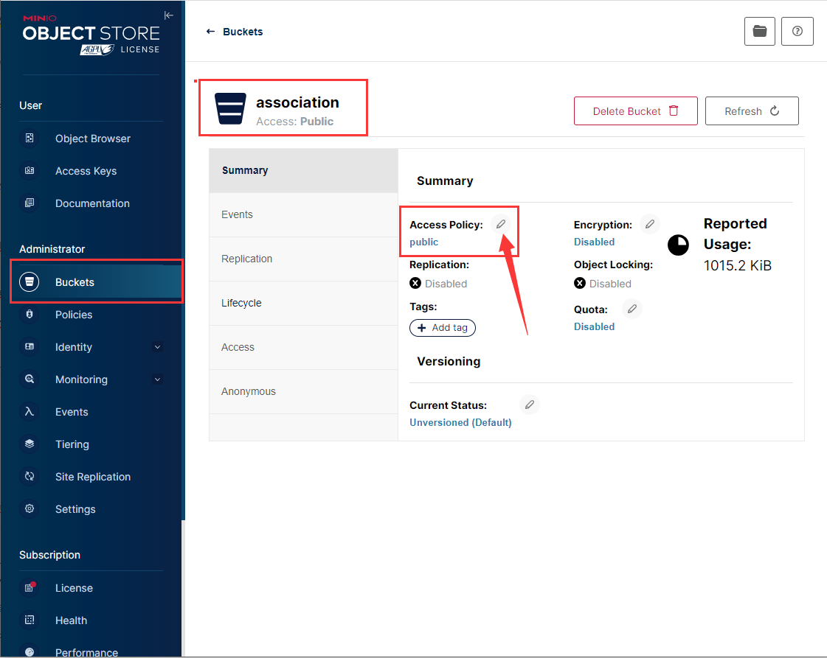

- 安装后端和运行大实例
- 安装IntelliJ IDEA；
- 打开后端工程，导入相关依赖；
- 检查下application-dev.yaml文件中的相关配置，主要是数据库名称、账号、密码；redis地址和端口，minio地址、账号、密码是否有变；
- 运行后端；
- 前端控制台输入npm run serve，执行前端。

