7-5 定义一个基类Shape，在此基础上派生出Rectangle和Circle，二者都有getArea()函数计算对象的面积。使用Rectangle类创建一个派生类Square。
答：源代码
#include <iostream>
#define PI 3.1415926

class Shape {
public:
virtual ~Shape() {};
virtual double getArea() const = 0;
};

class Rectangle : public Shape {
private:
double width;
double height;

public:
Rectangle(double w, double h) : width(w), height(h) {}

double getArea() const override {
return width * height;
}
};

class Circle : public Shape {
private:
double radius;

public:
Circle(double r) : radius(r) {}

double getArea() const override {
return PI * radius * radius;
}
};

class Square : public Rectangle {
public:
Square(double side) : Rectangle(side, side) {}
};

int main() {

Rectangle rect(1.0, 2.0);
Circle circle(1.0);
Square square(1.0);

std::cout << "Rectangle area: " << rect.getArea() << std::endl;
std::cout << "Circle area: " << circle.getArea() << std::endl;
std::cout << "Square area: " << square.getArea() << std::endl;

return 0;
}
执行结果：
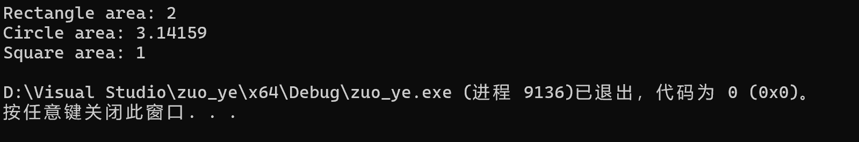
7-10定义一个Object类，有数据成员weight 及相应的操作函数，由此派生出Box类，增加数据成员 height 和 width 及相应的操作函数,声明一个 Box 对象，观察构造函数与析构函数的调用顺序。
答：源代码
#include <iostream>
using namespace std;

class Object {
protected:
double weight;
public:
Object(double w) : weight(w) {
cout << "Object_weight: " << weight << endl;
}
~Object() {
cout << "Object_weight: " << weight << endl;
}
};

class Box : public Object {
private:
double height;
double width;
public:
Box(double w, double h, double wi) : Object(w), height(h), width(wi) {
cout << "Box_height: " << height << ", width: " << width << endl;
}
~Box() {
cout << "Box_height: " << height << ", width: " << width << endl;
}
};

int main() {
Box box(1.0, 2.0, 3.0);
return 0;
}
执行结果：
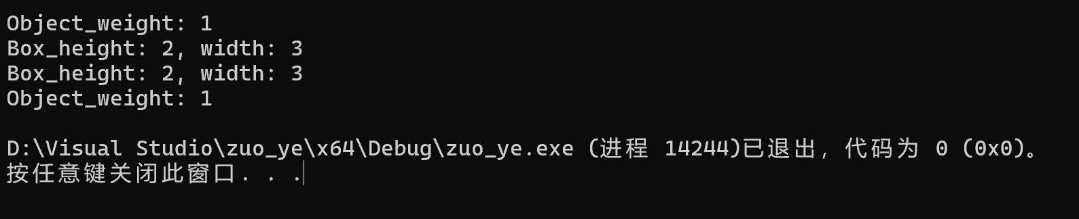
7-11定义一个基类 BaseClass,从它派生出类 DerivedClass。BaseClass 有成员函数fn1(),fn2(),DerivedClass 也有成员函数fn1(),fn2()。在主函数中声明一个DerivedClass的对象,分别用 DerivedClass 的对象以及 BaseClass 和 DerivedClas的指针来调用fn1（），fn2（）观察运行结果。

答：源代码（虚函数）：
#include <iostream>
using namespace std;

class BaseClass {
public:
virtual void fn1() {
cout << "BaseClass::fn1()" << endl;
}

virtual void fn2() {
cout << "BaseClass::fn2()" << endl;
}
};

class DerivedClass : public BaseClass {
public:
void fn1() override {
cout << "DerivedClass::fn1()" << endl;
}

void fn2() override {
cout << "DerivedClass::fn2()" << endl;
}
};

int main() {
DerivedClass derivedObj;

derivedObj.fn1();
derivedObj.fn2();

BaseClass* basePtr = &derivedObj;

basePtr->fn1();
basePtr->fn2();

DerivedClass* derivedPtr = &derivedObj;

derivedPtr->fn1();
derivedPtr->fn2();

return 0;
}
源代码（无虚函数）:
#include <iostream>
using namespace std;

class BaseClass {
public:
void fn1() {
cout << "BaseClass::fn1()" << endl;
}

void fn2() {
cout << "BaseClass::fn2()" << endl;
}
};

class DerivedClass : public BaseClass {
public:
void fn1() {
cout << "DerivedClass::fn1()" << endl;
}

void fn2() {
cout << "DerivedClass::fn2()" << endl;
}
};

int main() {
DerivedClass derivedObj;

derivedObj.fn1();
derivedObj.fn2();

BaseClass* basePtr = &derivedObj;

basePtr->fn1();
basePtr->fn2();

DerivedClass* derivedPtr = &derivedObj;

derivedPtr->fn1();
derivedPtr->fn2();

return 0;
}
执行结果（写虚函数）：
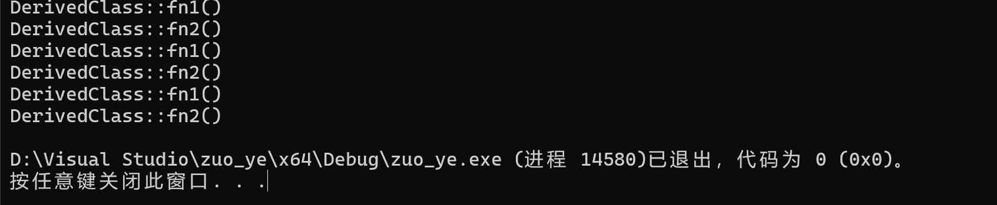
执行结果（无虚函数）：
